Contents

New ESXi Host Deployment (UCS) 1

Things Needed: 1

IP and DNS 1

UCS Service Profile 1

Boot LUN 1

Installation Media 2

# New ESXi Host Deployment (UCS)

ESXi Host Deployments are tracked from within the following document:

\\ad.dstsystems.com\dskcdfs\data1\AHS \Virtualization Support\VMware\ESXi\ESXi – HostDeploymentDetails.xlsx

# Things Needed:

1. IP address for host
2. DNS entry for host
3. Boot LUN
4. UCS service profile created
5. Installation media

## IP and DNS

This information can be found in the following document on the team share, if an IP is not assigned and shown in this document then a request to networking will need to be made.

\\ad.dstsystems.com\dskcdfs\data1\AHS\Virtualization Support\ISO\VMware\ESXi\ESXI - MgmtvMotionWWNs.xlsx

## UCS Service Profile

Having an available UCS service profile for the new host to be deployed is critical as without it you cannot request a boot LUN nor install ESXi. Validating a Service profile exists and is available is accomplished by logging into UCS manager of the appropriate UCS domain, going to the Servers tab in the inventory navigator pane on the left and looking to find a Service profile with the corresponding name to the host you are building. You can click on the correct Service profile to see its state regarding association and power. The Service profile you wish to build out must be associated to a blade.

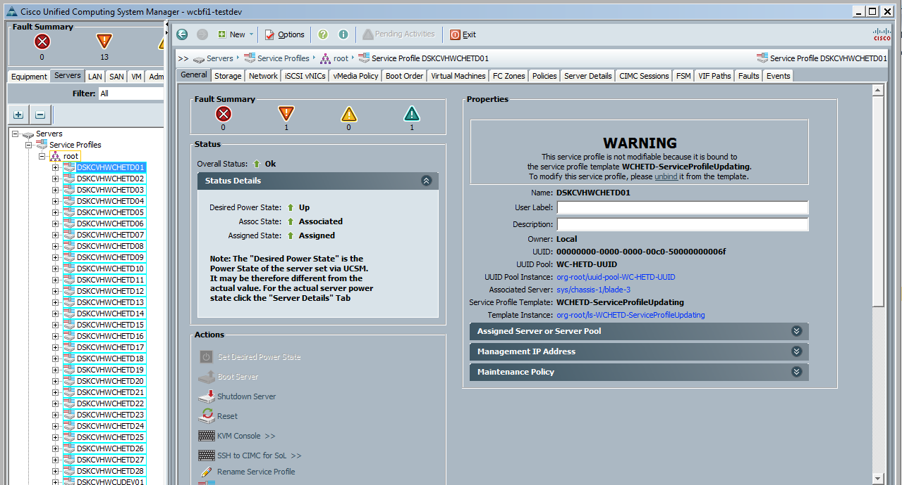

## Boot LUN

To validate that a boot LUN exists you can do some or all of the following, boot LUNs should be LUN 0:

1. Validate that you have been provided a boot LUN from the storage team from a corresponding request, you can ask them to provide you with the naa/LUN identifier for the boot LUN as validation.
2. If you believe a boot LUN already exists you can ask the storage team to validate that they see a boot LUN zoned to the target host by providing the name(s) of the host(s) and their corresponding WWPNs.
3. Log into UCS manager, launch a KVM session to the target blade and validate you do NOT see the following message after the blade is powered on.

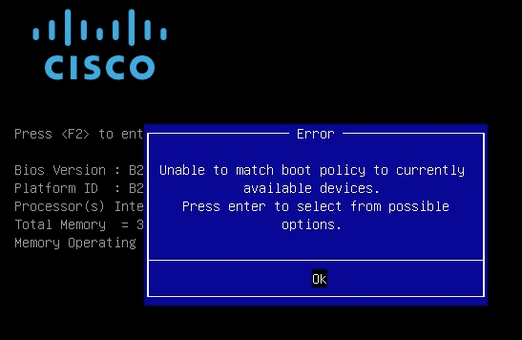

This is a really good indicator that the blade does not have a boot LUN, but is not the most official way to determine if one actually exists. If you see the below screen after booting or rebooting, then a boot LUN most likely DOES exist.

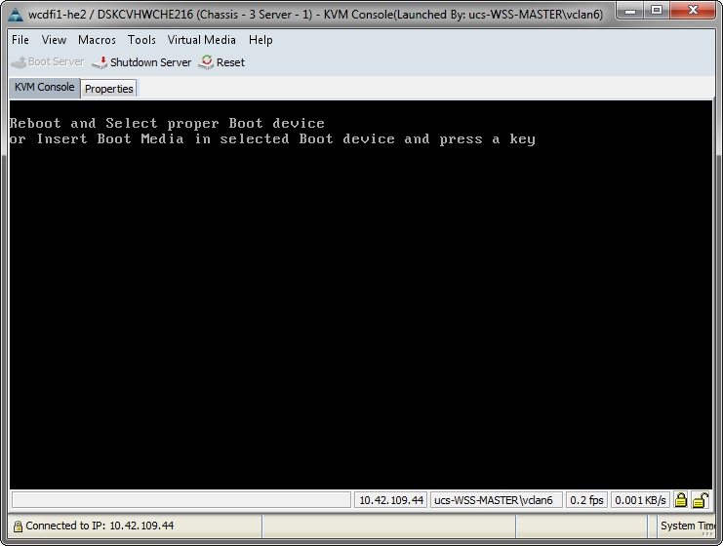

1. You can launch a KVM sessions and load the ESXi installation media, once it reaches the stage where you choose the device to install onto you can see if you can find a Boot LUN sized disk available (10-50GBs) without a VMFS partition on it. If you find one you can normally assume that is the boot LUN for the host but you can also get its naa/indentifier and pass it along to the storage team to have them validate.

## Installation Media

Obtain target ESXi installation media (.iso) from my.vmware.com or the Virtulization Team Share \\ad.dstsystems.com\dskcdfs\data1\AHS\Virtualization Support\ISO\VMware\ESXi\

# Host Build Out

To begin the host build out process log in to the associated UCS domain and locate the correct Service profile and validate that it is associated to a blade. If you know that a boot LUN does in fact exist then the blade does not need to be powered on until you attach the ESXi ISO image, if you need to check for a boot LUN follow the steps outlined earlier in this document.

Next you will launch a KVM sessions to the target service profile: