You must submit a “Build of Materials” (BOM) request in JIRA when you need infrastructure to support an application or service. Follow these instructions to generate and submit your BOM ticket. The request will route to the Integration Engineering team and they will prepare the BOM.

Create the BOM Request
- Open JIRA.
- Click Create on the Menu Bar at the top of the screen.

- Complete the fields in the Create Issue dialog box as follows:
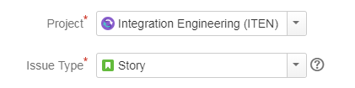

- Project = Integration Engineering (ITEN)
- Issue Type = Story
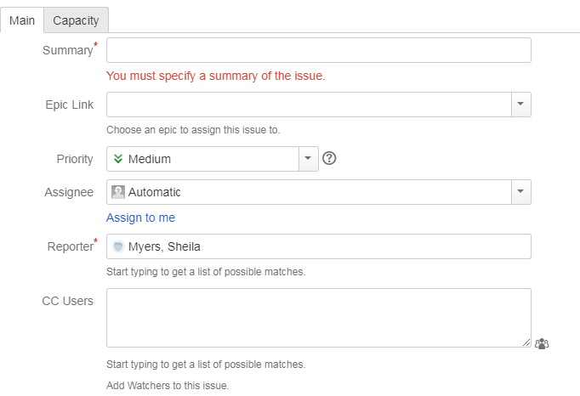

- Summary = Enter the name of the BOM (Include “BOM” in the title).
- Priority = Medium
- Assignee = Enter the name of the Integration Engineer responsible for the project.
- The Reporter field autofills.
- CC Users = Enter associates who should be informed about activity on the BOM.

- Project Identifier = Enter the code for any related project(s) (if applicable).

- Attachment = Attach files related to the project or program (if applicable).
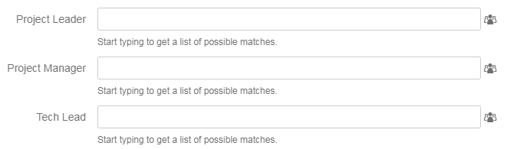

- Project Leader = Enter the name of the associate leading the project.
- Project Manager = Enter the team leader(s).
- Tech Lead = Enter the name of the Integration Engineer.
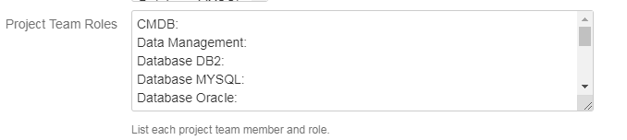

- Project Team Roles = Complete the list of project team members and roles.
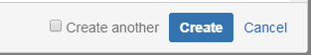

- At the end of the form, click Create.

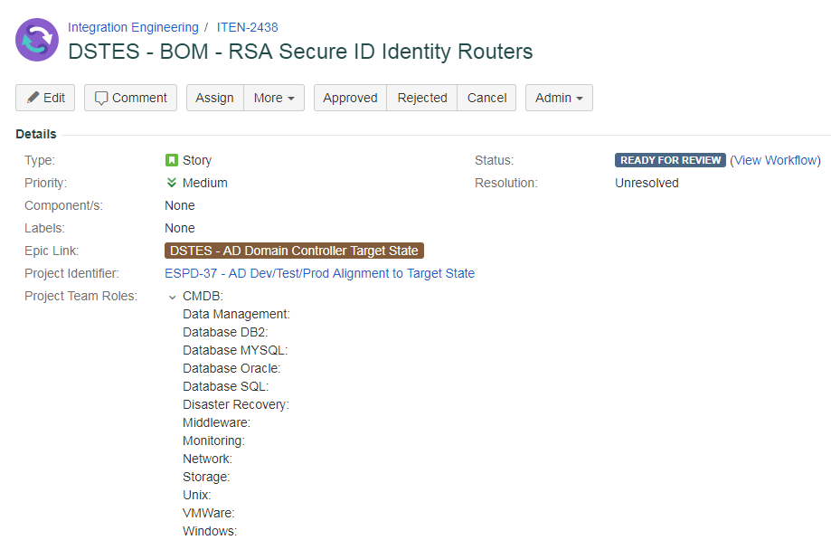

BOM ticket example

- The BOM request is created in JIRA.

Create BOM Subtasks
The Integration Engineer usually enters the subtasks, so you can skip this step. If you decide to enter the subtasks yourself, be sure to copy and paste the text from the table below and assign the correct resources to the subtask.
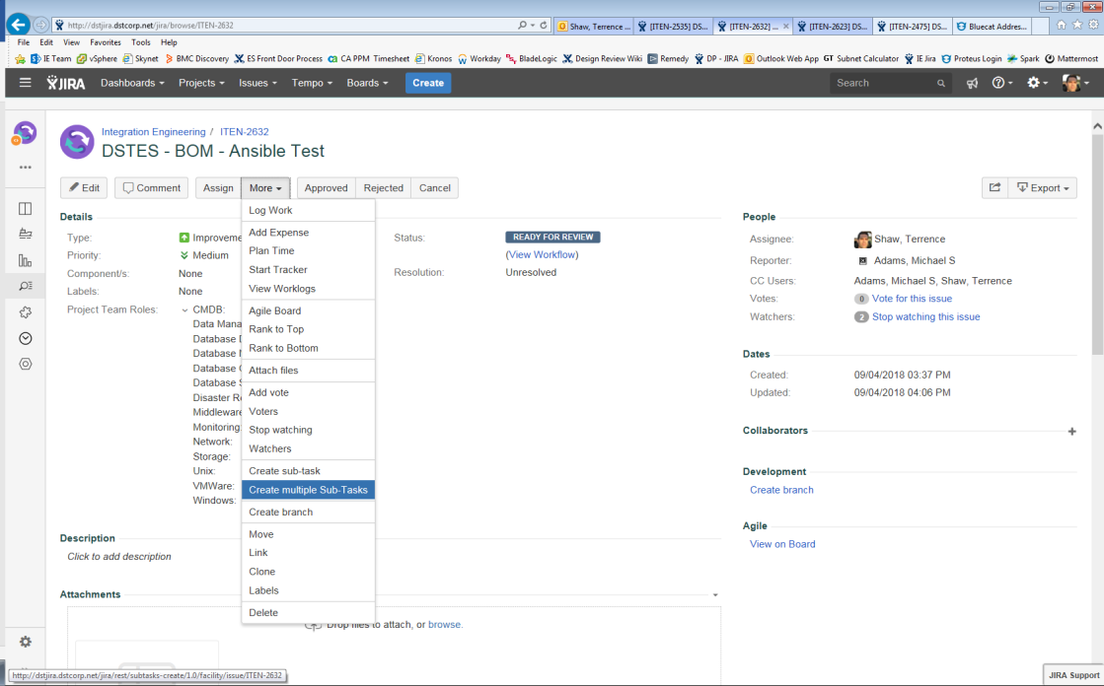

- On the main BOM page, click More > Create multiple Sub-Tasks.

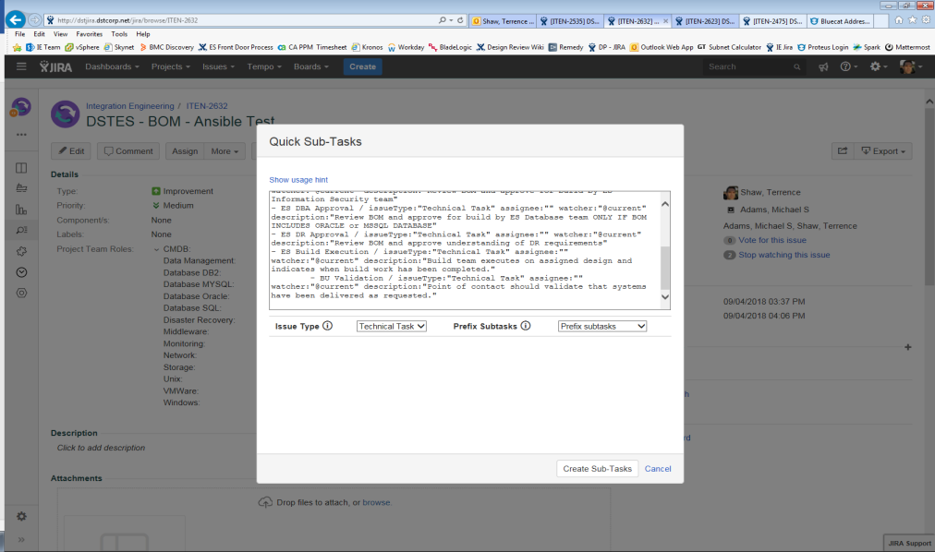

- On the Quick Sub-Tasks popup, select Issue Type = Technical Task and Prefix Subtasks = Prefix Subtasks.
Copy the following text and paste it into the Quick Sub-Tasks popup.
Subtask
- IE Peer Approval / issueType:"Technical Task" assignee:"" watcher:"@current" description: “Have another Integration Engineer review the design to make sure it is consistent with standards.”
- BU Contact Approval / issueType:"Technical Task" assignee:"" watcher:"@current" description: "Business unit point of contact should review and approve the draft version of design."
- ES Capacity Approval / issueType:"Technical Task" assignee:"" watcher:"@current" description: “Review design and approve for build by ES Capacity team."
- ES InfoSec Approval / issueType:"Technical Task" assignee:"" watcher:"@current" description: "Review BOM and approve for build by ES Information Security team"
- ES DBA Approval / issueType:"Technical Task" assignee:"" watcher:"@current" description: "Review BOM and approve for build by ES Database team ONLY IF BOM INCLUDES ORACLE or MSSQL database"
- ES DR Approval / issueType:"Technical Task" assignee:"" watcher:"@current" description: "Review BOM and approve understanding of DR requirements"
- ES Build Execution / issueType:"Technical Task" assignee:"" watcher:"@current" description: "Build team executes on assigned design and indicates when build work has been completed."
- BU Validation / issueType:"Technical Task" assignee:"" watcher:"@current" description: “Point of contact should validate that systems have been delivered as requested."

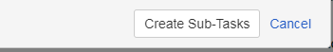

- When done, click Create Sub-Tasks.
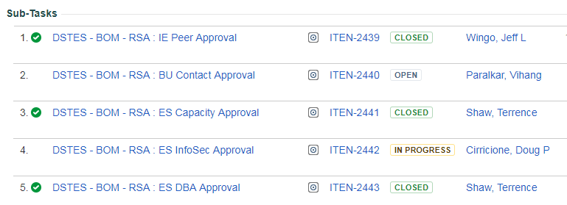

- On the main BOM page, scroll down to the Sub-Tasks section to confirm the subtasks were created.

Revision History
Version | Chapter | Date | Author | Change Description
1.0 | All | Sept. 11, 2018 | Sheila Myers per Tricia Adams | Final

