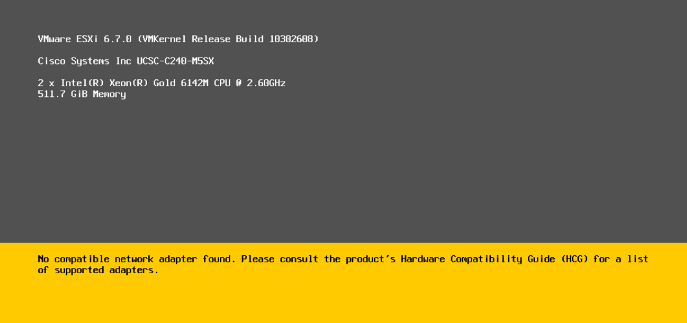

esxcfg-module -l

esxcfg-nics -l

esxcfg-module -l | grep nenic

(not found nenic module: that means nenic driver is missed module from esxi. need to install nenic driver)

Physical pci devices checking:

lspci | grep -i cisco

if it lists PCI list it has PCI devices only missed driver module. Even if not listing PCI as well need to contact Cisco.

If it working fine it shows result below

[root@wcdvhp01h08:~] esxcfg-nics -l

Name PCI Driver Link Speed Duplex MAC Address MTU Description

vmnic0 0000:3f:00.0 nenic Up 10000Mbps Full 00:25:b5:da:00:8b 1500 Cisco Systems Inc Cisco VIC Ethernet NIC

vmnic1 0000:3f:00.1 nenic Up 10000Mbps Full 00:25:b5:da:00:9b 1500 Cisco Systems Inc Cisco

[root@wcdvhp01h08:~] esxcfg-module -l | grep -i nenic

nenic 22 136

[root@wcdvhp01h08:~]

PCI listing in working host:

[root@wcdvhp01h08:~] lspci | grep -i cisco

0000:3b:00.0 Bridge: Cisco Systems Inc VIC 1300 PCIe Upstream Port

0000:3c:00.0 Bridge: Cisco Systems Inc VIC PCIe Downstream Port

0000:3d:00.0 Bridge: Cisco Systems Inc VIC PCIe Upstream Port

0000:3e:00.0 Bridge: Cisco Systems Inc VIC PCIe Downstream Port

0000:3e:01.0 Bridge: Cisco Systems Inc VIC PCIe Downstream Port

0000:3e:02.0 Bridge: Cisco Systems Inc VIC PCIe Downstream Port

0000:3f:00.0 Network controller: Cisco Systems Inc Cisco VIC Ethernet NIC [vmnic0]

[root@wcdvhp01h08:~]