<https://onlinexperiences.com/scripts/Server.nxp?LASCmd=AI:1;F:US!100&PreviousLoginCount=0&ForceProfileToBeFilledOut=0&DisplayItem=NULL&ShowKey=62410&ShowFrameFormatOverride=NULL&RandomValue=1549388846119>

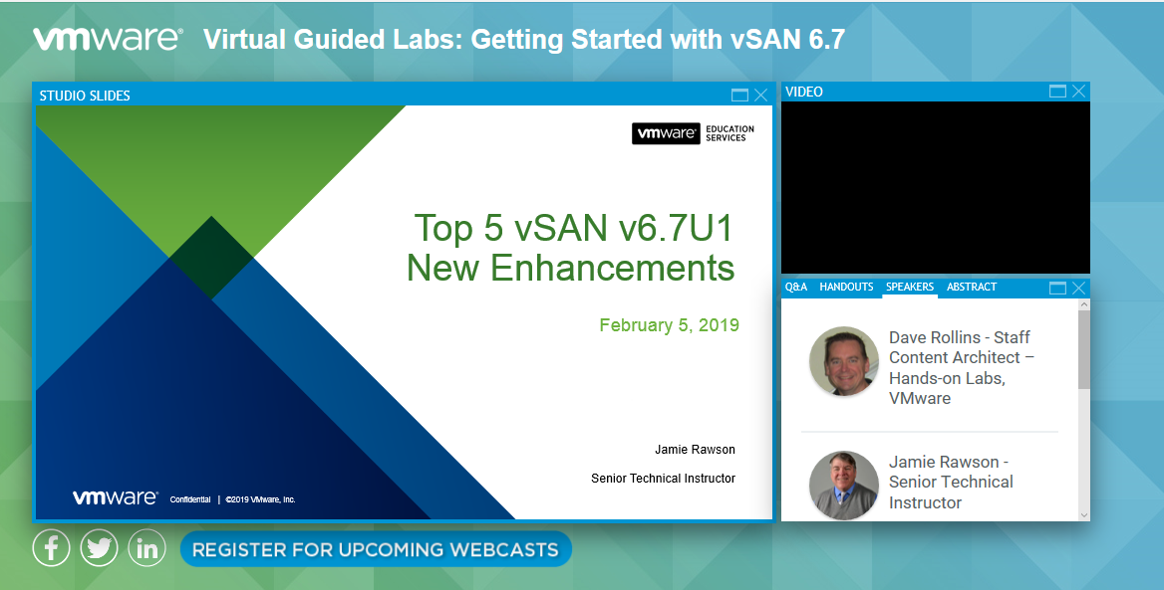

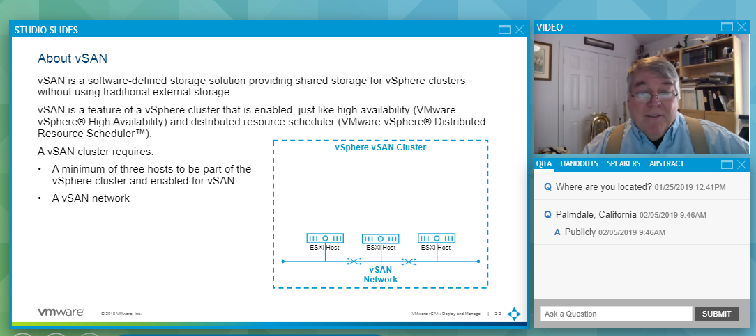

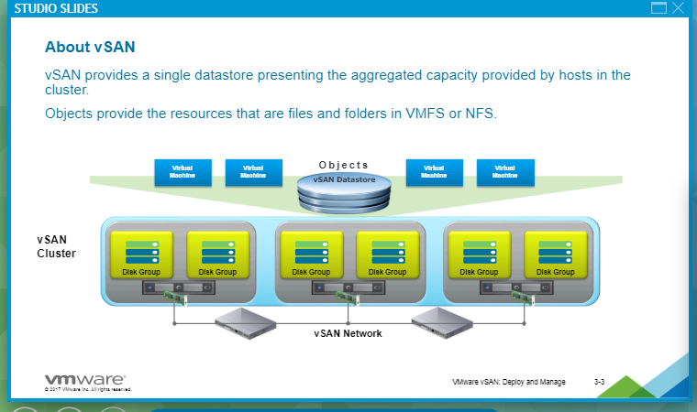

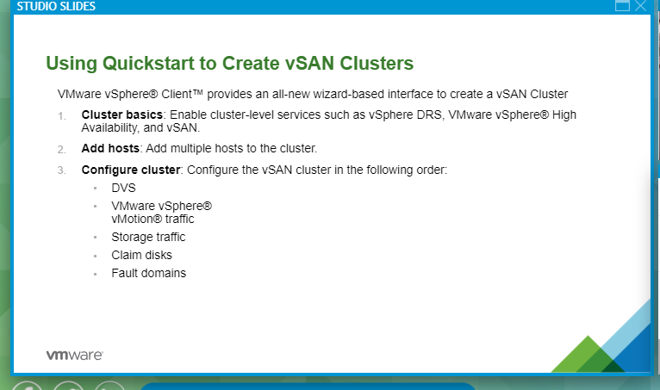

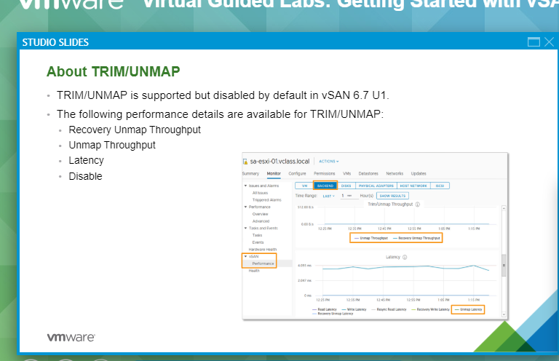

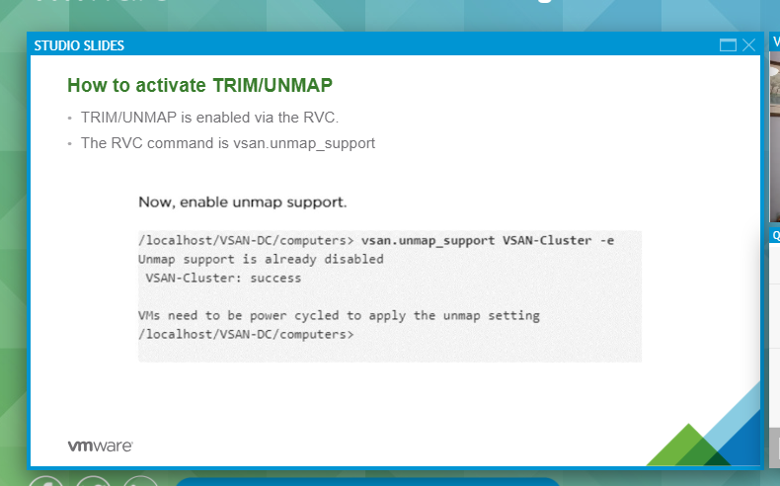

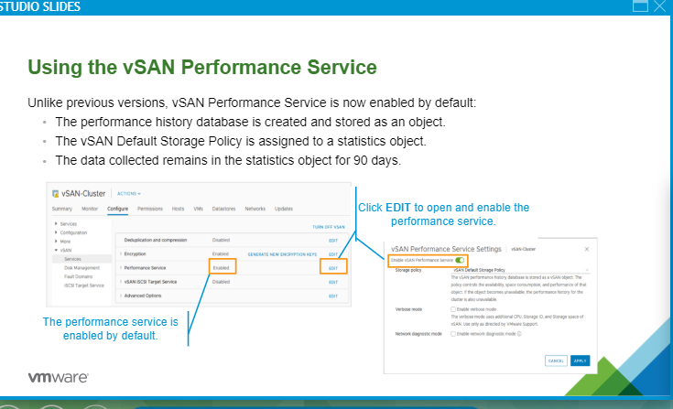

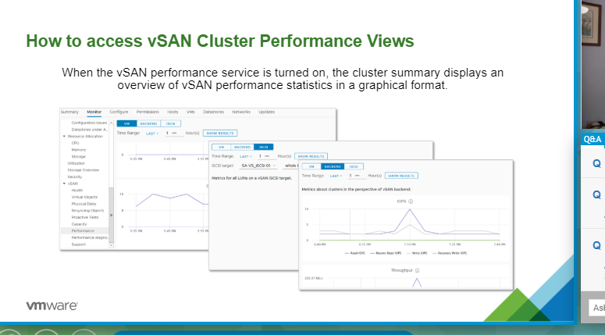

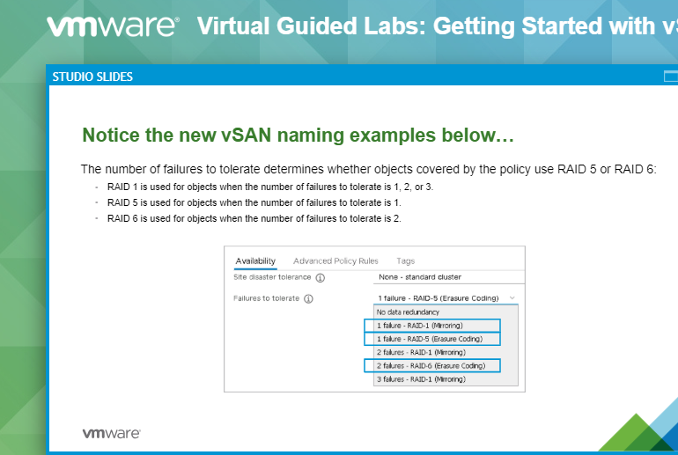

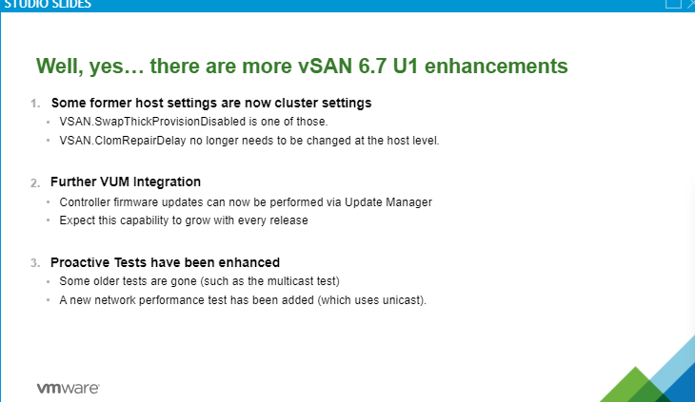

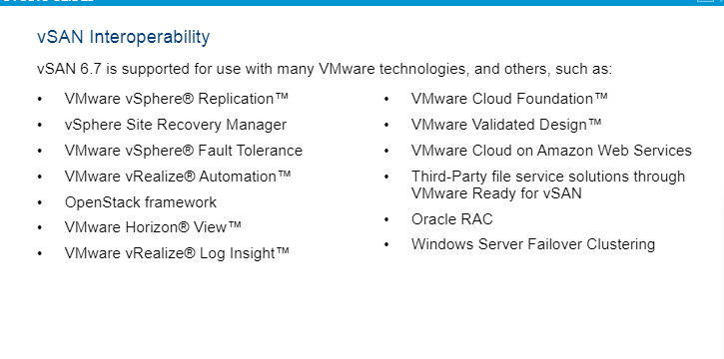

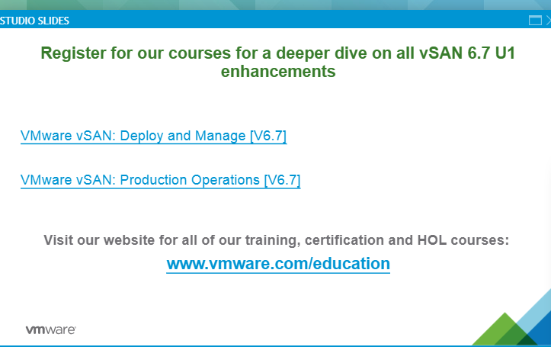

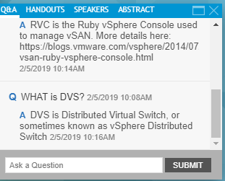

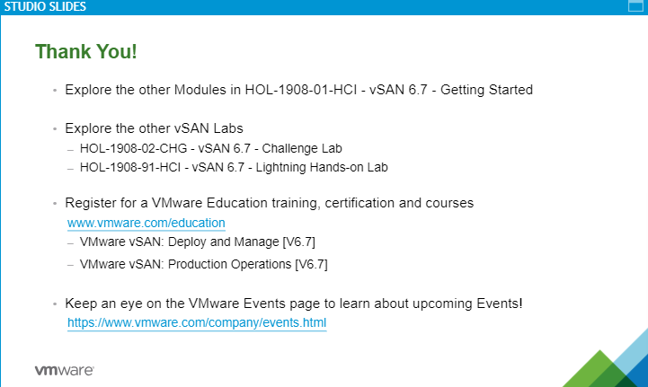

**Q**Where are you located? 01/25/2019 12:41PM

**Q**Palmdale, California 02/05/2019 9:46AM

**A**Publicly 02/05/2019 9:46AM

**Q**What is DVS? 2/5/2019 10:08AM

**A**DVS stands for Distributed Virtual Switch. 2/5/2019 10:10AM

**Q**RVC ? 2/5/2019 10:10AM

**A**RVC is the Ruby vSphere Console used to manage vSAN. More details here: https://blogs.vmware.com/vsphere/2014/07/managing-vsan-ruby-vsphere-console.html2/5/2019 10:14AM

**Q**WHAT is DVS? 2/5/2019 10:08AM

**A**DVS is Distributed Virtual Switch, or sometimes known as vSphere Distributed Switch 2/5/2019 10:16AM

**Q**1GB network wont work? 2/5/2019 10:04AM

**A**1Gb is acceptable for the Hybrid configuration -- SSD for cache; HDD for capacity. But All-Flash requires 10Gb.2/5/2019 10:43AM

**Q**labs.hol??? 2/5/2019 10:45AM

**A**labs.hol.vmware.com 2/5/2019 10:46AM

**Q**what's the address again for the lab latter2/5/2019 10:45AM

**A**http://labs.hol.vmware.com2/5/2019 10:47AM

**Q**Can you say the site again slowly, or type it . Thanks 2/5/2019 10:45AM

**A**Sorry about that: http://labs.hol.vmware.com2/5/2019 10:49AM

**Q**is there a .PDF document for this lab.2/5/2019 10:50AM

**A**Yes! You can download any of the lab manuals from http://docs.hol.vmware.com2/5/2019 10:51AM

**Q**Ware are the requirements for a SSD cache? Can it be 1-2 SSD driver per ESX host? 2/5/2019 10:45AM

**A**The cache device *must* be SSD, and there must be *one* cache device per disk group. We may have up to *five* disk groups per host. This means 5 cache devices and up to 35 capacity drives.2/5/2019 10:52AM

**Q**Can you confirm login for "VMware on AWS Lightning Hands-on Lab02/05/2019 10:51AM

**A**Since we aren't offering that lab here, you will need to sign up for a free account at http://labs.hol.vmware.com and take the lab from that site. 2/5/2019 10:52AM

**Q**Do you need a separate license for vsan?2/5/2019 10:51AM

**A**There is a separate license required. The Licensing Guide for vSAN 6.7 is here: https://www.vmware.com/content/dam/digitalmarketing/vmware/en/pdf/products/vsan/vmware-vsan-67-licensing-guide.pdf2/5/2019 10:53AM

**Q**what is kms cluster option? 2/5/2019 10:51AM

**A**Here are some details on how to setup and configure the KMS server. https://docs.vmware.com/en/VMware-vSphere/6.5/com.vmware.vsphere.virtualsan.doc/GUID-1583A645-07EE-4D26-8698-080283694635.html 2/5/2019 10:54AM

**Q**Hi I am stuck with an urgent task.. can Irun lab later too ? 2/5/2019 10:49AM

**A**Yes, you can come back and run the lab at any time. you can just return to this portal/event or go directly to labs.hol.vmware.com 2/5/2019 10:55AM



**Q**Where are you located? 01/25/2019 12:41PM

**Q**Palmdale, California 02/05/2019 9:46AM

**A**Publicly 02/05/2019 9:46AM

**Q**What is DVS? 2/5/2019 10:08AM

**A**DVS stands for Distributed Virtual Switch. 2/5/2019 10:10AM

**Q**RVC ? 2/5/2019 10:10AM

**A**RVC is the Ruby vSphere Console used to manage vSAN. More details here: https://blogs.vmware.com/vsphere/2014/07/managing-vsan-ruby-vsphere-console.html2/5/2019 10:14AM

**Q**WHAT is DVS? 2/5/2019 10:08AM

**A**DVS is Distributed Virtual Switch, or sometimes known as vSphere Distributed Switch 2/5/2019 10:16AM

**Q**1GB network wont work? 2/5/2019 10:04AM

**A**1Gb is acceptable for the Hybrid configuration -- SSD for cache; HDD for capacity. But All-Flash requires 10Gb.2/5/2019 10:43AM

**Q**labs.hol??? 2/5/2019 10:45AM

**A**labs.hol.vmware.com 2/5/2019 10:46AM

**Q**what's the address again for the lab latter2/5/2019 10:45AM

**A**http://labs.hol.vmware.com2/5/2019 10:47AM

**Q**Can you say the site again slowly, or type it . Thanks 2/5/2019 10:45AM

**A**Sorry about that: http://labs.hol.vmware.com2/5/2019 10:49AM

**Q**is there a .PDF document for this lab.2/5/2019 10:50AM

**A**Yes! You can download any of the lab manuals from http://docs.hol.vmware.com2/5/2019 10:51AM

**Q**Ware are the requirements for a SSD cache? Can it be 1-2 SSD driver per ESX host? 2/5/2019 10:45AM

**A**The cache device *must* be SSD, and there must be *one* cache device per disk group. We may have up to *five* disk groups per host. This means 5 cache devices and up to 35 capacity drives.2/5/2019 10:52AM

**Q**Can you confirm login for "VMware on AWS Lightning Hands-on Lab02/05/2019 10:51AM

**A**Since we aren't offering that lab here, you will need to sign up for a free account at http://labs.hol.vmware.com and take the lab from that site. 2/5/2019 10:52AM

**Q**Do you need a separate license for vsan?2/5/2019 10:51AM

**A**There is a separate license required. The Licensing Guide for vSAN 6.7 is here: https://www.vmware.com/content/dam/digitalmarketing/vmware/en/pdf/products/vsan/vmware-vsan-67-licensing-guide.pdf2/5/2019 10:53AM

**Q**what is kms cluster option? 2/5/2019 10:51AM

**A**Here are some details on how to setup and configure the KMS server. https://docs.vmware.com/en/VMware-vSphere/6.5/com.vmware.vsphere.virtualsan.doc/GUID-1583A645-07EE-4D26-8698-080283694635.html 2/5/2019 10:54AM

**Q**Hi I am stuck with an urgent task.. can Irun lab later too ? 2/5/2019 10:49AM

**A**Yes, you can come back and run the lab at any time. you can just return to this portal/event or go directly to labs.hol.vmware.com 2/5/2019 10:55AM

**Q**Do you have to have a Flash Cache layer if you are using all Flash? 2/5/2019 10:44AM

**A**YES 2/5/2019 10:56AM

**Q**Hand on lab is out of capacity2/5/2019 10:46AM

**A**Yes, Very Sorry About that, we had way more customers register than expected, we will arrange for more cloud capacity for our next event!! 2/5/2019 10:57AM

**Q**is there any link for compatibility list page?2/5/2019 10:51AM

**A**Here is the link to the vSAN compatibility guide. https://www.vmware.com/resources/compatibility/search.php?deviceCategory=vsan 2/5/2019 10:57AM



**Q**Where are you located? 01/25/2019 12:41PM

**Q**Palmdale, California 02/05/2019 9:46AM

**A**Publicly 02/05/2019 9:46AM

**Q**What is DVS? 2/5/2019 10:08AM

**A**DVS stands for Distributed Virtual Switch. 2/5/2019 10:10AM

**Q**RVC ? 2/5/2019 10:10AM

**A**RVC is the Ruby vSphere Console used to manage vSAN. More details here: https://blogs.vmware.com/vsphere/2014/07/managing-vsan-ruby-vsphere-console.html2/5/2019 10:14AM

**Q**WHAT is DVS? 2/5/2019 10:08AM

**A**DVS is Distributed Virtual Switch, or sometimes known as vSphere Distributed Switch 2/5/2019 10:16AM

**Q**1GB network wont work? 2/5/2019 10:04AM

**A**1Gb is acceptable for the Hybrid configuration -- SSD for cache; HDD for capacity. But All-Flash requires 10Gb.2/5/2019 10:43AM

**Q**labs.hol??? 2/5/2019 10:45AM

**A**labs.hol.vmware.com 2/5/2019 10:46AM

**Q**what's the address again for the lab latter2/5/2019 10:45AM

**A**http://labs.hol.vmware.com2/5/2019 10:47AM

**Q**Can you say the site again slowly, or type it . Thanks 2/5/2019 10:45AM

**A**Sorry about that: http://labs.hol.vmware.com2/5/2019 10:49AM

**Q**is there a .PDF document for this lab.2/5/2019 10:50AM

**A**Yes! You can download any of the lab manuals from http://docs.hol.vmware.com2/5/2019 10:51AM

**Q**Ware are the requirements for a SSD cache? Can it be 1-2 SSD driver per ESX host? 2/5/2019 10:45AM

**A**The cache device *must* be SSD, and there must be *one* cache device per disk group. We may have up to *five* disk groups per host. This means 5 cache devices and up to 35 capacity drives.2/5/2019 10:52AM

**Q**Can you confirm login for "VMware on AWS Lightning Hands-on Lab02/05/2019 10:51AM

**A**Since we aren't offering that lab here, you will need to sign up for a free account at http://labs.hol.vmware.com and take the lab from that site. 2/5/2019 10:52AM

**Q**Do you need a separate license for vsan?2/5/2019 10:51AM

**A**There is a separate license required. The Licensing Guide for vSAN 6.7 is here: https://www.vmware.com/content/dam/digitalmarketing/vmware/en/pdf/products/vsan/vmware-vsan-67-licensing-guide.pdf2/5/2019 10:53AM

**Q**what is kms cluster option? 2/5/2019 10:51AM

**A**Here are some details on how to setup and configure the KMS server. https://docs.vmware.com/en/VMware-vSphere/6.5/com.vmware.vsphere.virtualsan.doc/GUID-1583A645-07EE-4D26-8698-080283694635.html 2/5/2019 10:54AM

**Q**Hi I am stuck with an urgent task.. can Irun lab later too ? 2/5/2019 10:49AM

**A**Yes, you can come back and run the lab at any time. you can just return to this portal/event or go directly to labs.hol.vmware.com 2/5/2019 10:55AM

**Q**Do you have to have a Flash Cache layer if you are using all Flash? 2/5/2019 10:44AM

**A**YES 2/5/2019 10:56AM

**Q**Hand on lab is out of capacity2/5/2019 10:46AM

**A**Yes, Very Sorry About that, we had way more customers register than expected, we will arrange for more cloud capacity for our next event!! 2/5/2019 10:57AM

**Q**is there any link for compatibility list page?2/5/2019 10:51AM

**A**Here is the link to the vSAN compatibility guide. https://www.vmware.com/resources/compatibility/search.php?deviceCategory=vsan 2/5/2019 10:57AM

**Q**In the education site, typed in Hands On Labs, and only saw 26 labs 2/5/2019 10:58AM

**A**The Hands-on Labs site will have more labs.hol.vmware.com 2/5/2019 10:59AM

**Q**Is RVC still part of VSAN 6.7 ?2/5/2019 10:50AM

**A**It is! More details can be found in the Administering VMware vSAN guide. https://docs.vmware.com/en/VMware-vSphere/6.7/vsan-67-administration-guide.pdf 2/5/2019 11:00AM

