IMB SkillsBuild Gamification User Manual:
Introduction:
IBM SkillsBuild Gamification is a tool designed to enhance engagement with IBM SkillsBuild by introducing a leaderboard and levelling system. It allows users to track their progress and encourages participation through a competitive learning environment. The software aims to make online learning more interactive and rewarding, focusing on students using IBM SkillsBuild to develop key skills in computer science.
This manual provides guidance on how to install, navigate, and use all available features of the software.

Feature Breakdown:
- Dashboard Overview
The Dashboard serves as the main interface for users to access courses, track progress, and navigate to key sections such as the Leaderboard and User Profile. It provides an easy-to-use layout for selecting courses and updating learning progress.
  - Main Dashboard Interface

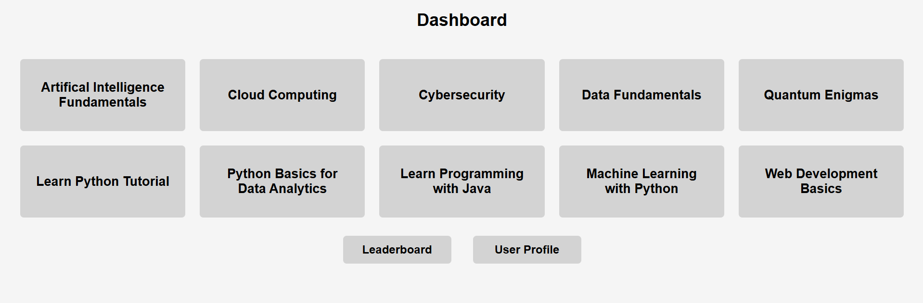
Dashboard – Users are greeted with this page after logging in.
Course selection:
- The dashboard displays multiple courses in individual grey boxes, each representing a different learning module.
- Users can click a course tile to be redirected to the official IBM SkillsBuild website, where they can access the course content.
- After completing or progressing through the course on IBM SkillsBuild, users return to the platform to update their course status.
- Example courses include:
  - Artificial Intelligence Fundamentals
  - Cybersecurity
  - Cloud Computing
Leaderboard Button:
- Clicking this button takes the user to the Leaderboard, where they can see rankings based on progress and achievements.
User Profile Button:
- Clicking this button Navigates to the User Profile page, where users can view and edit their profile along with their completed courses and courses that are currently in progress.

  - Course Status Page
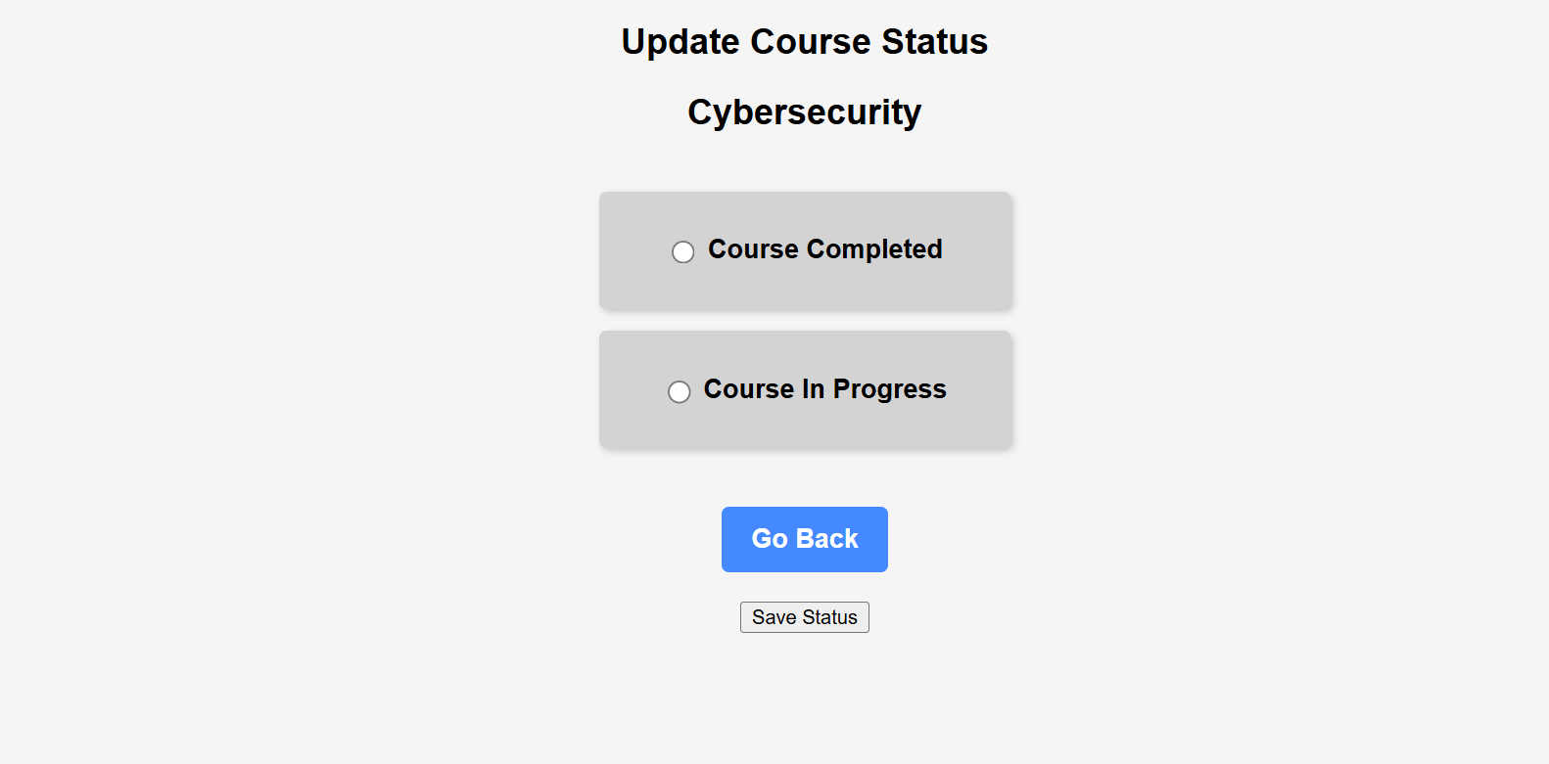
Course Status – Users are greeted with this page after accessing course content
Features:
Course Title Display:
- The name of the selected course (e.g., "Cybersecurity") is displayed at the top to indicate the current course being updated.
Status Selection Options:
- Users can mark their course status as:
  - "Course Completed"
  - "Course In Progress"
- The selected status will be saved upon submission.
Go Back Button:
- Allows users to return to the Dashboard without making changes.
Save Status Button:
- Clicking this button updates the user's course status - either "In Progress" or "Completed".

2. Leaderboard
The leader board is a way for students to see all students, ranked in order of the number of points they scored, from highest to lowest. This allows students to compare progress, and it may motivate them to complete more courses, to climb the leader board, and see their name at the very top!
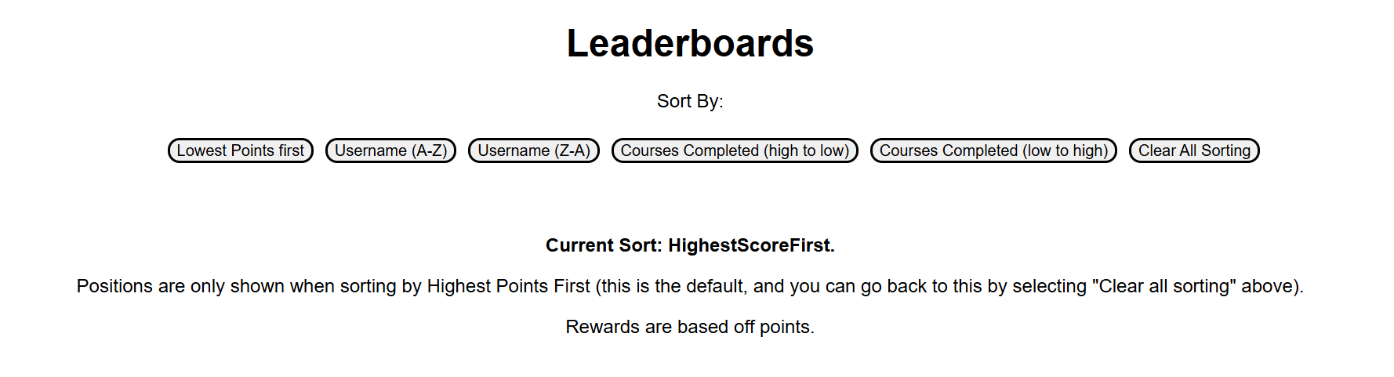
2.1
Sorting: Users are met by the leader board page, when pressing the leaderboard button on the dashboard page, where they will see some information about sorting the leaderboard. Each button corresponds to a way to sort the leaderboard, for example, sorting by lowest points first, sorting alphabetically (usernames A – Z) or sorting by the number of courses completed.

Positions will only be shown when sorting by highest points first, as this is the primary metric of the leader board, and it may cause confusion if users see positions for other sorting methods, that do not measure performance.
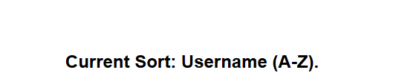Current sorting changes to show the currently selected sorting option

2.2
Clear Sorting: users can return back to Highest Points First sorting, by selecting clear all sorting from the sort by options.

2.3 – User Position in leaderboard shown in separate section

Users can see their position in the leader board, in a separate section before the full leader board is shown. This helps as if there are many users, it allows users to quickly see their progress, and compare this to others via their position, without having to scroll down for long. For example, if there are 100 users, and user “bob12” is in position 58, they do not have to scroll down a lot, to be able to find their position and see how they are doing relative to others.
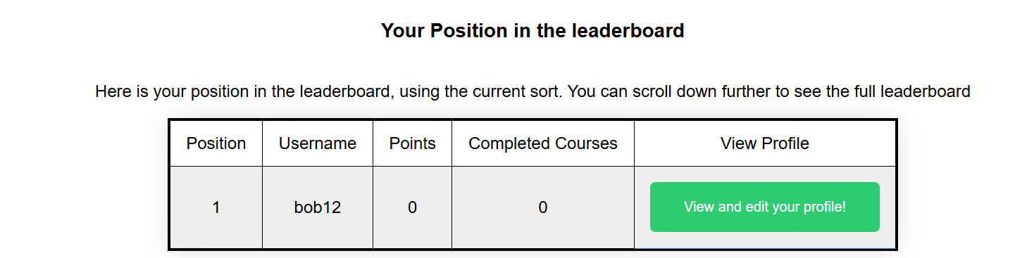Users can see their position in a separated section before the full leader board

2.3 – Global Leaderboard

Users are then presented with the full leader board, in which every user is shown, along with their position, username, points, number of completed courses, and a button in which users can visit other students’ profiles. The currently logged in student is highlighted green, which can aid in quickly identifying their position on the leaderboard, from which they can compare themselves against those around them.

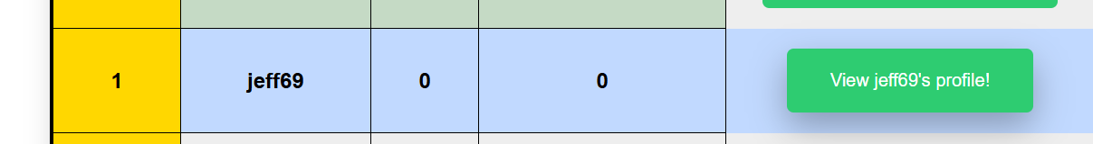
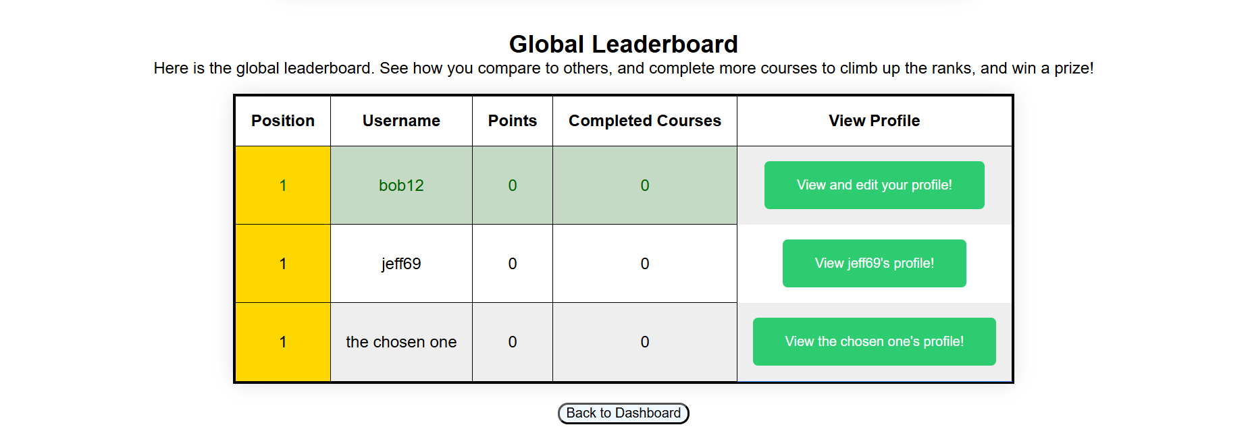Users can see the full leaderboard, and they are highlighted in green, to help visual recognition
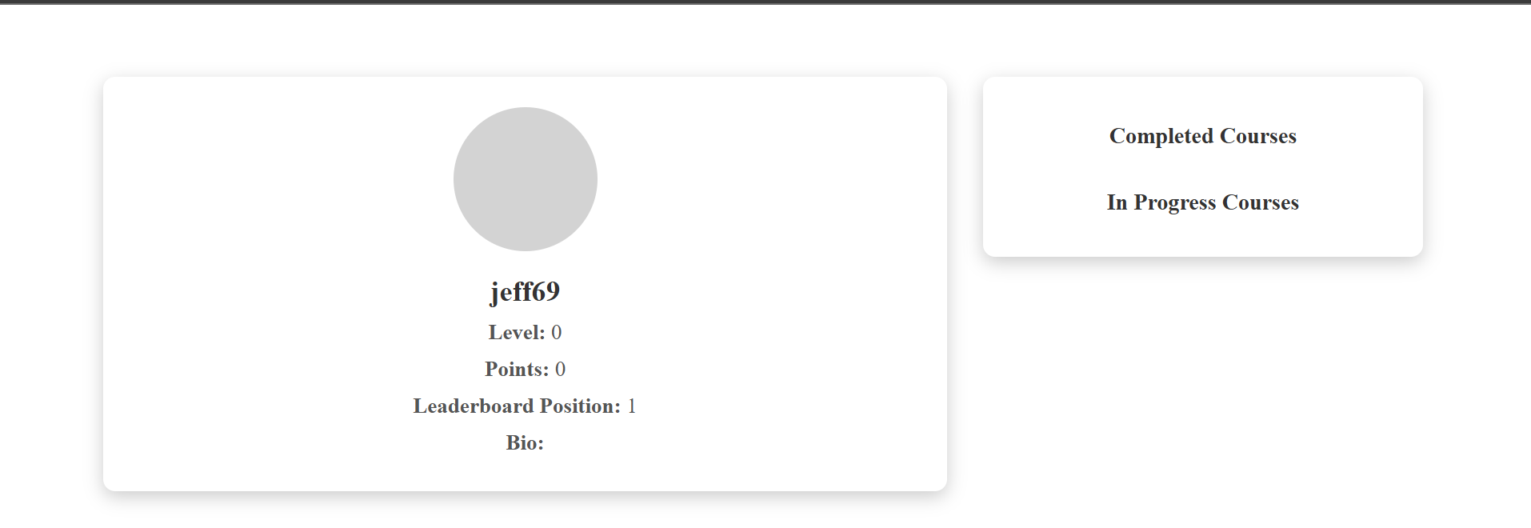Pressing view profile on the leaderboard will allow students to see the profile of the selected student
2.4 Joint Positions
In order to ensure fairness, students will notice that the leader board utilizes joint positions. This was a design choice to ensure users positions accurately represent their performance, in terms of points and the number of courses completed, and allows for better comparisons against other students.

2.5 Back To Dashboard
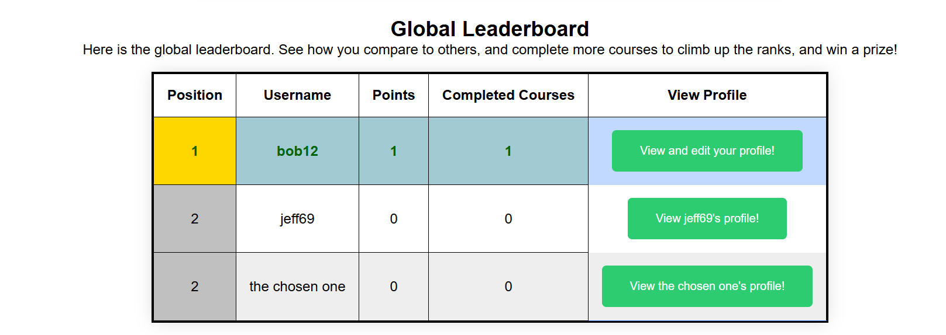The global leaderboard updates, and shows joint positions for users that have the same number of positions

The leader board page has a “Back to Dashboard” button located at the bottom of the page, which students can press to return back to the dashboard page.

3. User Profile Management and Badges
3.1 Profile Page Overview
The Profile Page displays key details about the user, their progress, and achievements. Users can view their personal information, track progress, and access settings.
Main Features on the Profile Page
User Information
- Displays the username, profile picture, and user level.
- Shows basic details like email (if applicable) and registration date.
Completed and In-Progress Courses
- Shows the total number of completed courses.
- Displays courses currently in progress, helping users track learning progress.
Badges and Achievements
- Displays all earned badges for milestones in completing courses
- Hovering over a badge shows detailed information about how it was earned.
Edit Profile Button
- Clicking this button redirects to the Edit Profile Page, where users can update their details.
Leaderboard and Ranking
- Displays the user’s position in the leaderboard, based on points and completed courses.
Logout
- Allows users to logout of their ID returning back to the login page.

3.2 Edit Profile Page
The Edit Profile Page allows users to modify their personal information and update their profile picture.
Features of the Edit Profile Page
Change Password
- Users can enter a new password and confirm it to change their login credentials.
Upload Profile Picture
- Allows users to upload a profile picture or choose an avatar.
Add and change Bio
- Allows users to add or change their bio to tell other about them.

Save Changes Button
- Clicking Save Changes updates the user’s details.
- If an error occurs (e.g., weak password), a message is displayed.
Cancel Button
- Redirects back to the Profile Page without saving changes.
3.3. How Badges Work
Earning Badges
Badges are awarded based on user achievements. Users can track their badges collection from the Profile Page
Types of Badges
- Novice Badge – Awarded for completing the first course.
- Intermediate Badge – Earned after completing 3 courses.
- Advanced Badge – Earned after completing 5 courses.
- Expert Badge – Earned after completing 7 courses.
Hover Feature
- Hovering over a badge displays its criteria and progress
4.Search and filter
The search and filter enables the user to search through the available courses on the dashboards’ page that the IBM courses that are provided. This will enable the user to easily select which courses they want to start and not have to go through each one of the course that the website provides links to for.

4.1 Filter
You can filter them based on whether the user has: completed, in progress, or not started the courses. Once they have selected a filter they will press the filter button to submit the filter choice. If the user just wants to view all courses he can also select ‘—select a course—’ in the filter options (they will have to select the filter button again to return to that state once selected).

-insert pictures of completed, incomplete, not started, and ‘—select a course—.

4.2 Search
For the search feature, you have a text box and enter what the name of the courses that should match what they want. Lets say they enter ‘python’ into the text box the user will then have to press the search button to submit it and the dashboard page will only show courses that have the word python within their course name to the user. If the user wants to see all courses again they will have to leave the search text box empty for the user and press the search button to see all courses again.

(for context search text box needs to be empty and the button pressed to make sure that it can only show all courses that meet the current criteria of what the filter is on).

-insert pictures of examples of filter working

