IMB SkillsBuild Gamification User Manual:
Introduction:
IBM SkillsBuild Gamification is a tool designed to enhance engagement with IBM SkillsBuild by introducing a leaderboard and levelling system. It allows users to track their progress and encourages participation through a competitive learning environment. The software aims to make online learning more interactive and rewarding, focusing on students using IBM SkillsBuild to develop key skills in computer science.
This manual provides guidance on how to install, navigate, and use all available features of the software.

Feature Breakdown:
- Dashboard Overview
The Dashboard serves as the main interface for users to access courses, track progress, and navigate to key sections such as the Leaderboard and User Profile. It provides an easy-to-use layout for selecting courses and updating learning progress.
  - Main Dashboard Interface

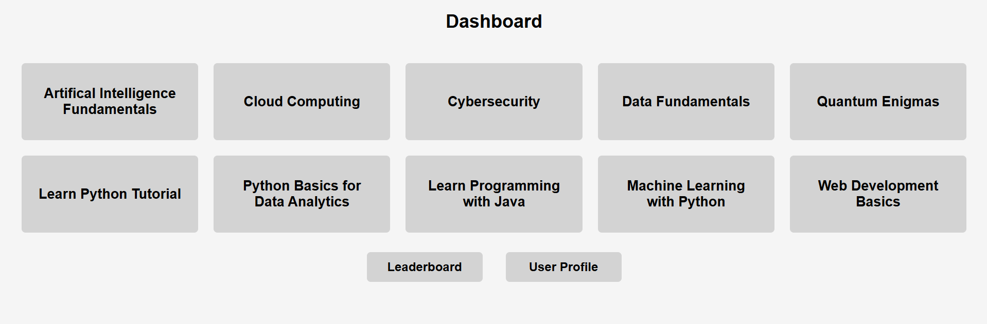
Dashboard – Users are greeted with this page after logging in.
Course selection:
- The dashboard displays multiple courses in individual grey boxes, each representing a different learning module.
- Users can click a course tile to be redirected to the official IBM SkillsBuild website, where they can access the course content.
- After completing or progressing through the course on IBM SkillsBuild, users return to the platform to update their course status.
- Example courses include:
  - Artificial Intelligence Fundamentals
  - Cybersecurity
  - Cloud Computing
Leaderboard Button:
- Clicking this button takes the user to the Leaderboard, where they can see rankings based on the number of courses completed.
User Profile Button:
- Clicking this button Navigates to the User Profile page, where users can view and edit their profile along with their completed courses and courses that are currently in progress.

  - Course Status Page
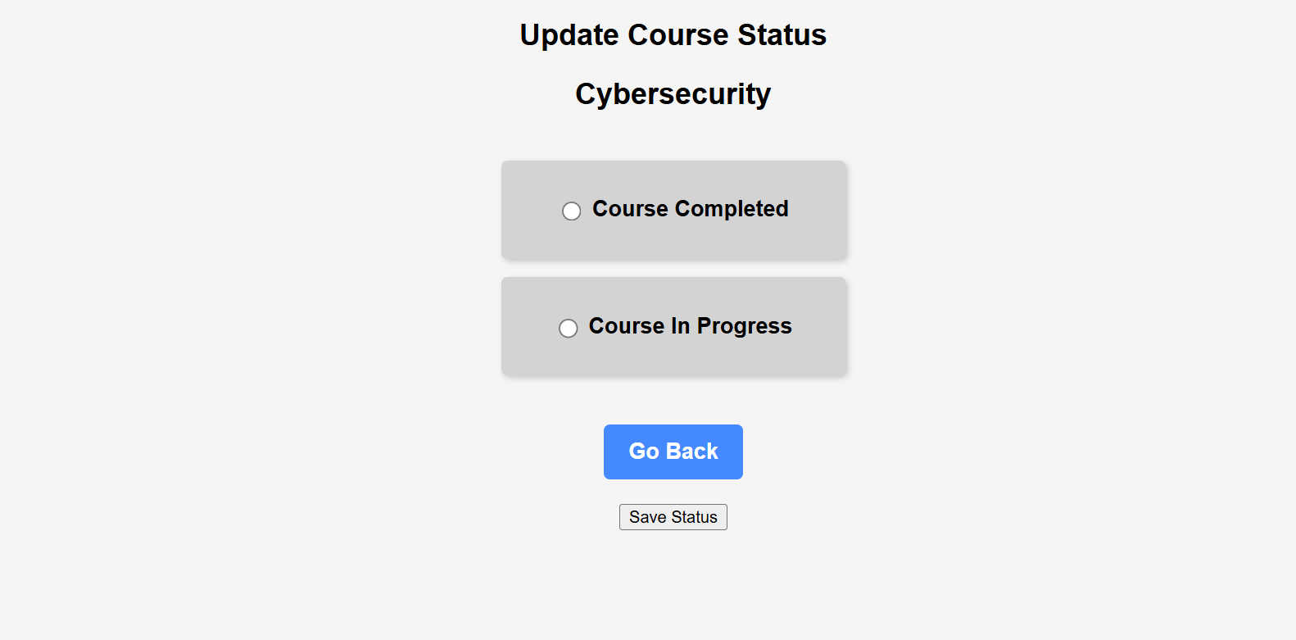
Course Status – Users are greeted with this page after accessing course content
Features:
Course Title Display:
- The name of the selected course (e.g., "Cybersecurity") is displayed at the top to indicate the current course being updated.
Status Selection Options:
- Users can mark their course status as:
  - "Course Completed"
  - "Course In Progress"
- The selected status will be saved upon submission.
Go Back Button:
- Allows users to return to the Dashboard without making changes.
Save Status Button:
- Clicking this button updates the user's course status - either "In Progress" or "Completed".

