IMB SkillsBuild Gamification User Manual:
Introduction:
IBM SkillsBuild Gamification is a tool designed to enhance engagement with IBM SkillsBuild by introducing a leaderboard and levelling system. It allows users to track their progress and encourages participation through a competitive learning environment. The software aims to make online learning more interactive and rewarding, focusing on students using IBM SkillsBuild to develop key skills in computer science.
This manual provides guidance on how to install, navigate, and use all available features of the software.

Feature Breakdown:
- Login and Register Overview
The login and register pages are there to allow users to easily sign in if they already have an account, or to create an account if they do not yet have one. If at any point the user attempts to access a page which requires authentication without being signed in, they will be redirected to the main login page.
  - Main Login Page

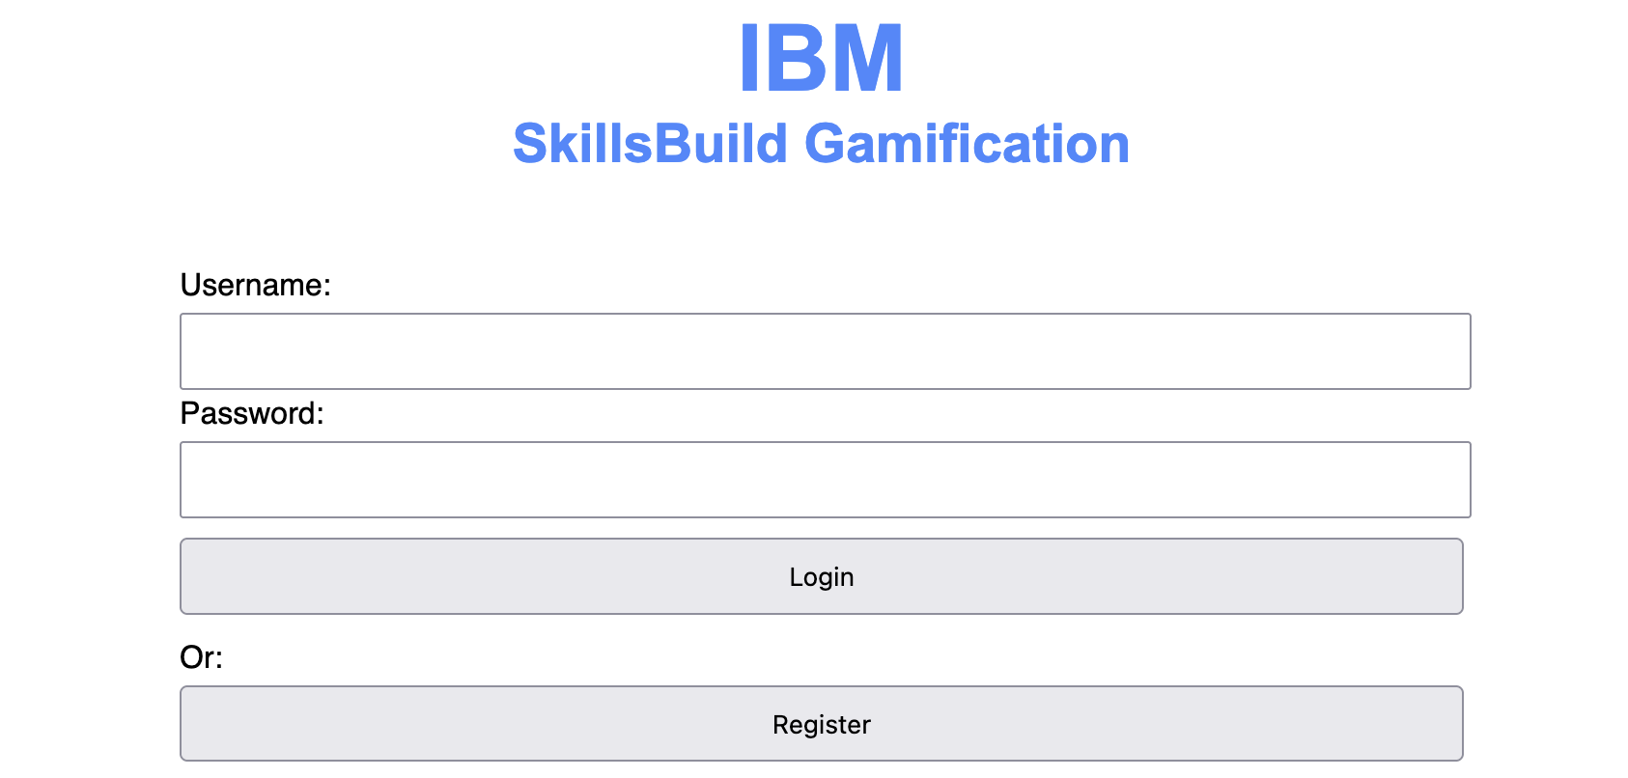
Login page – Users will see this page when they access the website
On this page, if the user already has an account, they can input their username and password and then press the “login” button. This will redirect them to the dashboard page. If the information is not entered correctly, an error will appear asking the user to ensure that the username and password are correct.
Alternatively, if they press the “register” button, they will be redirected to the registration page.

  - Registration Page
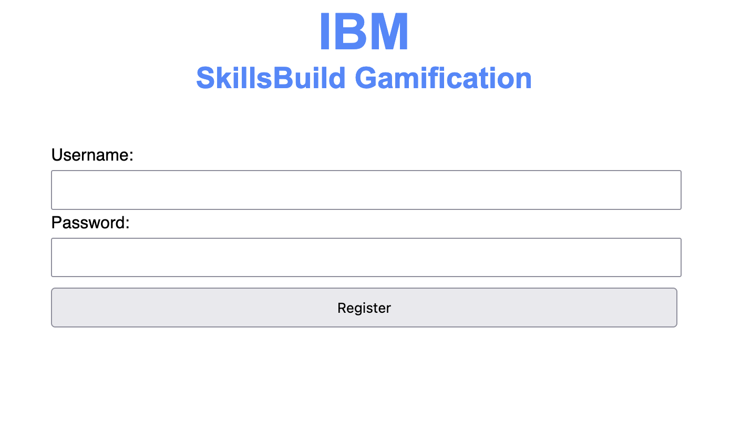
Registration Page – Users will see this page after clicking “register” from the main login page
On this page, the user can create a new account by filling in the username and password fields, and then pressing register. If the user forgets to fill in one of the fields, an appropriate error message will be displayed. Additionally, if the username the user picks is already being used by another account in the system, it will inform the user so that they can pick another username. Pressing register will forward the user back to the login page, where they can then sign in.

- Dashboard Overview
The Dashboard serves as the main interface for users to access courses, track progress, and navigate to key sections such as the Leaderboard and User Profile. It provides an easy-to-use layout for selecting courses and updating learning progress.
  - Main Dashboard Interface

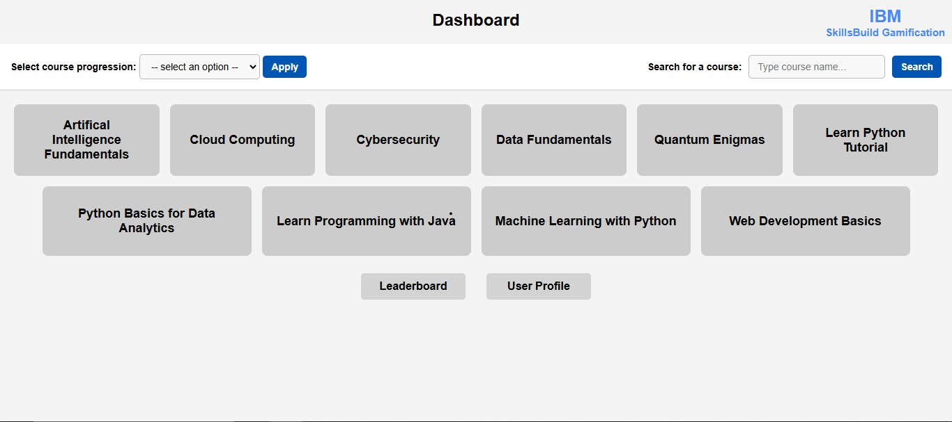
Dashboard – Users are greeted with this page after logging in.
Course selection:
- The dashboard displays multiple courses in individual grey boxes, each representing a different learning module.
- Users can click a course tile to be redirected to the official IBM SkillsBuild website, where they can access the course content.
- After completing or progressing through the course on IBM SkillsBuild, users return to the platform to update their course status.
- Example courses include:
  - Artificial Intelligence Fundamentals
  - Cybersecurity
  - Cloud Computing
Leaderboard Button:
- Clicking this button takes the user to the Leaderboard, where they can see rankings based on the number of courses completed.
User Profile Button:
- Clicking this button Navigates to the User Profile page, where users can view and edit their profile along with their completed courses and courses that are currently in progress.

  - Course Status Page
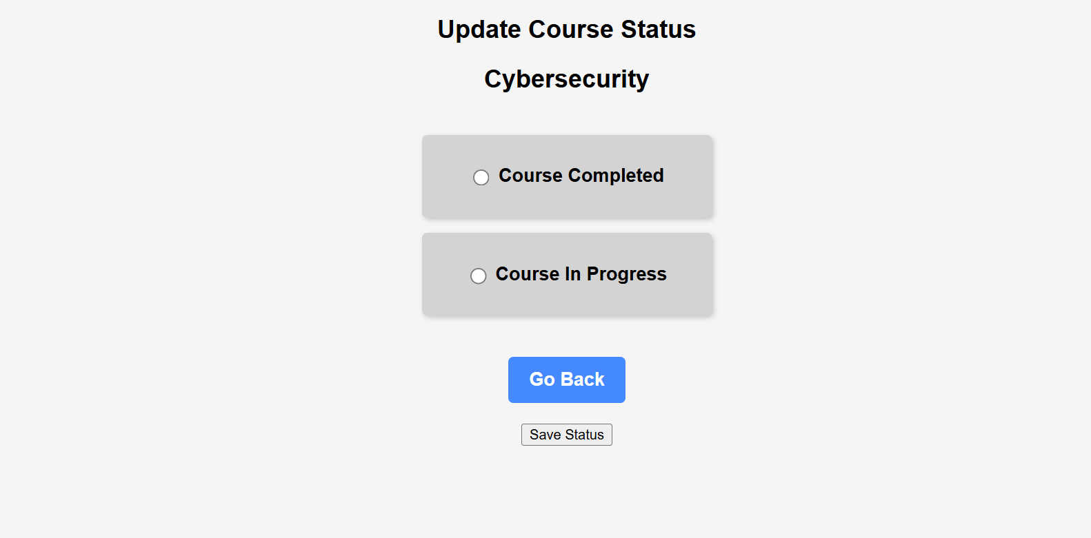
Course Status – Users are greeted with this page after accessing course content
Features:
Course Title Display:
- The name of the selected course (e.g., "Cybersecurity") is displayed at the top to indicate the current course being updated.
Status Selection Options:
- Users can mark their course status as:
  - "Course Completed"
  - "Course In Progress"
- The selected status will be saved upon submission.
Go Back Button:
- Allows users to return to the Dashboard without making changes.
Save Status Button:
- Clicking this button updates the user's course status - either "In Progress" or "Completed".

  - Goal Feature

The Goal Feature allows users to set personal learning goals by defining how many IBM Skills Build courses they aim to complete by a specific date. This promotes self-paced learning and encourages students to stay on track.
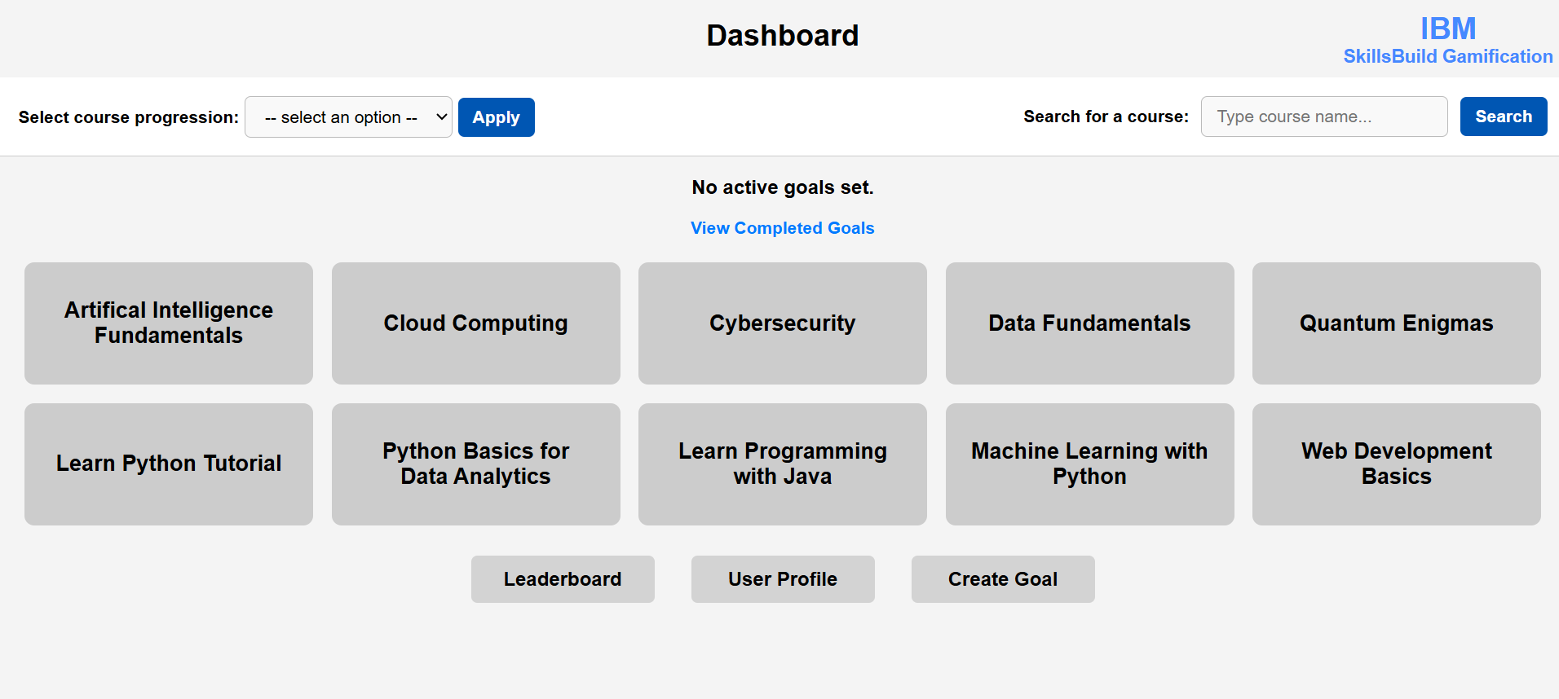

    - Creating a Goal:

- From the Dashboard, click on the "Create Goal" button.
- Users are taken to a form where they must:
  - Enter the number of courses they aim to complete (between 1 and 10).
  - Select a target completion date (only future dates are allowed).
- Once submitted, the goal is saved and visible on the Dashboard.
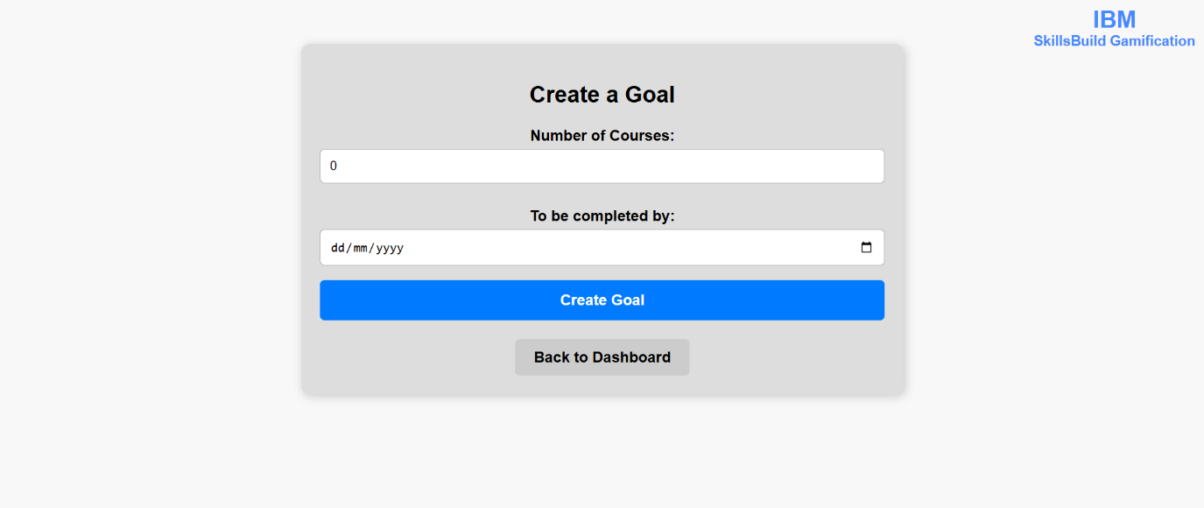

Active Goal Display:

- Users can only have one active goal at a time.
- The Dashboard displays:
  - The number of courses set as the goal.
  - The chosen target completion date.
  - A progress bar showing how many of the target courses have been completed as a percentage (i.e. 50% Completed).

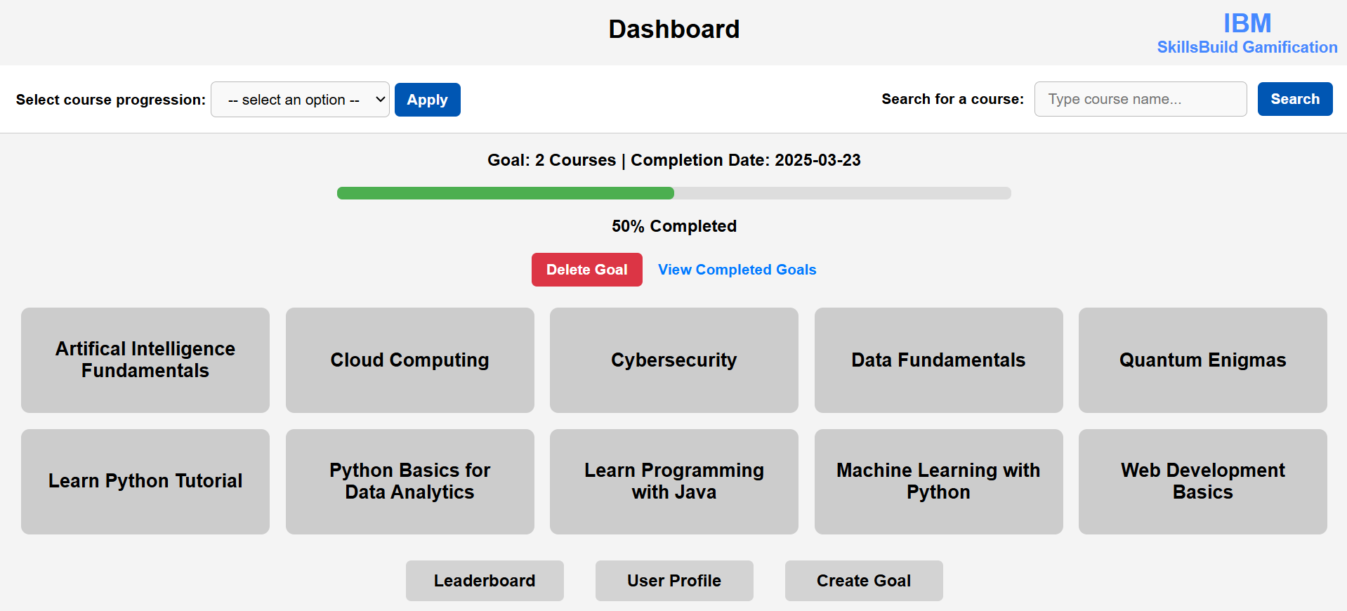

Goal Completion:

- When the user completes the required number of courses, the goal is marked as "Completed" automatically.
- A celebration message is shown on the Dashboard, indicating goal success.

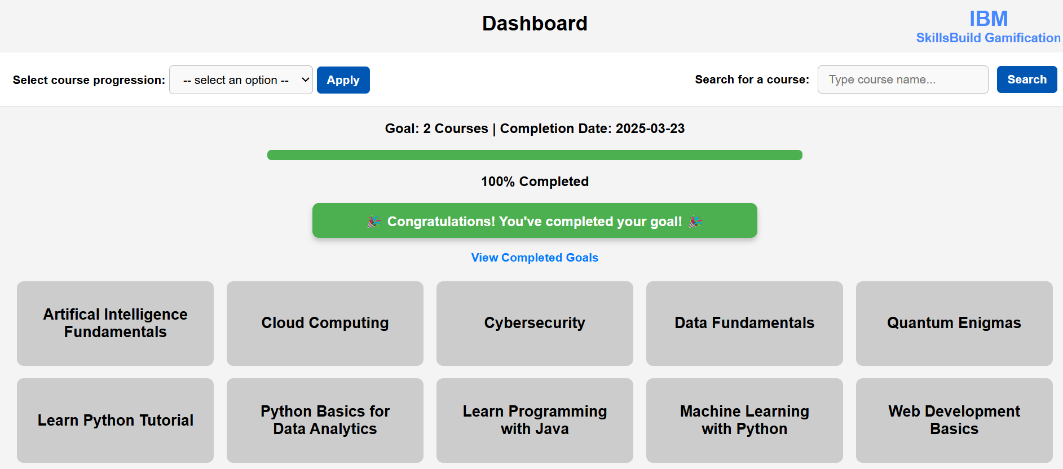

Deleting an Active Goal:
- If the user wishes to cancel their current goal, they can click the "Delete Goal" button.
- The goal is removed, and the user can create a new one.
- Note: This option only appears if the current goal is active and not yet completed.

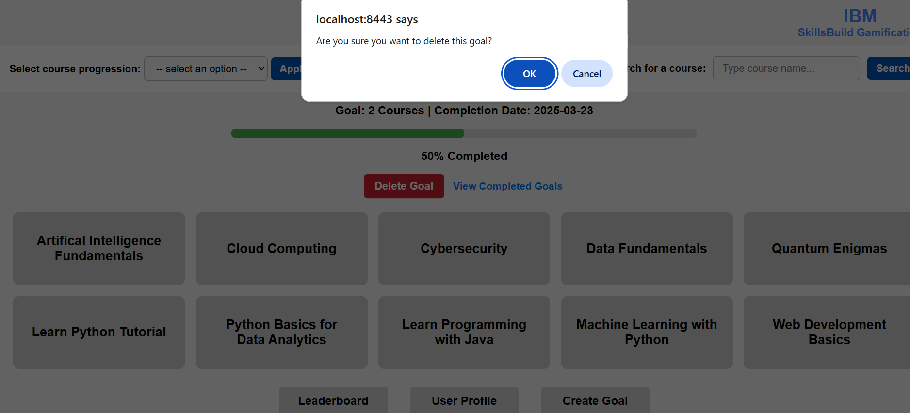

    - Viewing Completed Goals:
- A "View Completed Goals" link is available under the goal progress section.
- This page shows a list of previously completed goals with:
  - Number of courses in the goal.
  - The date each goal was completed.

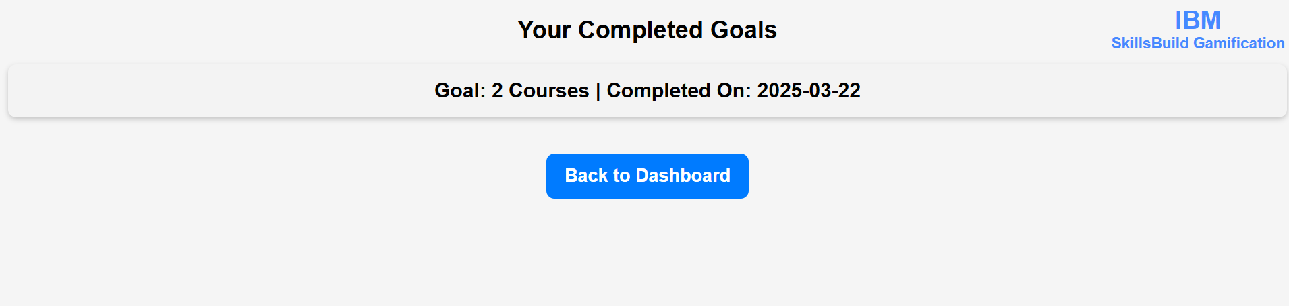
Course Filter and Search Functionality on Dashboard
The dashboard provides users with a course filtering and search functionality to help them easily locate and track their learning progress. Here is an overview of how these features work.
Course Filter Feature
The course filter allows users to filter courses based on their progress status. This makes it easier to view only the relevant courses.
How to Use the Course Filter
- Locate the "Filter Courses" section at the top left of the dashboard.
- Click on the dropdown menu labeled " Select Course Progression".
- Choose one of the following options:
  - Completed: Displays only the courses that the user has finished.
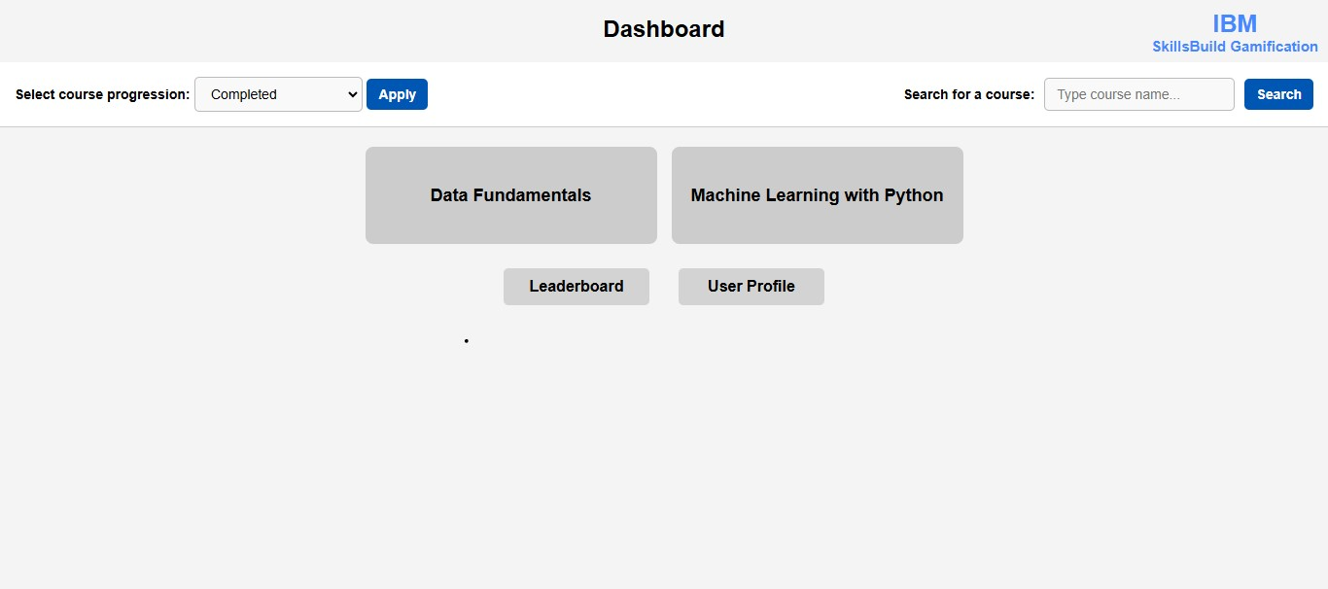
  - In Progress: Shows courses that the user has started but not yet completed.
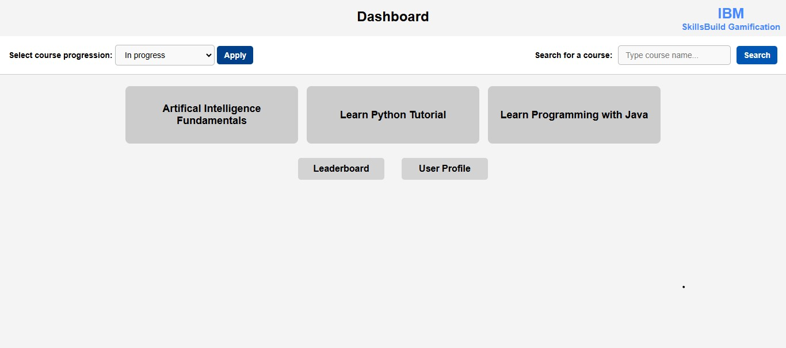
  - Not Completed: Displays all courses that the user has not enrolled in or has not started.
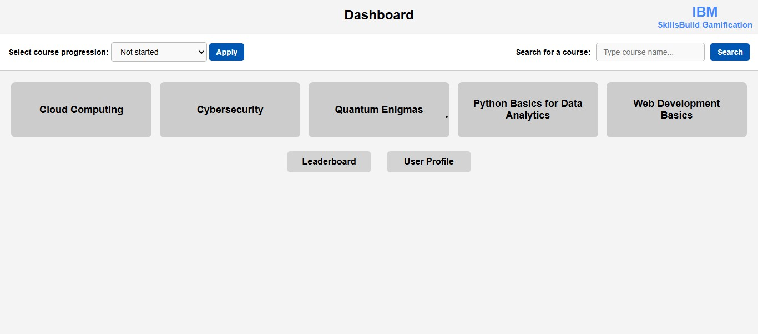
  - Default Option ("-- select an option --"): Displays all available courses without filtering.
Course Search Feature
The search functionality helps users quickly find a specific course by name.
How to Use the Search Feature
- Locate the "Search for a Course" section on the top right of dashboard.
- Enter the course name in the search box labeled "Please enter the name of the course manually that you wish to select".
- Click the "Enter course search" button.
- The dashboard will display only the courses that match your search query.

For demonstration, if a user searches for courses to do with Python:
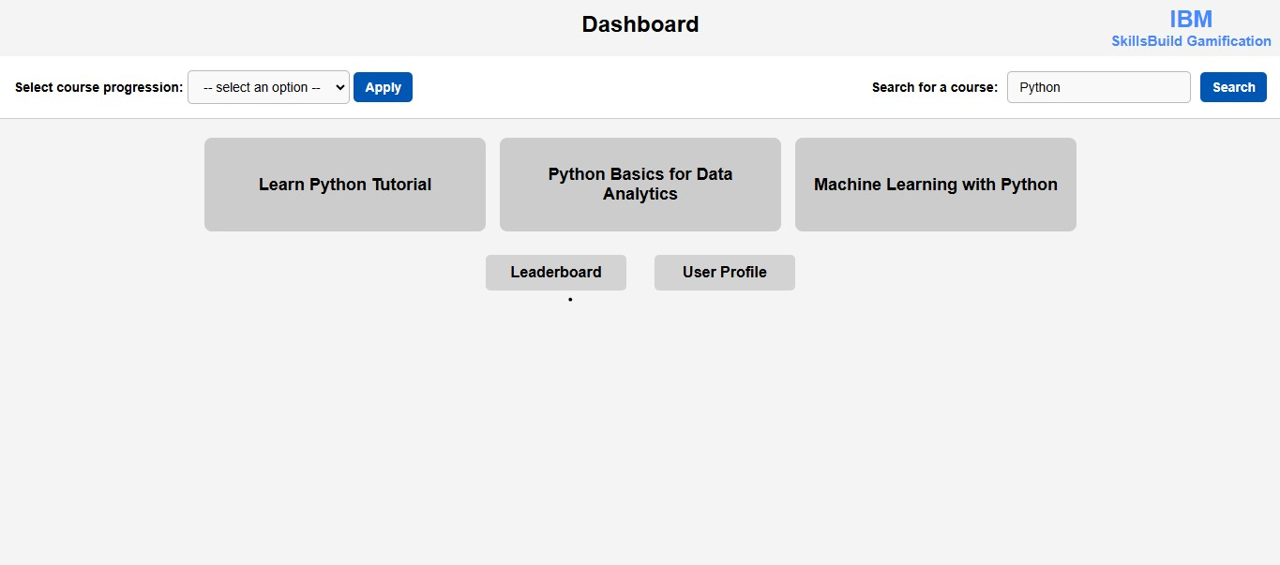

2. Leaderboard
The leaderboard is a way for students to see all students, ranked in order of the number of points they scored, from highest to lowest. This allows students to compare progress, and it may motivate them to complete more courses, to climb the leaderboard, and see their name at the very top!
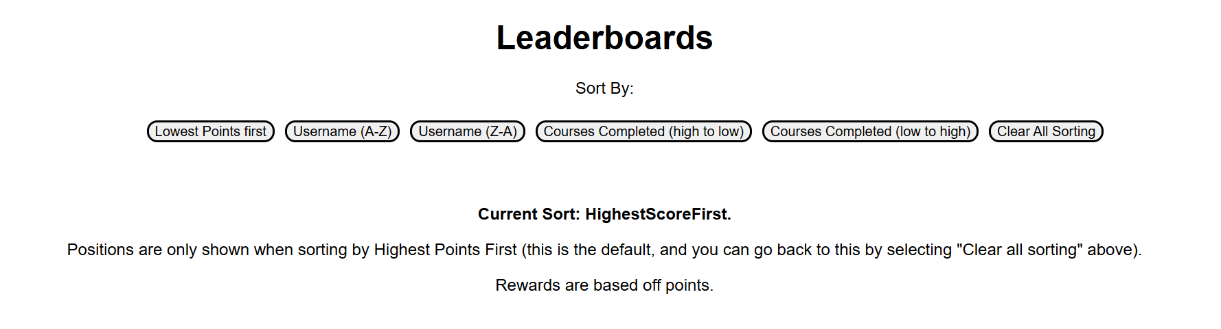
2.1 - Sorting
Sorting: Users are met by the leader board page, when pressing the leaderboard button on the dashboard page, where they will see some information about sorting the leaderboard. Each button corresponds to a way to sort the leaderboard, for example, sorting by lowest points first, sorting alphabetically (usernames A – Z) or sorting by the number of courses completed.

Positions will only be shown when sorting by highest points first, as this is the primary metric of the leader board, and it may cause confusion if users see positions for other sorting methods, that do not measure performance.
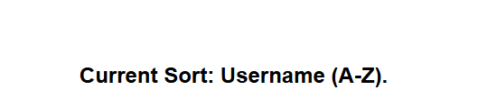Current sorting changes to show the currently selected sorting option

2.2 – Clear sorting
Clear Sorting: users can return back to Highest Points First sorting, by selecting clear all sorting from the sort by options.

2.3 – User Position in leaderboard shown in separate section
Users can see their position in the leader board, in a separate section before the full leader board is shown. This helps as if there are many users, it allows users to quickly see their progress, and compare this to others via their position, without having to scroll down for long. For example, if there are 100 users, and user “bob12” is in position 58, they do not have to scroll down a lot, to be able to find their position and see how they are doing relative to others.
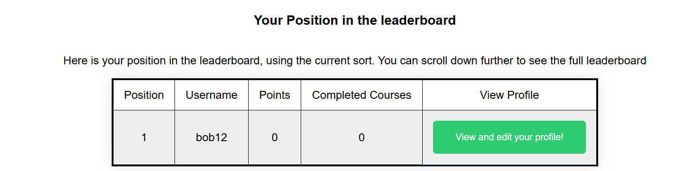Users can see their position in a separated section before the full leaderboard

2.3 – Global Leaderboard

Users are then presented with the full leader board, in which every user is shown, along with their position, username, points, number of completed courses, and a button in which users can visit other students’ profiles. The currently logged in student is highlighted green, which can aid in quickly identifying their position on the leaderboard, from which they can compare themselves against those around them.

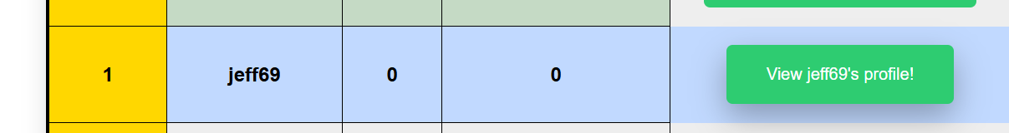
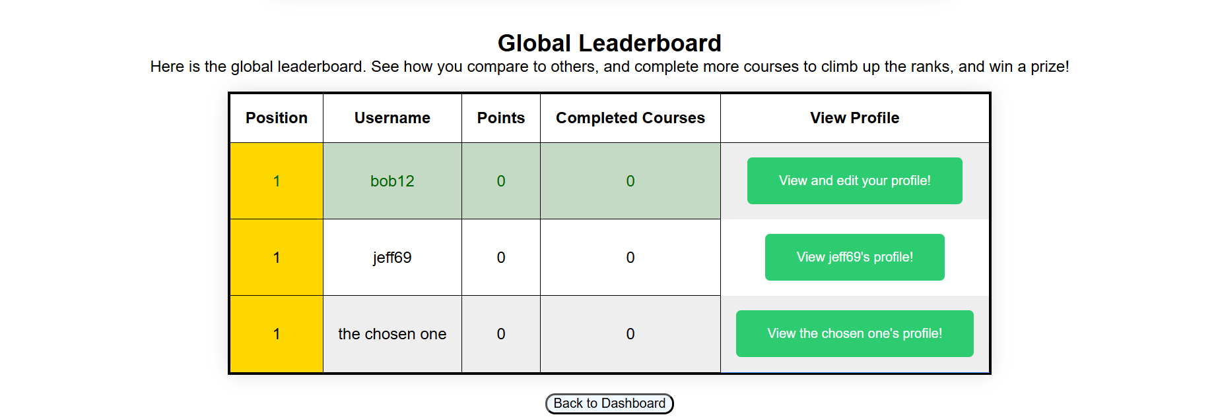Users can see the full leaderboard, and they are highlighted in green, to help visual recognition
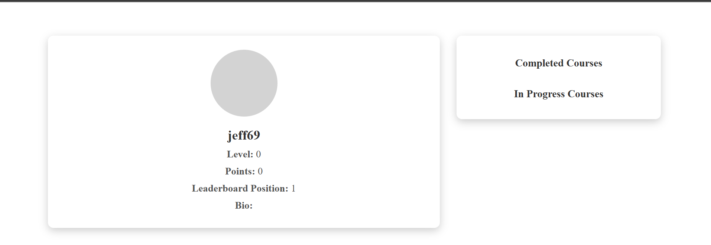Pressing view profile on the leaderboard will allow students to see the profile of the selected student
2.4 Joint Positions
In order to ensure fairness, students will notice that the leader board utilizes joint positions. This was a design choice to ensure users positions accurately represent their performance, in terms of points and the number of courses completed, and allows for better comparisons against other students.

2.5 Back To Dashboard
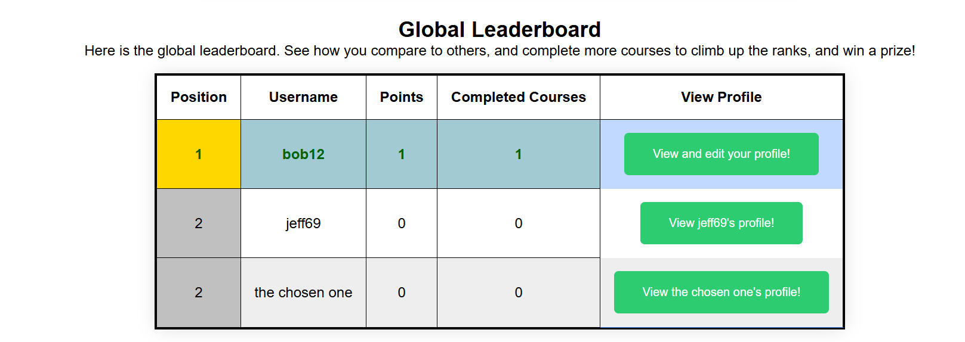The global leaderboard updates, and shows joint positions for users that have the same number of positions
The leader board page has a “Back to Dashboard” button located at the bottom of the page, which students can press to return back to the dashboard page.

3. User Profile Management and Badges
3.1 Profile Page Overview
The Profile Page displays key details about the user, their progress, and achievements. Users can view their personal information, track progress, and access settings.
Main Features on the Profile Page
User Information
- Displays the username, profile picture, and user level.
- Shows basic details like email (if applicable) and registration date.
Completed and In-Progress Courses
- Shows the total number of completed courses.
- Displays courses currently in progress, helping users track learning progress.
Badges and Achievements
- Displays all earned badges for milestones in completing courses
- Hovering over a badge shows detailed information about how it was earned.
Edit Profile Button
- Clicking this button redirects to the Edit Profile Page, where users can update their details.
Leaderboard and Ranking
- Displays the user’s position in the leaderboard, based on points and completed courses.
Logout
- Allows users to logout of their ID returning back to the login page.
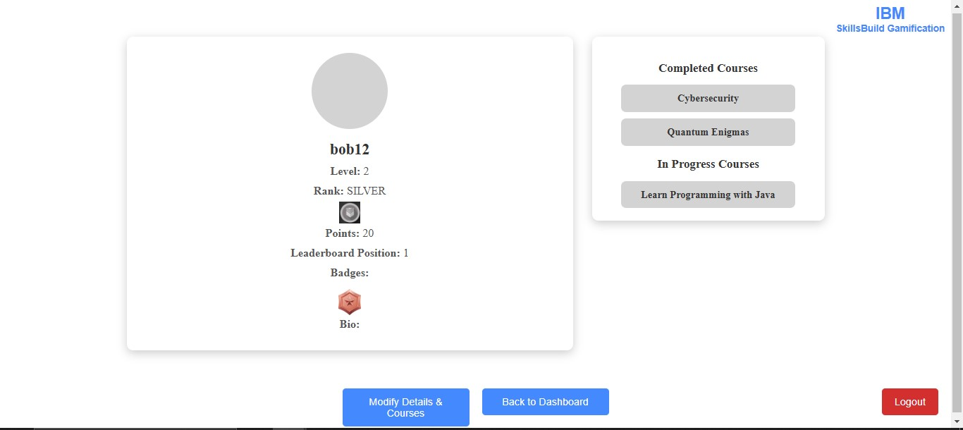

3.2 Edit Profile Page
The Edit Profile Page allows users to modify their personal information and update their profile picture.
Features of the Edit Profile Page
Change Password
- Users can enter a new password and confirm it to change their login credentials.
Upload Profile Picture
- Allows users to upload a profile picture or choose an avatar.
Add and change Bio
- Allows users to add or change their bio to tell other about them.
Change Course Status
- Allows users to change the status of their completed and in progress course.
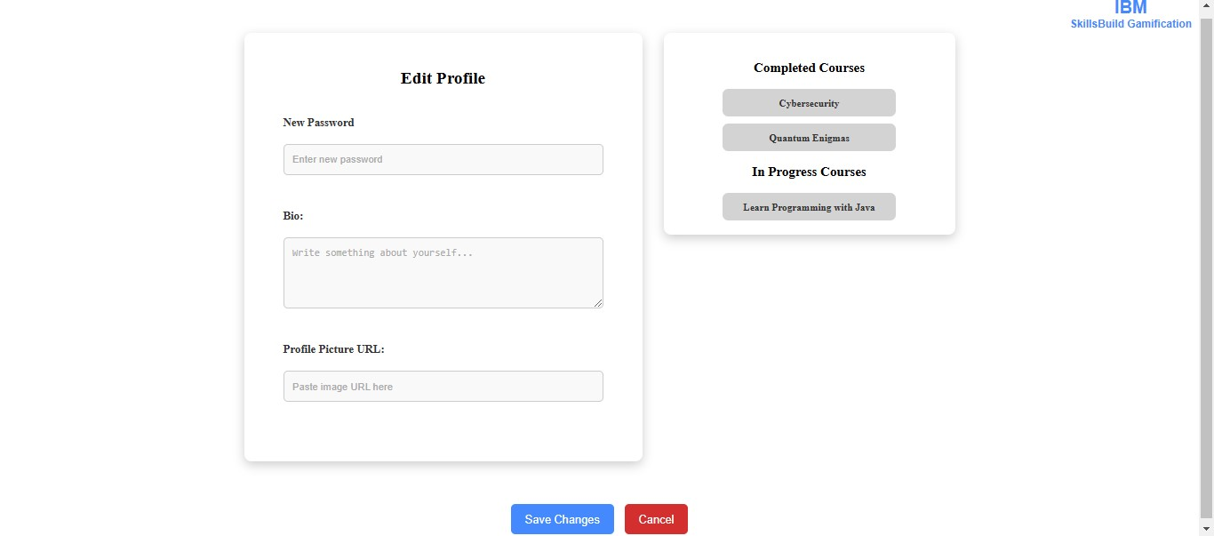
Add info:
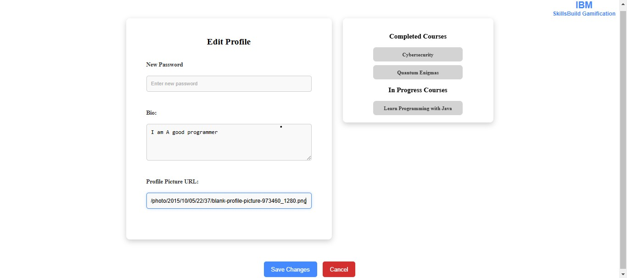
Change course status:
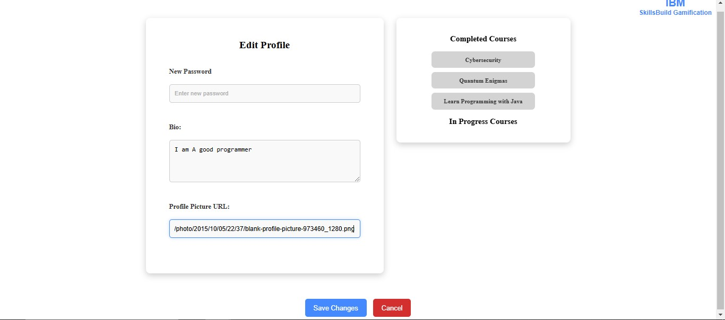
Cancel Button
- Redirects back to the Profile Page without saving changes.
Save Changes Button
- Clicking Save Changes updates the user’s details and redirects to user profile.
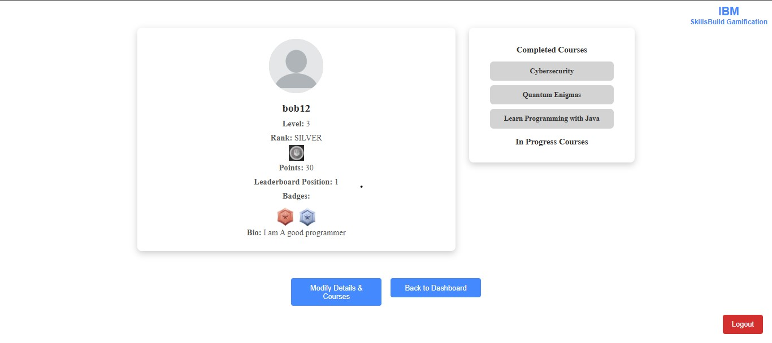

3.3. How Badges Work
Earning Badges
Badges are awarded based on user achievements. Users can track their badges collection from the Profile Page
Types of Badges
- Novice Badge – Awarded for completing the first course.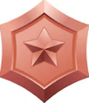
- Intermediate Badge – Earned after completing 3 courses.
- Advanced Badge – Earned after completing 5 courses.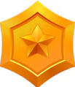
- Expert Badge – Earned after completing 7 courses.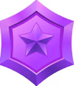
Hover Feature
- Hovering over a badge displays its criteria and progress.
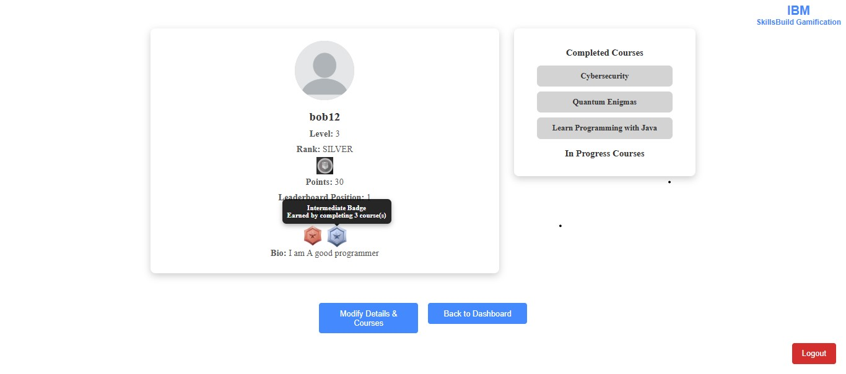

4. Levelling System
Overview
The Skills Build Gamification featueres two levelling systems working side by side. There are ranks and levels.

4.1 – How to view rank / level information
To view a student’s own levelling information, they can use the dashboard, and navigate to the user profile, by clicking the user profile button at the bottom of the page (more detail on the dashboard can be found in section “1. Dashboard”). Here, they will find the level and rank displayed underneath their username, as well as an image to show the logo of the rank, as well as other information, which is detailed in section “3. User Profile Management”.
To view other students’ ranks, a student, once logged in and on the dashboard page, can navigate to the leaderboard by selecting leaderboard at the bottom of the page (more detail on the leaderboard page can be found in section “2. Leaderboard”). Once on the leaderboard page, they can click the view profile button next to each student on the leaderboard to see information about their profile, including rank and level.
4.2 How to earn ranks and levels
Ranks and levels are both earned using the points system. Whenever a student completes a course, they will be awarded a certain amount of points, which contribute to progress towards the next rank, and the next level. It has intentionally been made slightly easier to progress to the next level compared to the next rank, to allow students to feel a constant sense of progression as they complete more courses and learn new skills
4.3 Initial Level and Rank
All students will begin on Level 0 and Rank Bronze when they have first created their account.
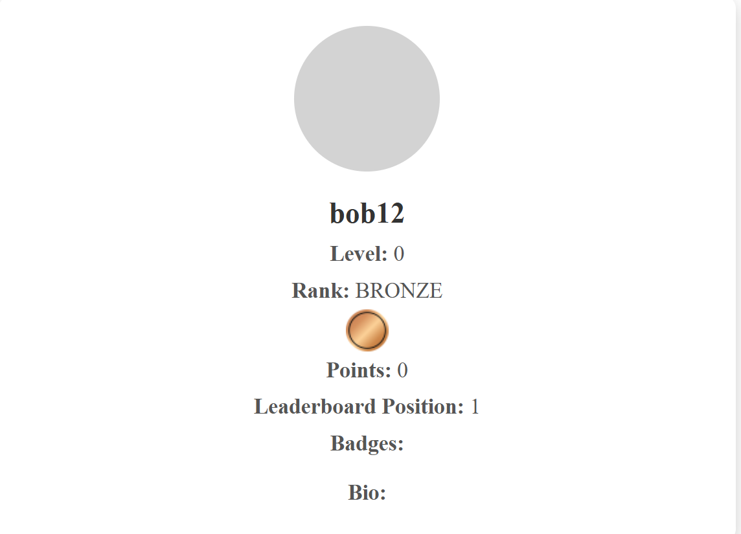New students start at Rank Bronze, and Level 0 when they have just created their account
/
As students complete more courses and earn more points, the level and rank will increase.
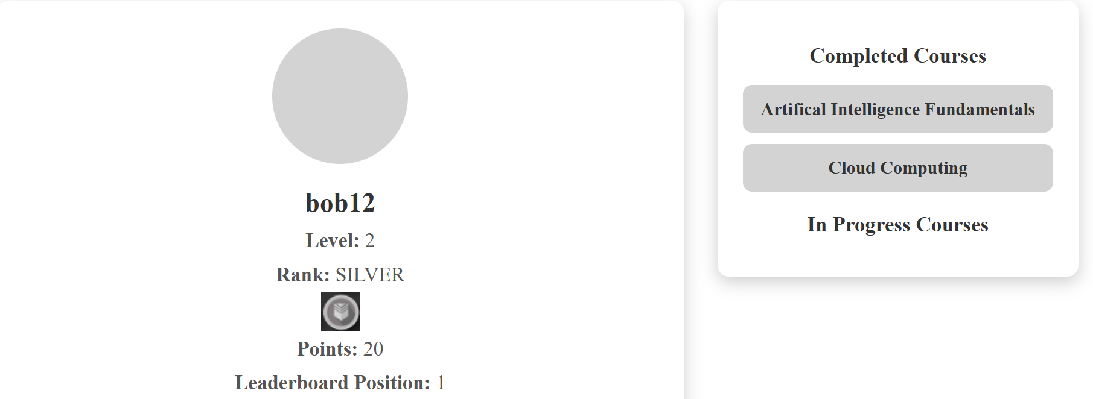After completing some courses and earning 20pts, student Bob12's rank increased from Bronze to Silver, and their level increased from 0 to 2.
4.4 What ranks are in SkillsBuild Gamification?
There are 8 ranks in SkillsBuild Gamification:
- Bronze: The initial rank all students start on
- Silver: Obtained after reaching 20pts
- Gold: Obtained after reaching 40pts.
- Platinum: Obtained after reaching 60pts
- Diamond: Obtained after reaching 80pts
- Champion: Obtained after reaching 100pts
- Mega Champion: Obtained after reaching 120pts
- Legend: Obtained after reaching 140pts

- Analytics Page
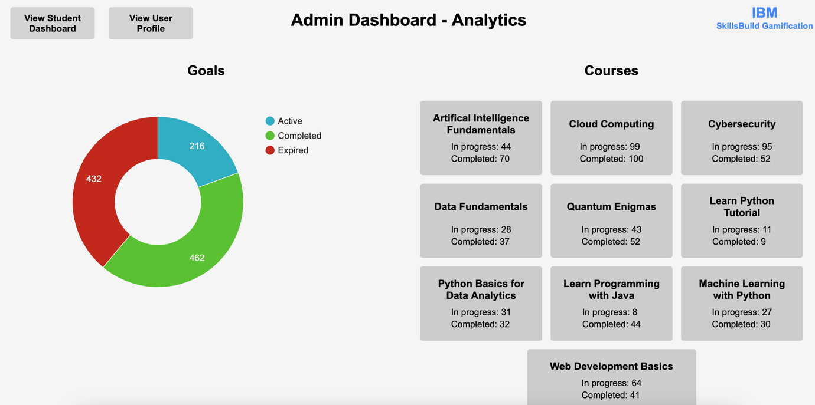
Overview
The analytics page provides an overview for the admins to understand trends on the site. It is the page that admins first see when they log into the site. Other users cannot access the analytics page.
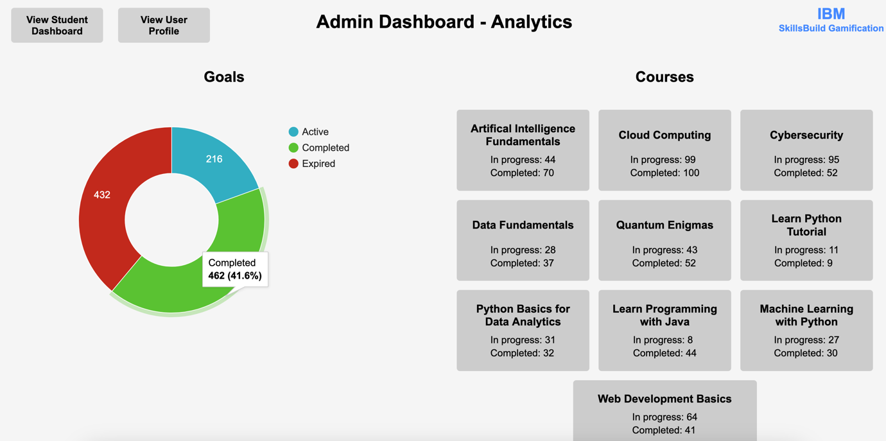
5.1 – Goals
On the left side of the screen, there is a doughnut chart which shows how many total student goals are active (ongoing), completed, and expired. Hovering over a segment in the doughnut chart reveals the percentage and count for that segment:

5.2 – Courses
On the right side of the screen, there is a list of courses. Each one has the number of students in progress (started but not completed) and the number of students who have completed the course. Additionally, clicking the header of any of the courses will direct the admin to the course’s page on IBM SkillsBuild.
5.3 – Other buttons
On the top left of the screen, there are buttons to view the student dashboard and to view the user profile. Clicking “View Student Dashboard” redirects the admin to the normal student dashboard page and allows the admin to interact as a student, to better comprehend the user experience. Clicking “View User Profile” allows the admin to view their profile.

6. Friends and Friend Leaderboard
6.1 Overview
This feature introduces friend functionality to our IBM SkillsBuildGamification. Students are now able to see incoming friend requests, see their friends list, send friend requests to other students, add friends by accepting an incoming friend request (or they can reject), and they can also unfriend students from their friends list.
In addition, this feature also introduces a friends leaderboard, where users can compare their overall progress – this is similar in functionality to the global leaderboard , though it only displays friends of the user, rather than every user that is registered.

6.2 Seeing incoming friend requests
Users can view their friend requests by first going to their profile page, by clicking the “User Profile” button on the dashboard (see Section 1 for more details about the dashboard).
Once they click the button: they are taken to their profile page. When the user then clicks on “See Friend Requests” in the “Manage Friends” section of their profile page, they will be able to see their friend requests:
When a user presses “See Friend Requests”, they are taken to the Friend Requests page:
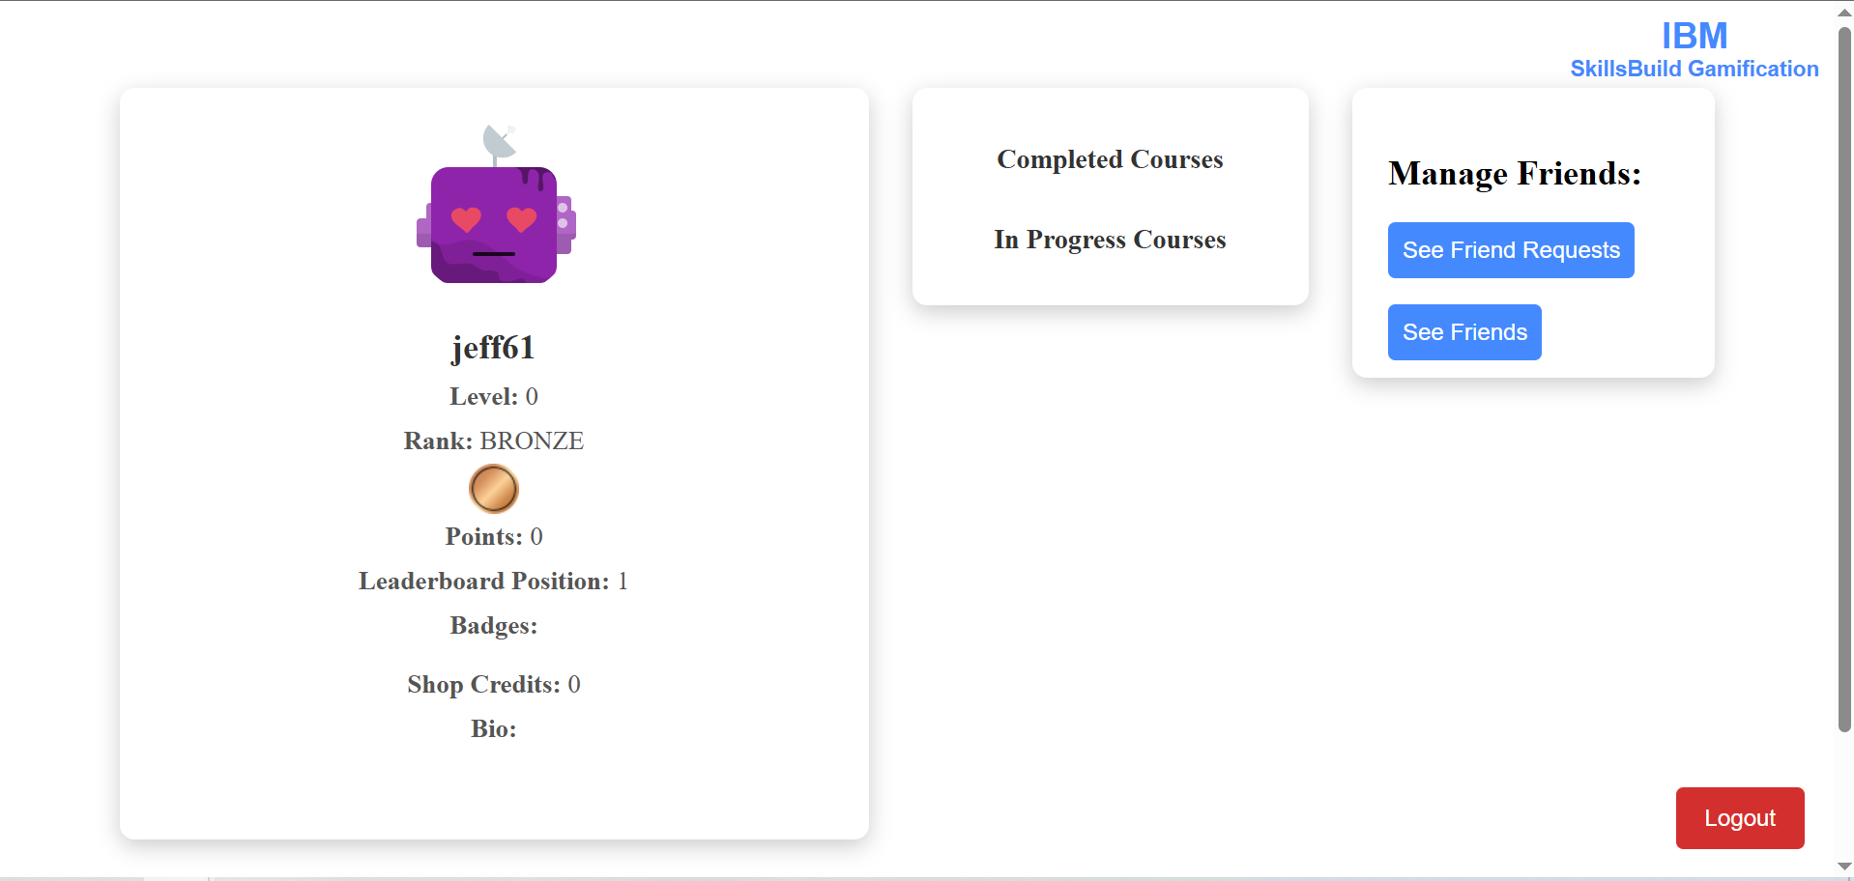When a user is logged in they can press "See friend requests" to view their incoming friend requests
There is also a back to dashboard button, which will redirect the user back to the dashboard shown in section 1: “Dashboard”.
6.3 Viewing Friends
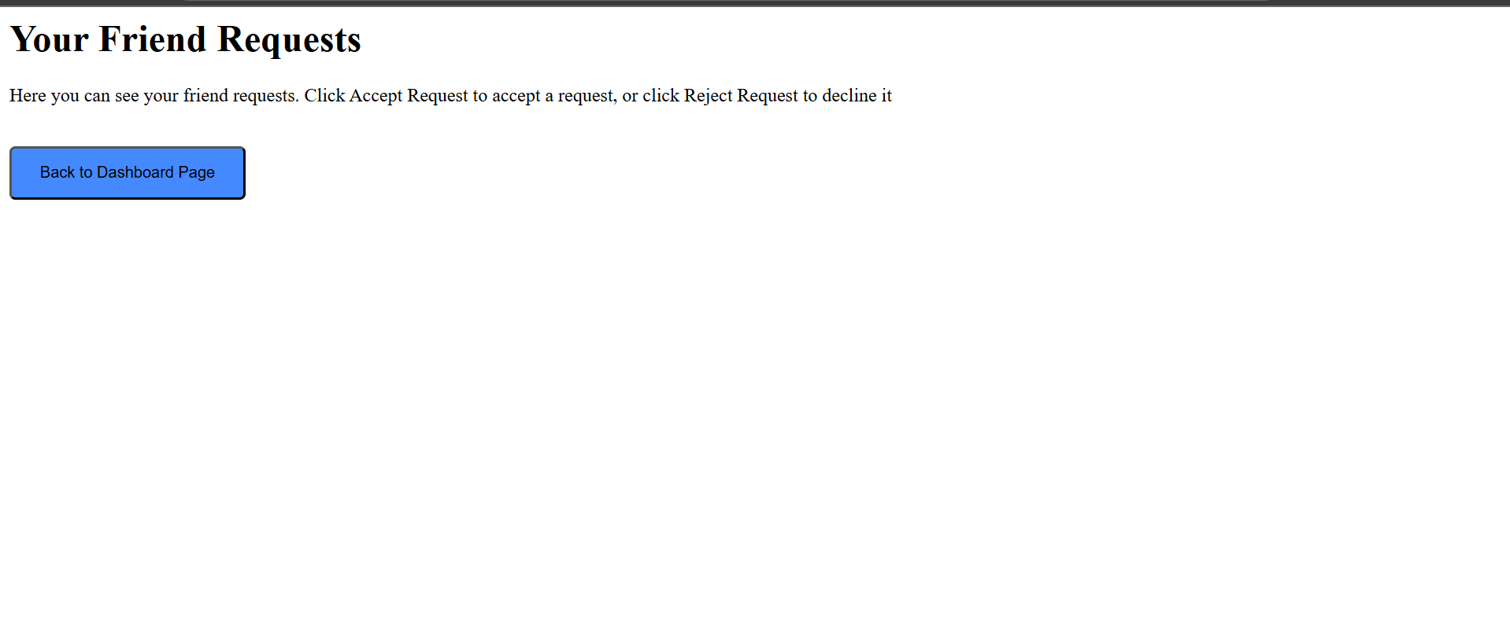When a User presses see friend requests they are taken to this requests page. This is how the page looks if the user has no incoming friend requests
When a user presses the “see friends” button in the “Manage Friends” section of their profile page (see image in section 6.2), they will be taken to the friends page, where they are able to see their friends. From this page, users will be able to unfriend the user, or view their profile.
6.4 Sending Friend Requests
Students can also send friend requests to other students. In order to do this, they must first go to the global leaderboard, which they can do by pressing the “Leaderboard” button on the dashboard page (see section 1: Dashboard for more details). Once on this page, they can press the “view profile” button next to the user they would like to press (see section 2.3 for more details), they will be taken to the profile page for that student.
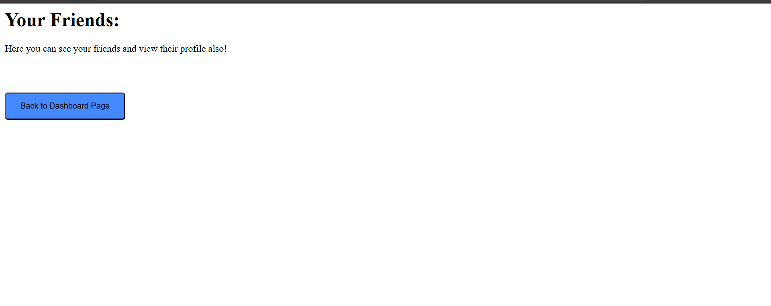When a user presses see friends, they are taken to this see friends page - this is what it will look like if the user has no friends. After adding friends, this page will show friends, see “Accepting friend Requests”, for more info.
From that page, users can press the blue (green when cursor hovers over it) “send friend request” button, located under the bio for the student:
6.5 Accepting Friend Requests
When a user has been sent a friend request by another student, they can choose to accept or reject this request.
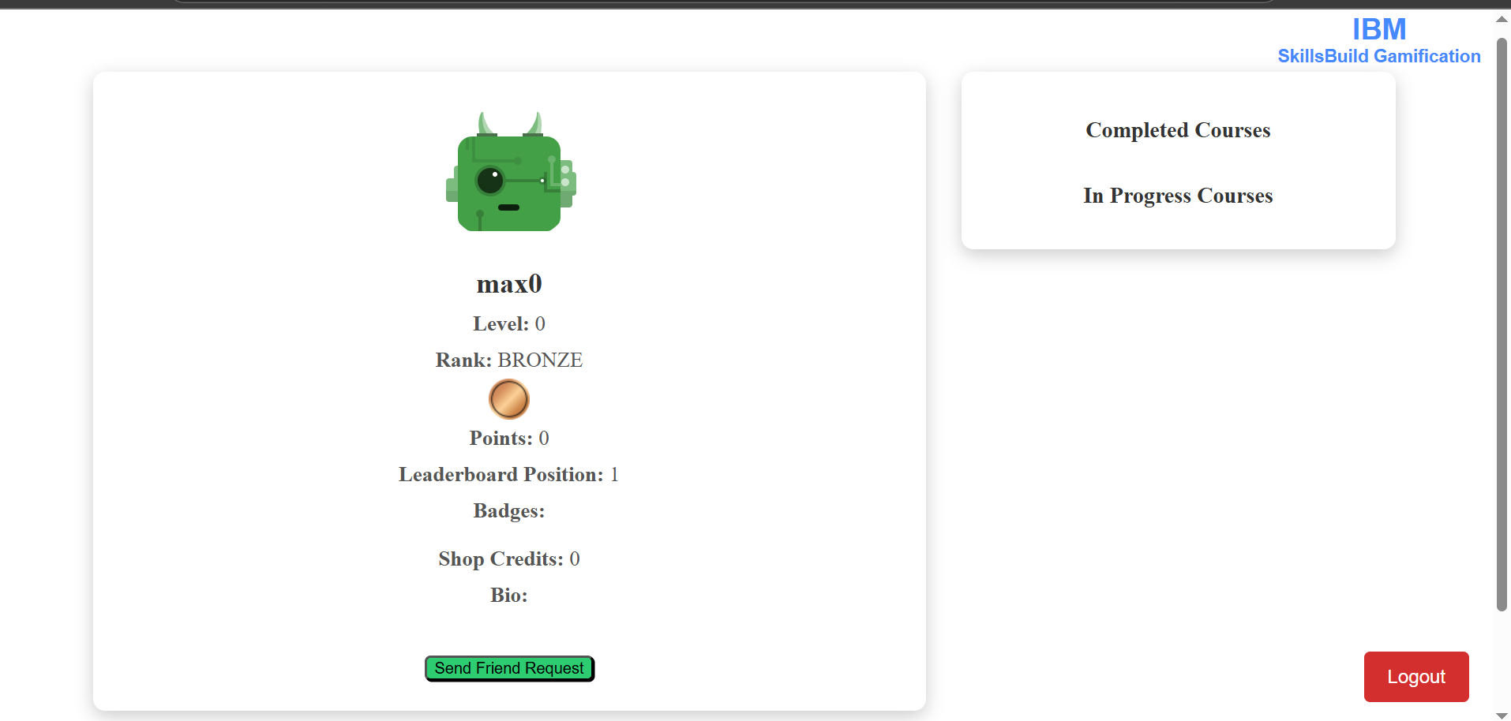Users can press "send friend request" on another students profile page in order to send them a request
To accept a request, you should go to the requests page (see section 6.2 Seeing incoming friend requests), from where, if you have requests that are pending, you will see an interface like the following:
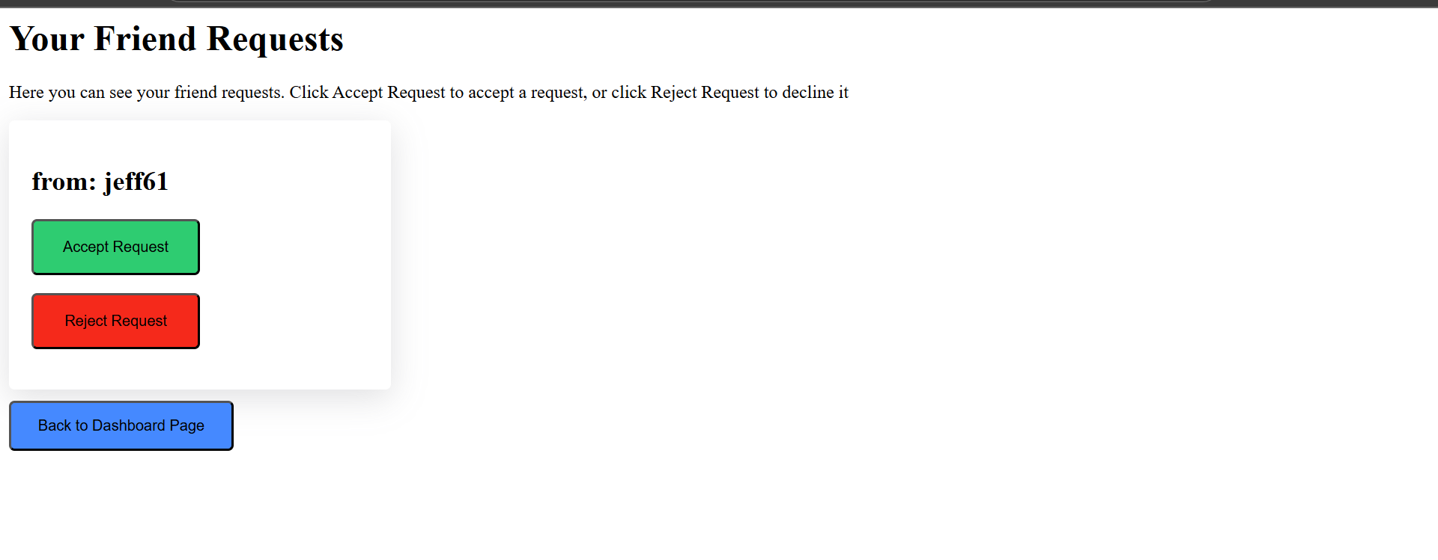When a user has incoming requests, that aren't answered they will see an interface like this
You should press the green “Accept Request” button, to accept the request. When a request is accepted, the student will appear in the friends list:
When the student accepts the request, the friends page of the student that sent the request will also be updated.
From this friends page, the student can unfriend or view the profile of the student.
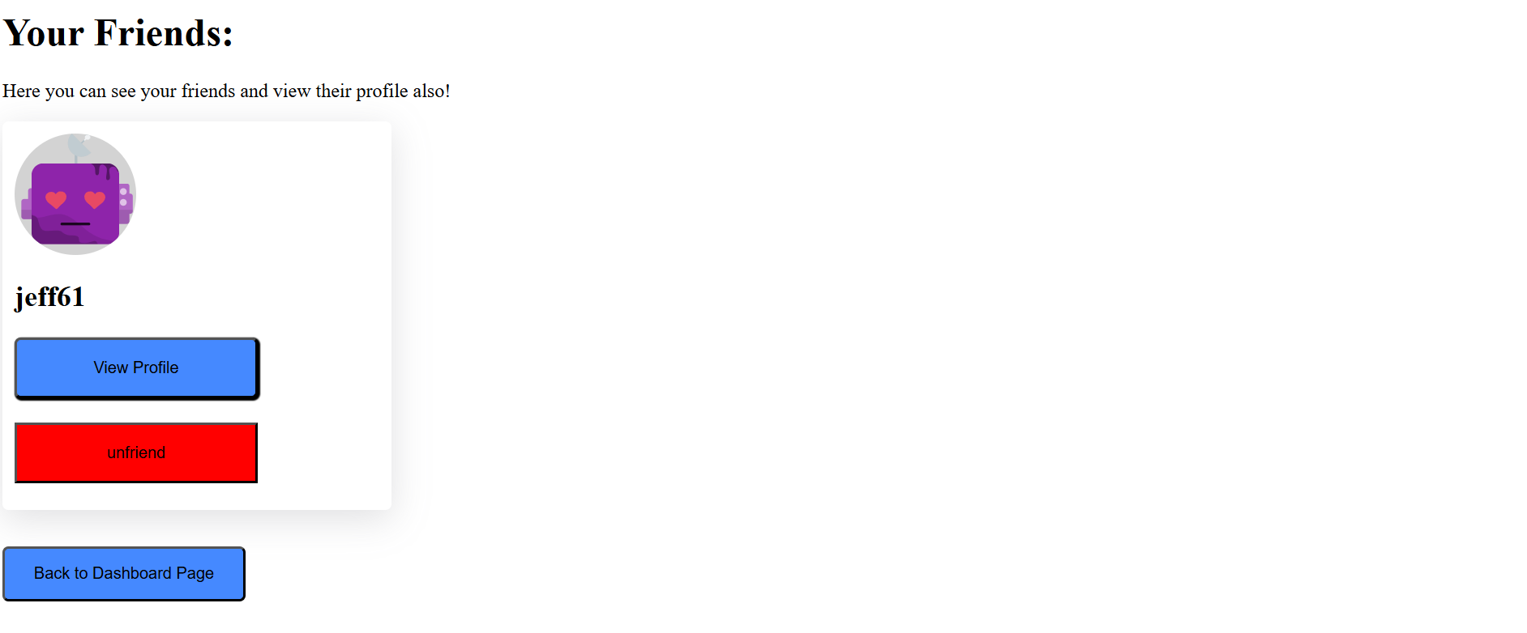When the user presses "Accept request", and then go to their friends page, they will see that the student who sent the request has been added to their friends list

6.6 Rejecting a friend request
When a user presses the red reject button on the friend request, they will be taken back to the dashboard page, and the sender of the request, will not be added to their friends list, and vice versa.
If the user presses the Reject button, they will be redirected to the dashboard
6.7 Unfriend
Students can also unfriend other users. To do this, they must first go to the friends page (see section 6.3 Seeing friends), and then click on the red unfriend button, after which, the friends page will update, and that student will no longer be part of their friend list.

6.8 Friend Leaderboard
Users are also able to see their friends in a leaderboard, similar to the global leaderboard, where they can compare their overall course progress to their friends. This offers users a more focussed comparison, as they can compare themselves against their friends, and compete to finish higher in the leaderboard.
Students can get to the friends leaderboard by navigating to the global leaderboard by pressing “Leaderboard” on the dashboard, and then scrolling down to the “view friends leaderboard” button at the bottom.
When users press this button, they are taken to the friends leader board page, which largely follows the same layout and functionality as the global leaderboard page explained in Section 2 Leaderboard.
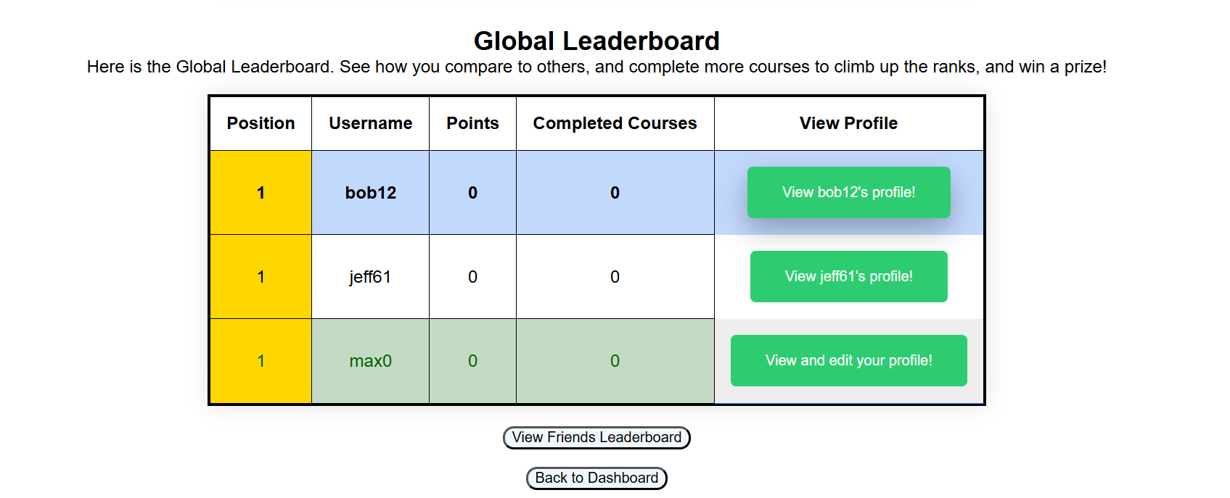
Press the View Friends Leaderboard button to see the friends leaderboard
When the user navigates to the friends leaderboard page, they will see an array of sorting options at the top, like the global leaderboard:
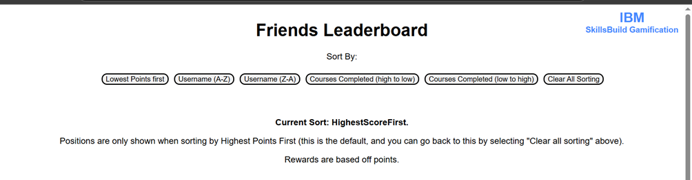
Users can sort by:
- Lowest Points first
- Username A-Z AND Username Z-A
- Courses Completed (High to low AND low to high)
- clear sorting – which returns to the default sorting method which is highest points first.

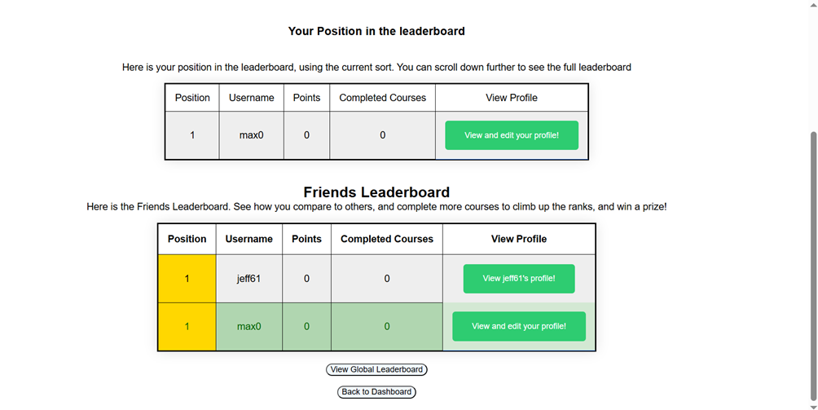
When users scroll down, they will see a leaderboard like above, which consists of their friends. The logged in student will be highlighted green, which, like the global leaderboard in section 2 “Leaderboard”, is intended to improve quick recognition as, if a student has many friends, they can quickly recognize their position in their leaderboard.
If the student has no friends, the position indicator will be blank, and the friends leaderboard will not show any users.

Position displays:
Like the global leader board, positions are only shown when sorting by highest points first (which users can get to by pressing “clear All sorting”). This decision was made as positions are envisioned to be an indicator of performance, with users that complete the most amount of courses – and thus earn the most points, being given the reward of seeing their name at the top of the leaderboard with the reward of a distinguished position indicator. For this reason, it did not make sense to show positions for ranking by, for example, usernames.
Students may also overlook the “current Sort” section and this can create confusion when using the leaderboard.
This means that for all other sorting options, the leaderboard will change to show friends in the order specified, however, the positions will have a place holder.

Back to dashboard and View Global Leaderboard button
At the bottom of the friends leaderboard page, there is a “View Global Leaderboard” button, which users can press to return to the global leaderboard, shown at the start of this section, and explained further in section “2 Leaderboard”.

- Avatar Shop & Inventory – User Guide
The Avatar Shop, where users can personalize their profile using a range of avatar features from multiple categories (like Bottts, Avataaars, Adventurer, etc.). Each avatar category comes with unique customization options such as eyes, mouth, top, clothing, and textures.
7.1 Navigating the Avatar Shop:
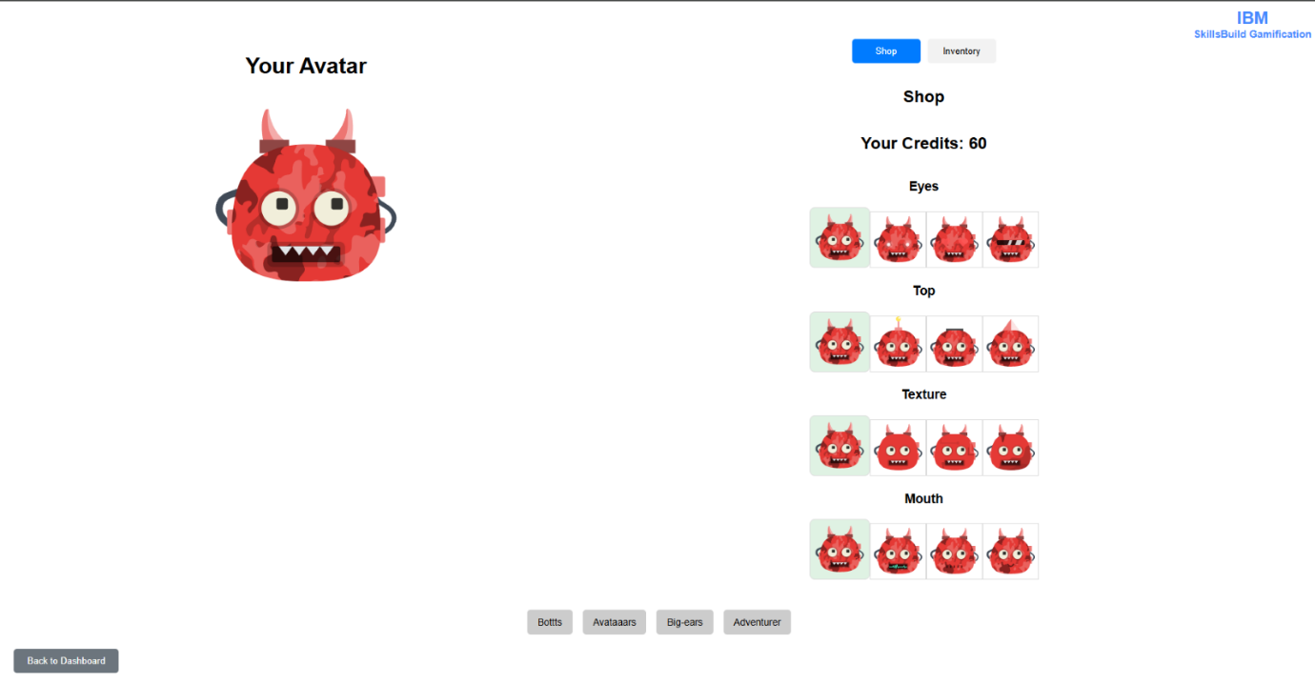
The Avatar customization interface is divided into two main sections:
Shop Tab – Browse and purchase new avatar features using your available credits.
Inventory Tab – View all owned features and equip them to customize your avatar.
The Category Buttons to switch between avatar types (e.g., Bottts, Avataaars). This will reload feature sets specific to that category.
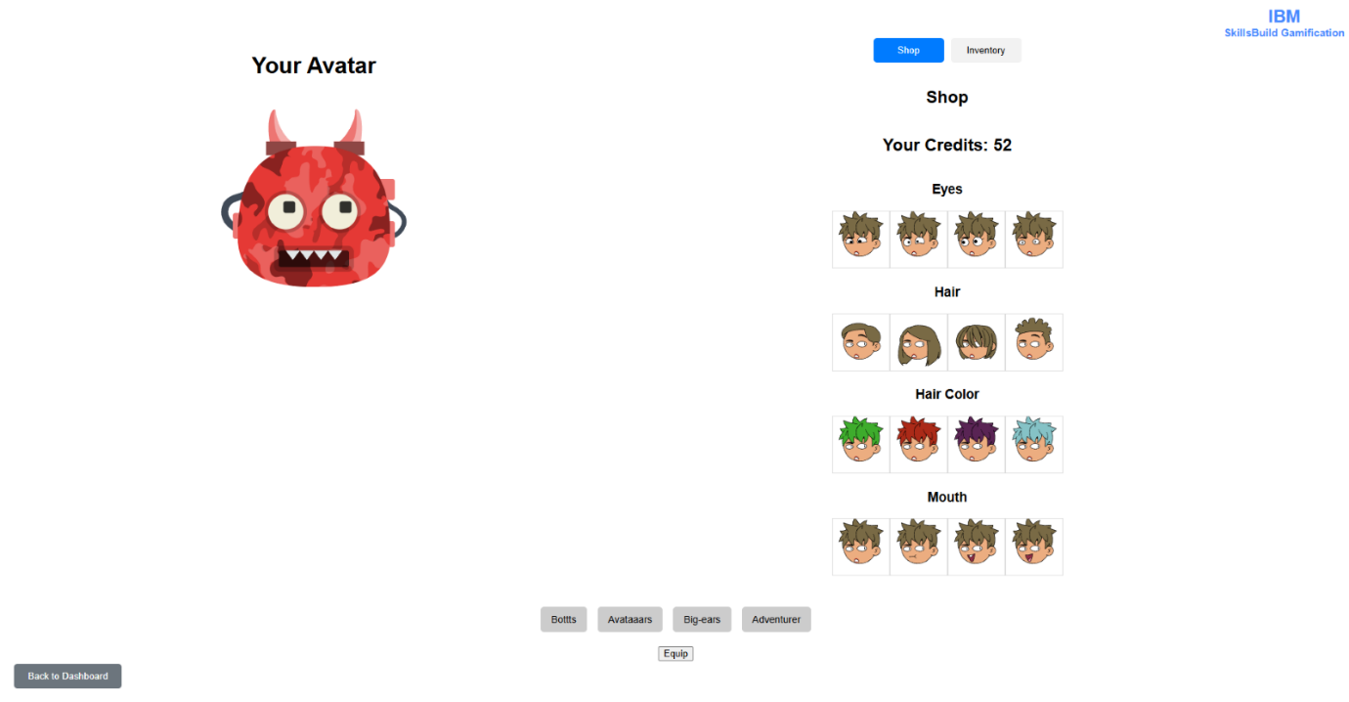
  - Shop Tab Functionality
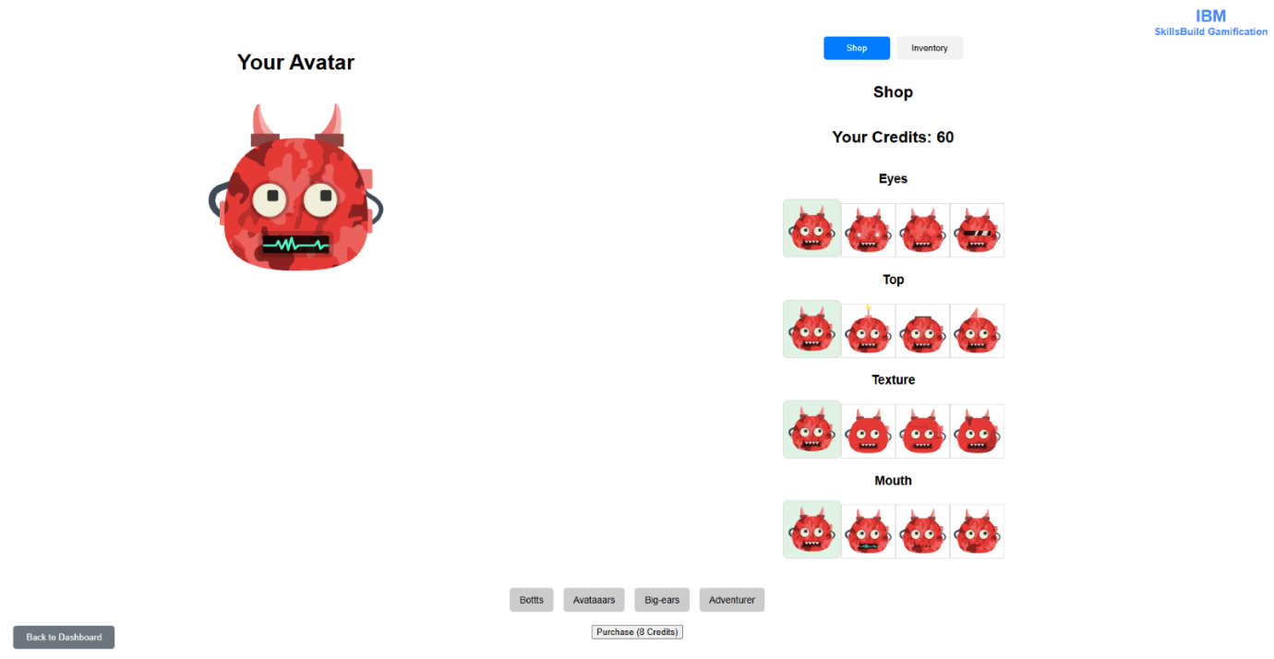
Each avatar category contains multiple features (like eyes, mouth, top).
Clicking a feature section reveals a grid of variant options.
Click a variant to preview it live on your avatar.
Variants already owned are highlighted in light blue, and variants currently equipped are marked in light green.
7.3 Purchase New Items
If you don't own a variant, you’ll see a button like:
Purchase (8 Credits)
After purchase, it becomes part of your inventory and can be equipped.
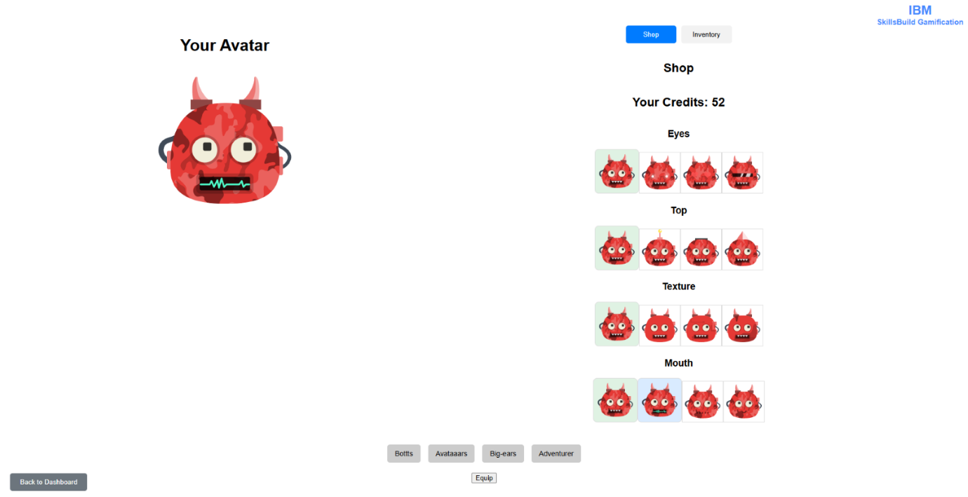
7.4 Inventory Tab Functionality
The Inventory tab shows only the items you own.
Click on a variant to preview it and equip it using the Equip button.
Your currently equipped features persist even after logout or category switch.

7.5 Equipping and Customizing
When you equip a variant:
The preview image instantly updates to reflect the change.
The feature is saved and becomes part of your active avatar.
Equipping a variant from a new category will clear previous category features, ensuring your avatar only uses features valid for the selected category.

Visual Highlights
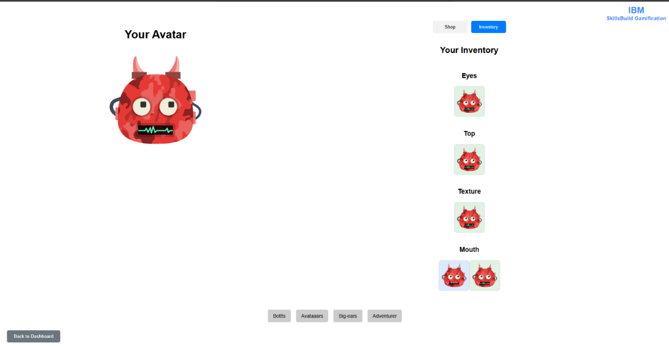
Real-Time Preview:
As you browse variants, the avatar image updates instantly to show how the new feature looks in combination with your currently equipped features. This helps you mix and match creatively before finalizing a purchase or equip.
7.6 Return to Dashboard:
A Back to Dashboard button is always available in the bottom-left corner for a smooth return to the main application.

8.0 Adding, seeing, and deleting reviews
On the dashboard a button which is called add review which will only appear below the button on the dashboard of its corresponding course if the user has completed the course. See review will always appear below its corresponding course on the main page to see all reviews. Example:
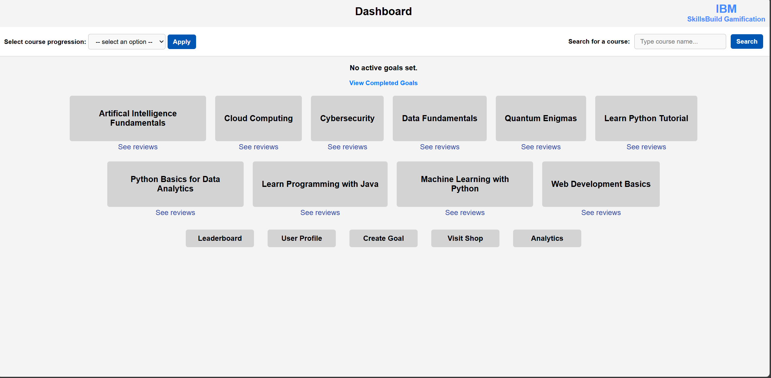

Once add review has been clicked this page will appear:
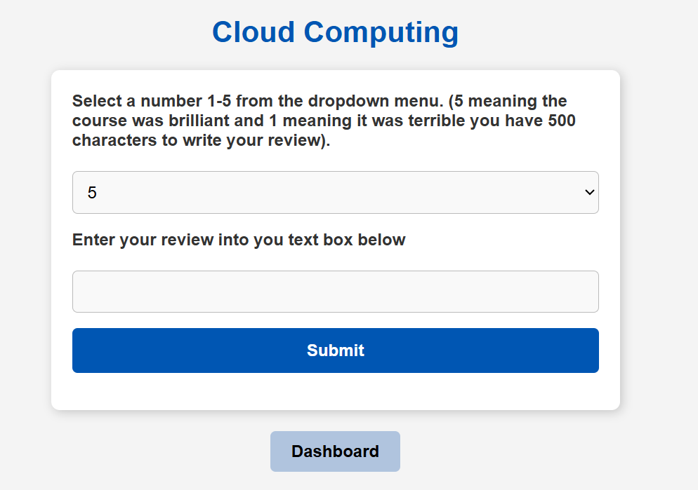
This page will allow the user to select a drop down of 1-5 to show how satisfied with the course they are. They can also enter text for their review if they want to add more context to their review. After you press submit and the page will take you see review.

This page will appear after submitting a new review or after you have clicked on see reviews:
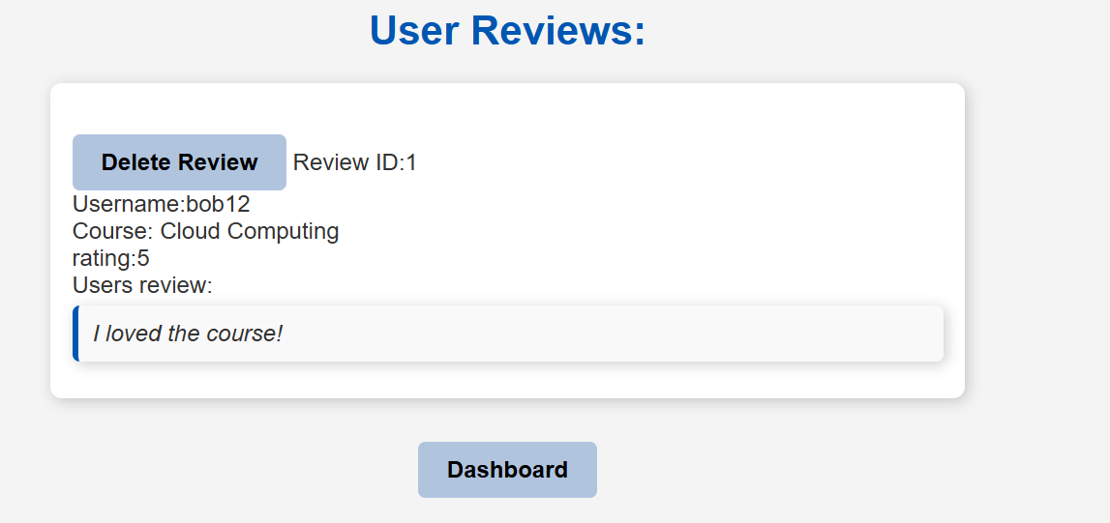
This page will appear and will show you reviews from other people about the course including your own. Also on this page If the user that is login is an admin the delete review button will appear for each review and when clicked on will remove the review from the database. When the dashboard button is clicked it will take you back to dashboard.

