CodingChallenge5

AJ Neff

2025-03-20

# Question 1 and 2

library(tidyverse)

## ── Attaching core tidyverse packages ──────────────────────── tidyverse 2.0.0 ──  
## ✔ dplyr 1.1.4 ✔ readr 2.1.5  
## ✔ forcats 1.0.0 ✔ stringr 1.5.1  
## ✔ ggplot2 3.5.1 ✔ tibble 3.2.1  
## ✔ lubridate 1.9.4 ✔ tidyr 1.3.1  
## ✔ purrr 1.0.4   
## ── Conflicts ────────────────────────────────────────── tidyverse_conflicts() ──  
## ✖ dplyr::filter() masks stats::filter()  
## ✖ dplyr::lag() masks stats::lag()  
## ℹ Use the conflicted package (<http://conflicted.r-lib.org/>) to force all conflicts to become errors

Diversity.Data <- read.csv("DiversityData.csv")  
str(Diversity.Data)

## 'data.frame': 70 obs. of 5 variables:  
## $ Code : chr "S01_13" "S02_16" "S03_19" "S04_22" ...  
## $ shannon : num 6.62 6.61 6.66 6.66 6.61 ...  
## $ invsimpson: num 211 207 213 205 200 ...  
## $ simpson : num 0.995 0.995 0.995 0.995 0.995 ...  
## $ richness : int 3319 3079 3935 3922 3196 3481 3250 3170 3657 3177 ...

Meta.data <- read.csv("Metadata.csv")  
str(Meta.data)

## 'data.frame': 70 obs. of 5 variables:  
## $ Code : chr "S01_13" "S02_16" "S03_19" "S04_22" ...  
## $ Crop : chr "Soil" "Soil" "Soil" "Soil" ...  
## $ Time_Point : int 0 0 0 0 0 0 6 6 6 6 ...  
## $ Replicate : int 1 2 3 4 5 6 1 2 3 4 ...  
## $ Water_Imbibed: chr "na" "na" "na" "na" ...

alpha <- left_join(Diversity.Data, Meta.data, by = "Code") # adding the meta data to the diversity data based on on the common column of Code  
head(alpha)

## Code shannon invsimpson simpson richness Crop Time_Point Replicate  
## 1 S01_13 6.624921 210.7279 0.9952545 3319 Soil 0 1  
## 2 S02_16 6.612413 206.8666 0.9951660 3079 Soil 0 2  
## 3 S03_19 6.660853 213.0184 0.9953056 3935 Soil 0 3  
## 4 S04_22 6.660671 204.6908 0.9951146 3922 Soil 0 4  
## 5 S05_25 6.610965 200.2552 0.9950064 3196 Soil 0 5  
## 6 S06_28 6.650812 199.3211 0.9949830 3481 Soil 0 6  
## Water_Imbibed  
## 1 na  
## 2 na  
## 3 na  
## 4 na  
## 5 na  
## 6 na

# Question 3

alpha2 <- alpha %>%  
 mutate(even = shannon/log(richness))  
  
alpha$even <- alpha$shannon/log(alpha$richness)

# Question 4

alpha_average <- alpha2 %>%  
 select(Time_Point, Crop, even) %>%   
 group_by(Crop, Time_Point) %>%   
 summarise(Mean.even = mean(even),  
 n = n(),   
 sd.dev = sd(even)) %>%  
 mutate(std.err = sd.dev/sqrt(n))

## `summarise()` has grouped output by 'Crop'. You can override using the  
## `.groups` argument.

# Question 5

alpha_average2 <- alpha_average %>%  
 select(Time_Point, Crop, Mean.even) %>%   
pivot_wider(names_from = Crop, values_from = Mean.even) %>%  
mutate(diff.cotton.even = Soil - Cotton) %>%   
mutate(diff.soybean.even = Soil - Soybean)

# Question 6

alpha_average2_diff <- alpha_average2 %>%  
 select(Time_Point, diff.cotton.even, diff.soybean.even) %>%  
 pivot_longer(c(diff.cotton.even, diff.soybean.even), names_to ="diff")  
library(ggplot2)  
ggplot(alpha_average2_diff,aes(x = Time_Point, y = value, color = diff)) +geom_line()+  
xlab("Time (hrs)") + ylab("Difference from soil in Pielou's Evenness")

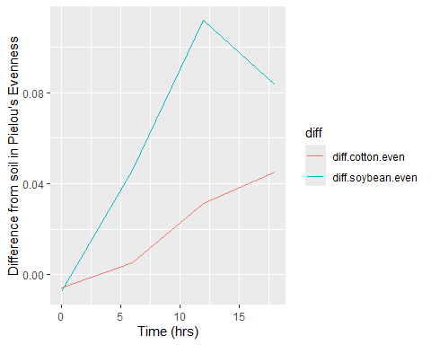 # Question 7