Neff_CodingChallenge4

AJ Neff

2025-02-27

The data is accessible via the link in this citation: Noel, Z.A., Roze, L.V., Breunig, M., Trail, F. 2022. Endophytic fungi as promising biocontrol agent to protect wheat from Fusarium graminearum head blight. Plant Disease. [Link text](https://doi.org/10.1094/PDIS-06-21-1253-RE)

# Question 1

1. YAML header includes title, author, date, output
2. Literate programming is a mixture of input code and outputs of code that allow for fully reproducible documents.

# Question 2

cbbPalette <- c("#000000", "#E69F00", "#56B4E9", "#009E73", "#F0E442", "#0072B2", "#D55E00", "#CC79A7")

library(readr)  
MycotoxinData <- read.csv("MycotoxinData.csv",na.strings = "na")  
View(MycotoxinData)

DON_data <- read.csv("MycotoxinData.csv", na.strings = "na")  
str(DON_data)

## 'data.frame': 375 obs. of 6 variables:  
## $ Treatment : chr "Fg" "Fg" "Fg" "Fg" ...  
## $ Cultivar : chr "Wheaton" "Wheaton" "Wheaton" "Wheaton" ...  
## $ BioRep : int 2 2 2 2 2 2 2 2 2 3 ...  
## $ MassperSeed_mg: num 10.29 12.8 2.85 6.5 10.18 ...  
## $ DON : num 107.3 32.6 416 211.9 124 ...  
## $ X15ADON : num 3 0.85 3.5 3.1 4.8 3.3 6.9 2.9 2.1 0.71 ...

## CC3 Q1

library(ggplot2)  
DON_plot <- ggplot(MycotoxinData, aes(x = Treatment, y = DON, fill = Cultivar)) +  
 geom_boxplot() +  
 xlab("") +  
 ylab("DON (ppm)") +  
 geom_jitter(alpha = 0.6, pch = 21, color = "black", position = position_jitterdodge()) +  
 scale_fill_manual(values = c(cbbPalette[[2]], cbbPalette[[8]])) +  
 facet_wrap(~Cultivar) +   
 theme_classic()  
DON_plot

## Warning: Removed 8 rows containing non-finite outside the scale range  
## (`stat_boxplot()`).

## Warning: Removed 8 rows containing missing values or values outside the scale range  
## (`geom_point()`).

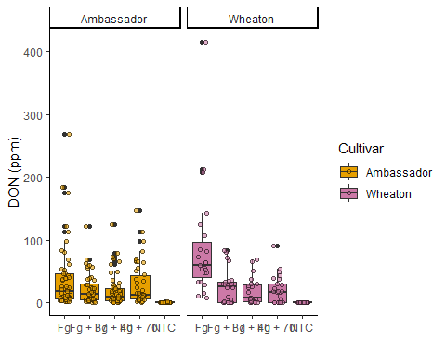

recordPlot()

## CC3 Q2

MycotoxinData$Treatment <- factor(MycotoxinData$Treatment, levels = c("NTC", "Fg", "Fg + 37", "Fg + 40", "Fg + 70"))

## CC3 Q3

DON15 <- ggplot (MycotoxinData, aes(x = Treatment, y = X15ADON, fill = Cultivar)) +  
 geom_boxplot(outliers = F) +  
 xlab("") +  
 ylab("DON (ppm)") +  
 geom_jitter(alpha = 0.6, pch = 21, color = "black", position = position_jitterdodge()) +  
 scale_fill_manual(values = c(cbbPalette[[2]], cbbPalette[[8]])) +  
 facet_wrap(~Cultivar) +   
 theme_classic()  
DON15

## Warning: Removed 10 rows containing non-finite outside the scale range  
## (`stat_boxplot()`).

## Warning: Removed 10 rows containing missing values or values outside the scale range  
## (`geom_point()`).

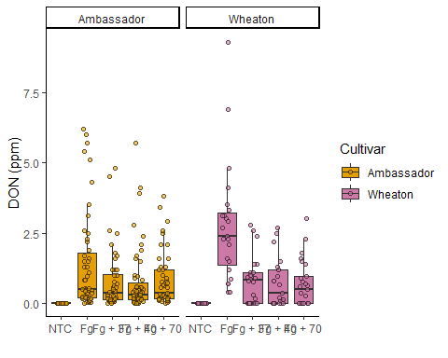

recordPlot()

DONSeed <- ggplot (MycotoxinData, aes(x = Treatment, y = MassperSeed_mg, fill = Cultivar)) +  
 geom_boxplot(outliers = F) +  
 xlab("") +  
 ylab("DON (ppm)") +  
 geom_jitter(alpha = 0.6, pch = 21, color = "black", position = position_jitterdodge()) +  
 scale_fill_manual(values = c(cbbPalette[[2]], cbbPalette[[8]])) +  
 facet_wrap(~Cultivar) +   
 theme_classic()  
DONSeed

## Warning: Removed 2 rows containing non-finite outside the scale range  
## (`stat_boxplot()`).

## Warning: Removed 2 rows containing missing values or values outside the scale range  
## (`geom_point()`).

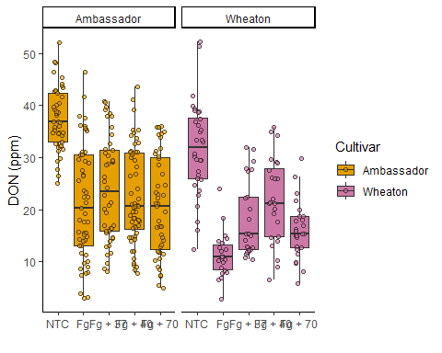

recordPlot()

## CC3 Q4

library(tidyverse)

## ── Attaching core tidyverse packages ──────────────────────── tidyverse 2.0.0 ──  
## ✔ dplyr 1.1.4 ✔ stringr 1.5.1  
## ✔ forcats 1.0.0 ✔ tibble 3.2.1  
## ✔ lubridate 1.9.4 ✔ tidyr 1.3.1  
## ✔ purrr 1.0.4   
## ── Conflicts ────────────────────────────────────────── tidyverse_conflicts() ──  
## ✖ dplyr::filter() masks stats::filter()  
## ✖ dplyr::lag() masks stats::lag()  
## ℹ Use the conflicted package (<http://conflicted.r-lib.org/>) to force all conflicts to become errors

library(ggpubr)  
library(ggrepel)

ggarrange(DON_plot, DON15, DONSeed, labels = "auto", ncol = 3, nrow = 1, common.legend = T)

## Warning: Removed 8 rows containing non-finite outside the scale range  
## (`stat_boxplot()`).

## Warning: Removed 8 rows containing missing values or values outside the scale range  
## (`geom_point()`).

## Warning: Removed 8 rows containing non-finite outside the scale range  
## (`stat_boxplot()`).

## Warning: Removed 8 rows containing missing values or values outside the scale range  
## (`geom_point()`).

## Warning: Removed 10 rows containing non-finite outside the scale range  
## (`stat_boxplot()`).

## Warning: Removed 10 rows containing missing values or values outside the scale range  
## (`geom_point()`).

## Warning: Removed 2 rows containing non-finite outside the scale range  
## (`stat_boxplot()`).

## Warning: Removed 2 rows containing missing values or values outside the scale range  
## (`geom_point()`).

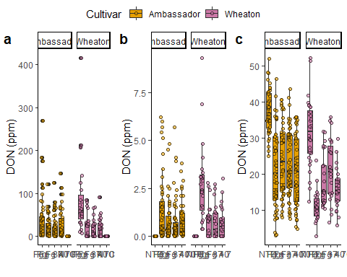

## CC3 Q5

stats_DON_plot <- DON_plot +  
 geom_pwc(aes(group = Treatment), method = "t_test", label = "p.adj.format")  
stats_DON_plot

## Warning: Removed 8 rows containing non-finite outside the scale range  
## (`stat_boxplot()`).

## Warning: Removed 8 rows containing non-finite outside the scale range  
## (`stat_pwc()`).

## Warning: Removed 8 rows containing missing values or values outside the scale range  
## (`geom_point()`).

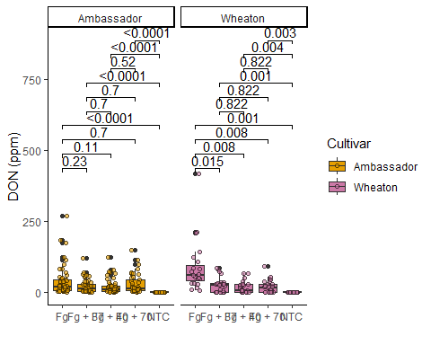

recordPlot()

stats_DON15 <- DON15 +  
 geom_pwc(aes(group = Treatment), method = "t_test", label = "p.adj.format")  
stats_DON15

## Warning: Removed 10 rows containing non-finite outside the scale range  
## (`stat_boxplot()`).

## Warning: Removed 10 rows containing non-finite outside the scale range  
## (`stat_pwc()`).

## Warning: Removed 10 rows containing missing values or values outside the scale range  
## (`geom_point()`).

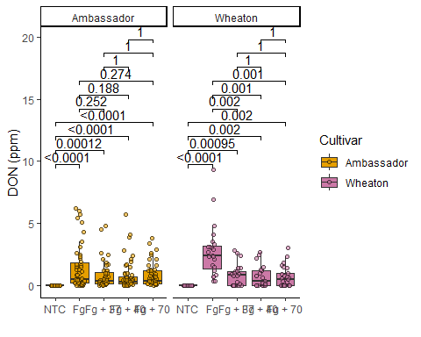

recordPlot()

stats_DONSeed <- DONSeed +  
 geom_pwc(aes(group = Treatment), method = "t_test", label = "p.adj.format")  
stats_DONSeed

## Warning: Removed 2 rows containing non-finite outside the scale range  
## (`stat_boxplot()`).

## Warning: Removed 2 rows containing non-finite outside the scale range  
## (`stat_pwc()`).

## Warning: Removed 2 rows containing missing values or values outside the scale range  
## (`geom_point()`).

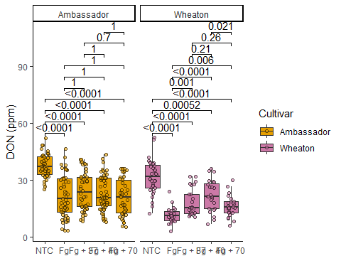

recordPlot()

## Combined

ggarrange(stats_DON_plot, stats_DON15, stats_DONSeed, labels = "auto", ncol = 3, nrow = 1, common.legend = T)

## Warning: Removed 8 rows containing non-finite outside the scale range  
## (`stat_boxplot()`).

## Warning: Removed 8 rows containing non-finite outside the scale range  
## (`stat_pwc()`).

## Warning: Removed 8 rows containing missing values or values outside the scale range  
## (`geom_point()`).

## Warning: Removed 8 rows containing non-finite outside the scale range  
## (`stat_boxplot()`).

## Warning: Removed 8 rows containing non-finite outside the scale range  
## (`stat_pwc()`).

## Warning: Removed 8 rows containing missing values or values outside the scale range  
## (`geom_point()`).

## Warning: Removed 10 rows containing non-finite outside the scale range  
## (`stat_boxplot()`).

## Warning: Removed 10 rows containing non-finite outside the scale range  
## (`stat_pwc()`).

## Warning: Removed 10 rows containing missing values or values outside the scale range  
## (`geom_point()`).

## Warning: Removed 2 rows containing non-finite outside the scale range  
## (`stat_boxplot()`).

## Warning: Removed 2 rows containing non-finite outside the scale range  
## (`stat_pwc()`).

## Warning: Removed 2 rows containing missing values or values outside the scale range  
## (`geom_point()`).

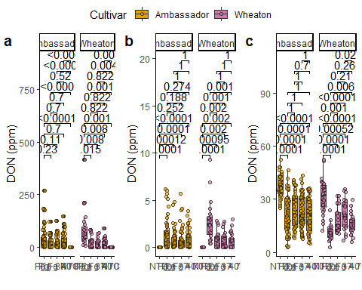

# Question 3