**Introduction**

[**https://marketplace.visualstudio.com/items?itemName=ProBITools.MicrosoftReportProjectsforVisualStudio**](https://marketplace.visualstudio.com/items?itemName=ProBITools.MicrosoftReportProjectsforVisualStudio)

[**https://sqlreportingservices.gallerycdn.vsassets.io/extensions/sqlreportingservices/microsoftrdlcreportdesignerforvisualstudio-18001/14.2/1493151637012/238792/3/Microsoft.RdlcDesigner.vsix**](https://sqlreportingservices.gallerycdn.vsassets.io/extensions/sqlreportingservices/microsoftrdlcreportdesignerforvisualstudio-18001/14.2/1493151637012/238792/3/Microsoft.RdlcDesigner.vsix)

**Install-Package amh1979.Microsoft.ReportViewer -Version 12.0.2402.20**

**Other don’t use**

Install-Package Microsoft.ReportingServices.ReportViewerControl.WebForms -Version 140.340.80

Install-Package Microsoft.ReportingServices.ReportViewerControl.Winforms -Version 140.1000.523

Install-Package Microsoft.ReportingServices.ReportViewerControl.WinForms

Install-Package Microsoft.ReportingServices.ReportViewerControl.WebForms

Install from tools

:\Users\jdoe\Documents\Projects\_Test\ReportViewerTest\WindowsFormsApp1\packages

In this post, I will show you how to create SSRS Report in ASP.NET MVC5. I hope you will like this.  
  
**Prerequisites**As I said earlier, we are going to use Report Viewer in our MVC application. For this, you must have Visual Studio 2015 (.NET Framework 4.5.2) and SQL Server.  
  
**SQL Database part**Here, find the scripts to create database and table.  
  
**Create Database**

1. USE [master]
2. GO
4. /****** Object: **Database** [DbEmployee] Script **Date**: 9/29/2016 2:37:24 AM ******/
5. **CREATE** **DATABASE** [DbEmployee]
6. CONTAINMENT = NONE
7. **ON** **PRIMARY**
8. ( **NAME** = N'DbEmployee', FILENAME = N'c:\Program Files (x86)\Microsoft SQL Server\MSSQL11.MSSQLSERVER\MSSQL\DATA\DbEmployee.mdf' , **SIZE** = 3072KB , MAXSIZE = UNLIMITED, FILEGROWTH = 1024KB )
9. LOG **ON**
10. ( **NAME** = N'DbEmployee_log', FILENAME = N'c:\Program Files (x86)\Microsoft SQL Server\MSSQL11.MSSQLSERVER\MSSQL\DATA\DbEmployee_log.ldf' , **SIZE** = 1024KB , MAXSIZE = 2048GB , FILEGROWTH = 10%)
11. GO
13. **ALTER** **DATABASE** [DbEmployee] **SET** COMPATIBILITY_LEVEL = 110
14. GO
16. IF (1 = FULLTEXTSERVICEPROPERTY('IsFullTextInstalled'))
17. **begin**
18. **EXEC** [DbEmployee].[dbo].[sp_fulltext_database] @**action** = 'enable'
19. **end**
20. GO
22. **ALTER** **DATABASE** [DbEmployee] **SET** ANSI_NULL_DEFAULT **OFF**
23. GO
25. **ALTER** **DATABASE** [DbEmployee] **SET** ANSI_NULLS **OFF**
26. GO
28. **ALTER** **DATABASE** [DbEmployee] **SET** ANSI_PADDING **OFF**
29. GO
31. **ALTER** **DATABASE** [DbEmployee] **SET** ANSI_WARNINGS **OFF**
32. GO
34. **ALTER** **DATABASE** [DbEmployee] **SET** ARITHABORT **OFF**
35. GO
37. **ALTER** **DATABASE** [DbEmployee] **SET** AUTO_CLOSE **OFF**
38. GO
40. **ALTER** **DATABASE** [DbEmployee] **SET** AUTO_CREATE_STATISTICS **ON**
41. GO
43. **ALTER** **DATABASE** [DbEmployee] **SET** AUTO_SHRINK **OFF**
44. GO
46. **ALTER** **DATABASE** [DbEmployee] **SET** AUTO_UPDATE_STATISTICS **ON**
47. GO
49. **ALTER** **DATABASE** [DbEmployee] **SET** CURSOR_CLOSE_ON_COMMIT **OFF**
50. GO
52. **ALTER** **DATABASE** [DbEmployee] **SET** CURSOR_DEFAULT **GLOBAL**
53. GO
55. **ALTER** **DATABASE** [DbEmployee] **SET** CONCAT_NULL_YIELDS_NULL **OFF**
56. GO
58. **ALTER** **DATABASE** [DbEmployee] **SET** NUMERIC_ROUNDABORT **OFF**
59. GO
61. **ALTER** **DATABASE** [DbEmployee] **SET** QUOTED_IDENTIFIER **OFF**
62. GO
64. **ALTER** **DATABASE** [DbEmployee] **SET** RECURSIVE_TRIGGERS **OFF**
65. GO
67. **ALTER** **DATABASE** [DbEmployee] **SET** DISABLE_BROKER
68. GO
70. **ALTER** **DATABASE** [DbEmployee] **SET** AUTO_UPDATE_STATISTICS_ASYNC **OFF**
71. GO
73. **ALTER** **DATABASE** [DbEmployee] **SET** DATE_CORRELATION_OPTIMIZATION **OFF**
74. GO
76. **ALTER** **DATABASE** [DbEmployee] **SET** TRUSTWORTHY **OFF**
77. GO
79. **ALTER** **DATABASE** [DbEmployee] **SET** ALLOW_SNAPSHOT_ISOLATION **OFF**
80. GO
82. **ALTER** **DATABASE** [DbEmployee] **SET** PARAMETERIZATION SIMPLE
83. GO
85. **ALTER** **DATABASE** [DbEmployee] **SET** READ_COMMITTED_SNAPSHOT **OFF**
86. GO
88. **ALTER** **DATABASE** [DbEmployee] **SET** HONOR_BROKER_PRIORITY **OFF**
89. GO
91. **ALTER** **DATABASE** [DbEmployee] **SET** RECOVERY SIMPLE
92. GO
94. **ALTER** **DATABASE** [DbEmployee] **SET** MULTI_USER
95. GO
97. **ALTER** **DATABASE** [DbEmployee] **SET** PAGE_VERIFY CHECKSUM
98. GO
100. **ALTER** **DATABASE** [DbEmployee] **SET** DB_CHAINING **OFF**
101. GO
103. **ALTER** **DATABASE** [DbEmployee] **SET** FILESTREAM( NON_TRANSACTED_ACCESS = **OFF** )
104. GO
106. **ALTER** **DATABASE** [DbEmployee] **SET** TARGET_RECOVERY_TIME = 0 SECONDS
107. GO
109. **ALTER** **DATABASE** [DbEmployee] **SET** READ_WRITE
110. GO

**Create Table**

1. USE [DbEmployee]
2. GO
4. /****** Object: **Table** [dbo].[Employee_tbt] Script **Date**: 9/29/2016 2:38:05 AM ******/
5. **SET** ANSI_NULLS **ON**
6. GO
8. **SET** QUOTED_IDENTIFIER **ON**
9. GO
11. **SET** ANSI_PADDING **ON**
12. GO
14. **CREATE** **TABLE** [dbo].[Employee_tbt](
15. [id] [**int**] IDENTITY(1,1) NOT NULL,
16. [**Name**] [**varchar**](50) NULL,
17. [Designation] [**varchar**](50) NULL,
18. [Gender] [**varchar**](50) NULL,
19. [JoinDate] [**date**] NULL,
20. [Salary] [**float**] NULL,
21. [City] [**varchar**](50) NULL,
22. [State] [**varchar**](50) NULL,
23. [Zip] [**int**] NULL,
24. **CONSTRAINT** [PK_Employee_tbt] **PRIMARY** **KEY** CLUSTERED
25. (
26. [id] **ASC**
27. )**WITH** (PAD_INDEX = **OFF**, STATISTICS_NORECOMPUTE = **OFF**, IGNORE_DUP_KEY = **OFF**, ALLOW_ROW_LOCKS = **ON**, ALLOW_PAGE_LOCKS = **ON**) **ON** [**PRIMARY**]
28. ) **ON** [**PRIMARY**]
30. GO
32. **SET** ANSI_PADDING **OFF**
33. GO

After creating the table, you can add some records as shown below for demo.  
  
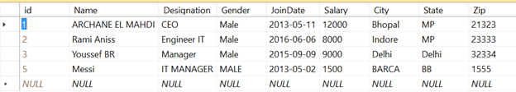  
  
**Create your MVC application**  
Open Visual Studio and select File >> New Project.  
  
The "New Project" window will pop up. Select ASP.NET Web Application (.NET Framework), name your project, and click OK.  
  
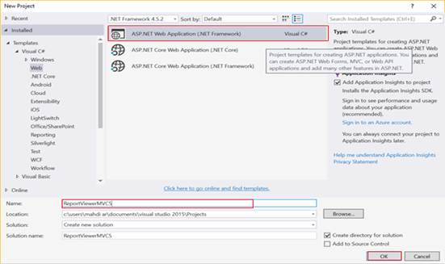  
  
Now, new dialog will pop up for selecting the template. We are going choose MVC template and click OK button.  
  
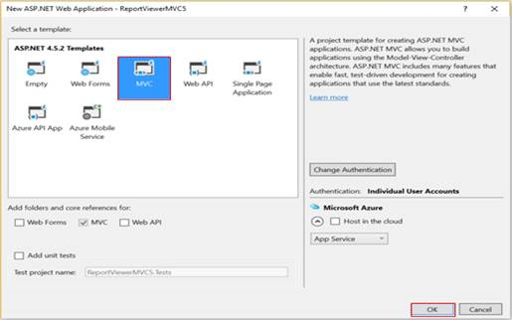  
  
After creating our project, we are going to add DataSet.  
  
**Create DataSet**In order to add DataSet component, right click on Reports folder > Add > New Item > Select DataSet > click Add button.   
  
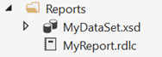  
  
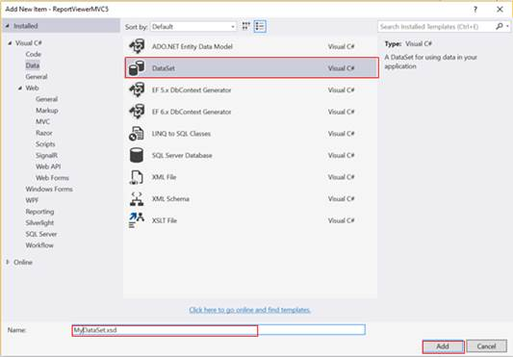  
  
Next, click on Server Explorer link.  
  
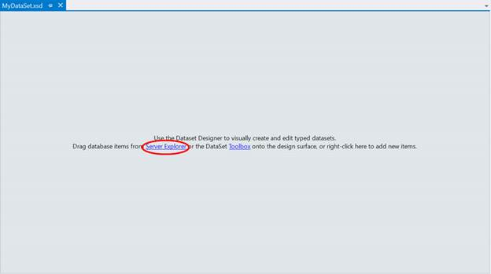  
  
Now, Server Explorer section will be shown as given below. Right click on Data connections > Select Add Connection…  
  
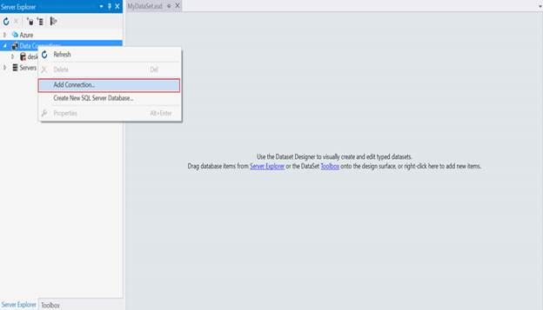  
  
As you can see below, we need to select server name, then via drop down list in connect to a database panel. You should choose your database name. Finally, click OK.  
  
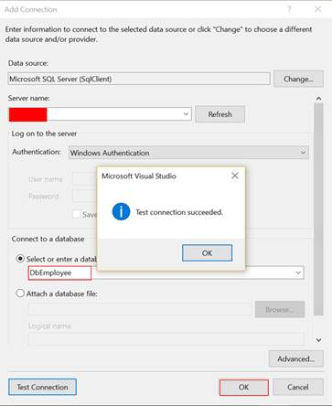  
  
Here, we will work with Employee_tbt table. For this, the next step is to drag our table, as shown below.   
  
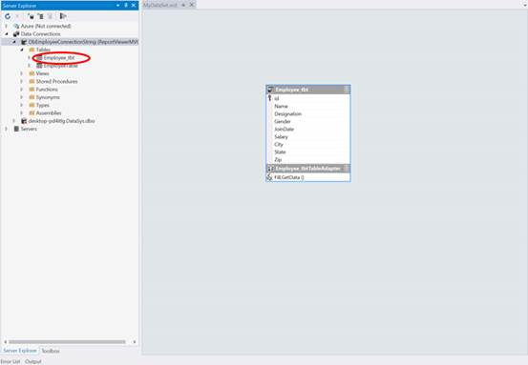  
  
**Create Report**  
For creating a report, right click on Reports folder > Add > New Item > Select Reporting. Here, we have three components. Select Report, finally click Add.   
  
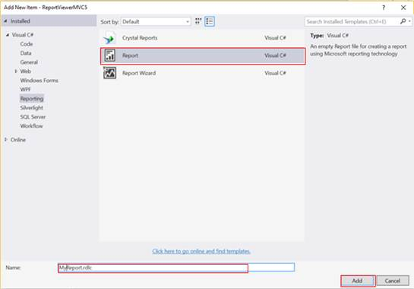  
  
  
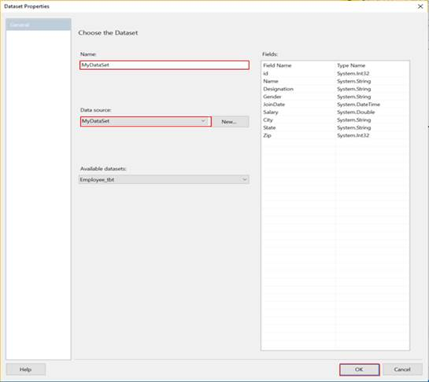  
  
After clicking on Add, new window will pop up. We need to name our Dataset, and choose data source (in this case, via dropdown list, select MyDataSet, which has been created previously).   
  
Next, we will design a table. Specify all fields that you want to display in your report.  
  
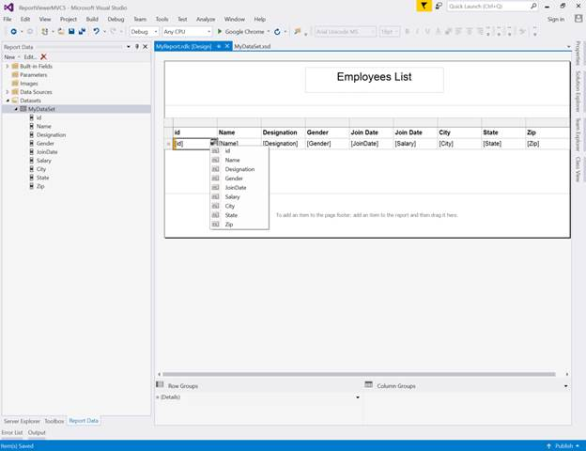  
  
**Note -**In order to start, you will need to install the ReportViewer for MVC. Run the following command in the Package Manager Console -  
  
PM> Install-Package ReportViewerForMvc  
  
**Create a Controller**Now, we are going to create a Controller. Right click on the Controllers folder > Add > Controller> selecting MVC 5 Controller – Empty > click Add.  
  
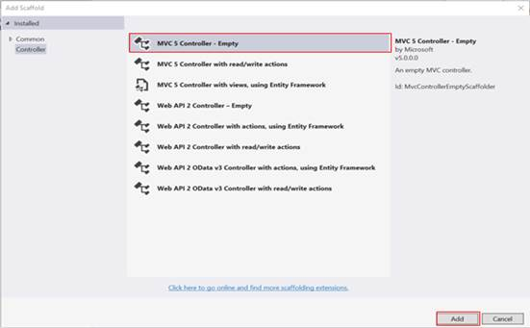  
  
Enter Controller name (‘EmployeeController’).  
  
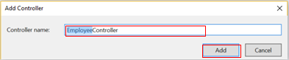  
  
**EmployeeController.cs**

1. using Microsoft.Reporting.WebForms;
2. using ReportViewerMVC5.Reports;
3. using System;
4. using System.Collections.Generic;
5. using System.Data.SqlClient;
6. using System.Linq;
7. using System.Web;
8. using System.Web.Mvc;
9. using System.Web.UI.WebControls;
11. namespace ReportViewerMVC5.Controllers
12. {
13. **public** **class** EmployeeController : Controller
14. {
15. // GET: Employee
16. **public** ActionResult Index()
17. {
18. **return** View();
19. }

22. MyDataSet ds = **new** MyDataSet();
23. **public** ActionResult ReportEmployee()
24. {
25. ReportViewer reportViewer = **new** ReportViewer();
26. reportViewer.ProcessingMode = ProcessingMode.Local;
27. reportViewer.SizeToReportContent = **true**;
28. reportViewer.Width = Unit.Percentage(900);
29. reportViewer.Height = Unit.Percentage(900);
31. **var** connectionString = ConfigurationManager.ConnectionStrings["DbEmployeeConnectionString"].ConnectionString;

34. SqlConnection conx = **new** SqlConnection(connectionString);            SqlDataAdapter adp = **new** SqlDataAdapter("SELECT * FROM Employee_tbt", conx);
36. adp.Fill(ds, ds.Employee_tbt.TableName);
38. reportViewer.LocalReport.ReportPath = Request.MapPath(Request.ApplicationPath) + @"Reports\MyReport.rdlc";
39. reportViewer.LocalReport.DataSources.Add(**new** ReportDataSource("MyDataSet", ds.Tables[0]));

42. ViewBag.ReportViewer = reportViewer;
44. **return** View();
45. }
46. }
47. }

Here, I’m creating ReportEmployee() action which will select all data from Employee_tbt table.  
  
**Explanation**  
As data provider, I’m using ADO.NET Framework.

1. Connect to database by using the following line.
   1. **var** connectionString = ConfigurationManager.ConnectionStrings["DbEmployeeConnectionString"].ConnectionString;
   2. SqlConnection conx = **new** SqlConnection(connectionString);
2. Using SqlDataAdapter object which takes two parameters: query and connection object, Fill() method is used for loading data to dataset object.
   1. SqlDataAdapter adp = **new** SqlDataAdapter("SELECT * FROM Employee_tbt", conx);
   2. adp.Fill(ds, ds.Employee_tbt.TableName);
3. We need to specify report path by using the following line.
   1. reportViewer.LocalReport.ReportPath = Request.MapPath(Request.ApplicationPath) + @"Reports\MyReport.rdlc";
4. To refresh our report datasource with new data selected from database table, we need to proceed as follow.
   1. reportViewer.LocalReport.DataSources.Add(**new** ReportDataSource("MyDataSet", ds.Tables[0]));

**Adding View**In Employee Controller, right click on ReportEmployee() action. Select Add View and a dialog will pop up. Write a name for your View and click Add.  
  
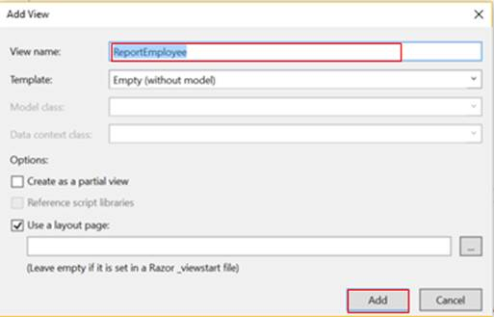  
  
**ReportEmployee.cshtml**

1. @using ReportViewerForMvc;
2. @{
3. ViewBag.Title = "ReportEmployee";
4. }

7. @Html.ReportViewer(ViewBag.ReportViewer as Microsoft.Reporting.WebForms.ReportViewer)

**Output**  
