**Keys**

* ctrl KC---Commit
* Ctrl KU---Uncomment
* Ctrl KF---format code
* ctrl KD ---format document
* #r tab tab make region
* Ctrl MM collapse/expand selection
* CTRL MO collapse all
* CTRL MP expand all

**Layout/views/RouteConfig**

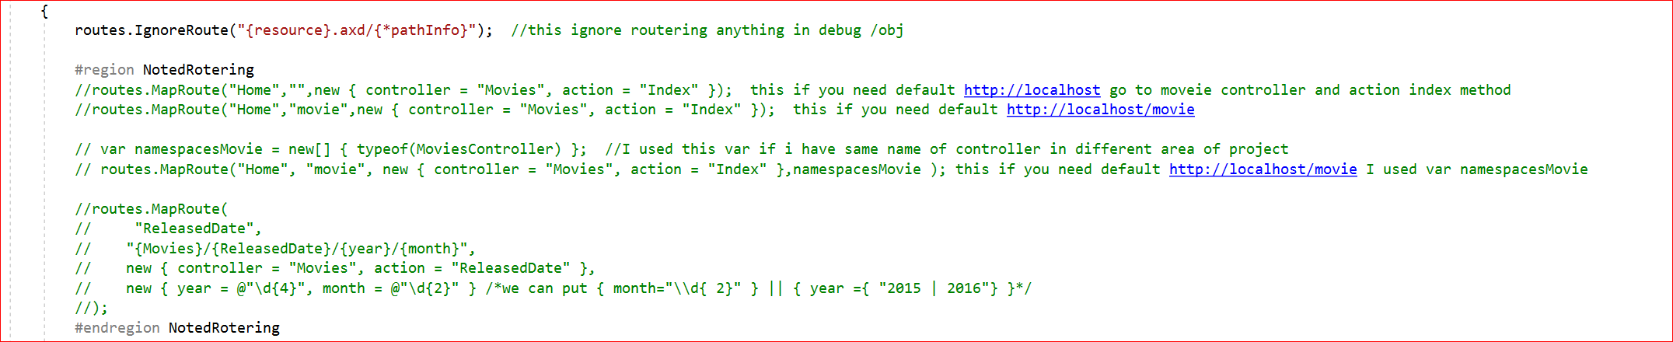

**Razor**

@{

} //c# block

@: //razor understand this as html

<text>

</text> //any thing inside text deal as html

Links

<a href="~/Views/Movies/Index.cshtml">click here </a> // don’t use this kind of directive link

Try to use below router engine

<a href="@Url.RouteUrl("Movies")"> click here </a> to see movies

Or

@Html.RouteLink("Click Here","Movies") to see movies