# Overview

This document shows the documentation of the APIs to retrieve data from PSQL for the Anghami coding challenge.

Due to timing constraint, only the first request will showcase a communication diagram.

Table of Contents

Overview 1

1. Get All People 1

a. Communication Diagram 1

b. Method Description 1

2. Search People In DB 3

a. Method Description 3

3. Insert Person To DB 4

a. Method Description 4

4. Insert Person To DB 4

a. Method Description 4

5. Insert Person To DB 5

a. Method Description 5

## Get All People

## Communication Diagram

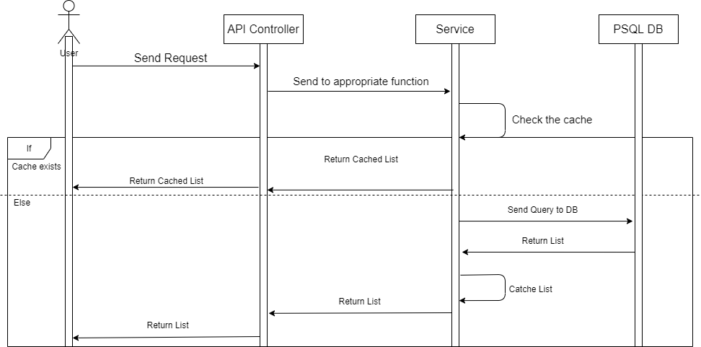

## Method Description

|  |  |
| --- | --- |
| Method Name | GetAllPeople |
| Expected URL | /api/v1/people |
| Verb | GET |
| Request Sample | <https://localhost:5001/api/v1/people?page=1&job=software>%20engineer |
| Request Parameters | |  |  |  | | --- | --- | --- | | **Name** | **Datatype** | **Binding** | | page | int | urlParam | | age | int | urlParam | | location | string | urlParam | | job | string | urlParam | |
| Response Parameters | |  |  | | --- | --- | | **Name** | **Datatype** | | firstname  lastname  age  email  phone  job  location | String  String  int  String  String  String  String | |
| Response Sample | [      {          "firstname": "Vincent",          "lastname": "Mcfadden",          "age": 22,          "email": "arcu.et@liberoProinsed.edu",          "phone": "89-517828",          "job": "Lawyer",          "location": "New York"      },      {          "firstname": "Hedy",          "lastname": "Hendrix",          "age": 45,          "email": "Quisque.porttitor@dolorsit.co.uk",          "phone": "40-567042",          "job": "Artist",          "location": "Damascus"      }  …  ] |
| Business Overview | This API is responsible for returning a list of people from the DB, paginated depending on the page number, filtered by parameters if they are existing, if not then it won’t be filtered. |

## Search People In DB

## Method Description

|  |  |
| --- | --- |
| Method Name | SearchPeopleInDB |
| Expected URL | /api/v1/people |
| Verb | GET |
| Request Sample | <https://localhost:5001/api/v1/people?firstname=Vincent&lastname=>Mcfadden |
| Request Parameters | |  |  |  | | --- | --- | --- | | **Name** | **Datatype** | **Binding** | | firstname | string | urlParam | | age | int | urlParam | | lastname | string | urlParam | | email | string | urlParam | | phone | string | urlParam | |
| Response Parameters | |  |  | | --- | --- | | **Name** | **Datatype** | | firstname  lastname  age  email  phone  job  location | String  String  int  String  String  String  String | |
| Response Sample | [      {          "firstname": "Vincent",          "lastname": "Mcfadden",          "age": 22,          "email": "arcu.et@liberoProinsed.edu",          "phone": "89-517828",          "job": "Lawyer",          "location": "New York"      }  ] |
| Business Overview | This API is responsible for returning a list of people from the DB corresponding to the search query entered. The user can filter through one or more filters present. |

## Insert Person To DB

## Method Description

|  |  |
| --- | --- |
| Method Name | InsertPersonToDB |
| Expected URL | /api/v1/person |
| Verb | PUT |
| Request Sample | <https://localhost:5001/api/v1/person> |
| Request Parameters | |  |  |  | | --- | --- | --- | | **Name** | **Datatype** | **Binding** | | firstname | string | FromBody | | age | int | FromBody | | lastname | string | FromBody | | email | string | FromBody | | phone | string | FromBody | | job | string | FromBody | | location | string | FromBody | |
| Response Parameters | |  |  | | --- | --- | | **Name** | **Datatype** | | Message | String | |
| Response Sample | Inserted successfully |
| Business Overview | This API is responsible inserting a Person to the DB by taking all of the request parameters. The API returns bad request if one of the parameters is missing or if the email is not valid or if the phone number format is wrong. |

## Insert Person To DB

## Method Description

|  |  |
| --- | --- |
| Method Name | UpdatePersonInDB |
| Expected URL | /api/v1/person |
| Verb | PATCH |
| Request Sample | [https://localhost:5001/api/v1/person/{email}](https://localhost:5001/api/v1/person/%7bemail%7d) |
| Request Parameters | |  |  |  | | --- | --- | --- | | **Name** | **Datatype** | **Binding** | | email | string | urlParam | |
| Response Parameters | |  |  | | --- | --- | | **Name** | **Datatype** | | Message | String | |
| Response Sample | Updated successfully |
| Business Overview | This API is responsible for updating a person in the DB based on his email, since email is the only unique identifier (non-id) that exists. |

## Insert Person To DB

## Method Description

|  |  |
| --- | --- |
| Method Name | UpdatePersonInDB |
| Expected URL | /api/v1/person |
| Verb | DELETE |
| Request Sample | [https://localhost:5001/api/v1/person/{email}](https://localhost:5001/api/v1/person/%7bemail%7d) |
| Request Parameters | |  |  |  | | --- | --- | --- | | **Name** | **Datatype** | **Binding** | | email | string | urlParam | |
| Response Parameters | |  |  | | --- | --- | | **Name** | **Datatype** | | Message | String | |
| Response Sample | Deleted successfully |
| Business Overview | This API is responsible for deleting a person in the DB based on his email, since email is the only unique identifier (non-id) that exists. |