* Press (Ctrl + A) or Add => Mesh => Cylinder.  
  [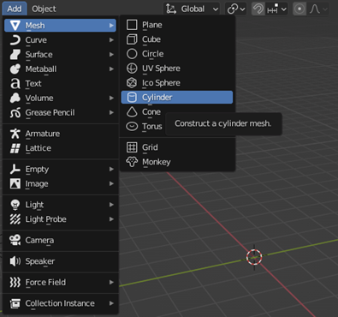](https://user-images.githubusercontent.com/103388162/182035193-29d51649-4b98-424d-b421-d878c32bb342.png)
* Change the (Depth and Rotation setting of the cylinder).  
  [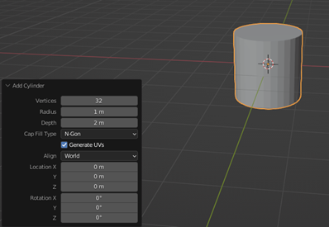](https://user-images.githubusercontent.com/103388162/182035344-c7dea350-c36e-4108-a628-046a98eca0c1.png)
* The new setting .  
  [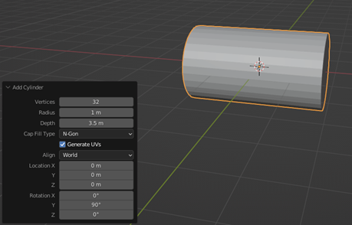](https://user-images.githubusercontent.com/103388162/182035405-17deeefc-e497-49a4-8aa9-acaf2972b466.png)
* Copy this shape (Copy and paste) then click on the (Move tool) to move it.  
  [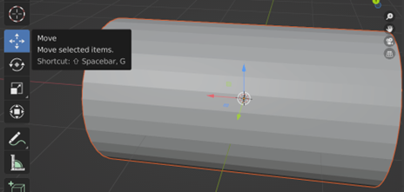](https://user-images.githubusercontent.com/103388162/182035448-b61c6e97-a2bc-4921-b527-4d3ae1127172.png)
* Then press on the red line to move this shape on the X-axis.  
  [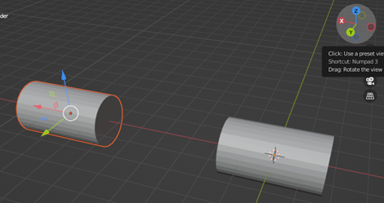](https://user-images.githubusercontent.com/103388162/182035499-ae161071-6c18-47b8-953a-807c414eb29d.png)
* Make a cylinder in the middle between these two cylinders and change the depth and radius of it to fit in the center well.  
  [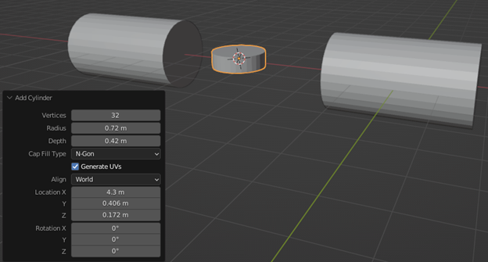](https://user-images.githubusercontent.com/103388162/182035563-3dc2e207-f0f0-4c26-a78b-102704fe4813.png)
* Then add another cylinder and change the Radius, Depth, and Rotation direction to make it on Y-axis.  
  [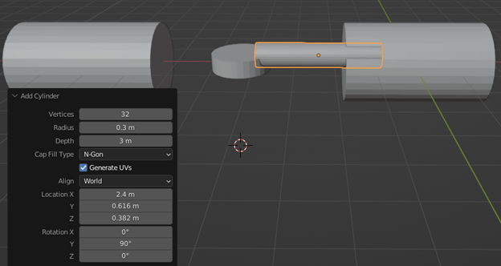](https://user-images.githubusercontent.com/103388162/182035634-cc6238e0-3f98-4a5f-b10d-195ef46db354.png)
* Connect the new cylinder with the two-by-move tool.  
  [](https://user-images.githubusercontent.com/103388162/182036405-ac914149-10f3-483f-aa9c-b6f1fb830b9f.png)
* Connect Cylinder .  
  [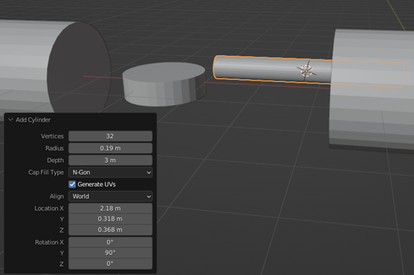](https://user-images.githubusercontent.com/103388162/182036457-0d8a1ed6-591e-4ced-996e-5f667a500b05.png)
* Make a hole in the middle cylinder to put the bearing inside it by clicking (Tab) on the middle cylinder.  
  [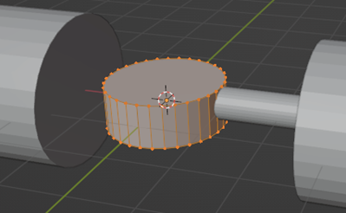](https://user-images.githubusercontent.com/103388162/182036498-ef274ecf-c65c-47f5-95a3-03cc72f1e413.png)
* Then press (Alt + click) on the top of the cylinder.  
  [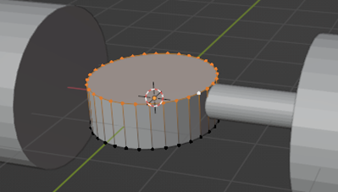](https://user-images.githubusercontent.com/103388162/182036547-719b26fb-13e6-4fa5-b7aa-58307c3ed607.png)
* Then press (i) .  
  [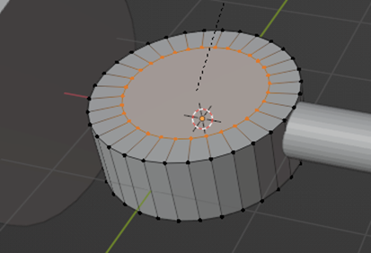](https://user-images.githubusercontent.com/103388162/182036602-f1d738ce-1e75-4200-9ef6-f6e1086a060d.png)
* Press (Enter) then press (E) to make a depth .  
  [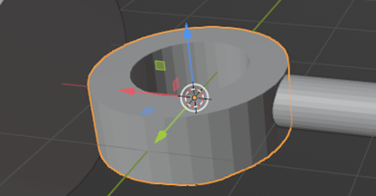](https://user-images.githubusercontent.com/103388162/182036660-c50dc5f7-a447-45f4-87eb-086e82082634.png)
* Then put the Bearing that you have in the center of this hole, but before you make this hole.

[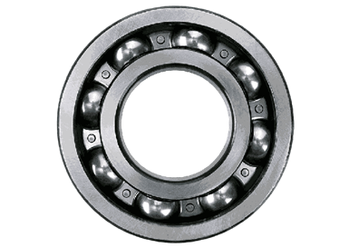](https://user-images.githubusercontent.com/103388162/182036708-2483aaec-5d2a-42e3-8701-fca924471705.png)

Note:  
First: You must know the exact measurement of the bearing before you make the hole.  
Second: There is a way to change the size of anything by clicking on the object then Press (S).

* An example of sizing :

[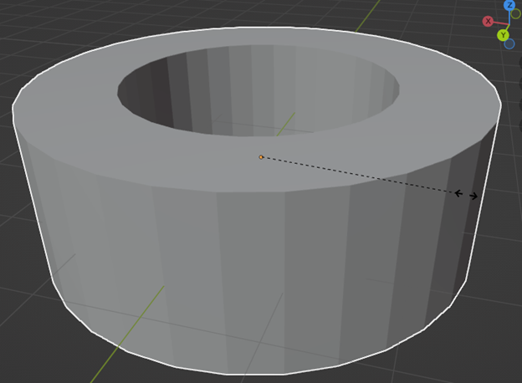](https://user-images.githubusercontent.com/103388162/182036773-264b0cb4-af2c-4174-ab59-081dc50f9d13.png)

Note:  
You can choose the place that you want to create by (Cursor Tool).

[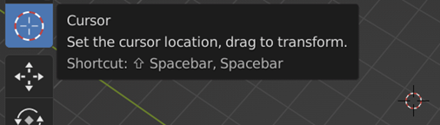](https://user-images.githubusercontent.com/103388162/182036841-d480b3a8-e23d-477f-b3d9-df2dd9a7e1c5.png)

* Make the Cursor in the middle center cylinder .  
  [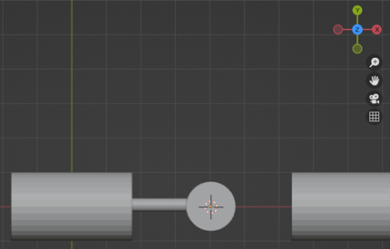](https://user-images.githubusercontent.com/103388162/182036917-cf10e235-9478-419e-bdca-08d37b768d10.png)
* Make another cylinder in the middle but bigger and change the depth and radius and the rotation to make it in the Z-axis .  
  [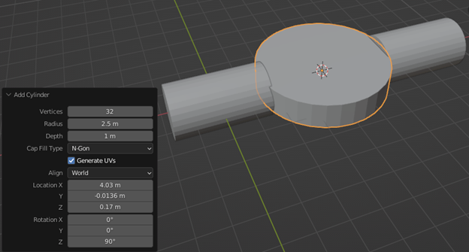](https://user-images.githubusercontent.com/103388162/182036971-da9bd9c2-edc9-49dd-a1c0-5e6ba27a1839.png)
* Choose the Move tool to move the cylinder far away at the edge of the middle cylinder.  
  [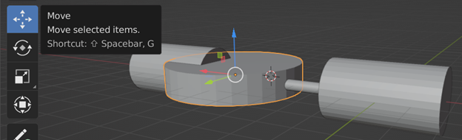](https://user-images.githubusercontent.com/103388162/182037028-b0fe2615-9a1b-494b-b3ef-2d8742583796.png)
* Press (Tab) on the last cylinder.  
  [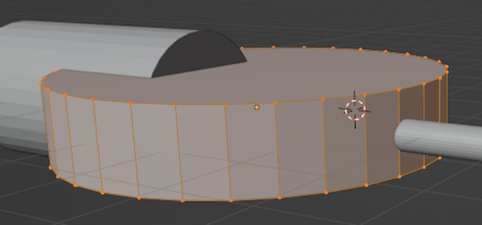](https://user-images.githubusercontent.com/103388162/182037091-488367b4-92e0-48f5-956e-d277001233d1.png)
* Then press on any space to get out of the selection then press (Alt + Shift) on the lines from the left middle lines to the right middle lines .  
  [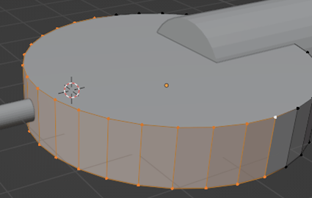](https://user-images.githubusercontent.com/103388162/182037130-2e85331a-497f-4051-a8d0-59c2654600c7.png)
* Then press ( i )  
  [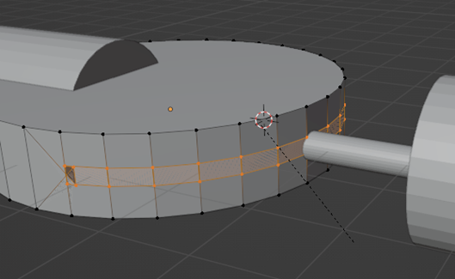](https://user-images.githubusercontent.com/103388162/182037173-e12f4812-3ee8-492b-a72a-c32a9e254d4a.png)  
  Then press (Enter)
* After that press (E) AND move the selected shape away back  
  [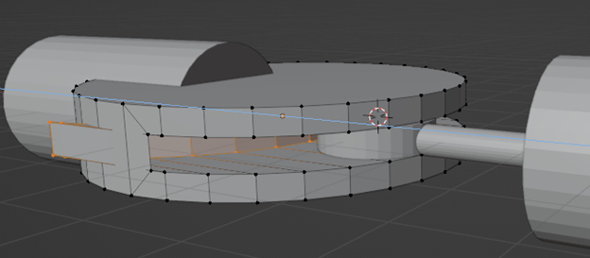](https://user-images.githubusercontent.com/103388162/182037271-f6e66987-85d3-42f7-8f5d-b6e0b5edc8f2.png)  
  After that delete the extra shapes by pressing on every line of it and deleting every line

Note:  
To delete press the right mouse then from the setting press

[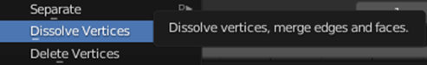](https://user-images.githubusercontent.com/103388162/182037346-1aebe95c-a080-456f-8a85-4f2a9c6f1d2a.png)  
[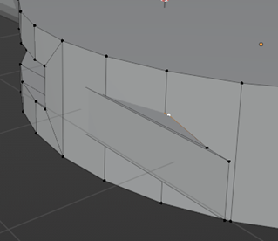](https://user-images.githubusercontent.com/103388162/182037371-ed3bc9a4-2cab-40ec-a16c-bf23e5030d01.png)

* The new shape :  
  [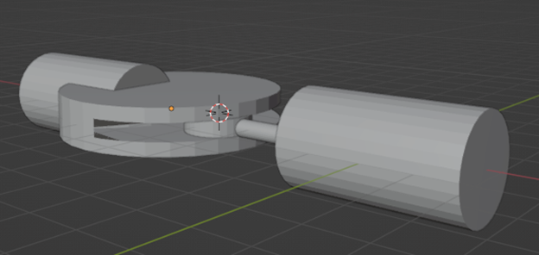](https://user-images.githubusercontent.com/103388162/182037424-13bd3d9a-9d54-4d4c-9427-7aae9c36100c.png)
* At the end make the final cylinder and put it in the middle to connect all cylinders together and make sure that it fits the center cylinder with the bearing  
  [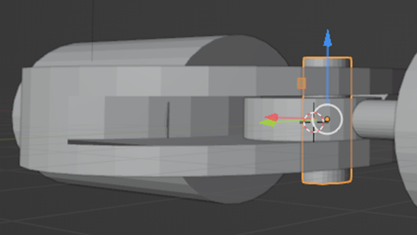](https://user-images.githubusercontent.com/103388162/182037468-2f628de3-86e4-41f7-bd71-6f4553b8581d.png)
* To change the color of the shapes press this icon  
  [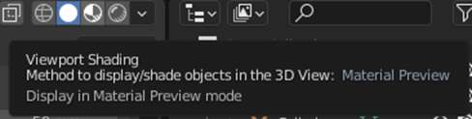](https://user-images.githubusercontent.com/103388162/182037503-4822912e-2690-41e5-9fda-ee2363089580.png)
* After that click on any shape then go to the right tools and press on Material Properties  
  [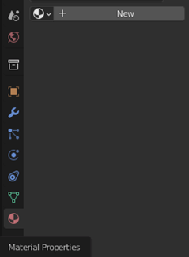](https://user-images.githubusercontent.com/103388162/182037550-be5a25e0-ff02-4c9c-a1e7-0dc5756a805d.png)  
  [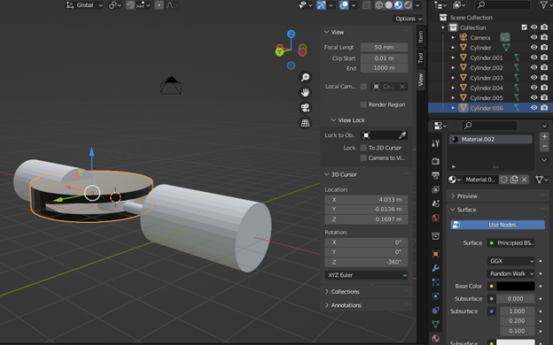](https://user-images.githubusercontent.com/103388162/182037600-8b22b088-3a67-460c-bcb9-c78c22a19112.png)
* The end shapes :  
  [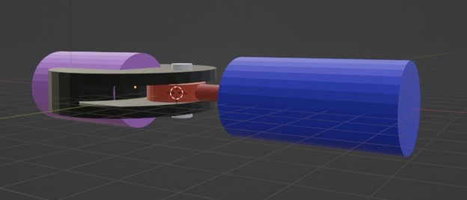](https://user-images.githubusercontent.com/103388162/182037654-2e2de9b1-37f4-4acf-8bca-735a22033914.jpg)