

KING ABDULAZIZ UNIVERSITY

Faculty of Computing & Information Technology Department of Computer Science

**CPCS-403**

**Assignment 1**

**BY**

|  |  |
| --- | --- |
| Name | ID |
| **Ammr Yaser Alrifaie** | **2036403** |

**[Winter 2024]**

# **Idea development:**

I'm creating a website that helps you stay updated with the latest on your favorite movies, films, and animations. It's designed to be the place where cinema and animation fans can get all the news and updates they're interested in.

# **b. Recommended Solution:**

The website will serve as a central place for fans to get the latest on movies and animations, saving them time from looking at multiple sources. It will be easy to use, offer personalized alerts, and help users discover new favorites based on their interests.

# **c. Benefits:**

The specific benefits provided by this website include:

* Stay informed: Users will receive the latest information, ensuring they are always up-to-date with the newest trends and releases in the entertainment world.
* Personalized experience: The website will offer customized alerts and suggestions, enhancing user engagement and satisfaction.
* Discover new favorites: With the discovery feature, users can explore and find new movies and animations that align with their tastes.
* User-friendly design: The straightforward and intuitive website design will make it easy for users to navigate and find the information they seek, enhancing their overall experience.

# **storyboard**

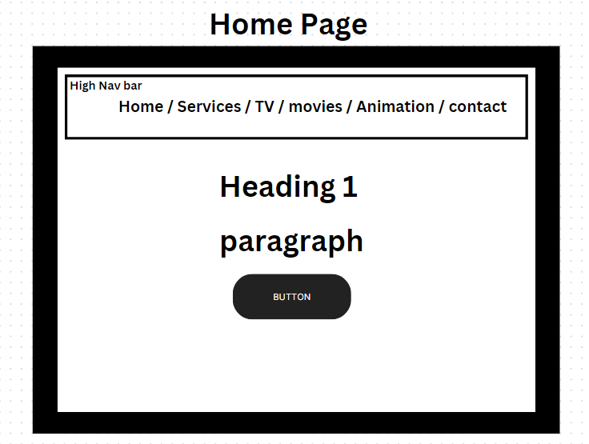

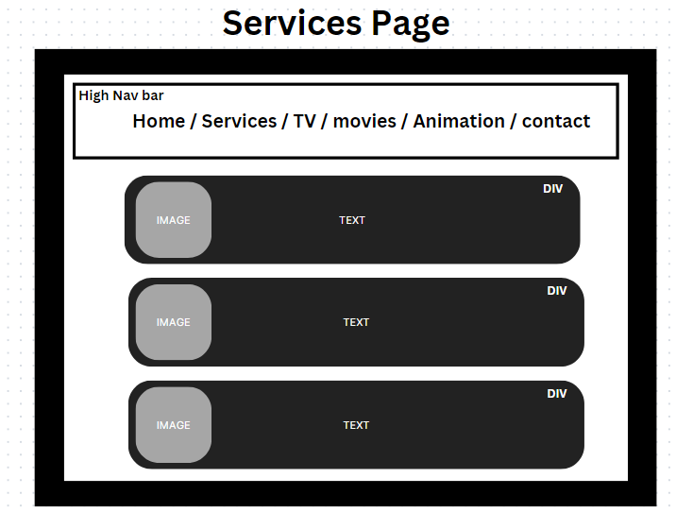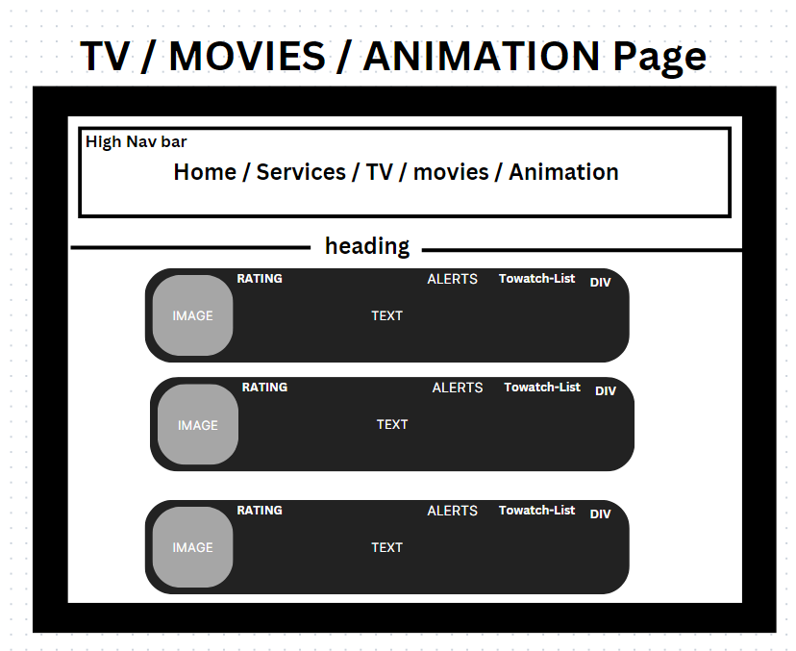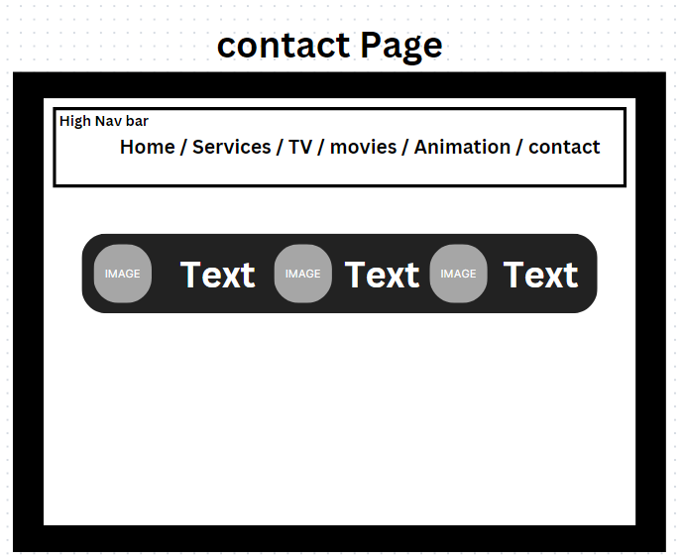

# **sitemap**

