EXPERIMENT 11: CNN for Image Classification

Aim
To build and train a Convolutional Neural Network (CNN) for multi-class image classification using CIFAR-10, and inspect training curves, confusion matrix, misclassified examples, and first-layer feature maps.

Formula / Mathematical Overview
Image normalisation: x_norm = x / 255
Pixel values in the range 0–255 are converted to 0–1.
Convolution: feature map = activation(input * filter + bias)
A small filter scans the image to detect local patterns such as edges and textures.
Sparse categorical cross-entropy: L = -log(p_true)
For a single example, the loss is the negative log probability assigned to the correct class.
Accuracy: Accuracy = correct predictions / total predictions
The fraction of images classified correctly.

Flow Diagram
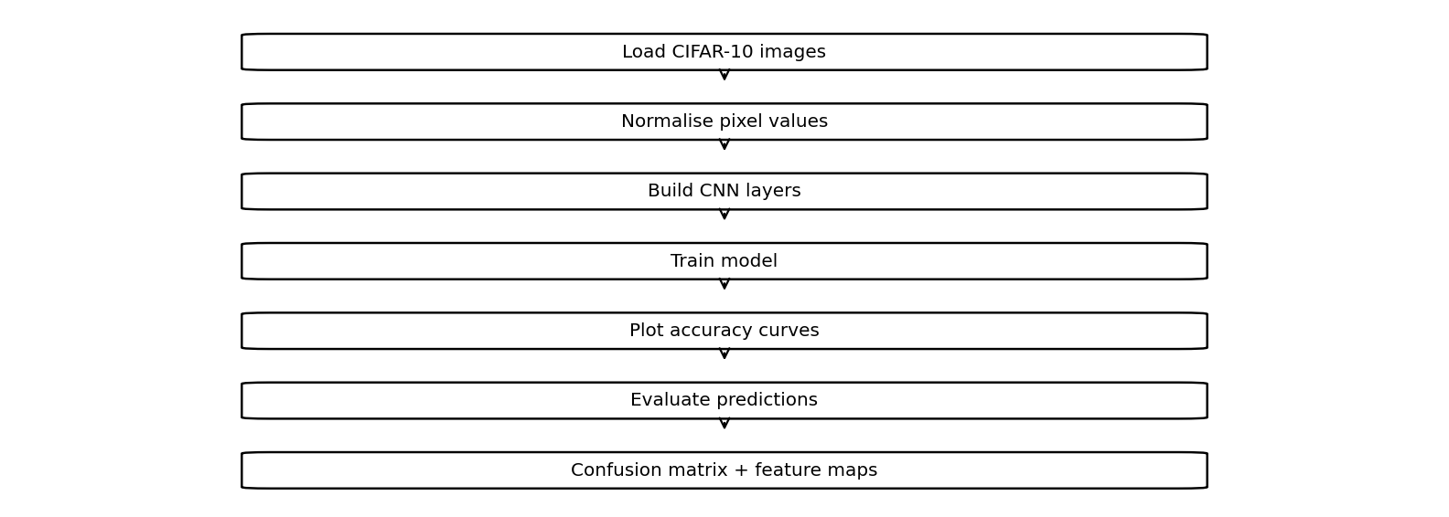

Code :
import tensorflow as tf
import matplotlib.pyplot as plt
import numpy as np
from sklearn.metrics import ConfusionMatrixDisplay
(X,y),(Xt,yt)=tf.keras.datasets.cifar10.load_data()
X,Xt=X/255.,Xt/255.
y,yt=y.ravel(),yt.ravel()
m=tf.keras.Sequential([
tf.keras.layers.Input((32,32,3)),
tf.keras.layers.Conv2D(16,3,activation="relu"),
tf.keras.layers.MaxPooling2D(),
tf.keras.layers.Flatten(),
tf.keras.layers.Dense(64,activation="relu"),
tf.keras.layers.Dense(10,activation="softmax")
])
m.compile("adam","sparse_categorical_crossentropy",metrics=["accuracy"])
h=m.fit(X[:10000],y[:10000],epochs=2,validation_split=.2,verbose=1)
plt.plot(h.history["accuracy"])
plt.plot(h.history["val_accuracy"])
plt.legend(["Train","Validation"])
plt.show()
p=m.predict(Xt[:500],verbose=0).argmax(1)
ConfusionMatrixDisplay.from_predictions(yt[:500],p)
plt.show()
plt.imshow(Xt[0])
plt.title(f"True:{yt[0]} Pred:{p[0]}")
plt.show()
f=tf.keras.Model(m.inputs,m.layers[0].output)
plt.imshow(f.predict(Xt[:1],verbose=0)[0,:,:,0],cmap="gray")
plt.show()

Saved Output from Colab

Output for code cell 13
Downloading data from https://www.cs.toronto.edu/~kriz/cifar-10-python.tar.gz
4554752/170498071 ━━━━━━━━━━━━━━━━━━━━ 51:10 19us/step

Output for code cell 14
Downloading data from https://www.cs.toronto.edu/~kriz/cifar-10-python.tar.gz
170498071/170498071 ━━━━━━━━━━━━━━━━━━━━ 3485s 20us/step
Epoch 1/2
250/250 ━━━━━━━━━━━━━━━━━━━━ 7s 22ms/step - accuracy: 0.2869 - loss: 1.9814 - val_accuracy: 0.3550 - val_loss: 1.7945
Epoch 2/2
250/250 ━━━━━━━━━━━━━━━━━━━━ 5s 20ms/step - accuracy: 0.4195 - loss: 1.6274 - val_accuracy: 0.4225 - val_loss: 1.5722
Saved figure 1 from Colab output:
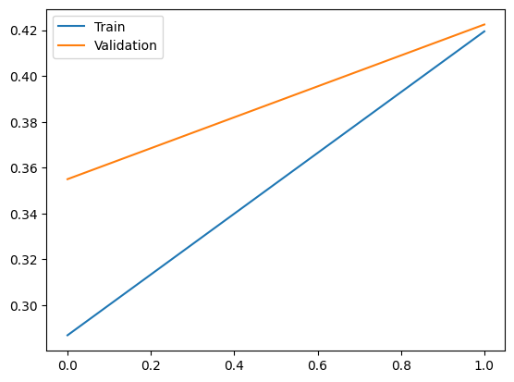
Saved figure 2 from Colab output:
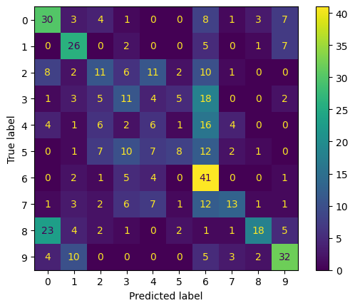
Saved figure 3 from Colab output:
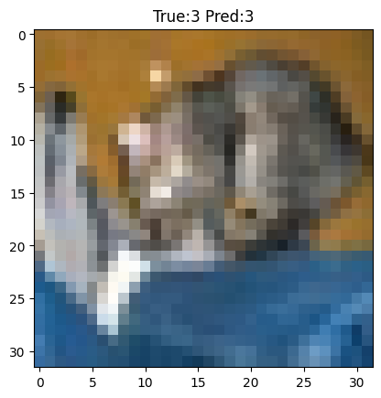
Saved figure 4 from Colab output:
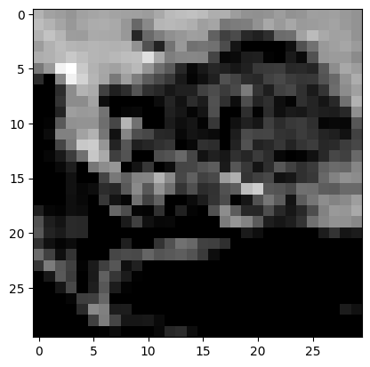

Result
A CNN training and analysis workflow is present in the notebook. The saved classification analysis reports training/validation curves, a confusion matrix, an example prediction, and a first-convolution feature map.

