EXPERIMENT 12: CNN Architecture and Hyperparameter Comparison

Aim
To compare CNNs with 2, 3, and 4 convolutional layers using the same CIFAR-10 subset, and record accuracy, parameter count, and training time.

Formula / Mathematical Overview
Accuracy: Accuracy = correct predictions / total predictions
Measures the fraction of correctly classified test images.
Parameter count: Total parameters = trainable + non-trainable parameters
Indicates the number of stored model parameters.
Training time: Elapsed time = end time - start time
Measures the time taken for fitting and evaluation.

Flow Diagram
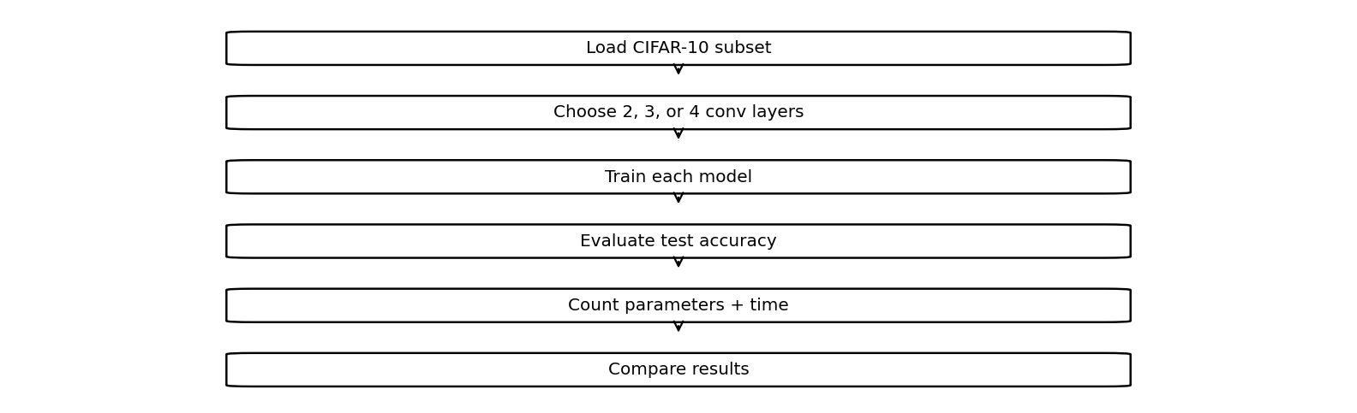

Code :
import tensorflow as tf
import time
(X,y),(Xt,yt)=tf.keras.datasets.cifar10.load_data()
X,Xt=X[:3000]/255.,Xt[:500]/255.
y,yt=y[:3000].ravel(),yt[:500].ravel()
for n in [2,3,4]:
m=tf.keras.Sequential([
tf.keras.layers.Input((32,32,3))
])
for i in range(n):
m.add(tf.keras.layers.Conv2D(16,3,padding="same",activation="relu"))
m.add(tf.keras.layers.BatchNormalization())
m.add(tf.keras.layers.MaxPooling2D())
m.add(tf.keras.layers.GlobalAveragePooling2D())
m.add(tf.keras.layers.Dense(10,activation="softmax"))
m.compile("adam","sparse_categorical_crossentropy",metrics=["accuracy"])
t=time.time()
m.fit(X,y,epochs=1,verbose=0)
acc=m.evaluate(Xt,yt,verbose=0)[1]
print(n,"Layers | Accuracy:",acc,
"| Parameters:",m.count_params(),
"| Time:",round(time.time()-t,2))

Saved Output from Colab

Output for code cell 15
2 Layers | Accuracy: 0.10199999809265137 | Parameters: 3066 | Time: 7.33
3 Layers | Accuracy: 0.1860000044107437 | Parameters: 5450 | Time: 8.72
4 Layers | Accuracy: 0.1120000034570694 | Parameters: 7834 | Time: 8.28

Result
The saved comparison records accuracy, parameter count, and elapsed time for 2-, 3-, and 4-convolution-layer models.

