EXPERIMENT 13: Sequential Dataset Preparation and RNN Prediction

Aim
To create sliding-window sequences from a synthetic sine-wave time series, train a SimpleRNN to predict the next value, and evaluate the predictions with MAE and RMSE.

Formula / Mathematical Overview
Sliding window: X_i = [d_i, d_(i+1), ..., d_(i+9)]; y_i = d_(i+10)
Uses the previous 10 values to predict the next value.
MAE: MAE = (1/n) * sum(|y_i - yhat_i|)
Average absolute prediction error.
RMSE: RMSE = sqrt((1/n) * sum((y_i - yhat_i)^2))
Penalises larger errors more strongly than MAE.

Flow Diagram
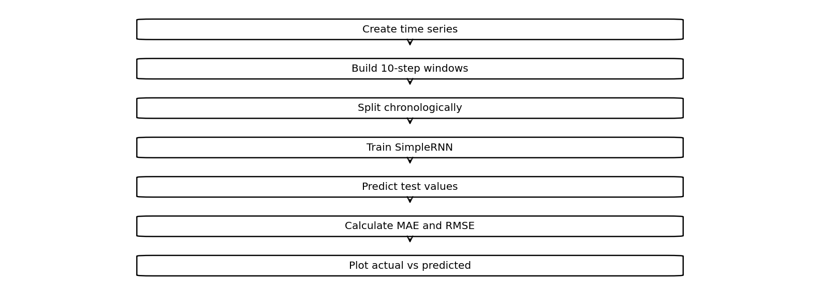

Code :
import numpy as np
import tensorflow as tf
import matplotlib.pyplot as plt
from sklearn.metrics import mean_absolute_error,mean_squared_error
d=np.sin(np.arange(300)*.1)
X=np.array([d[i:i+10] for i in range(290)])
y=d[10:]
m=tf.keras.Sequential([
tf.keras.layers.Input((10,1)),
tf.keras.layers.SimpleRNN(16),
tf.keras.layers.Dense(1)
])
m.compile("adam","mse")
m.fit(X[:230,:,None],y[:230],epochs=5,verbose=0)
p=m.predict(X[230:,:,None],verbose=0).ravel()
print("MAE:",mean_absolute_error(y[230:],p))
print("RMSE:",np.sqrt(mean_squared_error(y[230:],p)))
plt.plot(y[230:],label="Actual")
plt.plot(p,label="Predicted")
plt.legend()
plt.show()

Output
MAE: 0.09083682129406813
RMSE: 0.10339070972374391
Saved figure 1 from Colab output:
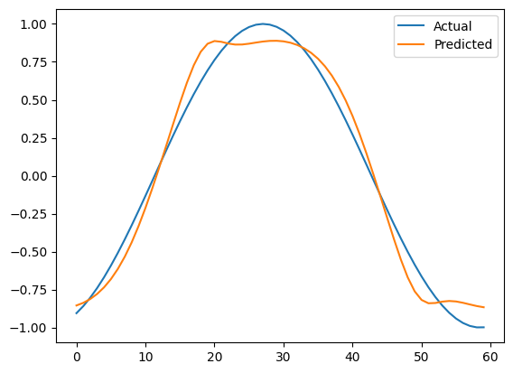

Result
The saved SimpleRNN run reports MAE and RMSE and have an actual-versus-predicted plot.

