EXPERIMENT 14: Unfolded RNN Architecture Visualization

Aim
To visualise a SimpleRNN across five time steps, extract its input and recurrent weights, and inspect the hidden-state values.

Formula / Mathematical Overview
RNN hidden state: h_t = tanh(x_t W_xh + h_(t-1) W_hh + b)
The current hidden state depends on the current input and the previous hidden state.
Output relation: y_t = h_t W_hy + b_y
A conceptual relation showing how hidden states can produce outputs; the notebook graph labels this edge but does not define a separate output layer.
Shared weights: W_xh and W_hh are reused at each time step
The same input and recurrent weights are applied throughout the sequence.

Flow Diagram
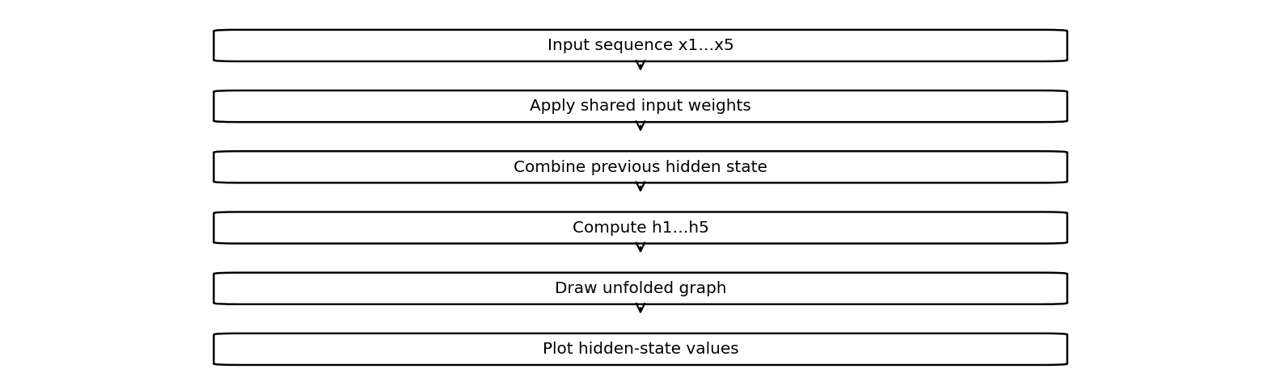

Code
import tensorflow as tf
import numpy as np
import matplotlib.pyplot as plt
import networkx as nx
x=np.array([[[1.],[2.],[3.],[4.],[5.]]])
r=tf.keras.layers.SimpleRNN(3,return_sequences=True)
h=r(x).numpy()[0]
Wx,Wh,b=r.get_weights()
print("Input weights:",Wx)
print("Recurrent weights:",Wh)
print("Hidden states:\n",h)
G=nx.DiGraph()
pos={}
for i in range(5):
G.add_edge(f"x{i+1}",f"h{i+1}",label="Wxh")
G.add_edge(f"h{i+1}",f"y{i+1}",label="Why")
pos[f"x{i+1}"]=(i,2)
pos[f"h{i+1}"]=(i,1)
pos[f"y{i+1}"]=(i,0)
if i:
G.add_edge(f"h{i}",f"h{i+1}",label="Whh")
nx.draw(G,pos,with_labels=True,node_color="lightblue")
plt.show()
plt.plot(h)
plt.title("Hidden States")
plt.show()

Saved Output from Colab

Output
Input weights: [[-1.0808014 0.8403841 -0.2128942]]
Recurrent weights: [[-0.04698634 0.36166495 -0.9311233 ]
[ 0.61445856 0.7453923 0.25851688]
[-0.7875486 0.5599899 0.25725156]]
Hidden states:
[[-0.79349613 0.6860125 -0.20973508]
[-0.91171896 0.945516 0.41069376]
[-0.99444854 0.9961557 0.5082175 ]
[-0.99941057 0.9993672 0.4322337 ]
[-0.9999232 0.9998718 0.23138241]]
Saved figure 1 from Colab output:
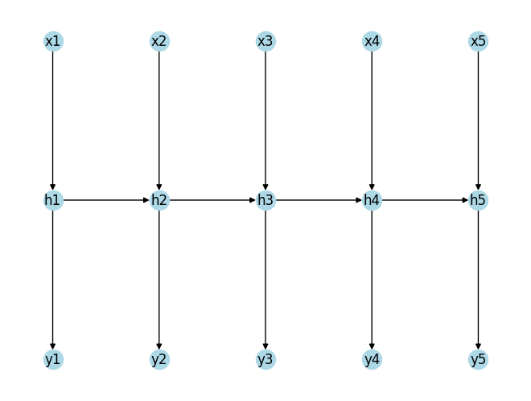
Saved figure 2 from Colab output:
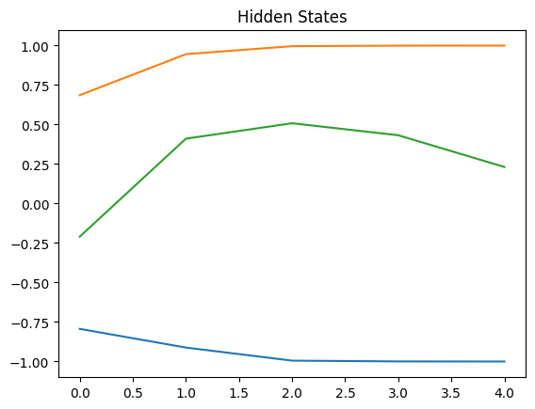

Result
The saved SimpleRNN output contains extracted weights, hidden-state values, an unfolded graph, and a hidden-state plot.

