EXPERIMENT 15: BPTT Flow and Gradient Analysis

Aim
To examine gradient magnitudes across time steps for SimpleRNNs using sequence lengths 10, 50, and 100 and tanh/ReLU activations.

Formula / Mathematical Overview
Gradient norm: ||g_t||_2 = sqrt(sum_j g_(t,j)^2)
Combines the gradient components at a time step into one magnitude.
Loss used in notebook: L = mean(h_last^2)
The saved code uses the mean square of the final hidden state as its loss.
Vanishing gradient: ||g_t|| becomes very small
Earlier time steps receive weak learning signals.
Exploding gradient: ||g_t|| becomes very large
Large gradients can make updates unstable.

Flow Diagram


Code
import tensorflow as tf
import numpy as np
import matplotlib.pyplot as plt
d=np.sin(np.arange(200)*.1).astype("float32")
for n in [10,50,100]:
for a in ["tanh","relu"]:
x=tf.random.normal((1,n,1))
r=tf.keras.layers.SimpleRNN(8,activation=a,return_sequences=True)
with tf.GradientTape() as tape:
h=r(x)
tape.watch(h)
loss=tf.reduce_mean(h[:,-1,:]**2)
g=tape.gradient(loss,h)
plt.plot(tf.norm(g[0],axis=1).numpy(),label=f"{n}-{a}")
plt.yscale("log")
plt.xlabel("Time Step")
plt.ylabel("Gradient Norm")
plt.legend()
plt.show()

Saved Output from Colab

Output for code cell 18
Saved figure 1 from Colab output:
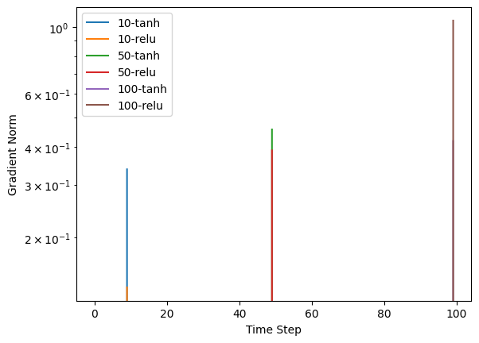

Result
The saved gradient plot compares sequence lengths and tanh/ReLU activations on a logarithmic gradient-norm axis.

