EXPERIMENT 16: LSTM and RNN Performance Comparison

Aim
To compare SimpleRNN and LSTM models on a synthetic daily series with a weekly pattern using MAE, RMSE, MAPE, training time, and plots.

Formula / Mathematical Overview
MAE: MAE = mean(|y - yhat|)
Average absolute error.
RMSE: RMSE = sqrt(mean((y - yhat)^2))
Root mean squared prediction error.
MAPE: MAPE = mean(|(y - yhat) / y|) * 100
Average absolute percentage error.
Training time: Elapsed time = end time - start time
Time taken to train and predict.

Flow Diagram
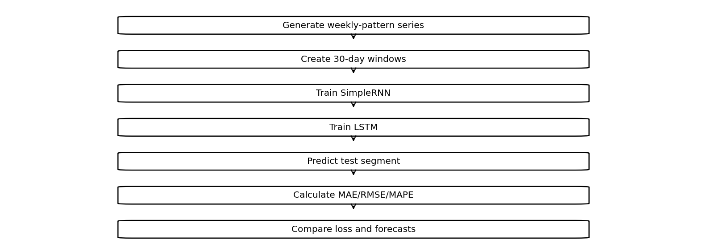

Code
import numpy as np
import pandas as pd
import tensorflow as tf
import matplotlib.pyplot as plt
import time
from sklearn.metrics import mean_absolute_error, mean_squared_error
d = 100 + 20*np.sin(np.arange(500)*2*np.pi/7) + np.random.randn(500)*3
X = np.array([d[i:i+30] for i in range(470)])
y = d[30:]
results = []
predictions = {}
for name, layer in [
("RNN", tf.keras.layers.SimpleRNN(16)),
("LSTM", tf.keras.layers.LSTM(16))
]:
m = tf.keras.Sequential([
tf.keras.layers.Input((30,1)), layer,
tf.keras.layers.Dense(1)
])
m.compile("adam", "mse")
start = time.time()
h = m.fit(X[:370,:,None], y[:370], epochs=5,
validation_split=.2, verbose=0)
p = m.predict(X[370:,:,None], verbose=0).ravel()
actual = y[370:]
predictions[name] = p
results.append([name, mean_absolute_error(actual,p),
np.sqrt(mean_squared_error(actual,p)),
np.mean(np.abs((actual-p)/actual))*100,
round(time.time()-start,2)])
plt.plot(h.history["loss"], label=name+" Train")
plt.plot(h.history["val_loss"], label=name+" Val")
plt.legend()
plt.title("Training and Validation Loss")
plt.show()
plt.plot(actual, label="Actual")
for name,p in predictions.items():
plt.plot(p, label=name)
plt.legend()
plt.show()
print(pd.DataFrame(results, columns=[
"Model","MAE","RMSE","MAPE","Time (sec)"
]))

Saved Output from Colab

Output
Saved figure 1 from Colab output:
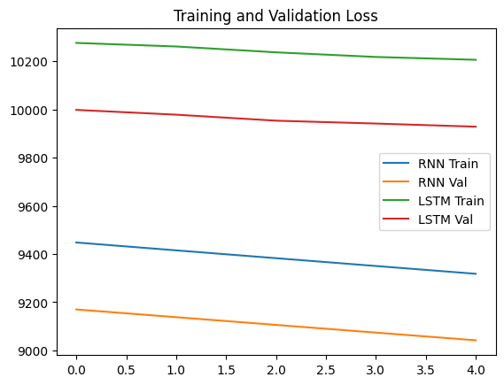
Saved figure 2 from Colab output:
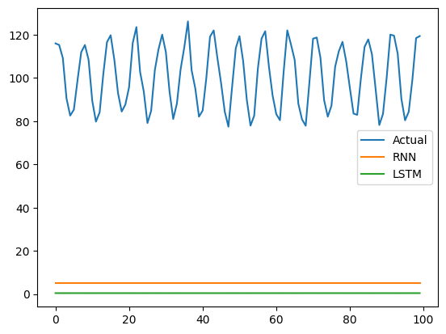
Model MAE RMSE MAPE Time (sec)
0 RNN 95.550989 96.627057 94.872328 6.72
1 LSTM 100.160584 101.187698 99.551621 8.11

Result
The saved notebook compares SimpleRNN and LSTM losses, forecast curves, and MAE/RMSE/MAPE/time values.

