EXPERIMENT 17: RNN Gradient Analysis and Gradient Clipping

Aim
To compare character-level RNN training with no clipping, clipnorm, and clipvalue settings and inspect the saved loss values and loss curve.

Formula / Mathematical Overview
Global gradient norm: ||g||_2 = sqrt(sum_i g_i^2)
Measures the combined size of the gradient values.
Clip by norm: g_new = g * min(1, c / ||g||_2)
Scales gradients down when their norm exceeds threshold c.
Clip by value: g_new_i = clip(g_i, -c, c)
Limits each gradient component to a specified range.

Flow Diagram
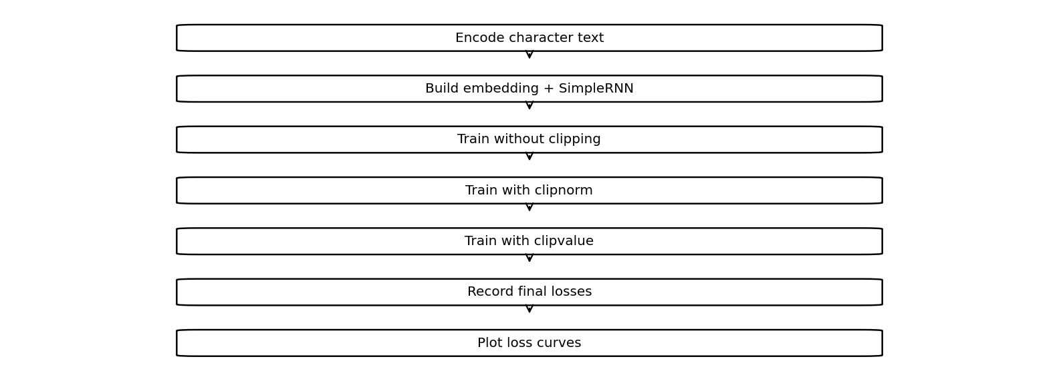

Code
import tensorflow as tf
import numpy as np
import matplotlib.pyplot as plt
text = "deep learning is useful " * 100
chars = sorted(set(text))
data = np.array([chars.index(c) for c in text])
X = np.array([data[i:i+10] for i in range(len(data)-10)])
y = data[10:]
for name, clip in [("No clipping",None),
("Clipnorm",1.0),("Clipvalue",0.5)]:
m = tf.keras.Sequential([
tf.keras.layers.Embedding(len(chars),8),
tf.keras.layers.SimpleRNN(16),
tf.keras.layers.Dense(len(chars))
])
opt = tf.keras.optimizers.Adam(learning_rate=.1,clipnorm=clip)
if name == "Clipvalue":
opt = tf.keras.optimizers.Adam(learning_rate=.1,clipvalue=.5)
m.compile(optimizer=opt,
loss=tf.keras.losses.SparseCategoricalCrossentropy(
from_logits=True))
h = m.fit(X[:500],y[:500],epochs=3,verbose=0)
print(name,"Final loss:",h.history["loss"][-1])
plt.plot(h.history["loss"],label=name)
plt.xlabel("Epoch")
plt.ylabel("Loss")
plt.legend()
plt.show()

Saved Output from Colab

Output
No clipping Final loss: 0.01875300146639347
Clipnorm Final loss: 0.016703156754374504
Clipvalue Final loss: 0.017000753432512283
Saved figure 1 from Colab output:
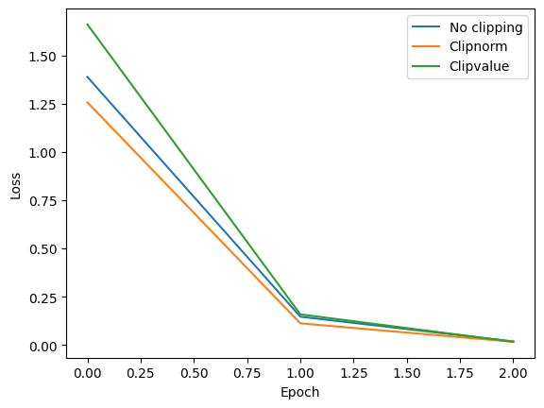

Result
The saved notebook compares the final loss for no clipping, clipnorm, and clipvalue and includes a loss plot.

