EXPERIMENT 18: RNN, LSTM and GRU Hyperparameter Comparison

Aim
To tune RNN, LSTM, and GRU sentiment classifiers on the IMDB dataset using KerasTuner and compare test accuracy and parameter count.

Formula / Mathematical Overview
Embedding: token ID -> dense vector
Maps each word ID to a learned numeric vector.
Binary cross-entropy: L = -[y log(p) + (1-y) log(1-p)]
Measures error for positive/negative classification.
Accuracy: Accuracy = correct predictions / total predictions
Fraction of reviews classified correctly.
Parameter count: Total parameters = trainable + non-trainable parameters
Measures model size by number of parameters.

Flow Diagram
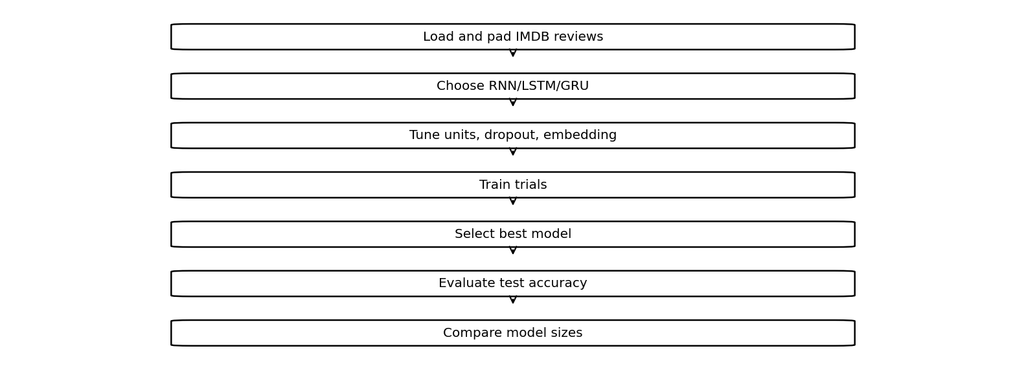

Code

Code cell 21
!pip -q install keras-tuner

Code cell 22
import tensorflow as tf
import keras_tuner as kt
import time
(X,y),(Xt,yt)=tf.keras.datasets.imdb.load_data(num_words=5000)
X=tf.keras.utils.pad_sequences(X,maxlen=100)
Xt=tf.keras.utils.pad_sequences(Xt,maxlen=100)
for cell in ["RNN","LSTM","GRU"]:
def build(hp):
units=hp.Choice("units",[16,32])
drop=hp.Choice("dropout",[0.2,0.4])
emb=hp.Choice("embedding",[16,32])
layer=(tf.keras.layers.SimpleRNN(units) if cell=="RNN"
else tf.keras.layers.LSTM(units) if cell=="LSTM"
else tf.keras.layers.GRU(units))
m=tf.keras.Sequential([
tf.keras.layers.Embedding(5000,emb),
layer,tf.keras.layers.Dropout(drop),
tf.keras.layers.Dense(1,activation="sigmoid")
])
m.compile(optimizer="adam",loss="binary_crossentropy",
metrics=["accuracy"])
return m
tuner=kt.RandomSearch(build,objective="val_accuracy",
max_trials=2,directory="tune",
project_name=cell,overwrite=True)
tuner.search(X[:5000],y[:5000],epochs=2,
validation_split=.2,verbose=0)
m=tuner.get_best_models(1)[0]
print(cell,"Best settings:",tuner.get_best_hyperparameters(1)[0].values)
print("Test accuracy:",m.evaluate(Xt,yt,verbose=0)[1])
print("Parameters:",m.count_params())

Saved Output from Colab

Output for code cell 21
━━━━━━━━━━━━━━━━━━━━━━━━━━━━━━━━━━━━━━━━ 0.0/129.4 kB ? eta -:--:-- ━━━━━━━━━━━━━━━━━━━━━━━━━━━━━━━━━━━━━━━━ 129.4/129.4 kB 4.0 MB/s eta 0:00:00

Output for code cell 22
Downloading data from https://storage.googleapis.com/tensorflow/tf-keras-datasets/imdb.npz
17464789/17464789 ━━━━━━━━━━━━━━━━━━━━ 1s 0us/step
/usr/local/lib/python3.13/dist-packages/keras/src/saving/saving_lib.py:797: UserWarning: Skipping variable loading for optimizer 'adam', because it has 2 variables whereas the saved optimizer has 14 variables.
saveable.load_own_variables(weights_store.get(inner_path))
RNN Best settings: {'units': 16, 'dropout': 0.2, 'embedding': 16}
Test accuracy: 0.7781999707221985
Parameters: 80545
LSTM Best settings: {'units': 32, 'dropout': 0.2, 'embedding': 16}
Test accuracy: 0.8017200231552124
Parameters: 86305
GRU Best settings: {'units': 16, 'dropout': 0.2, 'embedding': 16}
Test accuracy: 0.7630800008773804
Parameters: 81649

Result
The saved notebook reports the selected hyperparameters, test accuracy, and parameter count for RNN, LSTM, and GRU.

