EXPERIMENT 19: PCA and Explained Variance Analysis

Aim
To implement PCA using covariance and eigen-decomposition, compare it with Scikit-learn PCA, and reconstruct handwritten digit images with different component counts.

Formula / Mathematical Overview
Covariance matrix: C = cov(X)
Summarises how input features vary together.
Eigen-decomposition: C v_i = lambda_i v_i
Finds principal directions and their variances.
Explained variance ratio: r_i = lambda_i / sum_j lambda_j
Fraction of total variance explained by component i.
Cumulative variance: R_k = sum_(i=1)^k r_i
Total variance explained by the first k components.

Flow Diagram
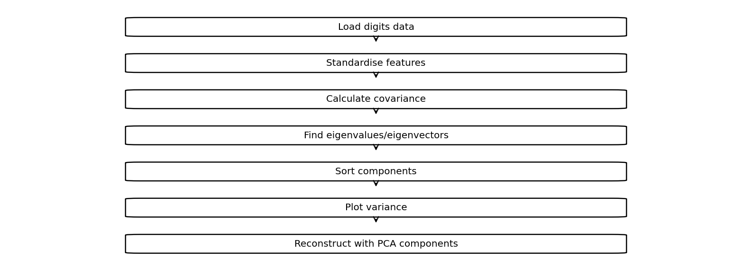

Code
import numpy as np
import matplotlib.pyplot as plt
from sklearn.datasets import load_digits
from sklearn.decomposition import PCA
# Load dataset
X = load_digits().data
X = (X - X.mean(axis=0)) / (X.std(axis=0) + 1e-8)
# 1. PCA from scratch
C = np.cov(X, rowvar=False)
v, W = np.linalg.eigh(C)
idx = np.argsort(v)[::-1]
v, W = v[idx], W[:, idx]
var = v / v.sum()
print("95% components:", np.argmax(np.cumsum(var) >= 0.95) + 1)
# 2. Scree plot and cumulative variance
plt.plot(var, label="Scree Plot")
plt.plot(np.cumsum(var), label="Cumulative Variance")
plt.axhline(0.95, linestyle="--")
plt.xlabel("Components")
plt.ylabel("Explained Variance")
plt.legend()
plt.show()
# 3. Compare with Scikit-learn PCA
p = PCA().fit(X)
print("Scratch PCA:", var[:5])
print("Sklearn PCA:", p.explained_variance_ratio_[:5])
# 4. Show top eigenfaces (eigenvectors)
plt.figure(figsize=(10, 3))
for i in range(5):
plt.subplot(1, 5, i+1)
plt.imshow(W[:, i].reshape(8, 8), cmap="gray")
plt.title(f"PC {i+1}")
plt.axis("off")
plt.show()
# 5. Reconstruct images using PCA
for n in [10, 30, 50, 64]:
p = PCA(n_components=n)
R = p.inverse_transform(p.fit_transform(X))
plt.imshow(R[0].reshape(8, 8), cmap="gray")
plt.title(f"Reconstruction: {n} Components")
plt.axis("off")
plt.show()

Saved Output from Colab

Output for code cell 23
95% components: 40
Saved figure 1 from Colab output:
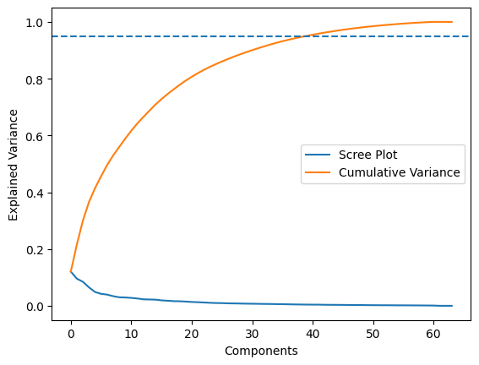
Scratch PCA: [0.12033917 0.09561055 0.08444415 0.06498408 0.04860155]
Sklearn PCA: [0.12033917 0.09561055 0.08444415 0.06498408 0.04860155]
Saved figure 2 from Colab output:
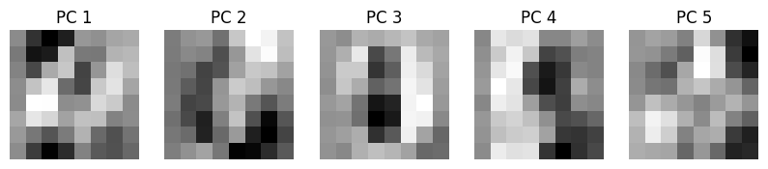
Saved figure 3 from Colab output:
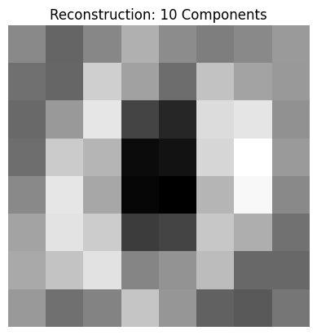
Saved figure 4 from Colab output:
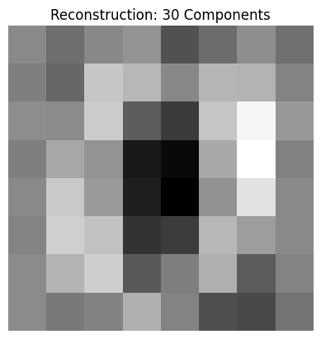
Saved figure 5 from Colab output:
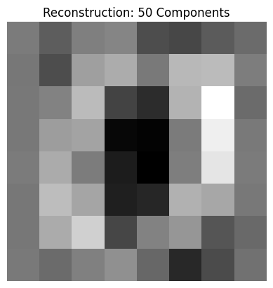
Saved figure 6 from Colab output:
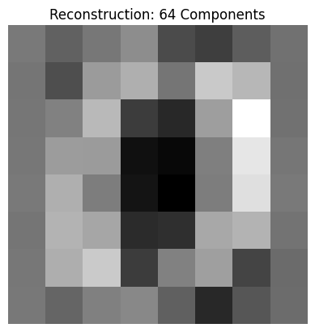

Result
Scratch PCA matches Scikit-learn's first five explained-variance ratios in the saved output; 40 components retain at least 95% of variance.

