EXPERIMENT 20: Probabilistic PCA and Reconstruction Analysis

Aim
To fit PCA to synthetic noisy sensor readings, inspect estimated noise variance and reconstruction error, and generate new synthetic samples.

Formula / Mathematical Overview
PPCA generative model: x = Wz + mu + epsilon
Observed data x is represented by latent variables z, a mean mu, and noise epsilon.
Noise assumption: epsilon ~ N(0, sigma^2 I)
Assumes independent Gaussian noise with variance sigma squared.
Reconstruction MSE: MSE = mean((X - X_reconstructed)^2)
Measures average squared reconstruction error.

Flow Diagram
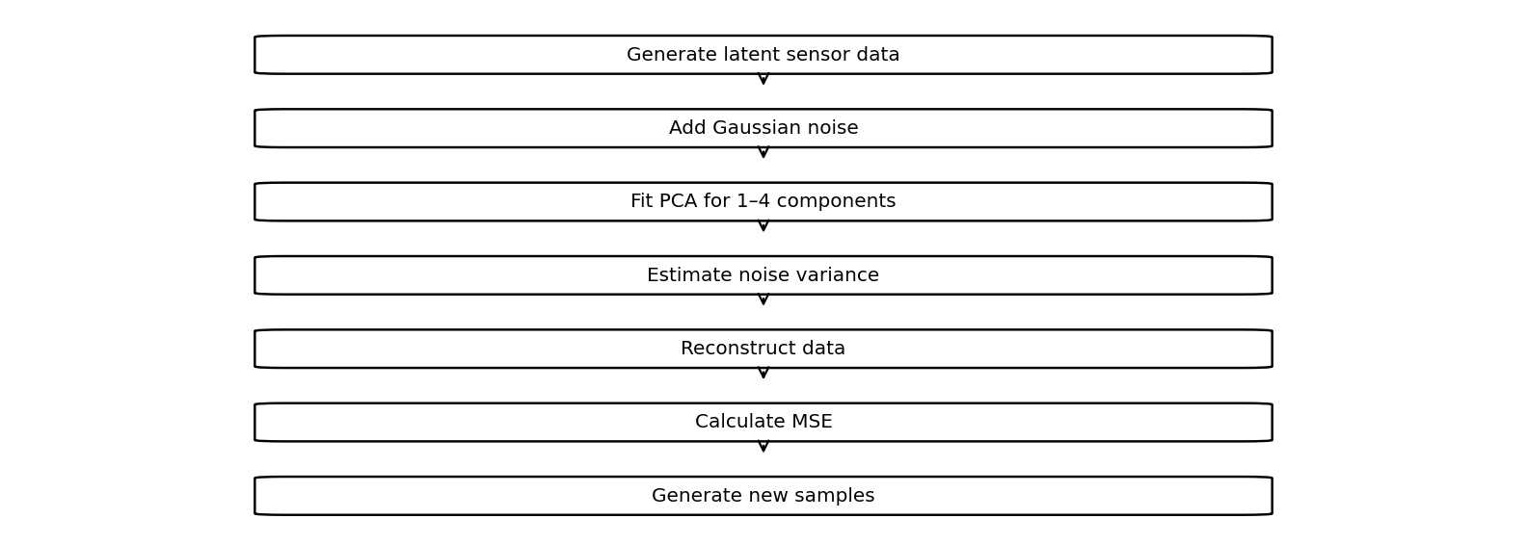

Code
import numpy as np
import matplotlib.pyplot as plt
from sklearn.decomposition import PCA
np.random.seed(1)
# Synthetic sensor data with noise
Z=np.random.randn(500,2)
X=Z@np.random.randn(2,5)+0.5*np.random.randn(500,5)
# PPCA model: x = Wz + mean + noise
for n in [1,2,3,4]:
p=PCA(n_components=n).fit(X)
R=p.inverse_transform(p.transform(X))
print("Components:",n,
"Noise variance:",p.noise_variance_,
"Error:",np.mean((X-R)**2))
plt.scatter(X[:,0],R[:,0],s=10)
plt.title(f"Actual vs Reconstructed: {n} Components")
plt.show()
# Generate new sensor samples
p=PCA(n_components=2).fit(X)
z=np.random.randn(5,2)*np.sqrt(p.explained_variance_)
new=z@p.components_+p.mean_
print("Generated samples:\n",new)

Saved Output from Colab

Output for code cell 24
Components: 1 Noise variance: 1.338559909366535 Error: 1.0687062316382423
Saved figure 1 from Colab output:
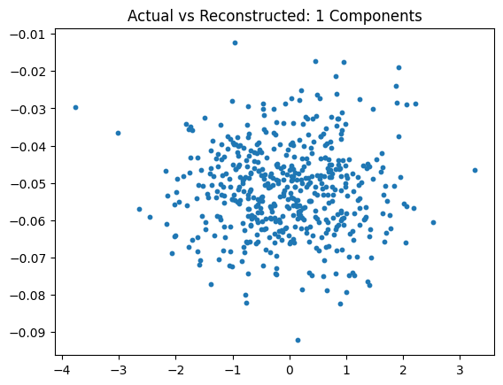
Components: 2 Noise variance: 0.25861331430133844 Error: 0.15485765260364193
Saved figure 2 from Colab output:
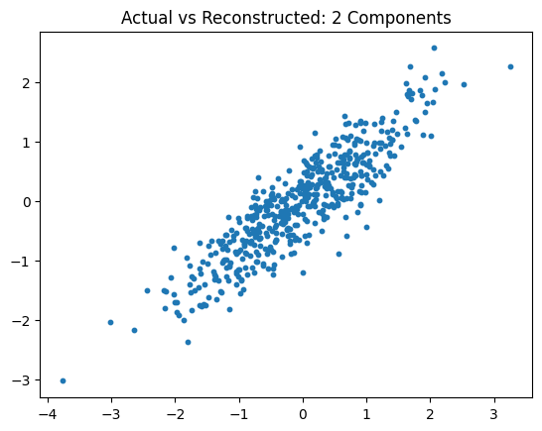
Components: 3 Noise variance: 0.24291228310891402 Error: 0.09697058341707891
Saved figure 3 from Colab output:
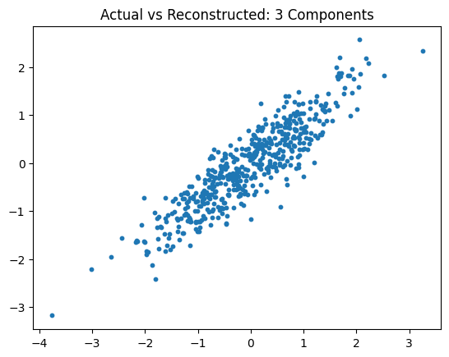
Components: 4 Noise variance: 0.2305282148358802 Error: 0.046013431681241924
Saved figure 4 from Colab output:
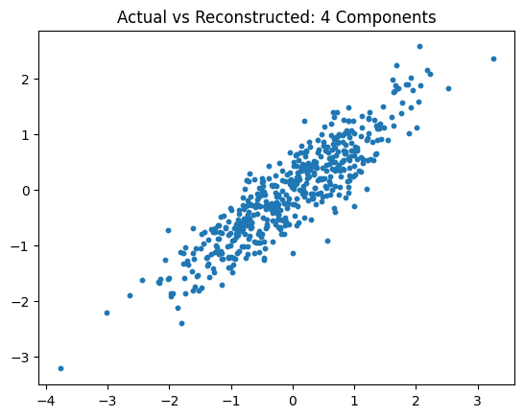
Generated samples:
[[-0.09319963 -4.28743573 0.86722196 -0.50454213 -3.09204952]
[-0.82380777 -5.29105221 1.4062985 -0.05966809 -1.99483898]
[-0.82209573 0.10084866 0.37453103 0.67121144 2.0657913 ]
[-0.3570384 -1.33038244 0.42719575 0.1069104 -0.19325293]
[ 1.11609037 1.66669701 -0.84588085 -0.65788851 -1.67165167]]

Result
The saved notebook reports estimated noise variance and reconstruction error for 1–4 components and prints five generated synthetic samples.

