EXPERIMENT 10: L2, Dropout and Early Stopping Comparison

1. Aim
To compare baseline training with L2 regularization, dropout and early stopping using train/test accuracy and validation loss.

2. Formula(s)
L2-regularized objective: Ltotal = Ldata + λΣwᵢ²
Dropout: randomly sets a fraction of activations to zero during training.
Early stopping: stop training when validation loss fails to improve for the chosen patience.
Train-test gap: training accuracy − testing accuracy.

3. Overall Flow Diagram
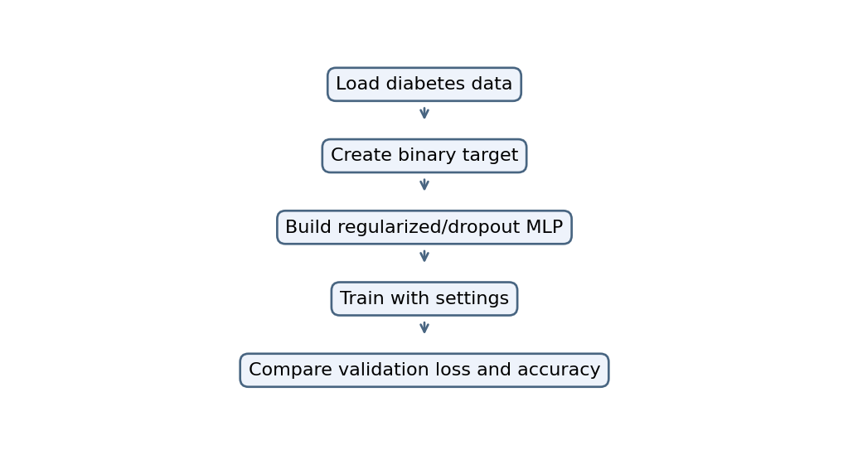

4. Code
import numpy as np
import pandas as pd
import matplotlib.pyplot as plt
import tensorflow as tf

from sklearn.datasets import load_diabetes
from sklearn.model_selection import train_test_split
from sklearn.preprocessing import StandardScaler
from sklearn.metrics import accuracy_score

np.random.seed(1)
tf.random.set_seed(1)

# Diabetes dataset: convert disease progression into a binary target
data = load_diabetes()
X = data.data
y = (data.target > np.median(data.target)).astype(int)

X_train, X_test, y_train, y_test = train_test_split(
X, y, test_size=0.2, random_state=1, stratify=y
)

scaler = StandardScaler()
X_train = scaler.fit_transform(X_train)
X_test = scaler.transform(X_test)

def build_model(l2=0, dropout=0):
reg = tf.keras.regularizers.l2(l2)

model = tf.keras.Sequential([
tf.keras.layers.Input(shape=(X_train.shape[1],)),
tf.keras.layers.Dense(128, activation="relu",
kernel_regularizer=reg),
tf.keras.layers.Dropout(dropout),
tf.keras.layers.Dense(64, activation="relu",
kernel_regularizer=reg),
tf.keras.layers.Dense(1, activation="sigmoid")
])

model.compile(optimizer="adam",
loss="binary_crossentropy",
metrics=["accuracy"])
return model

results = []

# Baseline, L2, dropout, and early stopping
settings = [
("Baseline", 0, 0, False),
("L2 0.001", 0.001, 0, False),
("L2 0.01", 0.01, 0, False),
("L2 0.1", 0.1, 0, False),
("Dropout 0.2", 0, 0.2, False),
("Dropout 0.3", 0, 0.3, False),
("Dropout 0.5", 0, 0.5, False),
("Early Stopping", 0, 0, True)
]

for name, l2, dropout, early in settings:
model = build_model(l2, dropout)

callbacks = []
if early:
callbacks = [
tf.keras.callbacks.EarlyStopping(
monitor="val_loss", patience=5,
restore_best_weights=True
)
]

history = model.fit(
X_train, y_train, epochs=100, batch_size=16,
validation_split=0.2, verbose=0, callbacks=callbacks
)

train_acc = model.evaluate(X_train, y_train, verbose=0)[1]
test_prob = model.predict(X_test, verbose=0).ravel()
test_pred = (test_prob >= 0.5).astype(int)
test_acc = accuracy_score(y_test, test_pred)

results.append([name, train_acc, test_acc,
train_acc-test_acc])

if name in ["Baseline", "Early Stopping"]:
plt.plot(history.history["val_loss"], label=name)

plt.title("Validation Loss Comparison")
plt.xlabel("Epoch")
plt.ylabel("Loss")
plt.legend()
plt.show()

df = pd.DataFrame(results, columns=[
"Model", "Train Accuracy", "Test Accuracy", "Train-Test Gap"
])
print(df.round(3))

5. Output
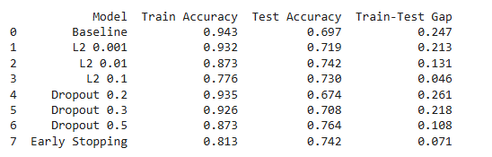
.

Graph image(s)
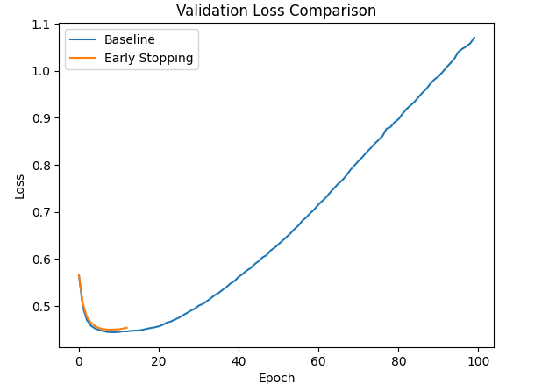

6. Result
The supplied code defines baseline, L2, dropout and early-stopping comparisons; the result table and validation-loss plot need execution in Colab with TensorFlow.

