EXPERIMENT 2: Covariance, Eigenvalues and Eigenvectors Analysis

1. Aim
To standardize patient-feature data, compute covariance/correlation, obtain eigenvalues and eigenvectors, and examine explained variance.

2. Formula(s)
Standardization: z = (x − μ)/σ
Covariance: Cov(X,Y) = Σ[(xᵢ−x̄)(yᵢ−ȳ)]/(n−1)
Correlation: r = Cov(X,Y)/(sₓsᵧ)
Explained variance (%): λᵢ/Σλ × 100%

3. Overall Flow Diagram
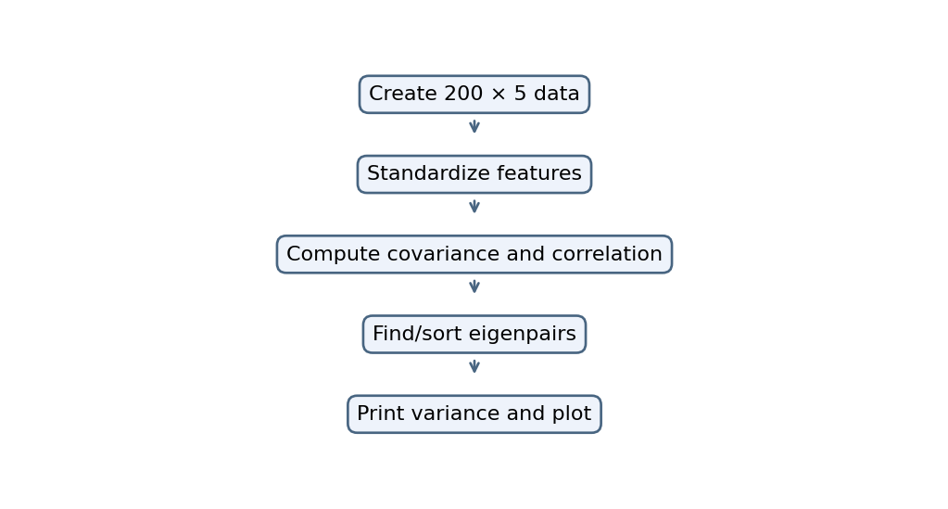

4. Code
import numpy as np
import pandas as pd
import matplotlib.pyplot as plt

np.random.seed(1)
df = pd.DataFrame(np.random.randn(200, 5),
columns=["Hb", "RBC", "Glucose",
"Cholesterol", "BMI"])

X = (df - df.mean()) / df.std()

cov = X.cov()
corr = X.corr()

print("Covariance:\n", cov)
print("Correlation:\n", corr)

plt.imshow(corr, cmap="coolwarm", vmin=-1, vmax=1)
plt.colorbar()
plt.show()

values, vectors = np.linalg.eigh(cov)
idx = np.argsort(values)[::-1]
values = values[idx]
vectors = vectors[:, idx]

print("Eigenvalues:", values)
print("Eigenvectors:\n", vectors)
print("Variance (%):", values / values.sum() * 100)

plt.scatter(X.iloc[:, 0], X.iloc[:, 1])
plt.arrow(0, 0, vectors[0, 0], vectors[1, 0],
color="red", head_width=0.2)
plt.show()

5. Output
Covariance:
Hb RBC Glucose Cholesterol BMI
Hb 1.000000 -0.055981 0.017517 -0.029860 0.122173
RBC -0.055981 1.000000 0.042619 0.029688 -0.180337
Glucose 0.017517 0.042619 1.000000 0.025828 0.051632
Cholesterol -0.029860 0.029688 0.025828 1.000000 -0.136060
BMI 0.122173 -0.180337 0.051632 -0.136060 1.000000
Correlation:
Hb RBC Glucose Cholesterol BMI
Hb 1.000000 -0.055981 0.017517 -0.029860 0.122173
RBC -0.055981 1.000000 0.042619 0.029688 -0.180337
Glucose 0.017517 0.042619 1.000000 0.025828 0.051632
Cholesterol -0.029860 0.029688 0.025828 1.000000 -0.136060
BMI 0.122173 -0.180337 0.051632 -0.136060 1.000000
Eigenvalues: [1.29790239 1.03091263 0.97627796 0.93645111 0.7584559 ]
Eigenvectors:
[[ 0.40441098 0.27895949 -0.28736421 -0.80074456 -0.18671726]
[-0.50654755 0.26011165 0.47177692 -0.45104723 0.49973437]
[ 0.03121867 0.89099465 0.14577686 0.33599052 -0.26648341]
[-0.38739297 0.21766191 -0.81915236 0.09236601 0.35072482]
[ 0.65483846 0.11521875 0.05086118 0.18423747 0.72206712]]
Variance (%): [25.95804788 20.61825265 19.52555921 18.72902227 15.169118 ]

Graph
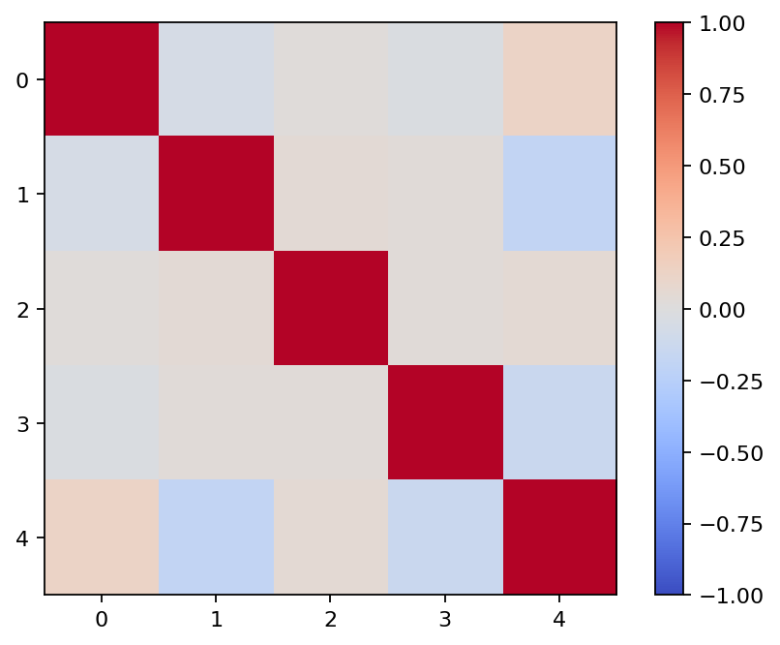
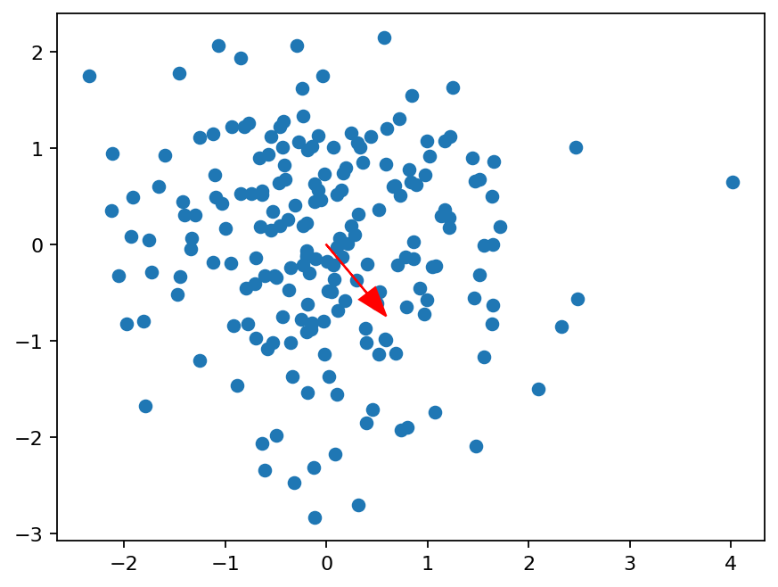

6. Result
The supplied code standardizes five synthetic features, computes covariance/correlation and eigenpairs, and reports explained variance.

