EXPERIMENT 3: Probability Distributions and Bayes’ Theorem

1. Aim
To plot a Gaussian distribution, calculate discrete distribution probabilities, and apply Bayes’ theorem to a diagnostic test.

2. Formula(s)
Bayes’ theorem: P(D|+) = P(+|D)P(D)/P(+)
For this code: P(+) = sensitivity·prevalence + (1−specificity)(1−prevalence).
Binomial PMF: P(X=k)=C(n,k)pᵏ(1−p)ⁿ⁻ᵏ
Poisson PMF: P(X=k)=e⁻λλᵏ/k!

3. Overall Flow Diagram
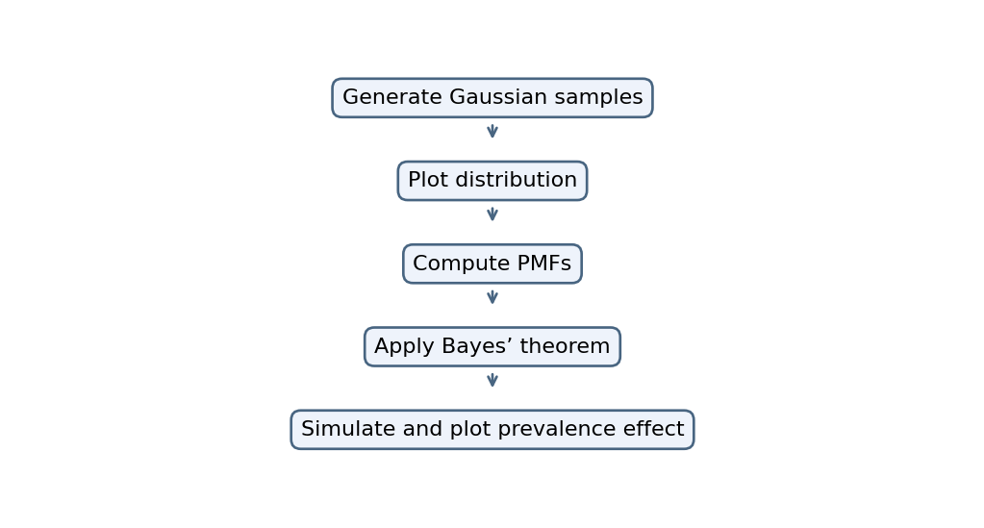

4. Code
import numpy as np
import matplotlib.pyplot as plt
from scipy.stats import norm, binom, poisson

np.random.seed(1)

plt.hist(norm.rvs(size=1000), bins=30, density=True)
x = np.linspace(-4, 4, 100)
plt.plot(x, norm.pdf(x))
plt.title("Gaussian Distribution")
plt.show()

print("Binomial PMF:", binom.pmf(3, 10, 0.5))
print("Poisson PMF:", poisson.pmf(4, 4))

# Bayes' theorem
p, sensitivity, specificity = 0.01, 0.95, 0.90
posterior = (sensitivity * p) / (
sensitivity * p + (1 - specificity) * (1 - p)
)
print("P(Disease | Positive):", posterior)
print("Percentage:", posterior * 100)

# Simulation
N = 100000
disease = np.random.rand(N) < p
positive = np.where(disease,
np.random.rand(N) < sensitivity,
np.random.rand(N) < (1 - specificity))
print("Simulated Probability:",
np.sum(disease & positive) / np.sum(positive))

prev = np.linspace(0.001, 0.2, 100)
post = sensitivity * prev / (
sensitivity * prev + (1-specificity) * (1-prev))
plt.plot(prev * 100, post * 100)
plt.xlabel("Prevalence (%)")
plt.ylabel("Posterior (%)")
plt.show()

5. Output
Binomial PMF: 0.1171875
Poisson PMF: 0.19536681481316454
P(Disease | Positive): 0.08755760368663597
Percentage: 8.755760368663596
Simulated Probability: 0.0844954128440367

Graph image
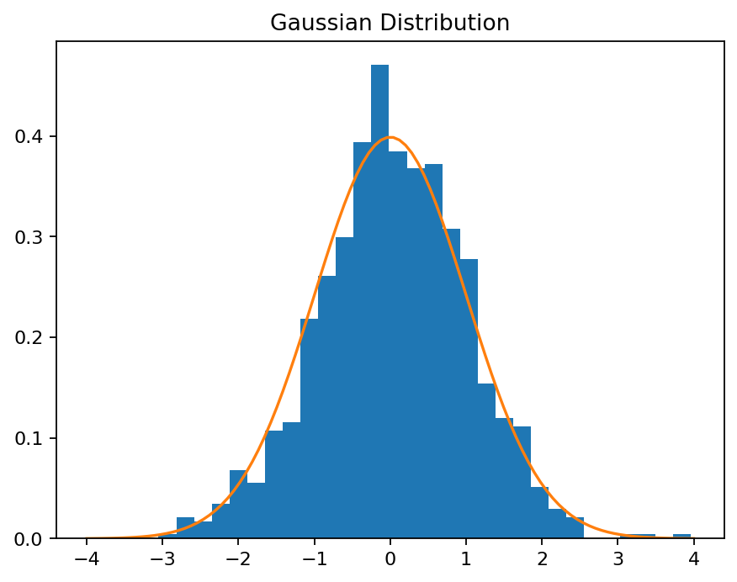
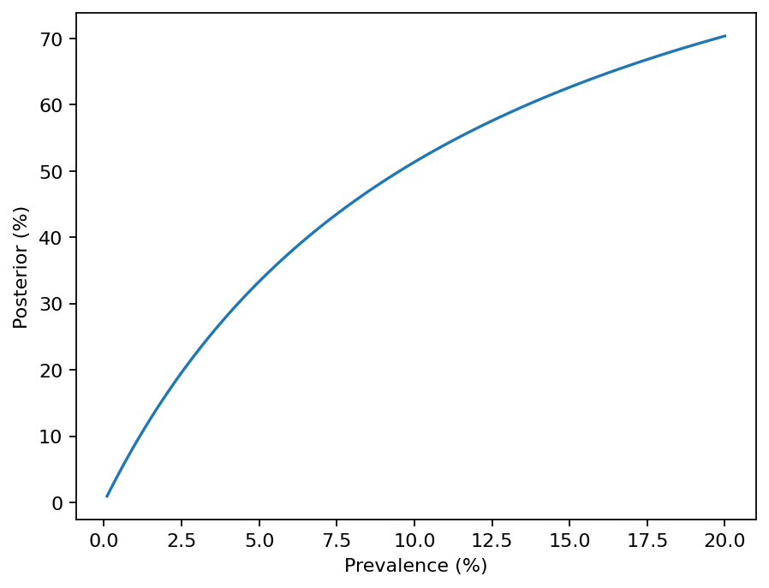

6. Result
The supplied code plots Gaussian samples and computes binomial/Poisson probabilities, Bayes posterior probability, a simulation estimate and prevalence curve.

