EXPERIMENT 4: Entropy, Cross-Entropy and KL Divergence

1. Aim
To calculate entropy, cross-entropy and KL divergence for probability distributions and visualize cross-entropy loss.

2. Formula(s)
Entropy: H(P)=−Σpᵢlog₂pᵢ
Cross-entropy: H(P,Q)=−Σpᵢlog₂qᵢ
KL divergence: DKL(P‖Q)=Σpᵢlog₂(pᵢ/qᵢ)
For matching definitions: cross-entropy = entropy + KL divergence.

3. Overall Flow Diagram
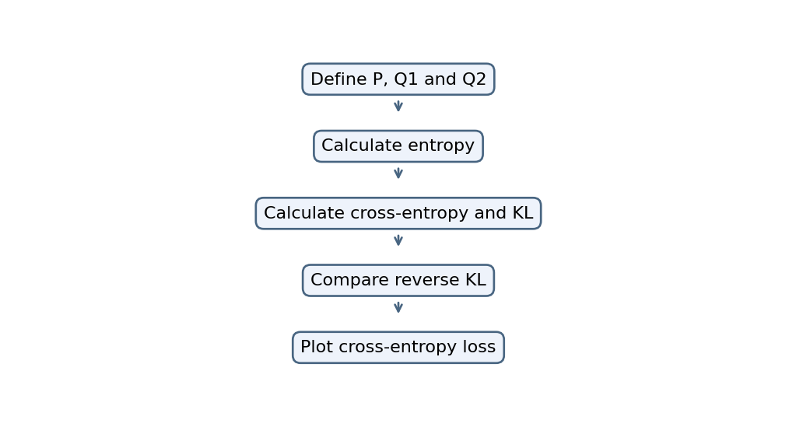

4. Code
import numpy as np
import matplotlib.pyplot as plt
from scipy.stats import entropy

P = np.array([0.5, 0.3, 0.2])
Q1 = np.array([0.4, 0.4, 0.2])
Q2 = np.array([0.7, 0.2, 0.1])

H = entropy(P, base=2)
CE = lambda p, q: -np.sum(p * np.log2(q))

print("Entropy:", H)
print("Cross Entropy Q1:", CE(P, Q1))
print("Cross Entropy Q2:", CE(P, Q2))
print("KL Divergence Q1:", entropy(P, Q1, base=2))
print("KL Divergence Q2:", entropy(P, Q2, base=2))
print("Reverse KL:", entropy(Q1, P, base=2))

p = np.linspace(0.01, 0.99, 100)
plt.plot(p, -np.log(p), label="Actual = 1")
plt.plot(p, -np.log(1-p), label="Actual = 0")
plt.xlabel("Predicted Probability")
plt.ylabel("Cross Entropy Loss")
plt.legend()
plt.show()

5. Output
Entropy: 1.4854752972273346
Cross Entropy Q1: 1.5219280948873621
Cross Entropy Q2: 1.6182506338585605
KL Divergence Q1: 0.036452797660027965
KL Divergence Q2: 0.13277533663122576
Reverse KL: 0.03724376175659267

Graph image(s)
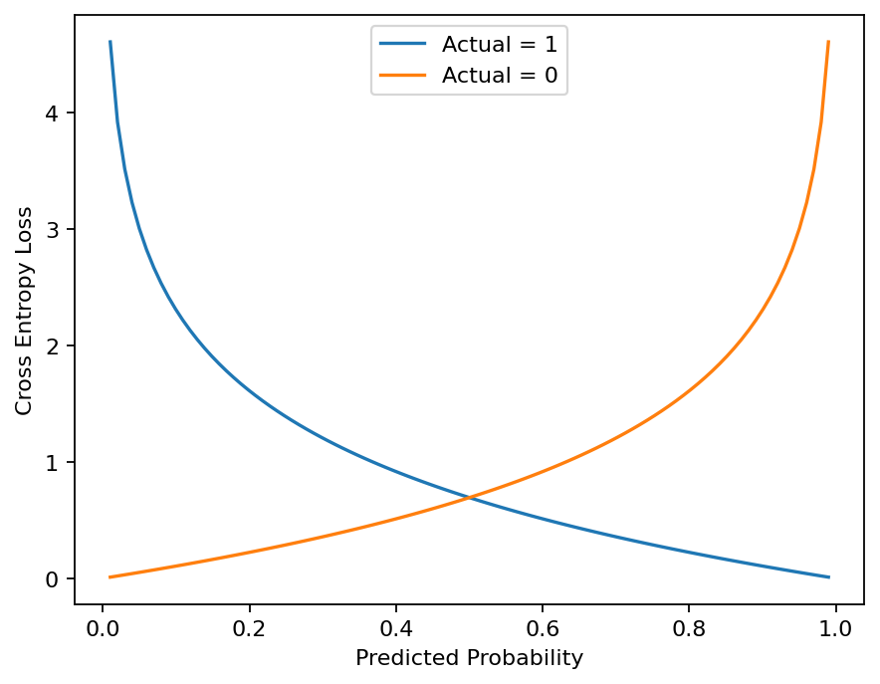

6. Result
The supplied code calculates entropy, cross-entropy and KL divergence for the given probability vectors and plots cross-entropy loss.

