EXPERIMENT 5: Bias–Variance, Overfitting and Underfitting Analysis

1. Aim
To compare polynomial regression models of different degrees using training and testing mean-squared error.

2. Formula(s)
Polynomial model: ŷ = b₀+b₁x+b₂x²+…+b_dxᵈ
Mean squared error: MSE = (1/n)Σ(yᵢ−ŷᵢ)²
Lower training error alone does not guarantee better generalization; compare testing error too.

3. Overall Flow Diagram
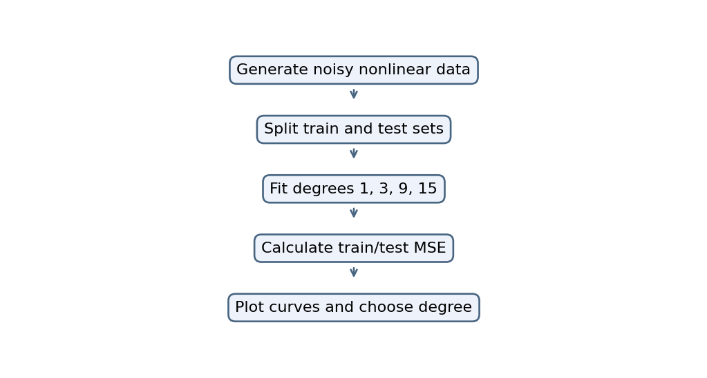

4. Code
import numpy as np
import matplotlib.pyplot as plt
from sklearn.preprocessing import PolynomialFeatures
from sklearn.linear_model import LinearRegression
from sklearn.metrics import mean_squared_error
from sklearn.model_selection import train_test_split
from sklearn.pipeline import make_pipeline

np.random.seed(1)
X = np.sort(np.random.rand(150) * 10).reshape(-1, 1)
y = X.ravel()**2 + np.random.randn(150) * 5

X_train, X_test, y_train, y_test = train_test_split(
X, y, test_size=0.25, random_state=1)

degrees = [1, 3, 9, 15]
train_errors, test_errors = [], []
x_plot = np.linspace(0, 10, 200).reshape(-1, 1)

for d in degrees:
model = make_pipeline(
PolynomialFeatures(d),
LinearRegression())
model.fit(X_train, y_train)

train_errors.append(mean_squared_error(
y_train, model.predict(X_train)))
test_errors.append(mean_squared_error(
y_test, model.predict(X_test)))

plt.scatter(X, y, s=10)
plt.plot(x_plot, model.predict(x_plot), label=f"Degree {d}")
plt.legend()
plt.show()

plt.plot(degrees, train_errors, "o-", label="Training Error")
plt.plot(degrees, test_errors, "o-", label="Testing Error")
plt.xlabel("Polynomial Degree")
plt.ylabel("MSE")
plt.legend()
plt.show()

print("Best Degree:", degrees[np.argmin(test_errors)])

5. Output
Best Degree: 3

Graph image(s)
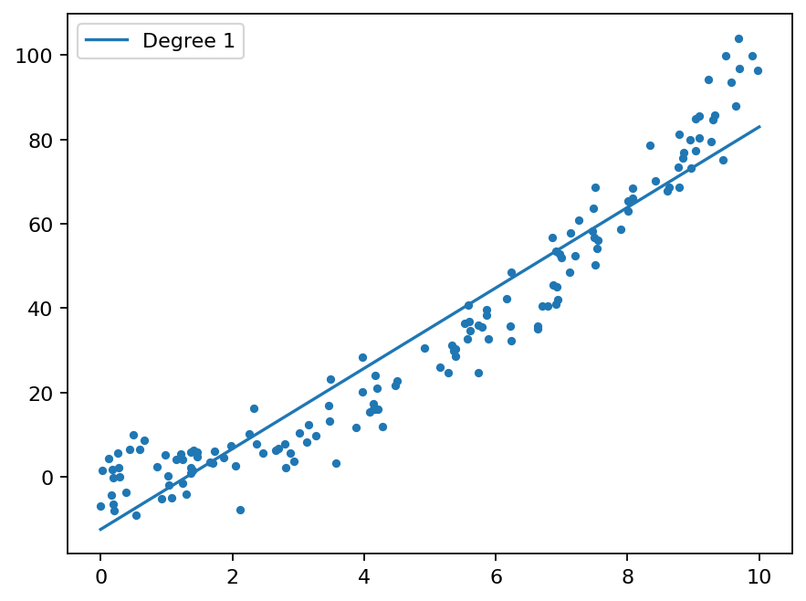
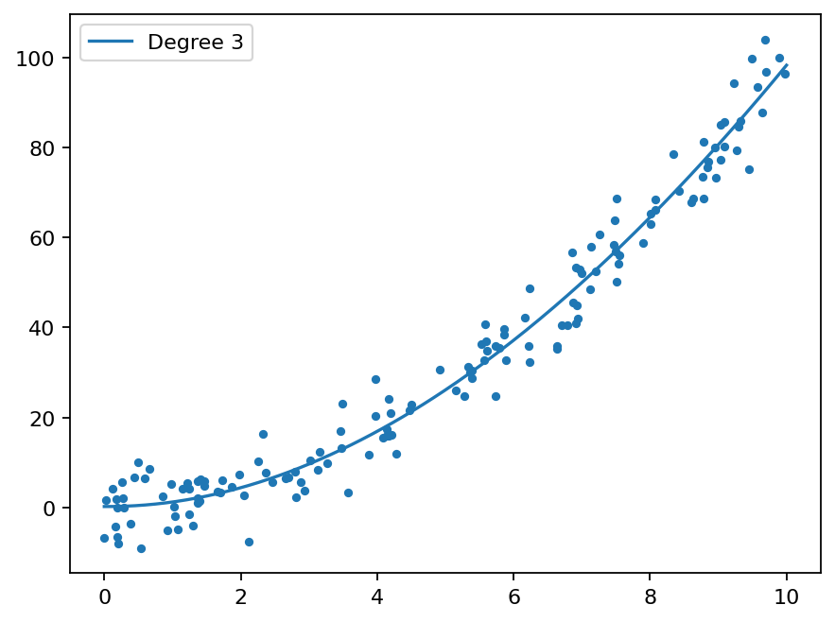
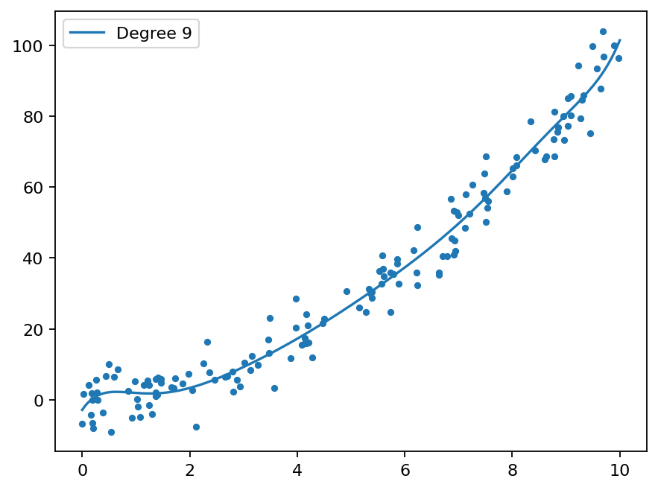
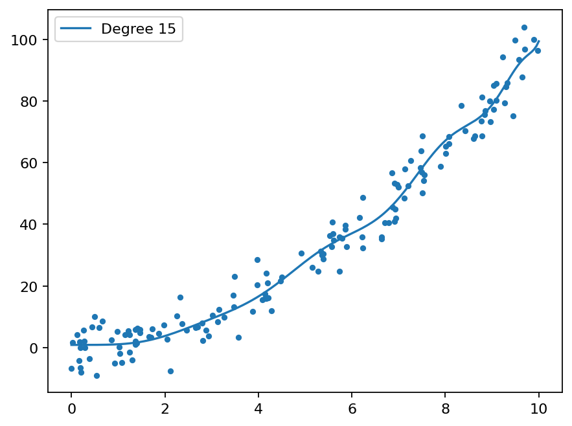
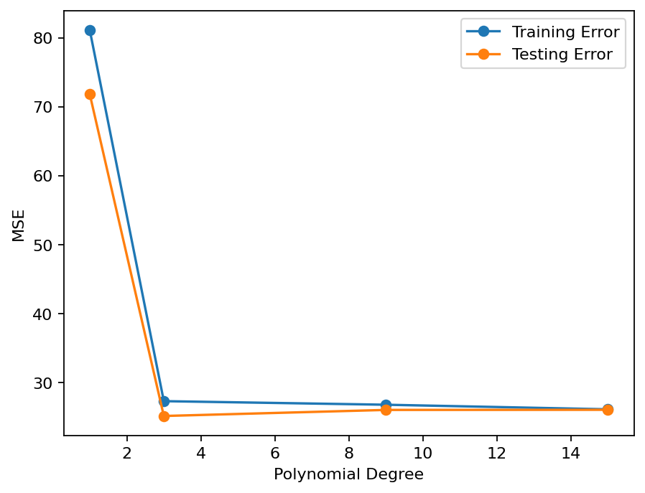

6. Result
The supplied code fits polynomial models of degrees 1, 3, 9 and 15, compares training/testing MSE and prints the best degree by test error.

