EXPERIMENT 6: Gradient Descent, SGD, Momentum and Adam Comparison

1. Aim
To visualize gradient-descent paths and compare optimizer loss curves for a regression task.

2. Formula(s)
Objective function in the path plot: f(x,y)=x²+y²
Gradient descent update: wₜ₊₁ = wₜ − η∇L(wₜ)
Momentum update: vₜ = βvₜ₋₁+∇L(wₜ); wₜ₊₁=wₜ−ηvₜ
Regression loss: MSE = (1/n)Σ(yᵢ−ŷᵢ)²

3. Overall Flow Diagram
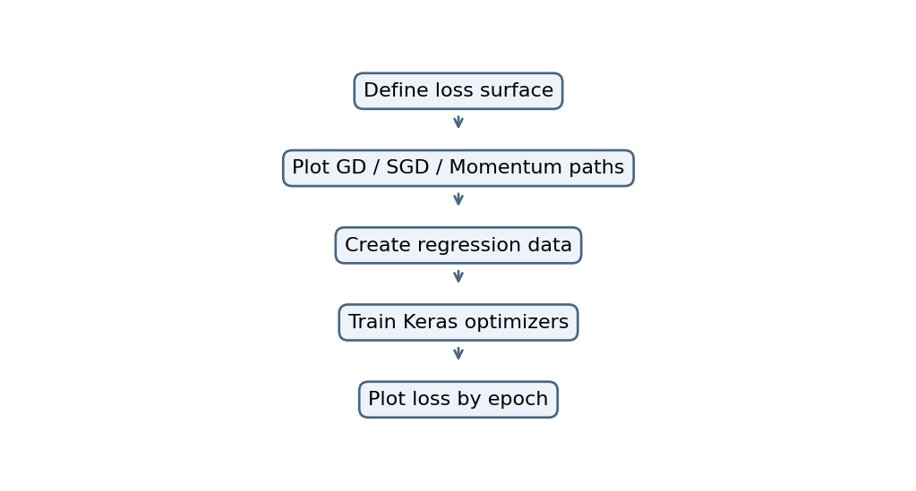

4. Code
import numpy as np
import matplotlib.pyplot as plt
import tensorflow as tf

# Simple loss function: f(x,y) = x² + y²
def loss(x, y):
return x**2 + y**2

# Batch GD, SGD, Momentum
for name in ["GD", "SGD", "Momentum"]:
x, y = 4.0, 4.0
vx, vy = 0.0, 0.0
path = []

for i in range(50):
path.append([x, y])
lr = 0.1

if name == "Momentum":
vx = 0.9*vx + 2*x
vy = 0.9*vy + 2*y
x -= lr*vx
y -= lr*vy
else:
x -= lr*2*x
y -= lr*2*y

path = np.array(path)
plt.plot(path[:, 0], path[:, 1], label=name)

plt.xlabel("x")
plt.ylabel("y")
plt.title("Optimiser Paths")
plt.legend()
plt.show()

# Compare Keras optimisers on regression
np.random.seed(1)
X = np.random.rand(200, 4)
y = 3*X[:, 0] + 2*X[:, 1] + np.random.randn(200)*0.1

for name, opt in [
("SGD", tf.keras.optimizers.SGD(0.01)),
("Momentum", tf.keras.optimizers.SGD(0.01, momentum=0.9)),
("Adam", tf.keras.optimizers.Adam(0.01))
]:
model = tf.keras.Sequential([
tf.keras.layers.Input(shape=(4,)),
tf.keras.layers.Dense(1)
])
model.compile(optimizer=opt, loss="mse")
h = model.fit(X, y, epochs=30, verbose=0)
plt.plot(h.history["loss"], label=name)

plt.xlabel("Epoch")
plt.ylabel("MSE Loss")
plt.title("Optimiser Comparison")
plt.legend()
plt.show()

Graph Output:
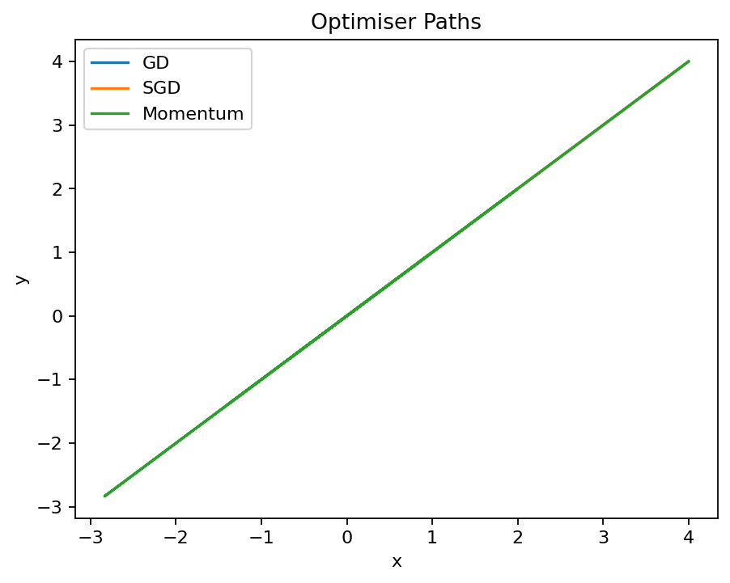
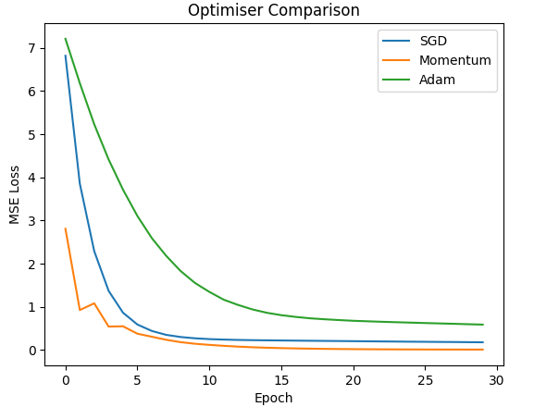

6. Result
The supplied code plots optimization paths. The Keras optimizer comparison is present in the source but could not be run here without TensorFlow.

