EXPERIMENT 7: Perceptron and Forward Propagation

1. Aim
To train a simple perceptron, show a decision boundary, demonstrate why a single perceptron struggles with XOR, and illustrate forward-propagation activations.

2. Formula(s)
Perceptron score: z = w·x+b
Binary prediction in this code: ŷ = 1 if z ≥ 0, otherwise 0
Weight update: w ← w+η(target−prediction)x
Bias update: b ← b+η(target−prediction)
Forward activations shown: sigmoid(z)=1/(1+e⁻ᶻ); ReLU(z)=max(0,z).

3. Overall Flow Diagram
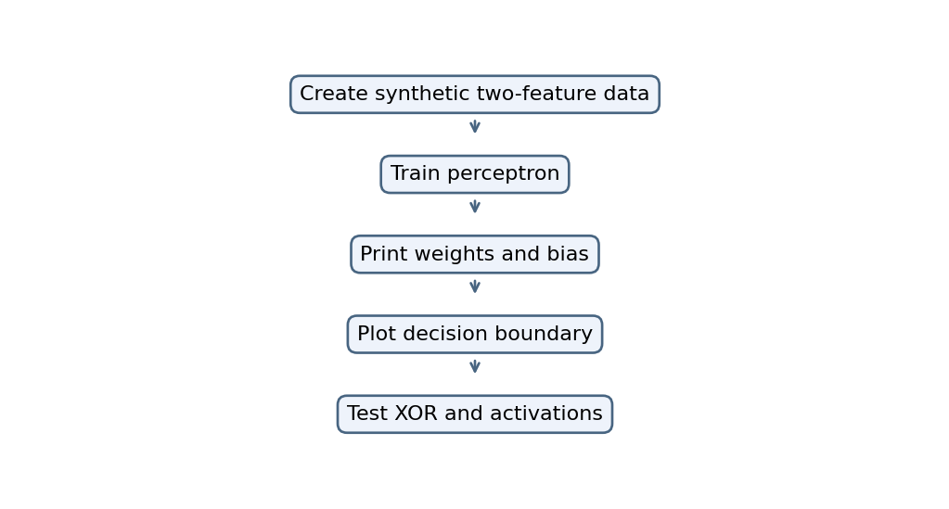

4. Code.
import numpy as np
import matplotlib.pyplot as plt

np.random.seed(1)

# Loan approval data
X = np.random.rand(100, 2)
y = (X[:, 0] + X[:, 1] > 1).astype(int)

# Perceptron
w = np.zeros(2)
b = 0
lr = 0.1
errors = []

for epoch in range(20):
error_count = 0

for xi, target in zip(X, y):
pred = int(np.dot(xi, w) + b >= 0)
error = target - pred
w += lr * error * xi
b += lr * error
error_count += error != 0

errors.append(error_count)

print("Weights:", w)
print("Bias:", b)

# Decision boundary
plt.scatter(X[:, 0], X[:, 1], c=y, cmap="coolwarm")
xx = np.linspace(0, 1, 100)
if abs(w[1]) > 1e-8:
plt.plot(xx, -(w[0]*xx+b)/w[1], color="black")
plt.title("Perceptron Decision Boundary")
plt.show()

# XOR: a single perceptron cannot learn XOR
XOR = np.array([[0,0], [0,1], [1,0], [1,1]])
Y = np.array([0,1,1,0])
w = np.zeros(2)
b = 0
errors = []

for epoch in range(20):
count = 0
for xi, target in zip(XOR, Y):
pred = int(np.dot(xi, w) + b >= 0)
error = target - pred
w += 0.1 * error * xi
b += 0.1 * error
count += error != 0
errors.append(count)

print("XOR errors per epoch:", errors)

# Activation functions
z = np.array([-2, -1, 0, 1, 2])
print("Step:", (z >= 0).astype(int))
print("Sigmoid:", 1/(1+np.exp(-z)))
print("ReLU:", np.maximum(0, z))

plt.plot(errors)
plt.title("XOR Perceptron Errors")
plt.xlabel("Epoch")
plt.ylabel("Errors")
plt.show()

5. Output
Weights: [0.51012709 0.49807146]
Bias: -0.5
XOR errors per epoch: [np.int64(3), np.int64(3), np.int64(4), np.int64(4), np.int64(4), np.int64(4), np.int64(4), np.int64(4), np.int64(4), np.int64(4), np.int64(4), np.int64(4), np.int64(4), np.int64(4), np.int64(4), np.int64(4), np.int64(4), np.int64(4), np.int64(4), np.int64(4)]
Step: [0 0 1 1 1]
Sigmoid: [0.11920292 0.26894142 0.5 0.73105858 0.88079708]
ReLU: [0 0 0 1 2]

Graph image(s)
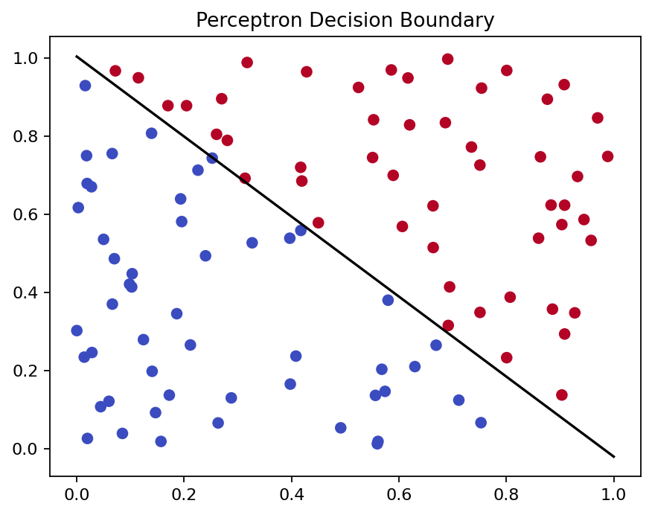
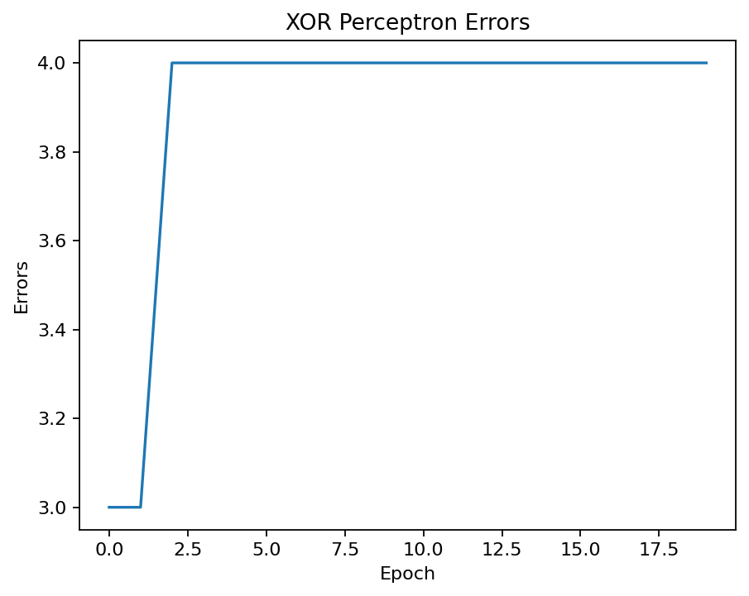

6. Result
The supplied code trains a perceptron and demonstrates decision boundaries, XOR limitations and activation values.

