EXPERIMENT 8: Two-Layer Neural Network with Backpropagation

1. Aim
To train a two-layer neural network on XOR using sigmoid activations and backpropagation, then visualize training loss and decision regions.

2. Formula(s)
Forward pass: h = sigmoid(XW₁+b₁); ŷ = sigmoid(hW₂+b₂)
Binary cross-entropy: L=−mean[y log(ŷ)+(1−y)log(1−ŷ)]
Gradient descent update: W ← W−η∂L/∂W (and similarly for biases).

3. Overall Flow Diagram
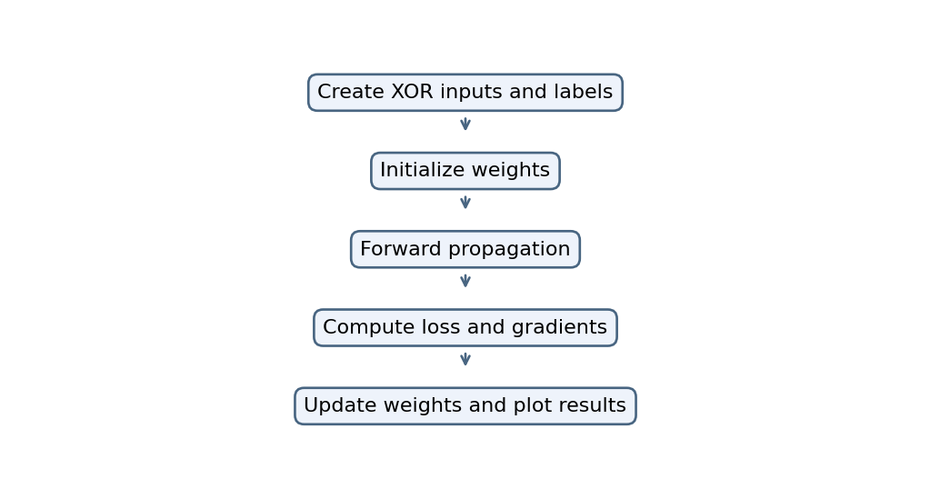

4. Code
import numpy as np
import matplotlib.pyplot as plt

np.random.seed(1)

# XOR dataset
X = np.array([[0,0], [0,1], [1,0], [1,1]])
Y = np.array([[0], [1], [1], [0]])

def sigmoid(x):
return 1/(1+np.exp(-np.clip(x, -50, 50)))

W1 = np.random.randn(2, 4)
b1 = np.zeros((1, 4))
W2 = np.random.randn(4, 1)
b2 = np.zeros((1, 1))

losses = []
lr = 0.5

for epoch in range(5000):
# Forward pass
h = sigmoid(X @ W1 + b1)
out = sigmoid(h @ W2 + b2)

loss = -np.mean(Y*np.log(out+1e-8) +
(1-Y)*np.log(1-out+1e-8))
losses.append(loss)

# Backpropagation
d_out = (out-Y)/len(X)
dW2 = h.T @ d_out
db2 = np.sum(d_out, axis=0, keepdims=True)

d_h = (d_out @ W2.T) * h * (1-h)
dW1 = X.T @ d_h
db1 = np.sum(d_h, axis=0, keepdims=True)

W2 -= lr*dW2
b2 -= lr*db2
W1 -= lr*dW1
b1 -= lr*db1

print("Predictions:\n", out.round(3))

plt.plot(losses)
plt.xlabel("Epoch")
plt.ylabel("Loss")
plt.title("Backpropagation Training Loss")
plt.show()

# Decision boundary
xx, yy = np.meshgrid(np.linspace(-0.2, 1.2, 100),
np.linspace(-0.2, 1.2, 100))
grid = np.c_[xx.ravel(), yy.ravel()]
pred = sigmoid(sigmoid(grid @ W1+b1) @ W2+b2)
plt.contourf(xx, yy, pred.reshape(xx.shape), levels=20, cmap="coolwarm")
plt.scatter(X[:,0], X[:,1], c=Y.ravel(), edgecolors="black")
plt.title("XOR Decision Boundary")
plt.show()

5. Output
.
Predictions:
[[0.001]
[0.997]
[0.996]
[0.007]]

Graph image(s)
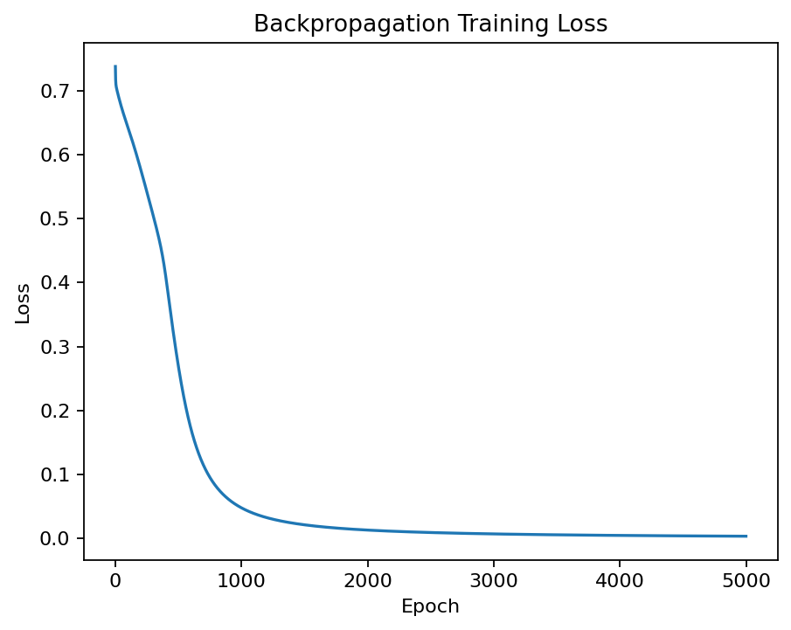
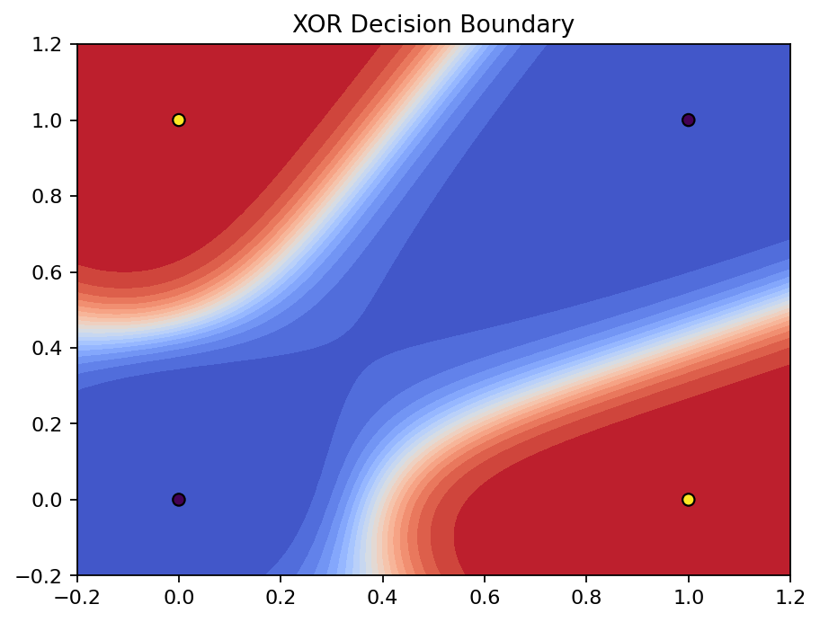

6. Result
The supplied code trains a two-layer sigmoid network on XOR using backpropagation and plots training loss and decision regions.

