EXPERIMENT 9: Multilayer Perceptron Implementation

1. Aim
To implement a multilayer perceptron for a synthetic telecom-churn classification task and compare hidden-layer widths.

2. Formula(s)
Dense layer: z = Wx+b; activation a = ReLU(z) for hidden layers
Output probability: p = sigmoid(z)=1/(1+e⁻ᶻ)
Binary cross-entropy: L=−[y log(p)+(1−y)log(1−p)]
Classification rule: predicted class = 1 when p ≥ 0.5, otherwise 0.

3. Overall Flow Diagram
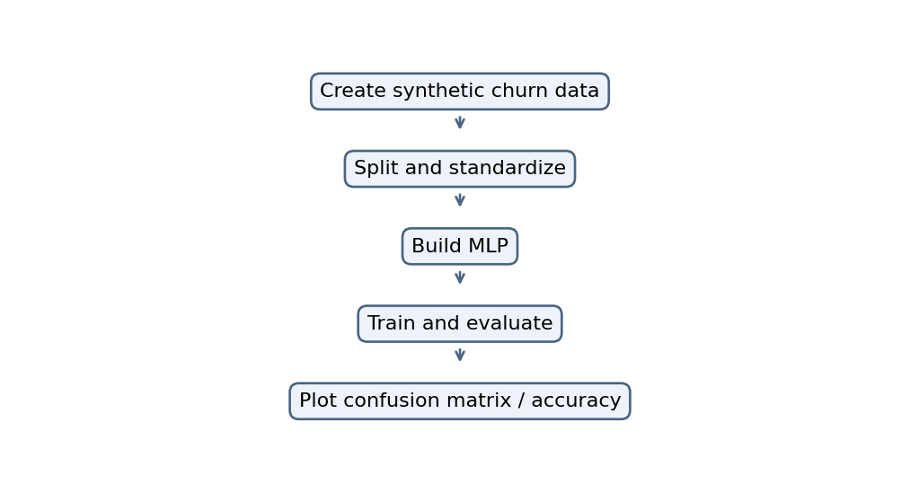

4. Code from the uploaded Colab file
The code below is extracted from the corresponding code cell in the supplied Colab HTML. It is not replaced with a newly written implementation.
import numpy as np
import matplotlib.pyplot as plt
import tensorflow as tf
from sklearn.model_selection import train_test_split
from sklearn.preprocessing import StandardScaler
from sklearn.metrics import classification_report, ConfusionMatrixDisplay

np.random.seed(1)

# Synthetic telecom churn dataset
X = np.random.rand(500, 5)
y = ((X[:,0] < 0.3) & (X[:,1] > 0.5)).astype(int)

X_train, X_test, y_train, y_test = train_test_split(
X, y, test_size=0.2, random_state=1, stratify=y
)

scaler = StandardScaler()
X_train = scaler.fit_transform(X_train)
X_test = scaler.transform(X_test)

model = tf.keras.Sequential([
tf.keras.layers.Input(shape=(5,)),
tf.keras.layers.Dense(32, activation="relu"),
tf.keras.layers.Dense(16, activation="relu"),
tf.keras.layers.Dense(1, activation="sigmoid")
])

model.compile(optimizer="adam",
loss="binary_crossentropy",
metrics=["accuracy"])

history = model.fit(
X_train, y_train, epochs=30, batch_size=16,
validation_split=0.2, verbose=0
)

prob = model.predict(X_test, verbose=0).ravel()
pred = (prob >= 0.5).astype(int)

print(classification_report(y_test, pred, zero_division=0))
ConfusionMatrixDisplay.from_predictions(y_test, pred)
plt.show()

plt.plot(history.history["accuracy"], label="Training")
plt.plot(history.history["val_accuracy"], label="Validation")
plt.xlabel("Epoch")
plt.ylabel("Accuracy")
plt.legend()
plt.show()

# Try different hidden-layer widths
for width in [8, 16, 32, 64]:
m = tf.keras.Sequential([
tf.keras.layers.Input(shape=(5,)),
tf.keras.layers.Dense(width, activation="relu"),
tf.keras.layers.Dense(1, activation="sigmoid")
])
m.compile(optimizer="adam", loss="binary_crossentropy",
metrics=["accuracy"])
m.fit(X_train, y_train, epochs=10, verbose=0)
print("Width:", width,
"Test accuracy:", m.evaluate(X_test, y_test, verbose=0)[1])

5. Output
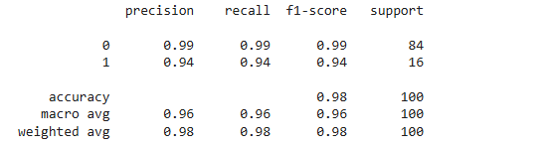
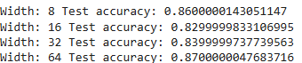

Graph image(s)
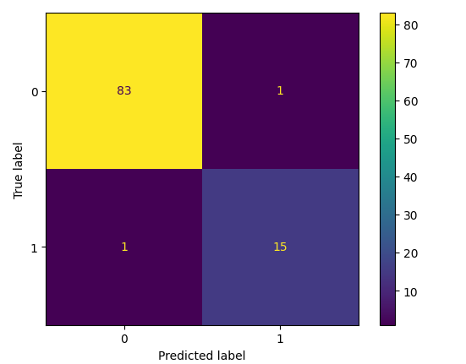
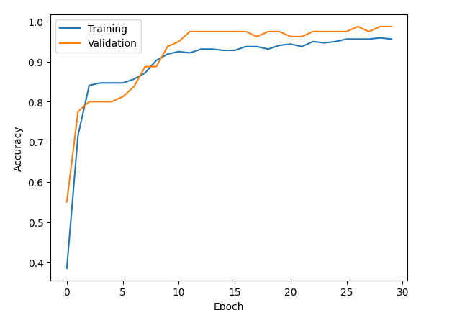

6. Result
The supplied code defines MLP training, confusion-matrix, accuracy-history and hidden-width comparisons; the results need execution in Colab with TensorFlow.

