MICROPROCESSOR AND MICROCONTROLLER
Experiment 1: Arithmetic Operations using 8085
EXPERIMENT 1: 8-bit Addition

Aim
To write and execute an 8085 assembly language program to add two 8-bit numbers and store the 8-bit sum in memory.

Procedure
- Open Microprocessor 8085 Simulator Software Kit 1.0.
- Set the starting address to 8000H and enter the program in the code editor.
- Enter the input data in the User Data Grid at the memory addresses specified below.
- Assemble/execute the program using the simulator controls.
- Check the result in the User Data Grid and compare it with the expected hexadecimal result.

Program
LDA 2000
MOV B A
LDA 2001
ADD B
STA 2002
HLT

Input
Memory address | Data (Hex) | Meaning
2000H | 02H | First number
2001H | 05H | Second number

Output
Memory address | Data (Hex) | Meaning
2002H | 07H | Sum = 02H + 05H

Simulator Output Screenshot
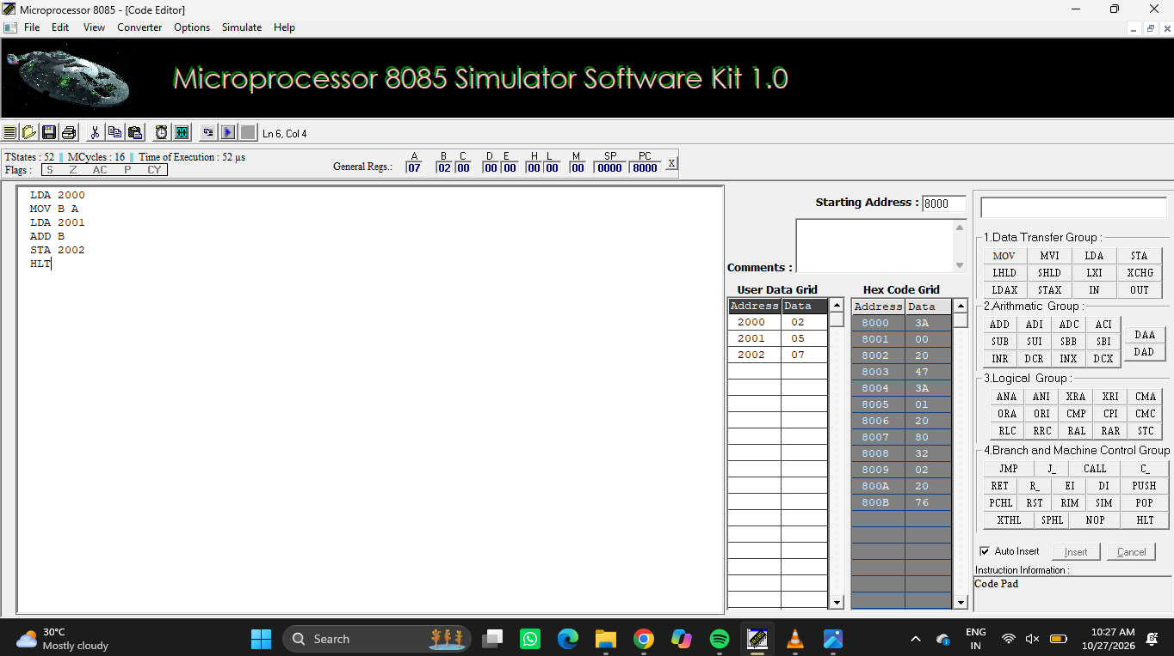

Result
The two 8-bit numbers were added successfully. The result 07H was stored at memory location 2002H.

EXPERIMENT 2: 8-bit Subtraction

Aim
To subtract one 8-bit number from another using the 8085 microprocessor and store the difference in memory.

Procedure
- Open Microprocessor 8085 Simulator Software Kit 1.0.
- Set the starting address to 8000H and enter the program in the code editor.
- Enter the input data in the User Data Grid at the memory addresses specified below.
- Assemble/execute the program using the simulator controls.
- Check the result in the User Data Grid and compare it with the expected hexadecimal result.

Program
LDA 2001
MOV B A
LDA 2000
SUB B
STA 2002
HLT

Input
Memory address | Data (Hex) | Meaning
2000H | 35H | Minuend
2001H | 15H | Subtrahend

Output
Memory address | Data (Hex) | Meaning
2002H | 20H | Difference = 35H - 15H

Simulator Output Screenshot
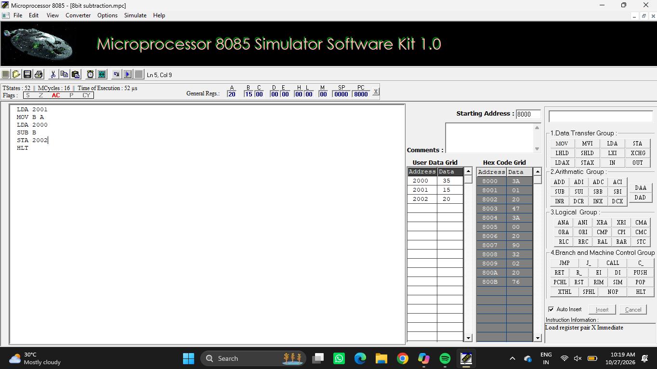

Result
The subtraction was completed successfully. The difference 20H was stored at memory location 2002H.

EXPERIMENT 3: 8-bit Multiplication

Aim
To multiply two 8-bit numbers using repeated addition and store the product in memory.

Procedure
- Open Microprocessor 8085 Simulator Software Kit 1.0.
- Set the starting address to 8000H and enter the program in the code editor.
- Enter the input data in the User Data Grid at the memory addresses specified below.
- Assemble/execute the program using the simulator controls.
- Check the result in the User Data Grid and compare it with the expected hexadecimal result.

Program
LDA 2000
MOV B A
LDA 2001
MOV C A
MVI A 00
LOOP: ADD B
DCR C
JNZ LOOP
STA 2002
HLT

Input
Memory address | Data (Hex) | Meaning
2000H | 02H | Multiplicand
2001H | 03H | Multiplier

Output
Memory address | Data (Hex) | Meaning
2002H | 06H | Product = 02H x 03H

Simulator Output Screenshot
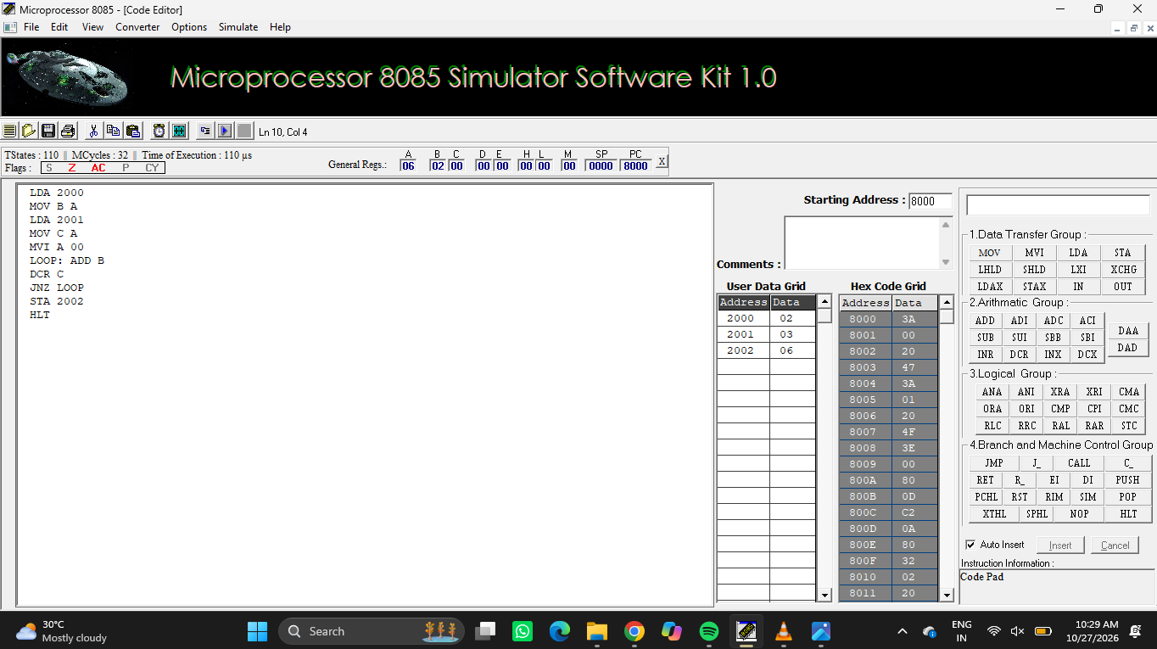

Result
The multiplication was performed successfully by repeated addition. The product 06H was stored at 2002H.

EXPERIMENT 4: 8-bit Division

Aim
To divide an 8-bit dividend by an 8-bit divisor using repeated subtraction and store the quotient and remainder.

Procedure
- Open Microprocessor 8085 Simulator Software Kit 1.0.
- Set the starting address to 8000H and enter the program in the code editor.
- Enter the input data in the User Data Grid at the memory addresses specified below.
- Assemble/execute the program using the simulator controls.
- Check the result in the User Data Grid and compare it with the expected hexadecimal result.

Program
LDA 2000
MOV B A
LDA 2001
MOV C A
MVI D 00
LOOP: MOV A B
CMP C
JC DONE
SUB C
MOV B A
INR D
JMP LOOP
DONE: MOV A D
STA 2002
MOV A B
STA 2003
HLT

Input
Memory address | Data (Hex) | Meaning
2000H | 14H | Dividend = 20 decimal
2001H | 04H | Divisor = 4 decimal

Output
Memory address | Data (Hex) | Meaning
2002H | 05H | Quotient
2003H | 00H | Remainder

Simulator Output Screenshot
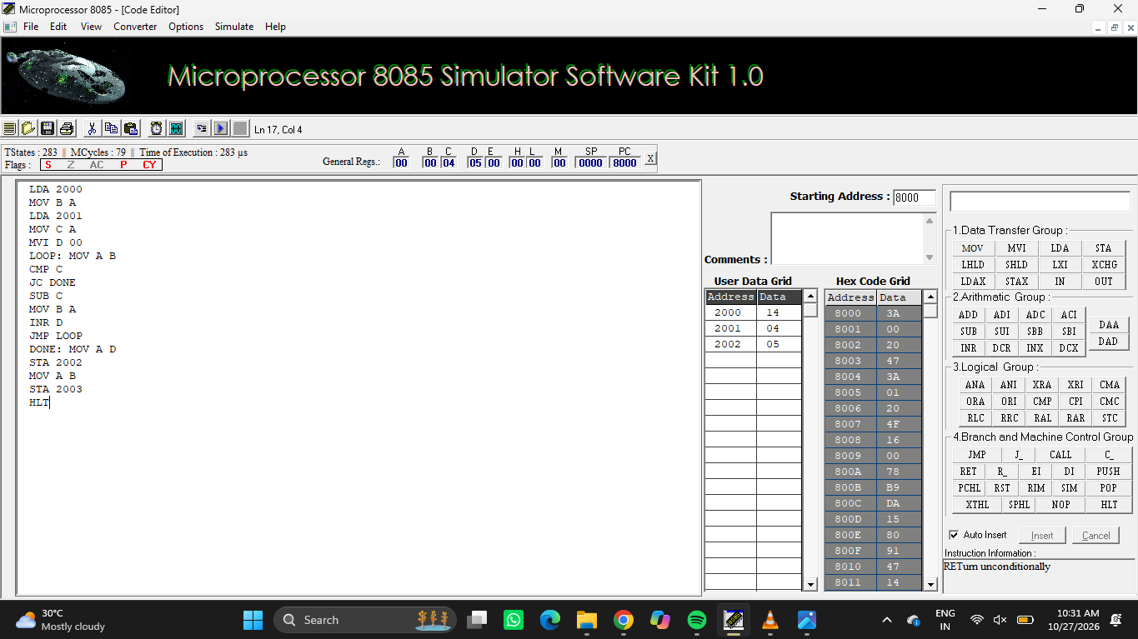

Result
The division was completed successfully. The quotient 05H was stored at 2002H and the remainder 00H was stored at 2003H.

EXPERIMENT 5: 16-bit Addition

Aim
To add two 16-bit numbers using the 8085 microprocessor and store the 16-bit sum in consecutive memory locations.

Procedure
- Open Microprocessor 8085 Simulator Software Kit 1.0.
- Set the starting address to 8000H and enter the program in the code editor.
- Enter the input data in the User Data Grid at the memory addresses specified below.
- Assemble/execute the program using the simulator controls.
- Check the result in the User Data Grid and compare it with the expected hexadecimal result.

Program
LHLD 2000
XCHG
LHLD 2002
DAD D
SHLD 2004
HLT

Input
Memory address | Data (Hex) | Meaning
2000H | 34H | First number, low byte
2001H | 12H | First number, high byte
2002H | 11H | Second number, low byte
2003H | 01H | Second number, high byte

Output
Memory address | Data (Hex) | Meaning
2004H | 45H | Sum, low byte
2005H | 13H | Sum, high byte

Simulator Output Screenshot
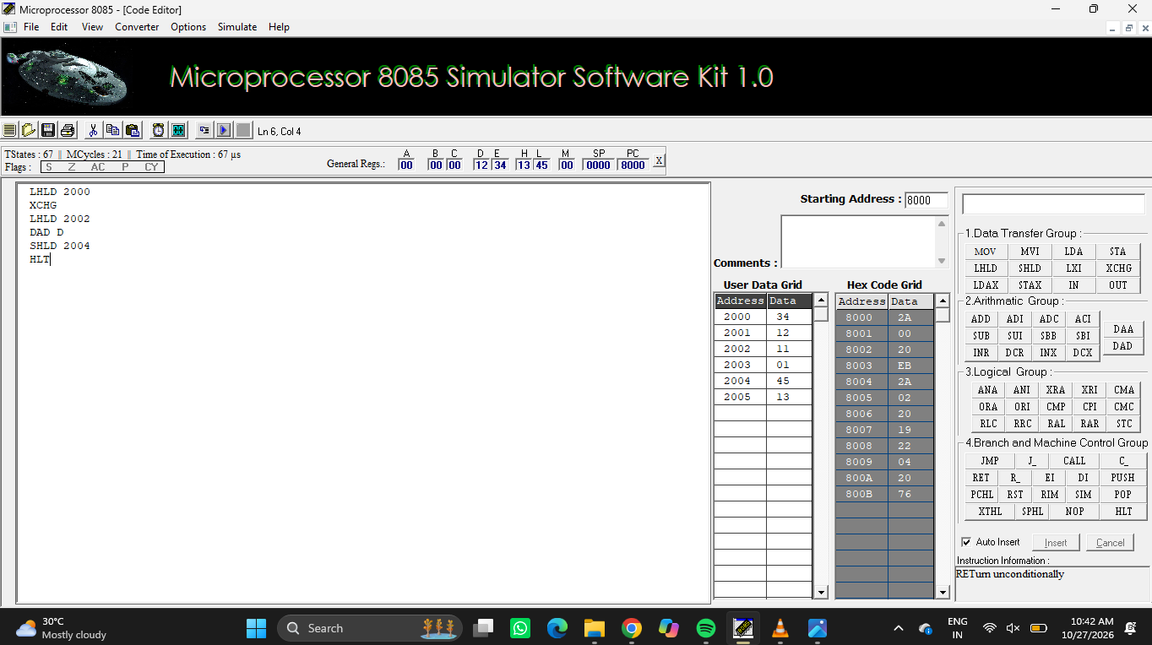

Result
The two 16-bit numbers were added successfully. The result 1345H was stored at 2005H-2004H (high byte-low byte).

EXPERIMENT 6: 16-bit Subtraction

Aim
To subtract one 16-bit number from another using the 8085 microprocessor, including borrow propagation, and store the difference.

Procedure
- Open Microprocessor 8085 Simulator Software Kit 1.0.
- Set the starting address to 8000H and enter the program in the code editor.
- Enter the input data in the User Data Grid at the memory addresses specified below.
- Assemble/execute the program using the simulator controls.
- Check the result in the User Data Grid and compare it with the expected hexadecimal result.

Program
LDA 2000
MOV B A
LDA 2002
MOV C A
MOV A B
SUB C
STA 2004
LDA 2001
MOV B A
LDA 2003
MOV C A
MOV A B
SBB C
STA 2005
HLT

Input
Memory address | Data (Hex) | Meaning
2000H | 34H | Minuend, low byte
2001H | 12H | Minuend, high byte
2002H | 11H | Subtrahend, low byte
2003H | 01H | Subtrahend, high byte

Output
Memory address | Data (Hex) | Meaning
2004H | 23H | Difference, low byte
2005H | 11H | Difference, high byte

Simulator Output Screenshot
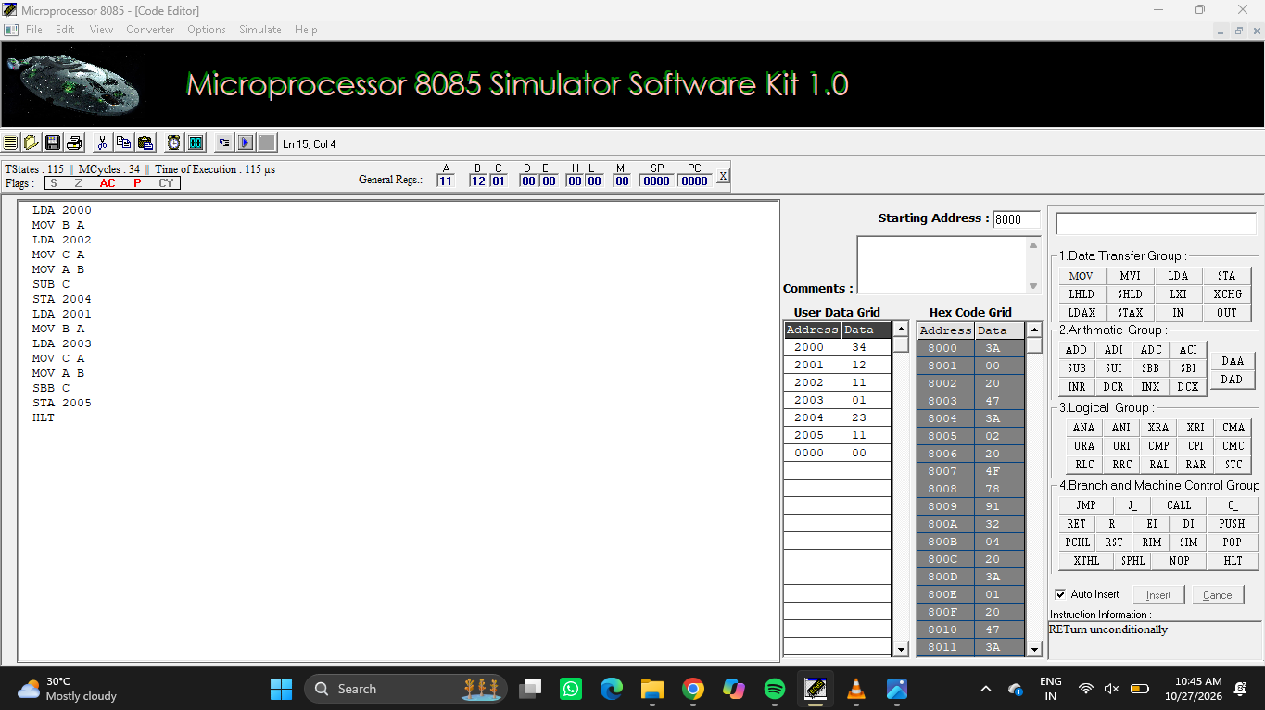

Result
The 16-bit subtraction was completed successfully. The difference 1123H was stored at 2005H-2004H.

EXPERIMENT 7: 16-bit Multiplication

Aim
To multiply a 16-bit number by a 16-bit number using repeated addition and store the 16-bit product.

Procedure
- Open Microprocessor 8085 Simulator Software Kit 1.0.
- Set the starting address to 8000H and enter the program in the code editor.
- Enter the input data in the User Data Grid at the memory addresses specified below.
- Assemble/execute the program using the simulator controls.
- Check the result in the User Data Grid and compare it with the expected hexadecimal result.

Program
LHLD 2000
XCHG
LHLD 2002
MOV B H
MOV C L
LXI H 0000
LOOP: MOV A B
ORA C
JZ DONE
DAD D
DCX B
JMP LOOP
DONE: SHLD 2004
HLT

Input
Memory address | Data (Hex) | Meaning
2000H | 05H | First number, low byte
2001H | 00H | First number, high byte
2002H | 03H | Second number, low byte
2003H | 00H | Second number, high byte

Output
Memory address | Data (Hex) | Meaning
2004H | 0FH | Product, low byte
2005H | 00H | Product, high byte

Simulator Output Screenshot
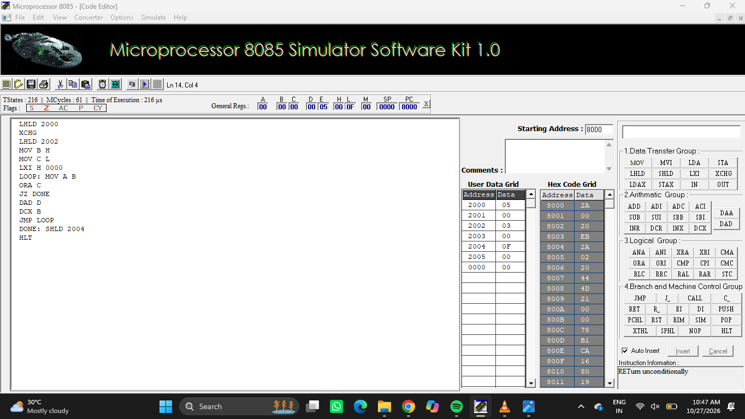

Result
The multiplication was performed successfully by repeated addition. The 16-bit result 000FH was stored at 2005H-2004H.

EXPERIMENT 8: 16-bit Division

Aim
To divide a 16-bit dividend by a 16-bit divisor using repeated subtraction and store both quotient and remainder.

Procedure
- Open Microprocessor 8085 Simulator Software Kit 1.0.
- Set the starting address to 8000H and enter the program in the code editor.
- Enter the input data in the User Data Grid at the memory addresses specified below.
- Assemble/execute the program using the simulator controls.
- Check the result in the User Data Grid and compare it with the expected hexadecimal result.

Program
LHLD 2002
XCHG
LHLD 2000
LXI B 0000
LOOP: MOV A L
SUB E
MOV L A
MOV A H
SBB D
MOV H A
JC RESTORE
INX B
JMP LOOP
RESTORE: DAD D
DONE: SHLD 2006
MOV H B
MOV L C
SHLD 2004
HLT

Input
Memory address | Data (Hex) | Meaning
2000H | 14H | Dividend, low byte
2001H | 00H | Dividend, high byte
2002H | 04H | Divisor, low byte
2003H | 00H | Divisor, high byte

Output
Memory address | Data (Hex) | Meaning
2004H | 05H | Quotient, low byte
2005H | 00H | Quotient, high byte
2006H | 00H | Remainder, low byte
2007H | 00H | Remainder, high byte

Simulator Output Screenshot
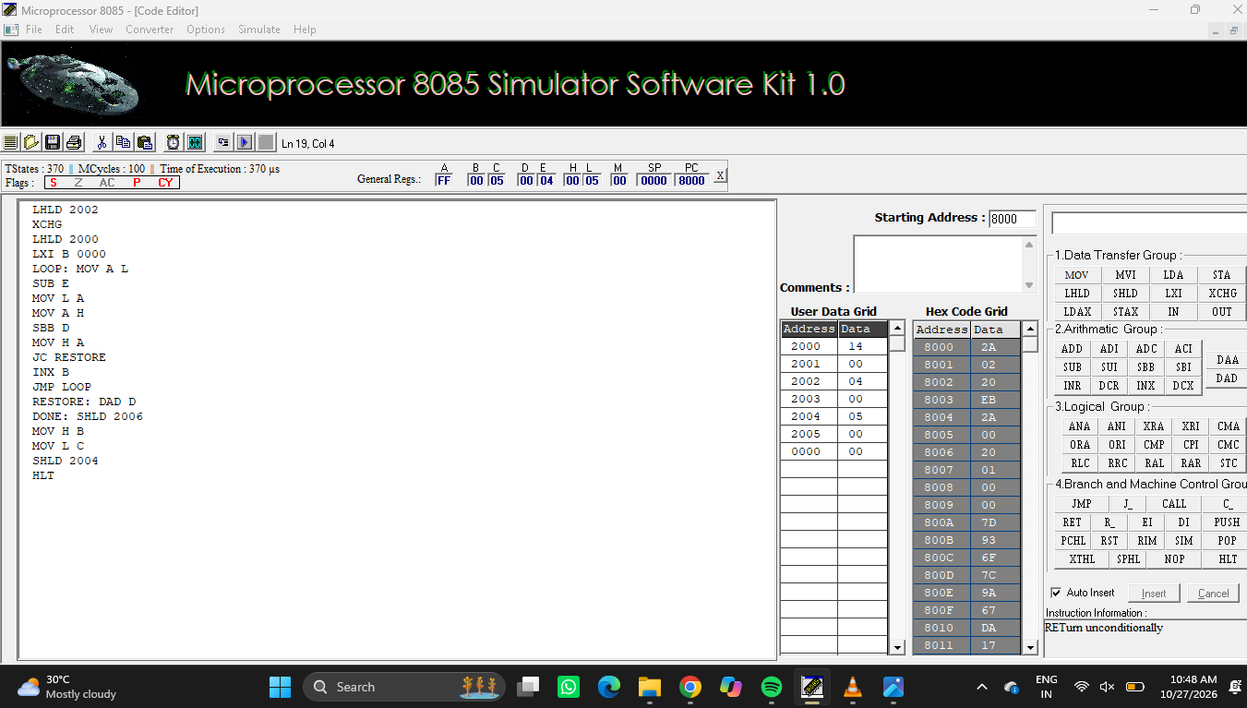

Result
The 16-bit division was completed successfully. The quotient 0005H and remainder 0000H were stored in memory.

