EXPERIMENT 2:LOGICAL, BIT-MANIPULATION AND SHIFT OPERATIONS
USING 8-BIT AND 16-BIT DATA MANIPULATION
8086 Assembly Language Programming – EMU8086

EXP 2(a): Verification of Bit Masking Operations Using 8-Bit Processor Assembly Language Programming
Aim: To verify bit masking operations using the AND logical instruction in 8086 assembly language.
Procedure:
- Open the EMU8086 application and create a new assembly program.
- Type the bit masking program in the editor.
- Click the ASSEMBLE button to compile the program.
- Click RUN or EMULATE to execute the instructions.
- Observe the AL register after the AND operation is performed.
- Verify that the result is 0AH and record the output.

Program
ORG 100H
MOV AL, 5AH
AND AL, 0FH
HLT

Input
Initial value: AL = 5AH
Mask value: 0FH

Output
After execution, AL = 0AH.
Verification: 5AH AND 0FH = 0AH.

EMU8086 Output Screenshot
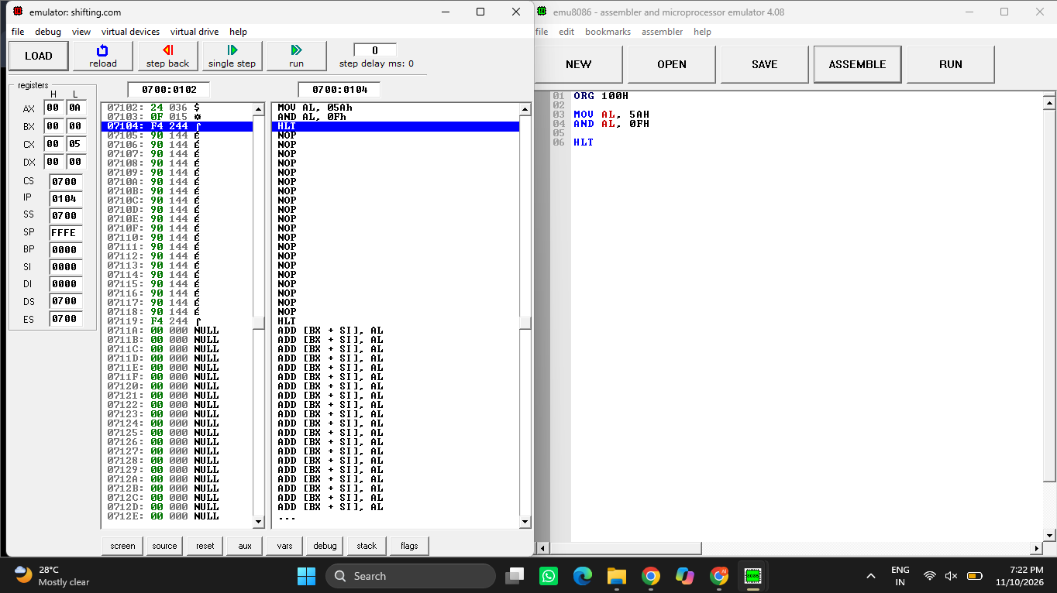
Figure 1: Output of bit masking operation in EMU8086.
Result: Thus, the bit masking operation was successfully verified using the AND instruction in 8086 assembly language.

EXP 2(b): Testing of Bit Setting and Clearing Operations Using 8-Bit Assembly Language Programming
Aim: To perform and test bit setting and bit clearing operations using OR and AND instructions in 8086 assembly language.
Procedure:
- Open EMU8086 and create a new program.
- Load the value 25H into the AL register.
- Use the OR instruction with 08H to set the selected bit.
- Load the original value 25H into the BL register.
- Use the AND instruction with 0F7H to clear the selected bit.
- Assemble and run the program, then verify the AL and BL register values.

Program
ORG 100H
MOV AL, 25H
OR AL, 08H
MOV BL, 25H
AND BL, 0F7H
HLT

Input
Original value: 25H
Bit-setting mask: 08H
Bit-clearing mask: 0F7H

Output
After setting the bit: AL = 2DH.
After clearing the bit: BL = 25H.
The emulator screenshot shows AX = 002DH and BX = 0025H.

EMU8086 Output Screenshot
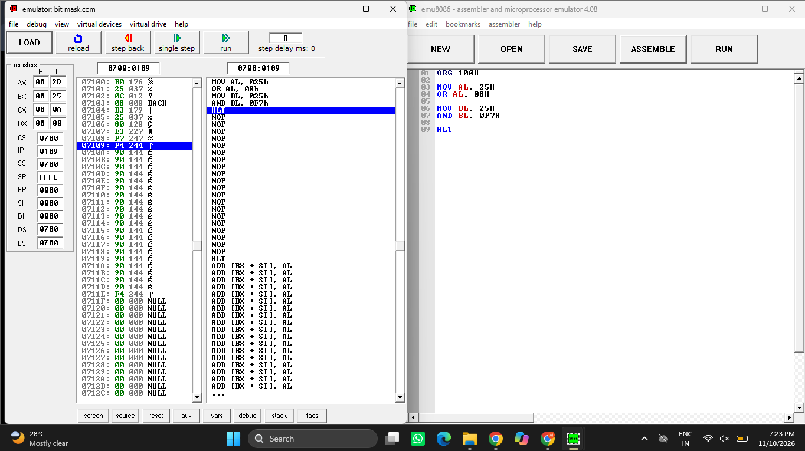
Figure 2: Output of bit setting and clearing operations in EMU8086.
Result: Thus, bit setting and bit clearing operations were successfully tested using the OR and AND instructions in 8086 assembly language.

