EXPERIMENT 3
MULTI-BYTE DATA AND ARRAY OPERATIONS USING 8086
Software / Simulation – EMU8086
PROGRAM 1: ADDITION OF ARRAY ELEMENTS
Aim
To write and execute an 8086 assembly language program to add the elements of an array and store the sum in memory.
Procedure
- Open the EMU8086 assembler and create a new program.
- Enter the array elements and initialize the SUM variable.
- Load the starting address of the array into the SI register.
- Set CX to the number of array elements and clear AX to zero.
- Add each array element to AX using a loop and increment SI.
- Store the final sum in SUM, assemble the program, run it, and check the result in memory.
Program
ORG 100H
JMP START
ARR DB 10H, 20H, 30H, 40H, 50H
SUM DW 0000H
START:
MOV SI, OFFSET ARR
MOV CX, 05
MOV AX, 0000H
L1:
MOV BL, [SI]
MOV BH, 00H
ADD AX, BX
INC SI
LOOP L1
MOV SUM, AX
HLT
Input
Array elements: 10H, 20H, 30H, 40H, 50H
Output
The sum of the array elements is 00F0H (240 in decimal).
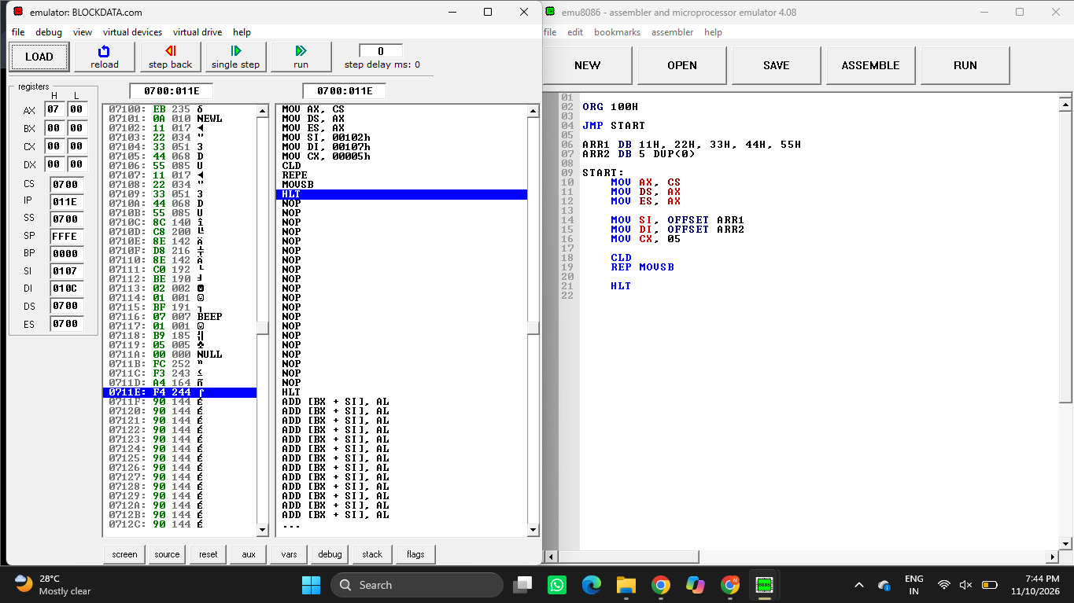
Figure 1: EMU8086 program execution – addition of array elements.
Result
Thus, the 8086 assembly language program to add the elements of an array was executed successfully, and the sum 00F0H was stored in the SUM variable.

PROGRAM 2: BLOCK DATA TRANSFER
Aim
To write and execute an 8086 assembly language program to transfer a block of data from one array location to another using the string instruction MOVSB.
Procedure
- Open EMU8086 and create a new program.
- Declare the source array ARR1 and destination array ARR2.
- Load the code segment value into DS and ES.
- Load the starting addresses of ARR1 and ARR2 into SI and DI.
- Set CX to 05 and clear the direction flag using CLD.
- Execute REP MOVSB to transfer the bytes, assemble the program, run it, and inspect ARR2.
Program
ORG 100H
JMP START
ARR1 DB 11H, 22H, 33H, 44H, 55H
ARR2 DB 5 DUP(0)
START:
MOV AX, CS
MOV DS, AX
MOV ES, AX
MOV SI, OFFSET ARR1
MOV DI, OFFSET ARR2
MOV CX, 05
CLD
REP MOVSB
HLT
Input
Source array ARR1: 11H, 22H, 33H, 44H, 55H
Destination array ARR2: five bytes initialized to 00H.
Output
After execution, ARR2 contains: 11H, 22H, 33H, 44H, 55H.
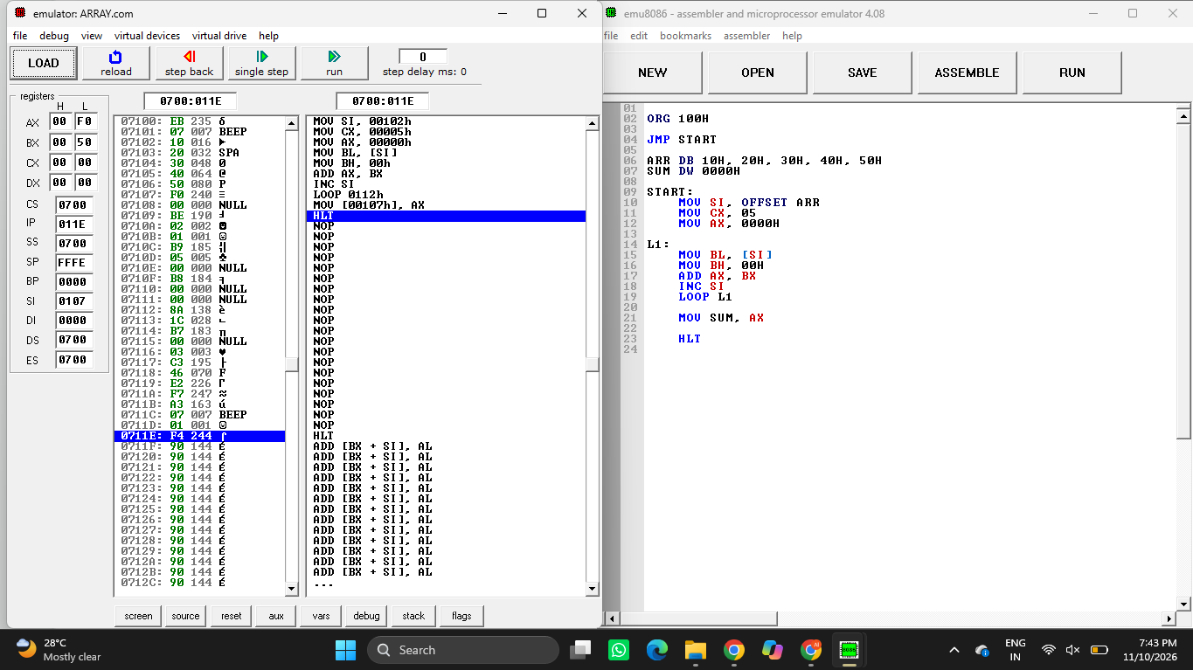
Figure 2: EMU8086 program execution – block data transfer.
Result
Thus, the 8086 assembly language program to transfer a block of data from ARR1 to ARR2 using REP MOVSB was executed successfully.

