EXPERIMENT 4
STRING COMPARISON AND STRING TRANSFER USING 8086
8086 Assembly Language Programming – EMU8086

EXP 4(a): Compare Two Strings Using 8086 Assembly Language
Aim: To compare two strings using the CMPSB instruction in 8086 assembly language and identify whether they are equal.
Procedure:
- Open EMU8086 and create a new assembly language program.
- Declare the two strings STR1 and STR2 and a RESULT variable.
- Initialize the data segment and load the offsets of the strings into SI and DI.
- Load the number of characters to compare into the CX register.
- Use CLD and REPE CMPSB to compare the strings byte by byte.
- Check the comparison result and store 01H if equal or 00H if not equal; run the program and verify RESULT.

Program
ORG 100H
JMP START
STR1 DB 'HELLO'
STR2 DB 'HELLO'
RESULT DB 00H
START:
MOV AX, CS
MOV DS, AX
MOV ES, AX
MOV SI, OFFSET STR1
MOV DI, OFFSET STR2
MOV CX, 05
CLD
REPE CMPSB
JNE NOTEQUAL
MOV RESULT, 01H
JMP EXIT
NOTEQUAL:
MOV RESULT, 00H
EXIT:
HLT

Input
STR1 = HELLO
STR2 = HELLO
Number of characters = 5

Output
RESULT = 01H (The two strings are equal.)
The comparison stops after all five characters match.

EMU8086 Output Screenshot
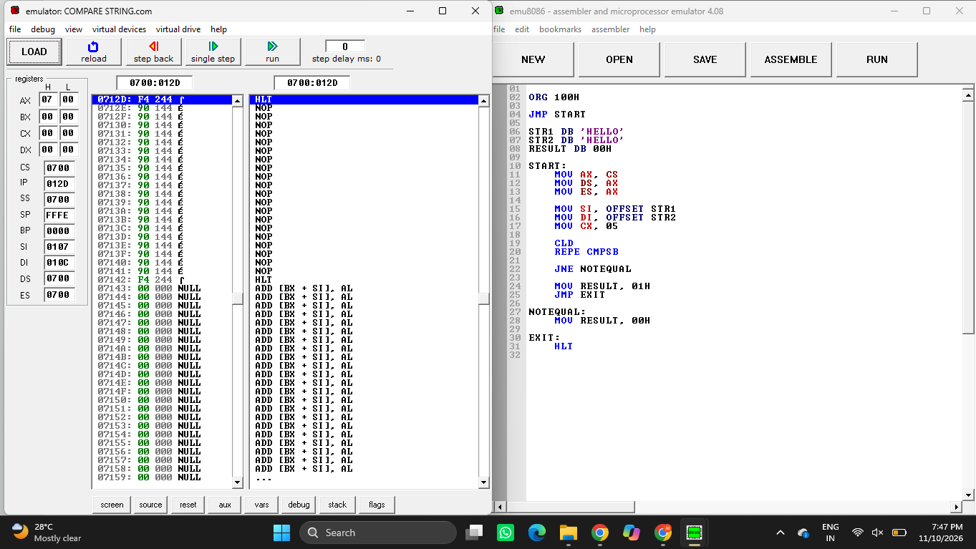
Figure 1: EMU8086 execution of the string comparison program.
Result: Thus, the two strings were successfully compared using the REPE CMPSB instruction. Since both strings contain HELLO, the result is 01H, indicating that they are equal.

EXP 4(b): Transfer a String Using 8086 Assembly Language
Aim: To transfer a string from the source memory location to the destination memory location using the MOVSB instruction in 8086 assembly language.
Procedure:
- Open EMU8086 and create a new assembly language program.
- Declare the source string STR1 and reserve five bytes for the destination string STR2.
- Initialize DS and ES with the code segment address.
- Load the source address into SI and the destination address into DI.
- Load 5 into CX, clear the direction flag using CLD, and execute REP MOVSB.
- Run the program and check that all five characters are copied to the destination string.

Program
ORG 100H
JMP START
STR1 DB 'HELLO'
STR2 DB 5 DUP(0)
START:
MOV AX, CS
MOV DS, AX
MOV ES, AX
MOV SI, OFFSET STR1
MOV DI, OFFSET STR2
MOV CX, 0005H
CLD
REP MOVSB
HLT

Input
Source string STR1 = HELLO
Destination string STR2 = 5 bytes initialized to 00H
Number of bytes to transfer = 5

Output
Destination string STR2 = HELLO
The five characters H, E, L, L and O are copied from STR1 to STR2.

EMU8086 Output Screenshot
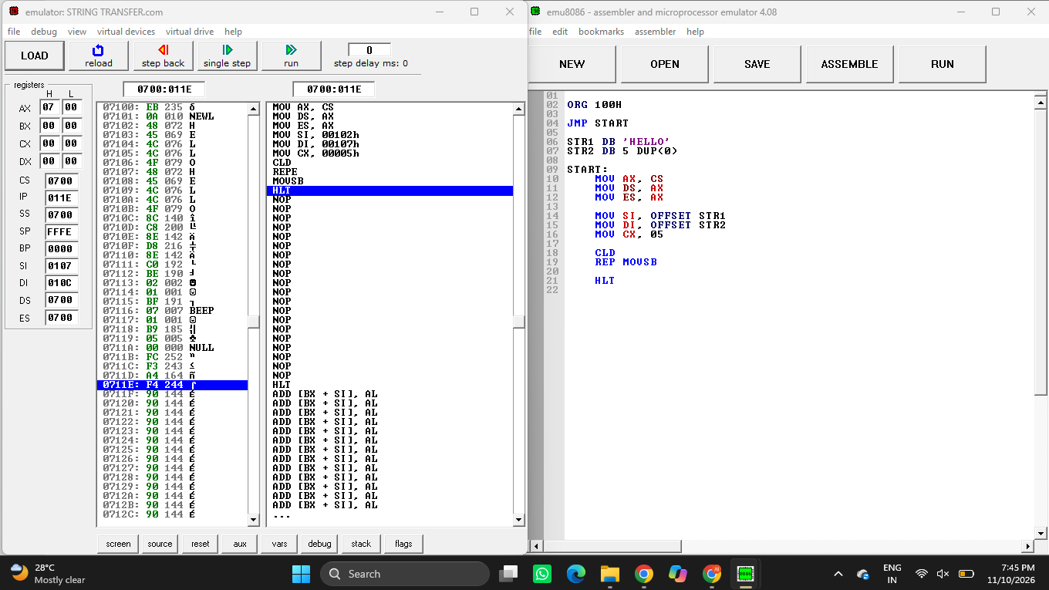
Figure 2: EMU8086 execution of the string transfer program.
Result: Thus, the string HELLO was successfully transferred from the source location to the destination location using the REP MOVSB instruction.

