EXPERIMENT – 5
FACTORIAL, SQUARE AND SUBROUTINE
8086 MICROPROCESSOR

1. AIM
To write and execute 8086 Assembly Language Programs to calculate the factorial of a given number, find the square of a given number, and perform addition using a subroutine.

2. PROCEDURE
- Open the EMU8086 emulator.
- Click on New to create a new assembly language program.
- Type the required 8086 assembly language code.
- Save the program with the .asm extension.
- Click on Assemble to check the program for errors.
- Click on Run to execute the program.
- Observe the output in the registers and memory locations.
- Verify the result and take a screenshot of the execution.

3. PROGRAM 1 – FACTORIAL OF A NUMBER
ORG 100H
JMP START
NUM DB 05H
FACT DW 0000H
START:
MOV AX, 0001H
MOV BL, NUM
L1:
MUL BL
DEC BL
JNZ L1
MOV FACT, AX
HLT
Input: NUM = 05H
Output: FACT = 0078H (120 in decimal)
The factorial of 5 is 5 × 4 × 3 × 2 × 1 = 120.

4. PROGRAM 2 – SQUARE OF A NUMBER
ORG 100H
JMP START
NUM DB 05H
SQUARE DW 0000H
START:
MOV AL, NUM
MUL AL
MOV SQUARE, AX
HLT
Input: NUM = 05H
Output: SQUARE = 0019H (25 in decimal)
The square of 5 is 5 × 5 = 25.

5. PROGRAM 3 – ADDITION USING SUBROUTINE
ORG 100H
JMP START
A DB 10H
B DB 20H
SUM DB 00H
START:
MOV AL, A
MOV BL, B
CALL ADDITION
MOV SUM, AL
HLT
ADDITION PROC
ADD AL, BL
RET
ADDITION ENDP
Input: A = 10H, B = 20H
Output: SUM = 30H (48 in decimal)
The subroutine adds the two numbers and returns the sum in AL.

6. SCREENSHOTS

Factorial program execution
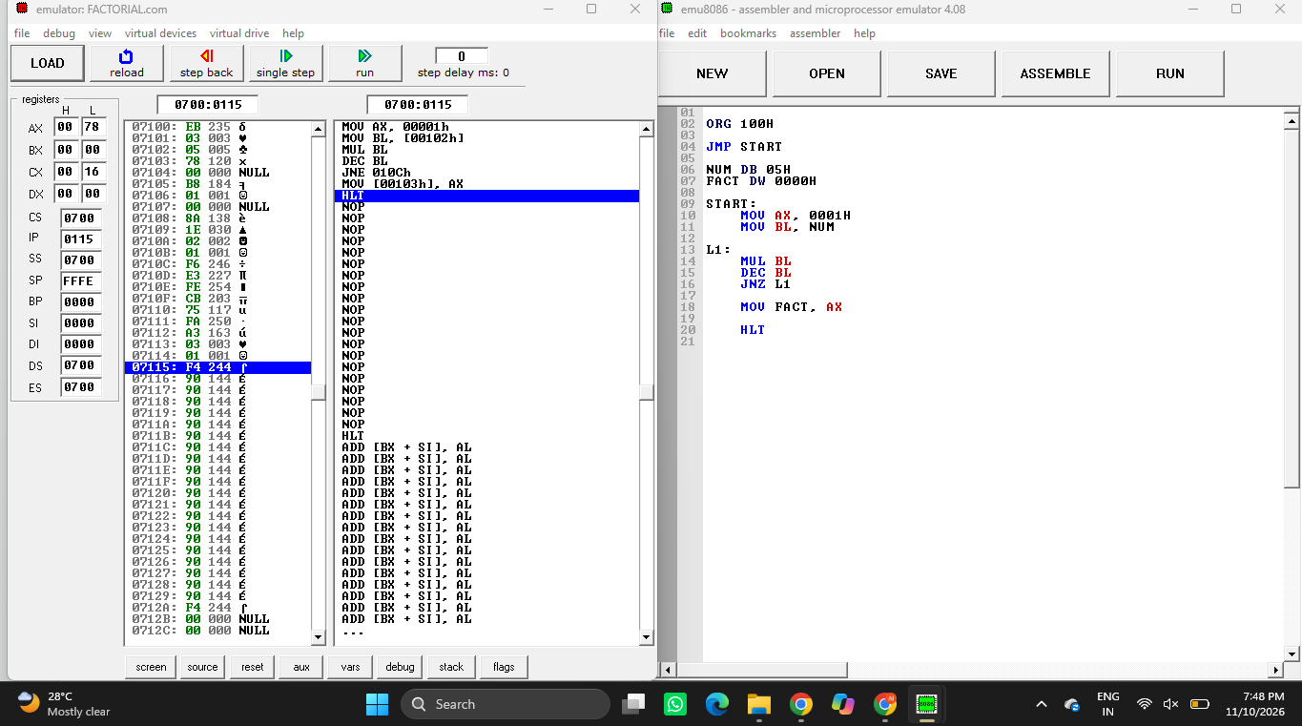
Square program execution
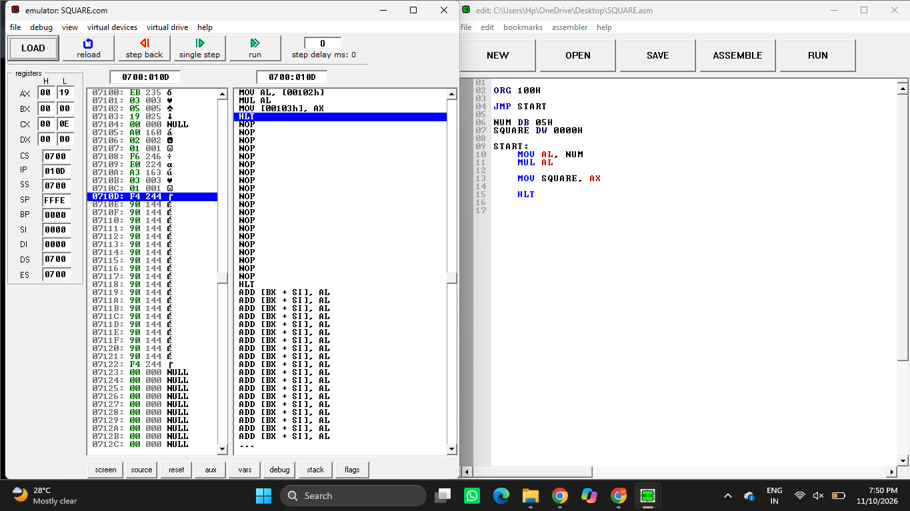

Addition using subroutine execution
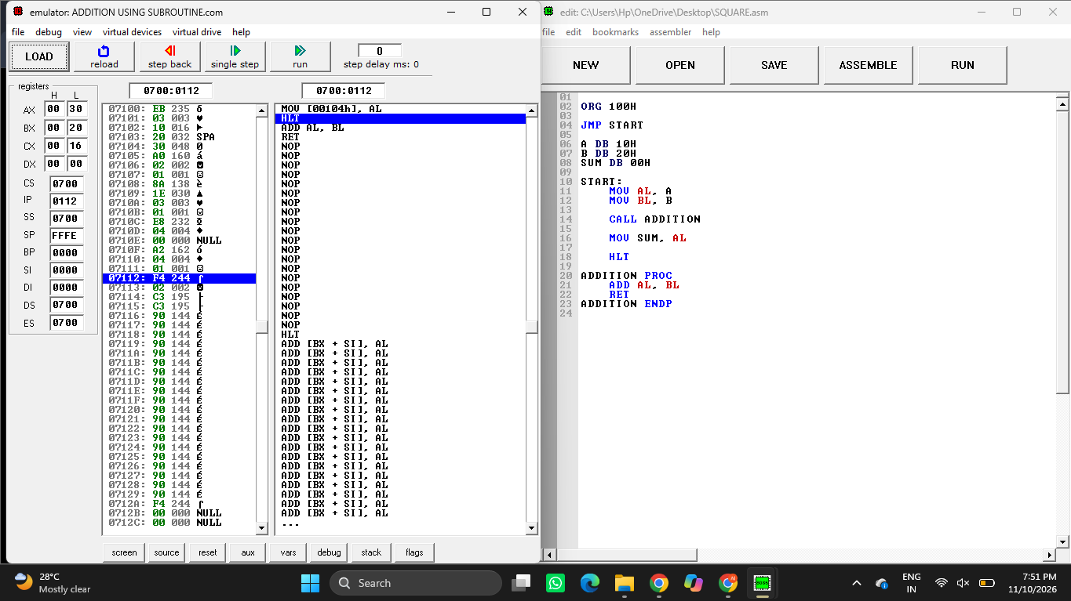

7. RESULT
Thus, the 8086 Assembly Language Programs to calculate the factorial of a number, find the square of a number, and perform addition using a subroutine were written and executed successfully in the EMU8086 emulator. The obtained outputs were verified.

