EXPERIMENT – 6
INTERRUPT HANDLING
8086 MICROPROCESSOR

1. AIM
To write and execute an 8086 Assembly Language Program to demonstrate interrupt handling by invoking a software interrupt and displaying a message on the emulator screen.

2. PROCEDURE
- Open the EMU8086 emulator.
- Click on New and type the 8086 assembly language program.
- Declare the message as a string ending with the $ symbol.
- Load the address of the message into the DX register.
- Set AH to 09H to select the DOS display-string service.
- Execute INT 21H to invoke the software interrupt.
- Save the program and click Assemble to check for errors.
- Click Run and observe the message displayed on the emulator screen.

3. PROGRAM – DISPLAY MESSAGE USING SOFTWARE INTERRUPT
ORG 100H
JMP START
MSG DB 'INTERRUPT HANDLING$'
START:
MOV DX, OFFSET MSG
MOV AH, 09H
INT 21H
HLT

4. INPUT
Message: INTERRUPT HANDLING
Interrupt number: 21H
AH = 09H (DOS function to display a string)

5. OUTPUT
INTERRUPT HANDLING
The message is displayed on the emulator screen by calling the DOS software interrupt INT 21H.

6. SCREENSHOTS
Screenshot 1 – Interrupt handling program and displayed message
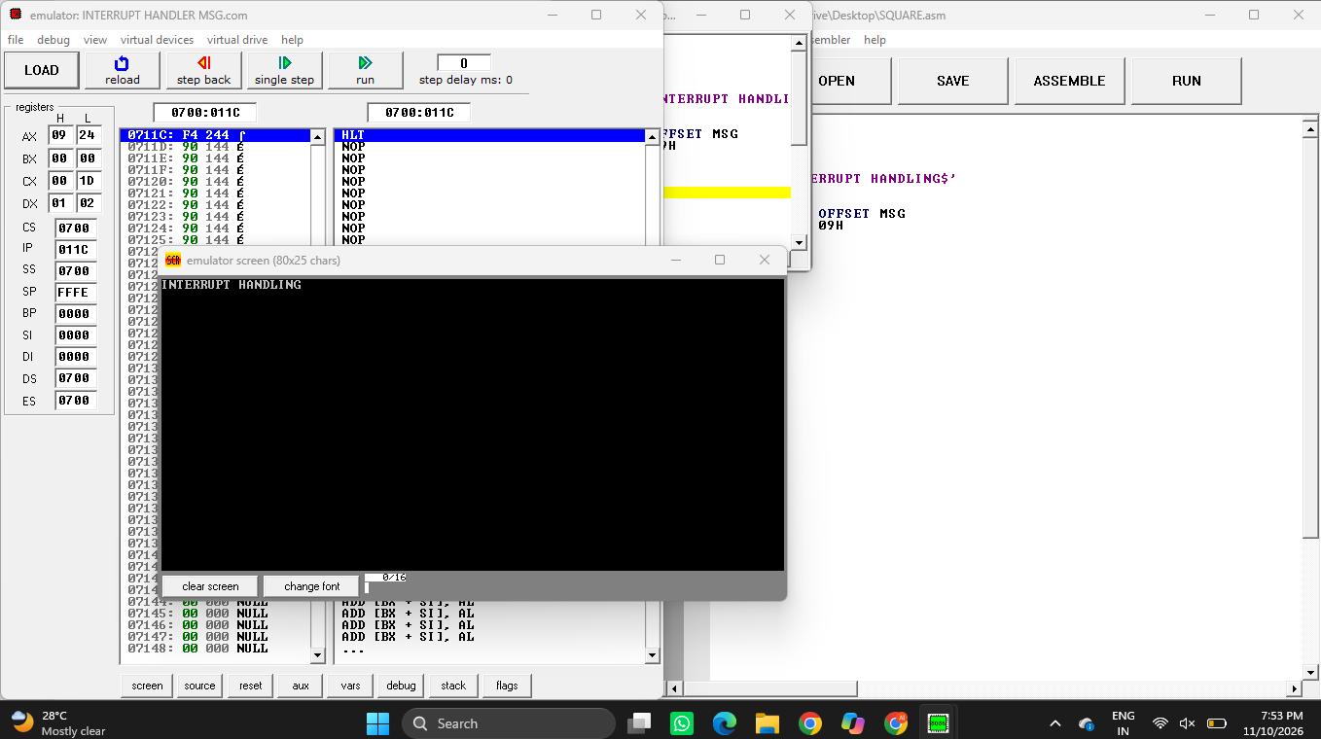
Screenshot 2 – Emulator interrupt response / additional execution view
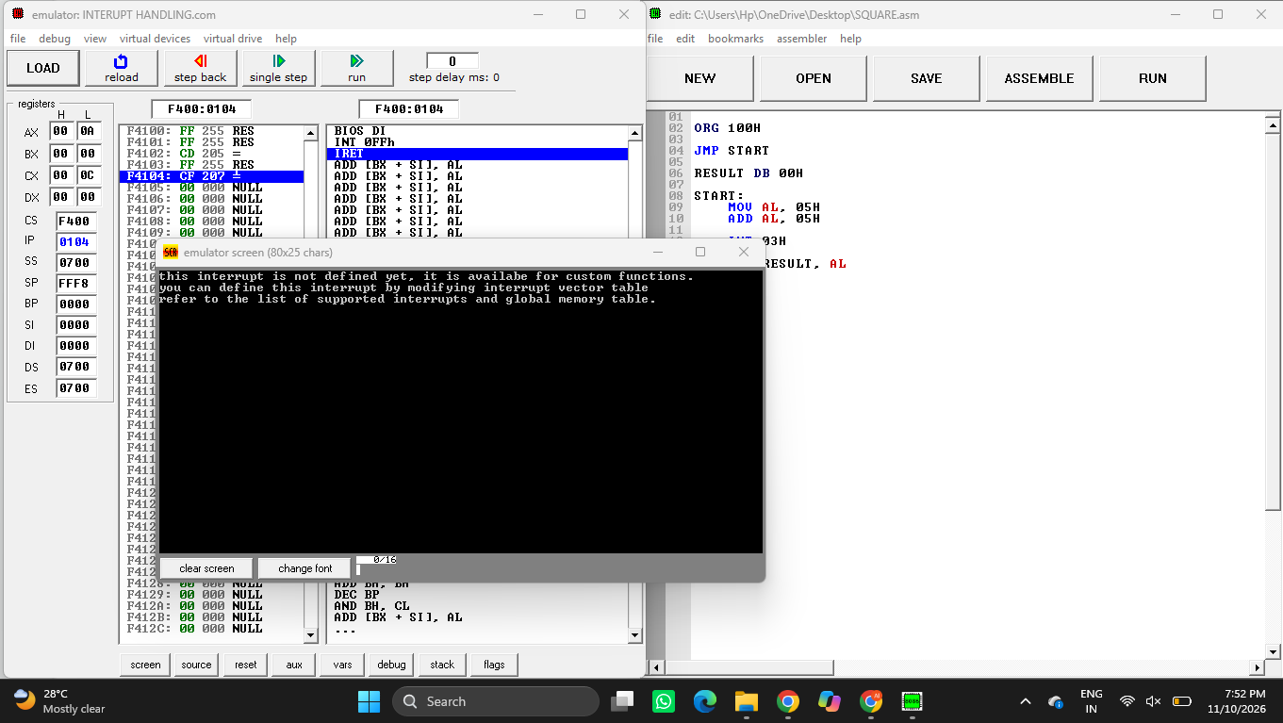

8. RESULT
Thus, the 8086 Assembly Language Program demonstrating software interrupt handling was written and executed. The message “INTERRUPT HANDLING” was displayed using INT 21H, function 09H.

