EXPERIMENT – 7
8087 COPROCESSOR
8086 MICROPROCESSOR LAB

1. AIM
To write and execute an assembly language program to multiply two 8-bit numbers and store the 16-bit result in memory.

2. PROCEDURE
- Open the EMU8086 emulator.
- Click on New and enter the assembly language program.
- Declare the two input numbers and reserve memory for the result.
- Load the first number into AL and the second number into BL.
- Use the MUL instruction to multiply AL by BL. The 16-bit result is stored in AX.
- Move the result from AX into the RESULT memory location.
- Save the program and click Assemble to check for errors.
- Click Run and verify the result in the registers and memory.

3. PROGRAM
ORG 100H
JMP START
NUM1 DB 05H
NUM2 DB 04H
RESULT DW 0000H
START:
MOV AL, NUM1
MOV BL, NUM2
MUL BL
MOV RESULT, AX
HLT

4. INPUT
NUM1 = 05H (5 in decimal)
NUM2 = 04H (4 in decimal)

5. OUTPUT
AX = 0014H
RESULT = 0014H (20 in decimal)
Calculation: 05H × 04H = 0014H

6. SCREENSHOT
EMU8086 program and execution output
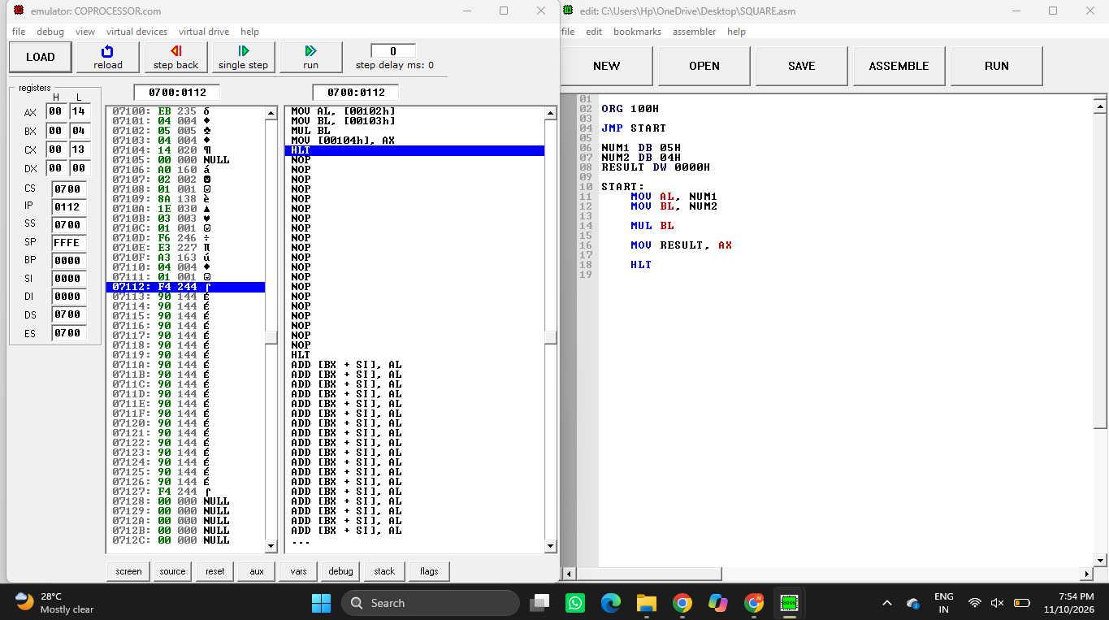

8. RESULT
Thus, the assembly language program to multiply two 8-bit numbers was executed successfully. For the inputs 05H and 04H, the result obtained was 0014H (20 in decimal), and it was stored in the RESULT memory location.

