CLICK — Home Page & Navigation Research
Social platform design • User experience (UX) • Navigation research
The goal of CLICK is to make it easy for users to understand the platform, discover content, communicate with friends, join communities, and find their way back whenever they need to.
The most important design principle is clarity before complexity. When someone opens CLICK for the first time, they should immediately understand where they are, what they can do, and where to go next.

1. Research: How do users move around a social platform?
Popular social platforms provide useful examples of navigation patterns. CLICK can learn from them without copying any one platform exactly.
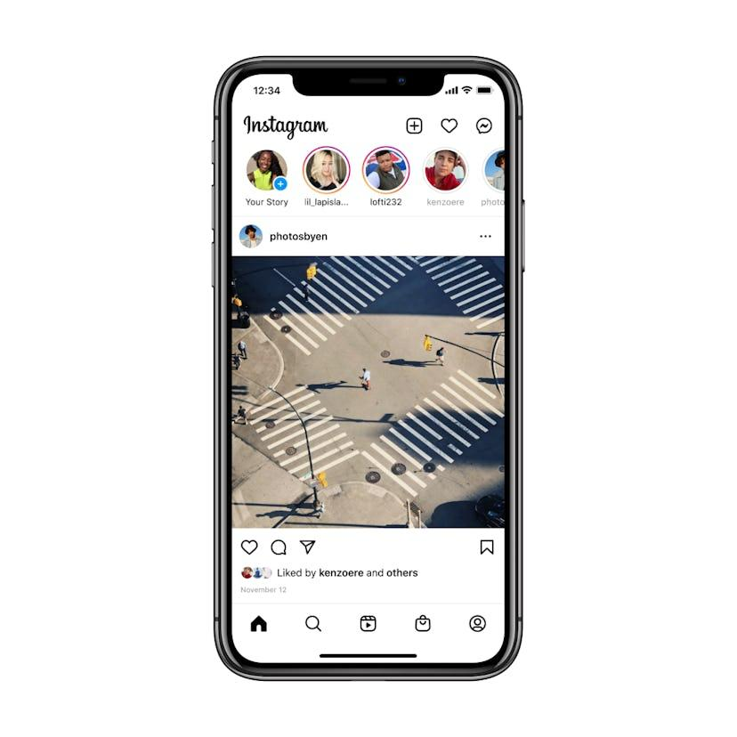
Add to Favorites
1. Instagram — content discovery
Users can browse a feed, explore content, open messages, and visit profiles. CLICK can adopt a simple home feed with clearly separated destinations for communication and discovery.
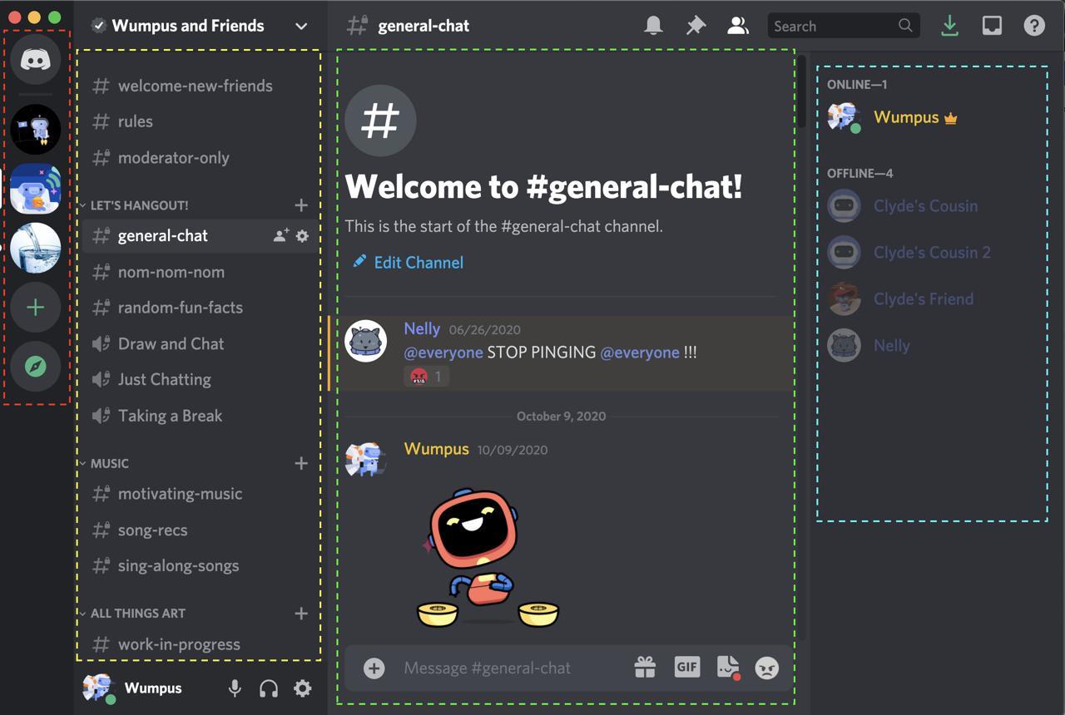
Add to Favorites
2. Discord — communication and communities
Discord organizes communication around direct messages, servers, and channels. CLICK can use a dedicated Chat area and a separate Communities area so users can distinguish private conversations from group spaces.

Discord
+1
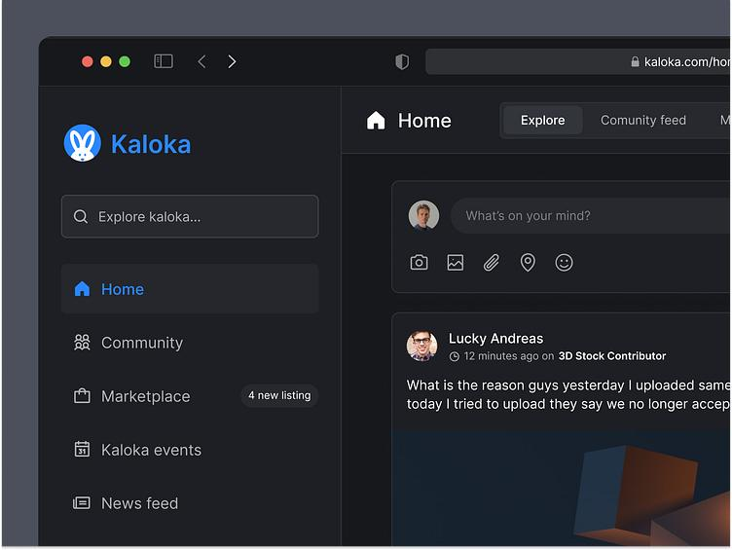
Add to Favorites
3. Desktop navigation research — visibility
Nielsen Norman Group recommends keeping navigation visible on larger screens, using understandable labels, and clearly indicating the current location. CLICK should therefore use a persistent desktop sidebar instead of hiding everything inside one menu.

NN/G
+1

2. Recommended CLICK home page
The home page should act as the user's main starting point. It should contain useful content immediately while making every major feature easy to find.

CLICK
Search people, posts and communities...
Home feed
Posts from people and communities the user follows.
Create a post
A clear “What's happening?” composer with options to share text, images, or videos.
Discover
Suggested people, trending topics, and communities to join.
Recent activity
A small preview of recent conversations, if there is enough screen space.
ILLUSTRATIVE WIREFRAME — NOT A FINISHED WEBSITE

What should users see first?
- The CLICK logo and a familiar home destination.
- A search field for finding people, posts, and communities.
- The main feed, with a clear way to create a post.
- Easy access to Chat, Communities, Notifications, and Profile.
- Optional suggestions that help new users discover useful content.
The first screen should not overwhelm users with too many panels, buttons, or unrelated features.

3. Navigation menu and main sections
I recommend five primary destinations for CLICK, plus a clearly visible search function.
Home
The main feed, followed accounts, recommended posts, and the post composer.
Communities
Browse, join, and manage interest-based groups; view group posts, discussions, and members.
Chat
Private messages, group conversations, message requests, and unread chats.
Notifications
Likes, comments, replies, mentions, follows, and community updates.
Profile
The user's posts, biography, followers, following, saved items, and account settings.
Search should be accessible from the top bar. Additional options such as Settings, Help, Saved Posts, and Log Out can appear in a secondary menu rather than competing with the main destinations.

4. Mobile navigation vs. desktop navigation
CLICK should be responsive, meaning that the layout changes to fit the screen while preserving the same essential features.

Mobile navigation

CLICK
Your Home Feed
What's happening in your world?
+ Create Post
Latest posts
Post preview and interactions
Another post preview
Home
Groups
Chat
Alerts
Profile
Mobile concept: a compact top bar and fixed bottom navigation. The illustration is a proposed design, not a functional application.
Recommended mobile layout:
- Top bar: CLICK logo, search, and a notification shortcut.
- Main content: A single-column feed that is comfortable to scroll.
- Bottom navigation: Home, Communities, Chat, Notifications, and Profile.
- Secondary menu: Settings, Help, and other less frequently used features.
A five-item bottom navigation is suitable because CLICK has five primary destinations. Keep the labels visible beneath the icons so new users do not have to guess what each icon means. Mobile UX research supports visible navigation when there are only a few major choices.
NN/G
+1

Desktop navigation

CLICK
Search CLICK...
Home
Communities
Chat
Notifications
Profile
Home Feed
Share something with your network.
Create Post
Your feed
Post, comments and reactions
More posts from your network
Desktop concept: persistent left sidebar, top search bar, and central content feed.
Recommended desktop layout:
- Left sidebar: The five main destinations, always visible.
- Top bar: CLICK logo, a wide search field, notifications, and profile access.
- Center column: The main feed and post composer.
- Optional right column: Suggested communities, people to follow, or trending topics.
Do not use a mobile-style hidden hamburger menu as the only way to access primary destinations on desktop. Visible links make the platform's structure easier to understand.
NN/G
+1

5. Where should Chat, Communities, and Notifications appear?
Feature | Mobile placement | Desktop placement | Reason
Home | Bottom bar | Top of left sidebar | Main starting point
Chat | Bottom bar | Left sidebar | Frequent access to conversations
Communities | Bottom bar | Left sidebar | Easy discovery and group participation
Notifications | Bottom bar and top shortcut | Top-right shortcut and sidebar | Makes updates easy to notice
Profile | Bottom bar | Top-right avatar and sidebar | Provides access to identity and settings
Search | Top bar | Wide top search field | Helps users find content directly
My recommendation: Keep Chat and Communities as separate destinations. Chat is for conversations; Communities is for shared interests, groups, and discussions. Notifications should have its own destination, not be buried inside the profile menu.
Use a small unread badge on Chat or Notifications when needed. Do not display a badge when there is nothing new.

6. How users should return to Home
Users should never feel trapped in a page or conversation.
CLICK should provide four reliable ways to return to Home:
- Click the CLICK logo. The logo should link to the Home feed on every major page.
- Select Home in the navigation. Keep it in the same position throughout the platform.
- Use the browser's Back button. It should behave predictably, allowing users to return to the previous page.
- Use breadcrumbs on deeper pages. For example: Home > Communities > Technology Club. Each breadcrumb should link to the relevant parent page.
Breadcrumbs are especially helpful when users enter a page directly from a shared link rather than navigating from Home first.
NN/G
+1
Avoid making users repeatedly press Back to escape a deep menu or conversation. The Home destination should remain available through the main navigation.

7. What happens when someone opens CLICK?
Open CLICK
Logo, search, and clear navigation
View Home Feed
Posts, post creation, and recommendations
Chat
Talk to people
Communities
Explore shared interests
Notifications
Check updates
Profile
Manage identity
Return to Home at any time
Logo, Home link, or predictable navigation

8. How should we test whether CLICK is easy to navigate?
Before finalizing the design, test it with a few people who have not used CLICK before. Ask them to perform these tasks without explaining where the buttons are.

Navigation test checklist
0 of 5
Find the Home feed.
Users recognize Home immediately.
Send a message to a friend.
Users can find Chat without confusion.
Find and join a community about their interests.
Users understand what Communities means.
Find a new notification.
Users can locate updates quickly.
Open a profile, then return to Home.
Users can navigate back confidently.
Observe where users hesitate, which labels they misunderstand, and how many clicks they need. Ask them to explain what they expect each menu item to do. If users cannot find a feature, improve its position or label before adding more instructions.

9. Final recommendation for your assignment
CLICK should have a content-first Home page, a visible and consistent navigation system, and responsive layouts for mobile and desktop. Use a five-item bottom navigation on mobile and a persistent left sidebar on desktop. Place Chat and Communities in the main navigation, give Notifications a dedicated destination, and make the CLICK logo a reliable route back to Home.
The central UX question is: Can a first-time user understand where everything is without needing someone to explain it? If the answer is yes, CLICK's navigation is doing its job.

