LinksInvite — Database Schema

Collaborators: Al Herndon, Mark Benson
May 2026

Document
This document defines the relational database schema design for LinksInvite. The database is hosted on Supabase using a PostgreSQL relational engine. It is architected to handle user registration, game configurations, scheduling, automated token validation, logs, and a strict FIFO (First-In, First-Out) queue for the player waitlist.

1. Schema Overview
The database comprises 7 core tables divided into foundational components (existing entities) and application updates (designated as [NEW]).
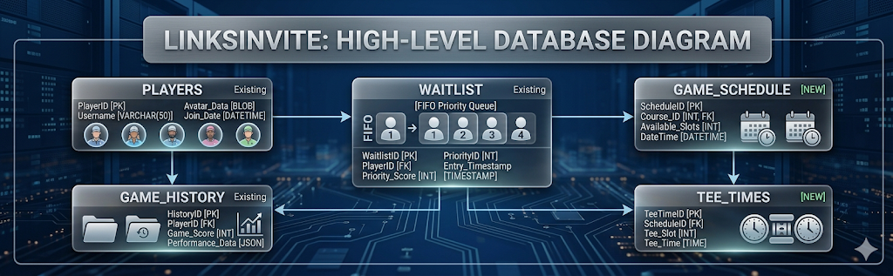

2. Table Definitions

1. players (Existing)
Stores foundational golfer profiles, authentication states, and unique encrypted tokens used for quick-action magic link registration bypasses.
Column Name | Data Type | Constraints | Description / Logic
id | UUID | PRIMARY KEY, DEFAULT gen_random_uuid() | Unique identifier for each golfer profile.
name | VARCHAR(255) | NOT NULL | Full name of the golfer.
email | VARCHAR(255) | UNIQUE, NULLABLE | Email address used for sending Resend templates.
phone | VARCHAR(50) | UNIQUE, NULLABLE | Mobile phone number used for SMS alerts.
ghin_number | VARCHAR(50) | UNIQUE, NULLABLE | USGA GHIN identifier for verification.
course_handicap | NUMERIC | NULLABLE | Player's handicap index utilized by the Balanced Pairing algorithm.
verification_token | VARCHAR(512) | UNIQUE, NULLABLE | Encrypted, player-specific token embedded in email magic links.

2. waitlist (Existing)
Maintains an accurate, real-time queue of players waiting for available openings when total game capacity limits are exceeded.
Column Name | Data Type | Constraints | Description / Logic
id | UUID | PRIMARY KEY, DEFAULT gen_random_uuid() | Unique tracking ID for the queue entry.
player_id | UUID | FOREIGN KEY -> players(id), ON DELETE CASCADE | The waitlisted player.
game_id | UUID | FOREIGN KEY -> game_schedule(id), ON DELETE CASCADE | The specific game date the player is queued for.
created_at | TIMESTAMP | NOT NULL, DEFAULT NOW() | Crucial for FIFO functionality. Identifies queue priority order.

3. game_history (Existing)
Tracks historic game logs, previous pairing fields, and results data for reference.
Column Name | Data Type | Constraints | Description / Logic
id | UUID | PRIMARY KEY, DEFAULT gen_random_uuid() | Unique tracking ID for the historical ledger.
game_date | DATE | NOT NULL | Calendar date the match occurred.
course_name | VARCHAR(255) | NOT NULL | The golf course venue.
roster_snapshot | JSONB | NOT NULL | Embedded list record of all participants and performance states.

4. tee_times [NEW]
Tracks the structure and specific scheduling increments assigned to a given game day.
Column Name | Data Type | Constraints | Description / Logic
id | UUID | PRIMARY KEY, DEFAULT gen_random_uuid() | Unique identifier for a tee time block.
game_id | UUID | FOREIGN KEY -> game_schedule(id), ON DELETE CASCADE | Linked to the active match schedule.
tee_time | TIME | NOT NULL | Incremental departure clock timestamp (defaulted to 10 minutes apart).
tee_time_email | EMAIL | VARCHAR(255) | UNIQUE, NULLABLE
player_slots | UUID[4] | ARRAY, NULLABLE (References players(id)) | Array of max 4 assigned player IDs per tee time.

5. game_schedule [NEW]
Manages temporal gatekeeping bounds, open/close registration states, and specific locations per weekly event.
Column Name | Data Type | Constraints | Description / Logic
id | UUID | PRIMARY KEY, DEFAULT gen_random_uuid() | Unique identifier for the game event.
game_date | DATE | NOT NULL | Scheduled calendar date for the weekly round.
course_name | VARCHAR(255) | DEFAULT 'Newnan Country Club' | Selected venue (defaults to Newnan Country Club, GA).
registration_open | TIMESTAMP | NOT NULL | Epoch time boundary defining when signups open.
registration_close | TIMESTAMP | NOT NULL | Explicit cutoff time (Locks 1 hour before first tee time by default).
status | VARCHAR(50) | DEFAULT 'Not Yet Open' | Current lifecycle phase: Not Yet Open, Open, Closed / Locked, or Cancelled.

6. game_config [NEW]
Houses backend administrative toggle adjustments and systemic algorithmic configurations.
Column Name | Data Type | Constraints | Description / Logic
id | UUID | PRIMARY KEY, DEFAULT gen_random_uuid() | Unique configuration instance ID.
pairing_mode | VARCHAR(50) | DEFAULT 'None' | Dictates pairings via No Pairings, Balanced Pairing (snake-distribution) or Random Shuffle.
active_days | INT[] | DEFAULT '{0}' | Array of integers reflecting scheduled weekdays for cron checks.
tee_time_assignment | BOOLEAN | DEFAULT TRUE | Toggles instant slot allocation (ON) vs general pool grouping for later manual sorting (OFF).

7. admin_event_log [NEW]
Audit trail capturing system events, critical manual overrides, capacity modifications, or outright cancellations executed by the game organizer.
Column Name | Data Type | Constraints | Description / Logic
id | UUID | PRIMARY KEY, DEFAULT gen_random_uuid() | Unique entry record tracking ID.
admin_id | UUID | NULLABLE | Identifier of the administrator making changes.
action_type | VARCHAR(100) | NOT NULL | Action executed (e.g., CANCEL_GAME, ADD_TEE_TIME, TOGGLE_PAIRING).
log_details | TEXT | NOT NULL | String overview logging specific state context alterations.
created_at | TIMESTAMP | DEFAULT NOW() | Event timestamp.

3. Core Structural Logic & Database Rules

⚠️ Strict Waitlist FIFO Rule
When capacity changes occur (such as adding extra tee slots): * Logic scans waitlist sequentially sorted by created_at ASC. * It shifts up to 4 eligible players from the queue, changes their operational states to registered players, and wipes those specific rows from the waitlist table.

🔒 Dynamic Temporal Bounds
Real-time database checks validate updates using game_schedule rules: * NOW() < registration_open ➡️ Rejects modifications (Returns Not Yet Open block). * NOW() > registration_close ➡️ Rejects modifications (Returns Closed / Locked boundary error). * If status == 'Cancelled' ➡️ Strict block preventing any interactive signups.

Appendix A: Database Schema ERD
