LinksInvite
System Architecture Document
Version 2.0 — Gap Analysis + Feature Updates
Collaborators: Al Herndon, Mark Benson
Prepared: May 2026

0. Executive Summary
This document presents an updated architecture for LinksInvite, a premium weekly golf game organizer. It covers:
- A structured gap analysis of the original v1.0 architecture
- Four specific issues flagged by the project owner
- New and revised features incorporated into the updated system design
- Revised data models, API contracts, and automation workflows

Key changes from v1.0 include a three-mode pairing engine (Blind Draw / Balanced / No Pairings), a live game format recommendation engine, a flat sign-up list as the default roster view, multi-day scheduling support, and a fix for tee time configuration not feeding through to the front end.

1. Gap Analysis — v1.0 Architecture
The following gaps and bugs were identified through a review of the original architecture document and project owner feedback.

Area | Current Gap / Issue | Recommended Fix
Tee Time Config | TTimes set in Railway/supabase.js are not feeding through to the frontend. Data pipeline broken between backend config and React state. | Expose a dedicated GET /api/config/teetimes endpoint; frontend fetches on load and stores in React context.
Pairing Engine | Only two modes documented (Balanced / Random). No Blind Draw option. No logic for odd vs. even player count format selection. | Add three modes: Blind Draw, Balanced Pairings, No Pairings. Add live format recommendation engine.
Roster Display | Architecture implies foursome-grouped display. Does not support a simple flat player list (Chip-style) as the default view. | Replace default view with a flat, numbered sign-up list. Foursomes view becomes a toggle or secondary tab.
Multi-Day Scheduling | System assumes a single game day (Saturday). 'Next Game' date logic fails when game moves to Sunday or spans both days. | Admin configures one or more game days per week. Frontend dynamically resolves 'Next Game' from the nearest upcoming day.
Format Logic | No automated game format recommendation based on field size. Format (points vs 2 best balls) is manual. | Backend calculates player count after registration closes and sets a recommended format flag, surfaced to admin and players.
Error Handling / Fallbacks | No documented fallback if Resend, Open-Meteo, or Nominatim are unavailable. No retry logic described. | Document retry policies and graceful degradation for all third-party calls.
Admin Visibility | Admin Suite capabilities are mentioned but not fully described. No audit trail or event log documented. | Add admin event log model to DB schema. Log roster changes, promotions, email sends with timestamps.

2. Owner-Reported Issues & Resolutions

Issue A — Tee Time Config Not Feeding Through
TTimes are being set inside Railway's supabase.js but are not rendering on the frontend.

Root Cause
Tee time values are written directly into server-side configuration rather than being stored in the database and exposed via a dedicated API endpoint. The React frontend has no mechanism to fetch them at runtime.

Resolution
- Create a tee_times table in Supabase with columns: id, day_of_week, start_time, slots, created_at.
- Add a GET /api/config/teetimes route on the Railway backend that queries this table.
- In src/api.js, add a fetchTeeTimes() method that calls this endpoint on app load.
- Store the result in React context (or a lightweight state manager) and consume it wherever tee times are rendered.

Issue B — Pairing Engine Modes
The original architecture only documented two pairing modes. The owner requires three distinct modes plus a live format recommendation based on field size.

Three Pairing Modes
- Blind Draw — Players are randomly grouped with no regard to handicap. Assignments are generated at lock-out time and displayed to all participants.
- Balanced Pairings — The existing snake-distribution algorithm. Players ranked by GHIN / Course Handicap are spread evenly across foursomes.
- No Pairings — No grouping is applied. The system displays a flat numbered list of registrants only.

Live Field Recommendation Engine
After the registration window closes (or on-demand via the Admin Suite), the backend evaluates the confirmed player count and sets a recommended_format flag:
- Odd number of confirmed players → Recommend Points game.
- Even number of confirmed players → Recommend 2 Best Balls.
This recommendation is surfaced as a banner in the Admin Suite and in the outbound game-day email. The admin can accept or override the recommendation before it is broadcast to players.

Issue C — Flat Sign-Up List (Chip-Style Roster)
The current architecture implies a foursome-grouped display as the default. The owner prefers a simple, flat list showing all registrants in the order they signed up.

Resolution
- The default roster view is replaced with a flat, numbered list sorted by registration timestamp.
- Each row displays: Position #, Player Name, GHIN / Course Handicap, Registration Time, Status (Registered / Waitlist).
- Foursome groupings (when a pairing mode is active) appear as a secondary view toggled by a tab or button labeled 'View Foursomes.'
- The waitlist section renders below the confirmed list with a clear visual separator.

Issue D — Multi-Day Scheduling (Saturday + Sunday Support)
The 'Next Game' date was hardcoded to Saturday logic. When the game falls on Sunday, or spans both days, the display showed the wrong date.

Resolution
- Admins configure game_days in the Admin Suite: one or both of Saturday / Sunday can be enabled per week.
- A scheduled backend job runs at midnight each day and evaluates the game_days configuration to determine the next upcoming game date.
- The frontend fetches GET /api/game/next and displays the resolved date and day name dynamically.
- If both Saturday and Sunday are active in the same week, both dates are shown on the frontend as separate upcoming events.
- The registration open/close window and lockout logic are evaluated independently for each active game day.

Discussion Note: The owner flagged this as an open question ('we should discuss'). The architecture above supports both single-day and dual-day configurations. The recommended default is to activate one day at a time and toggle the second day manually via the Admin Suite.

3. Updated Feature Summary

Feature | Status | Description
Blind Draw | New | Admin selects; players randomly assigned without skill weighting.
Balanced Pairings | Existing / Enhanced | Snake distribution by GHIN/Course Handicap. Now a named selectable mode.
No Pairings | New | Show all registrants as a flat list only; no grouping applied.
Live Format Recommendation | New | Odd count → Points game recommended. Even count → 2 Best Balls recommended.
Flat Sign-Up List View | New | Default roster view is a numbered list of registrants in sign-up order.
Multi-Day Game Support | New | Admin sets Saturday and/or Sunday; system resolves next upcoming game date.
Tee Time Config Feed | Bug Fix | GET /api/config/teetimes endpoint surfaces Railway-stored values to frontend.
Admin Event Log | New | All roster changes, email sends, and promotions written to audit table.

4. Revised System Architecture

4.1 Architecture Overview
The decoupled architecture from v1.0 is retained. The following diagram reflects new endpoints and data flows added in v2.0:

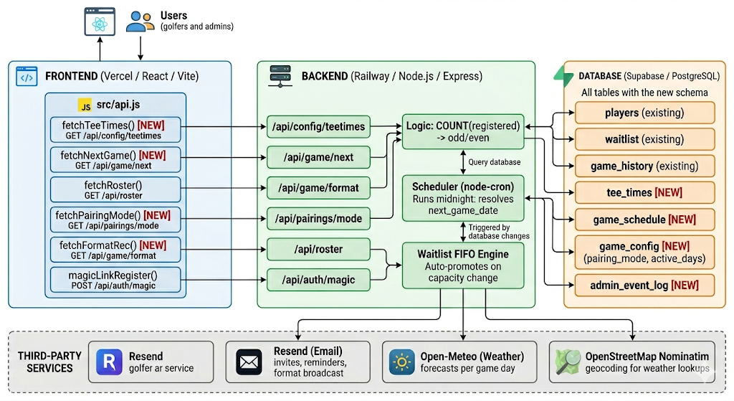

4.2 Database Schema — New Tables

tee_times
Column | Type | Notes
id | UUID PK | Auto-generated
day_of_week | TEXT | 'saturday' | 'sunday'
start_time | TIME | e.g. 08:00:00
slots | INTEGER | Number of spots in this tee time
is_active | BOOLEAN | Admin can disable individual times
created_at | TIMESTAMPTZ | Auto-set on insert

game_schedule
Column | Type | Notes
id | UUID PK | Auto-generated
game_date | DATE | Resolved date of the next game
day_of_week | TEXT | 'saturday' | 'sunday'
reg_open_at | TIMESTAMPTZ | When registration opens
reg_close_at | TIMESTAMPTZ | When registration closes (lockout − 1hr before tee)
recommended_format | TEXT | NULL until lock-out; 'points' | '2_best_balls'
pairing_mode | TEXT | 'blind_draw' | 'balanced' | 'none'
is_active | BOOLEAN | Whether this game is live to players

4.3 Revised Automation Workflows

A. Tee Time Feed (Fixed)
- Admin saves tee times via Admin Suite → written to Supabase tee_times table.
- Frontend calls GET /api/config/teetimes on app load and whenever the registration view mounts.
- Result cached in React context with a 5-minute TTL. Stale-on-revalidate pattern used.

B. Live Format Recommendation
The format recommendation is informational only. It is displayed in the Admin Suite as a reference signal and is never broadcast to players automatically.
- Triggered at registration lockout (1 hour before first tee time).
- Backend counts confirmed registrants: if odd → recommended_format = 'points'; if even → '2_best_balls'.
- Recommendation displayed in Admin Suite as an informational banner only. No action is required.
- Admin may use this signal to inform their own game-day communications but is not prompted to accept or reject it.
- If the admin overrides the displayed recommendation, no notification is sent to players. Override is silent and logged to admin_event_log only.

C. Pairing Engine (Three Modes)
- Blind Draw: Fisher-Yates shuffle on confirmed player IDs. Assignments are computed and revealed on the morning of game day, not at registration lockout. A scheduled job fires at 6:00 AM on the game date, generates the draw, and updates each player's assigned group in the database. Players receive their group assignment via Resend email at that time.
- Balanced: Existing snake-distribution by handicap index. No change to algorithm.
- No Pairings: No grouping computed. Roster API returns flat list only.
Mode is stored in game_schedule.pairing_mode and configurable per game (not global).

D. Multi-Day Scheduling
- Admin Suite exposes checkboxes for Saturday and/or Sunday per week.
- Midnight cron job (node-cron) evaluates active game_days and inserts/updates records in game_schedule for each active day.
- Each game_schedule record is independently managed. Saturday may be canceled (is_active = false) while Sunday remains active, and vice versa.
- GET /api/game/upcoming returns all future game_schedule records where is_active = true, ordered by game_date ascending.
- Frontend renders a separate game card for each active record. Cards are independent: each shows its own date, tee times, roster count, and registration status.
- Canceling a game sets is_active = false on that specific record only. The other day's card is unaffected.
- Admin Suite shows both cards in a side-by-side or stacked layout with individual Cancel / Reactivate toggles per day.

5. Retained Architecture (v1.0 — Unchanged)
The following components from v1.0 remain unchanged in v2.0:

- Frontend hosting on Vercel (React / Vite / Tailwind CSS).
- Backend hosting on Railway (Node.js / Express).
- Database on Supabase (PostgreSQL). Existing tables: players, waitlist, game_history.
- Resend as the communication engine for all outbound email.
- OpenStreetMap Nominatim for geocoding course selections.
- Open-Meteo for weather data retrieval.
- Magic Link authentication via encrypted tokens in Resend email templates.
- FIFO Waitlist Promotion Engine (Direct Promotion + Open Slots Broadcast logic).
- Registration temporal gatekeeper (open/close boundaries + 1-hour lockout window).

6. Decision Log
Items 1–4 are resolved based on owner input. Item 5 remains open pending QA.

# | Topic | Decision / Detail | Status
1 | Sat + Sun same week | Should the system show both days as separate game cards on the frontend, or merge into a single event? Needs UX decision. | Owner + Dev
2 | Format override UX | When admin overrides the recommended format, should players be notified of the override via email? | Owner
3 | Blind Draw timing | Should Blind Draw assignments be revealed immediately at lockout or only on game day morning? | Owner
4 | Handicap source | GHIN API vs. manual entry. Current architecture assumes manual. GHIN API integration would require authentication flow. | Dev
5 | Mobile magic link UX | Test magic link token expiry window on iOS (Safari) and Android (Chrome). Confirm token TTL is appropriate for mobile latency. Remains open pending QA testing. | Dev — Open

7. Version History
Version | Date | Changes
1.0 | Initial Release | Original architecture document. Decoupled frontend/backend. Resend, Open-Meteo, Nominatim integrations. FIFO waitlist. Two pairing modes.
2.0 | May 2026 | Gap analysis added. Fixed tee time API feed. Three-mode pairing engine. Live format recommendation. Flat sign-up list as default view. Multi-day scheduling. Admin event log. Four new DB tables. Five open items flagged.
2.1 | May 2026 | Owner decisions incorporated: independent per-day game cards; format recommendation informational only, no override notification; Blind Draw revealed game morning at 6AM; GHIN API confirmed unavailable, manual entry finalized; Item 5 (magic link QA) remains open.

