LinksInvite
Systems Architecture Document
Prepared for Al Herndon and Mark Benson
6/1/2026
2026
Table of Contents
1. System Overview 3
2. Infrastructure & Core Layers 3
Frontend Layer 3
Backend Layer 3
Database Layer 3
3. Relational Database Schema Mutations 3
4. Key Logic & Automation Frameworks 4
A. The Pro-Shop Handshake (Asynchronous Communication Loop) 5
B. Dynamic Scheduling & Advanced Recurrence Engine 5
C. Tournament Pairing Engine Integration 5
D. Open-Source Ecosystem Integrations 6
Resolution 6
Issue D — Multi-Day Scheduling (Saturday + Sunday Support) 6
Resolution 6
3. Updated Feature Summary 7
4. Revised System Architecture 8
4.1 Architecture Overview 8
4.2 Database Schema — New Tables 8
tee_times 8
game_schedule 9
4.3 Revised Automation Workflows 9
A. Tee Time Feed (Fixed) 9
B. Live Format Recommendation 9
C. Pairing Engine (Three Modes) 10
D. Multi-Day Scheduling 10
5. Retained Platform Capabilities 11
6. Operational Alignment & Decision Status 11
7. Document Revision Summary 12
Appendix A — System Architecture Diagrams 13
A.2 Pro-Shop Handshake — Asynchronous Sequence 14
A.3 Scheduling & Recurrence Engine — Execution Flow 15
A.4 Tournament Pairing Engine — Assignment Flow 16
A.5 External Data Enrichment — Integration Flow 17
A.6 Overall System Diagram 18
A.7 Database Schema 19

1. System Overview
LinksInvite operates on a decoupled, multi-tier asynchronous architecture. The frontend delivers an interactive player ecosystem and local state simulation environment, while a centralized backend API orchestrates the scheduling matrix, database actions, automated notification pipelines, and external facility interfaces.
The system has shifted from a basic binary schedule tracking model to a sophisticated N-tier relational entity infrastructure capable of supporting multi-course management, granular booking handshakes, and advanced handicap pairings.

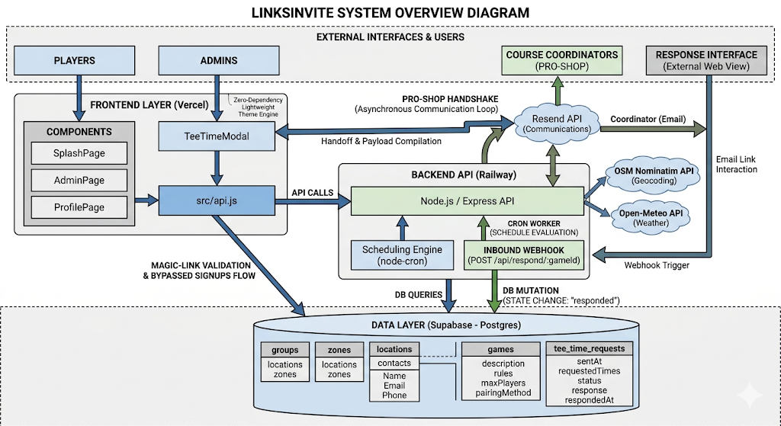
This revision aligns the system description with the current production direction, emphasizing asynchronous coordination, normalized data design, and operational flexibility across scheduling, player management, and facility communication.

2. Infrastructure & Core Layers

Frontend Layer
- Hosting Platform: Vercel.
- Architecture Strategy: The frontend consolidates external data transactions within src/api.js, centralizing authentication validations, game configuration fetches, and roster state changes away from UI presentation modules.
- Theme & Styling Engine Evolution: The Tailwind CSS footprint has been fully deprecated and removed. Layout now relies on a centralized, client-side Zero-Dependency Lightweight Theme Engine that maps tokenized hexadecimal values directly to structural elements.
- Core Interfaces: Frontend orchestration uses local state simulation handlers such as handleSimulateResponse across distinct views including SplashPage, AdminPage, and ProfilePage.

Backend Layer
- Hosting Platform: Railway.
- Tech Stack: Node.js / Express API with an integrated scheduler engine using node-cron.
- Core Responsibilities: Manages game configurations, orchestrates First-In, First-Out waitlist promotion workflows, validates transactional rules, and dispatches multi-step communication flows.

Database Layer
- Provider: Supabase.
- Engine: PostgreSQL relational database engine.
- Persistence Context: Securely handles system constraints, long-term analytical tables, player demographic profiles, USGA GHIN / course handicap indexes, and cryptographic authentication tokens.
TTimes are being set inside Railway's supabase.js but are not rendering on the frontend.

3. Relational Database Schema Mutations
The legacy table design mapping basic flat structures has been refactored into a normalized, N-tier relational entity diagram:
Entity (Table) | Target Mutations / Key Fields | Data Type / Constraints | Purpose & Operational Logic
groups | locations | JSONB Array / Relational Table | Supports complex multi-zone golf course configurations mapped per target organization.
locations | id, name, address, lat, lng, teeTimeContact | Table / Object Structural Model | Decouples geometric properties and facilities from static code configurations. Explicitly stores course coordinator contact details.
games | groupId, locationId, description, rules, maxPlayers, pairingMethod, assignFoursomes, recurring, recurrence | Foreign Keys, Varchar, Integer, Boolean, JSONB | Contains operational rules, participant parameters, grouping criteria, and recurrence payloads used by the scheduling engine.
tee_time_requests | id, gameId, sentAt, requestedTimes, players, toName, toEmail, status, response | Transactional Ledger Schema | Acts as the auditable state recorder for outgoing scheduling requests, pending negotiations, and confirmed responses from pro shops.
- Create a tee_times table in Supabase with columns: id, day_of_week, start_time, slots, created_at.
- Add a GET /api/config/teetimes route on the Railway backend that queries this table.
- In src/api.js, add a fetchTeeTimes() method that calls this endpoint on app load.
- Store the result in React context (or a lightweight state manager) and consume it wherever tee times are rendered.

4. Key Logic & Automation Frameworks

A. The Pro-Shop Handshake (Asynchronous Communication Loop)
- Outbound Compilation (TeeTimeModal): Admins execute a scheduling request within a live game instance. The frontend computes the required number of tee slots based on current capacity via the ceiling equation: ⌈maxPlayers / 4⌉. It generates standard 10-minute intervals, appends geolocated course data, and structures a secure tracking payload.
- Delivery Pipeline: The compiled dataset is handed to the Railway Express API, which offloads the email transmission payload to the Resend API.
- Inbound Ingestion Webhook: The Railway backend exposes a dedicated public endpoint for response handling. When an external course coordinator interacts with the response interface, the inbound transaction atomically updates the database from pending to responded and stores confirmed scheduling details in the ledger.
- Blind Draw — Players are randomly grouped with no regard to handicap. Assignments are generated at lock-out time and displayed to all participants.
- Balanced Pairings — The existing snake-distribution algorithm. Players ranked by GHIN / Course Handicap are spread evenly across foursomes.
- No Pairings — No grouping is applied. The system displays a flat numbered list of registrants only.

B. Dynamic Scheduling & Advanced Recurrence Engine
- Weekly Multiplication: Array-indexed tracks evaluate multiple active days within a single calendar cycle.
- Monthly Positional Coordinates: Supports exact day-of-month values or relative intervals such as first, second, or last weekday patterns.
- Yearly Pattern Maps: Month-and-day arrays define anniversary-style recurrence loops.
- Boundary Termination Gates: Filters evaluate never, after, or on termination modes to control propagation.
- Odd number of confirmed players → Recommend Points game.
- Even number of confirmed players → Recommend 2 Best Balls.

C. Tournament Pairing Engine Integration
- Balanced Pairing: Employs a handicap snake-distribution algorithm using recorded USGA GHIN or verified course handicap indexes to distribute skill levels evenly across foursomes.
- Random Shuffle: Bypasses skill rankings completely to mix active participants uniformly across available tee blocks.

D. Open-Source Ecosystem Integrations
- Geocoding Stack (OpenStreetMap Nominatim API): Translates plaintext course inputs into accurate latitude and longitude pairs without tracking parameters or API tokens.
- Meteorological Engine (Open-Meteo API): Uses the resulting coordinates to retrieve localized hourly precipitation probabilities, high/low limits, and precipitation indicators directly into the operational payload.

Resolution
- The default roster view is replaced with a flat, numbered list sorted by registration timestamp.
- Each row displays: Position #, Player Name, GHIN / Course Handicap, Registration Time, Status (Registered / Waitlist).
- Foursome groupings (when a pairing mode is active) appear as a secondary view toggled by a tab or button labeled 'View Foursomes.'
- The waitlist section renders below the confirmed list with a clear visual separator.

Issue D — Multi-Day Scheduling (Saturday + Sunday Support)
The 'Next Game' date was hardcoded to Saturday logic. When the game falls on Sunday, or spans both days, the display showed the wrong date.

Resolution
- Admins configure game_days in the Admin Suite: one or both of Saturday / Sunday can be enabled per week.
- A scheduled backend job runs at midnight each day and evaluates the game_days configuration to determine the next upcoming game date.
- The frontend fetches GET /api/game/next and displays the resolved date and day name dynamically.
- If both Saturday and Sunday are active in the same week, both dates are shown on the frontend as separate upcoming events.
- The registration open/close window and lockout logic are evaluated independently for each active game day.

Discussion Note: The owner flagged this as an open question ('we should discuss'). The architecture above supports both single-day and dual-day configurations. The recommended default is to activate one day at a time and toggle the second day manually via the Admin Suite.

3. Updated Feature Summary

Feature | Status | Description
Blind Draw | New | Admin selects; players randomly assigned without skill weighting.
Balanced Pairings | Existing / Enhanced | Snake distribution by GHIN/Course Handicap. Now a named selectable mode.
No Pairings | New | Show all registrants as a flat list only; no grouping applied.
Live Format Recommendation | New | Odd count → Points game recommended. Even count → 2 Best Balls recommended.
Flat Sign-Up List View | New | Default roster view is a numbered list of registrants in sign-up order.
Multi-Day Game Support | New | Admin sets Saturday and/or Sunday; system resolves next upcoming game date.
Tee Time Config Feed | Bug Fix | GET /api/config/teetimes endpoint surfaces Railway-stored values to frontend.
Admin Event Log | New | All roster changes, email sends, and promotions written to audit table.

4. Revised System Architecture

4.1 Architecture Overview
The decoupled architecture from v1.0 is retained. The following diagram reflects new endpoints and data flows added in v2.0:

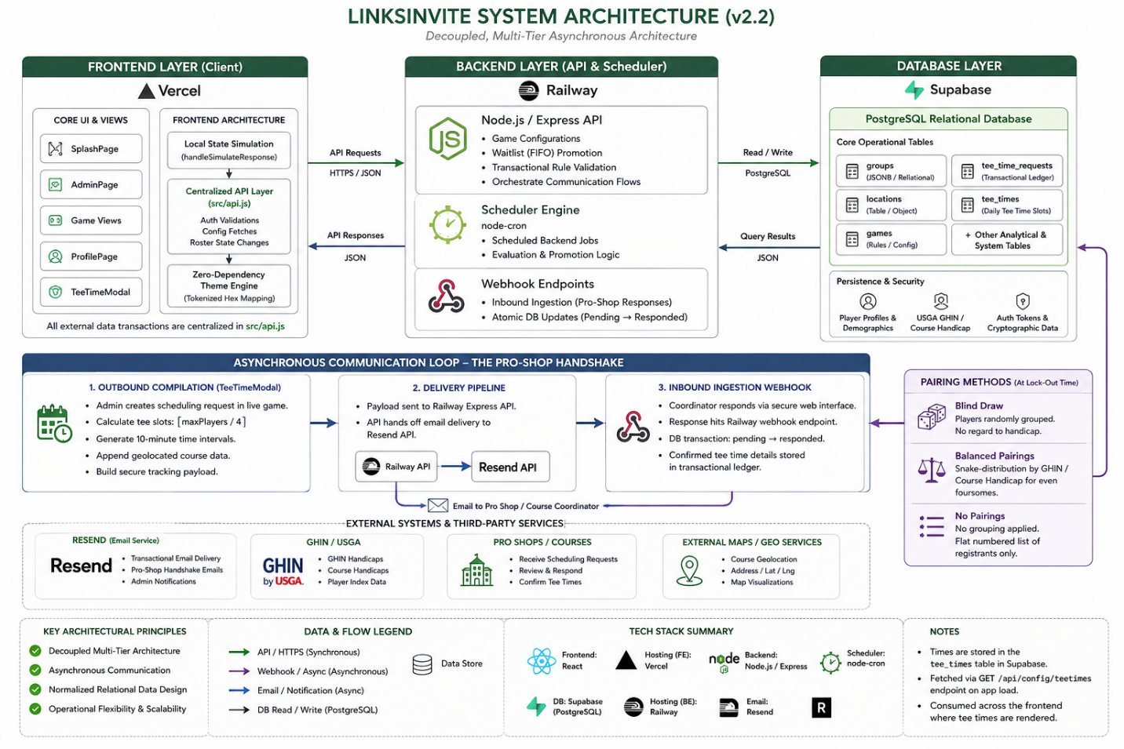

4.2 Database Schema — New Tables

tee_times
Column | Type | Notes
id | UUID PK | Auto-generated
day_of_week | TEXT | 'saturday' | 'sunday'
start_time | TIME | e.g. 08:00:00
slots | INTEGER | Number of spots in this tee time
is_active | BOOLEAN | Admin can disable individual times
created_at | TIMESTAMPTZ | Auto-set on insert

game_schedule
Column | Type | Notes
id | UUID PK | Auto-generated
game_date | DATE | Resolved date of the next game
day_of_week | TEXT | 'saturday' | 'sunday'
reg_open_at | TIMESTAMPTZ | When registration opens
reg_close_at | TIMESTAMPTZ | When registration closes (lockout − 1hr before tee)
recommended_format | TEXT | NULL until lock-out; 'points' | '2_best_balls'
pairing_mode | TEXT | 'blind_draw' | 'balanced' | 'none'
is_active | BOOLEAN | Whether this game is live to players

4.3 Revised Automation Workflows

A. Tee Time Feed (Fixed)
- Admin saves tee times via Admin Suite → written to Supabase tee_times table.
- Frontend calls GET /api/config/teetimes on app load and whenever the registration view mounts.
- Result cached in React context with a 5-minute TTL. Stale-on-revalidate pattern used.

B. Live Format Recommendation
The format recommendation is informational only. It is displayed in the Admin Suite as a reference signal and is never broadcast to players automatically.
- Triggered at registration lockout (1 hour before first tee time).
- Backend counts confirmed registrants: if odd → recommended_format = 'points'; if even → '2_best_balls'.
- Recommendation displayed in Admin Suite as an informational banner only. No action is required.
- Admin may use this signal to inform their own game-day communications but is not prompted to accept or reject it.
- If the admin overrides the displayed recommendation, no notification is sent to players. Override is silent and logged to admin_event_log only.

C. Pairing Engine (Three Modes)
- Blind Draw: Fisher-Yates shuffle on confirmed player IDs. Assignments are computed and revealed on the morning of game day, not at registration lockout. A scheduled job fires at 6:00 AM on the game date, generates the draw, and updates each player's assigned group in the database. Players receive their group assignment via Resend email at that time.
- Balanced: Existing snake-distribution by handicap index. No change to algorithm.
- No Pairings: No grouping computed. Roster API returns flat list only.
Mode is stored in game_schedule.pairing_mode and configurable per game (not global).

D. Multi-Day Scheduling
- Admin Suite exposes checkboxes for Saturday and/or Sunday per week.
- Midnight cron job (node-cron) evaluates active game_days and inserts/updates records in game_schedule for each active day.
- Each game_schedule record is independently managed. Saturday may be canceled (is_active = false) while Sunday remains active, and vice versa.
- GET /api/game/upcoming returns all future game_schedule records where is_active = true, ordered by game_date ascending.
- Frontend renders a separate game card for each active record. Cards are independent: each shows its own date, tee times, roster count, and registration status.
- Canceling a game sets is_active = false on that specific record only. The other day's card is unaffected.
- Admin Suite shows both cards in a side-by-side or stacked layout with individual Cancel / Reactivate toggles per day.

5. Retained Platform Capabilities
The current architecture preserves several foundational platform capabilities from earlier releases. These components remain active because they continue to support the production-aligned operating model without requiring structural redesign.
- Hosting & Runtime: Frontend delivery remains on Vercel, backend execution remains on Railway, and persistence continues on Supabase PostgreSQL.
- Communication Pipeline: Resend remains the outbound email engine for administrative workflows, player messaging, and magic-link authentication flows.
- Location & Weather Services: OpenStreetMap Nominatim continues to resolve course coordinates, while Open-Meteo remains the source for localized weather enrichment.
- Authentication Model: Magic-link access remains token-based and email-delivered, preserving the low-friction player entry model.
- Registration Controls: FIFO waitlist promotion and registration timing gates remain core control mechanisms for roster integrity and slot management.

6. Operational Alignment & Decision Status
The following implementation decisions have been aligned with the production model and should be treated as the active operating assumptions for engineering, QA, and deployment planning.
Operational Area | Aligned Production Decision | Implementation Status
Multi-day scheduling | Saturday and Sunday are treated as independent active game records. The frontend should render each as a separate game card with isolated status, cancellation, and registration behavior. | Aligned
Format recommendation | Recommended game format remains informational only inside the admin experience. Overrides do not trigger player notifications and are logged silently for auditability. | Aligned
Blind draw timing | Blind draw assignments are generated and communicated on the morning of the game rather than immediately at registration lockout. | Aligned
Handicap data source | Manual GHIN or course-handicap entry remains the supported input model. External GHIN API integration is not part of the current architecture baseline. | Aligned
Mobile magic-link QA | Token-expiry validation across mobile browsers remains a QA verification item and should be tracked as an open operational test case rather than an architectural unknown. | Open QA Check

7. Document Revision Summary
Revision | Date | Summary of Revisions
Initial baseline | Initial release | Established the original decoupled LinksInvite architecture, including frontend/backend separation, core messaging workflows, geocoding, weather enrichment, waitlist controls, and early pairing logic.
Production alignment revision | June 2026 | Reframed the document as a production-aligned architecture specification, updated the system narrative, normalized the schema description, clarified asynchronous tee-time coordination, expanded recurrence and pairing logic, and restructured downstream sections to emphasize active platform capabilities, implementation decisions, and operational status.

Appendix A — System Architecture Diagrams
This appendix contains reference diagrams that illustrate key system behaviors and data flows. These diagrams are non-normative and are provided to support understanding of the production architecture described in Sections 1–6.
A.1 High-Level System Topology
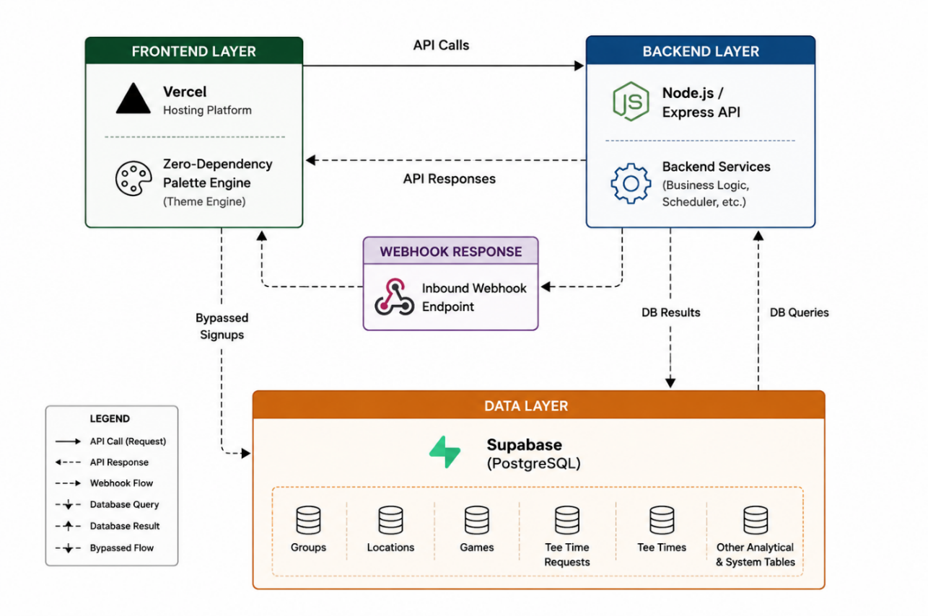
Description:
Illustrates the separation of concerns between frontend delivery, backend orchestration, and persistent storage. The frontend maintains local simulation state, the backend coordinates asynchronous workflows, and the database serves as the authoritative system of record.

A.2 Pro-Shop Handshake — Asynchronous Sequence
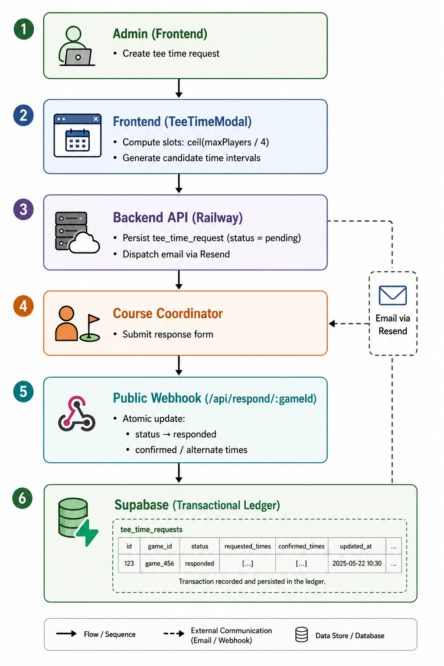
Description:
Represents the asynchronous booking negotiation loop between administrators and course coordinators, with all state transitions recorded in an auditable ledger.

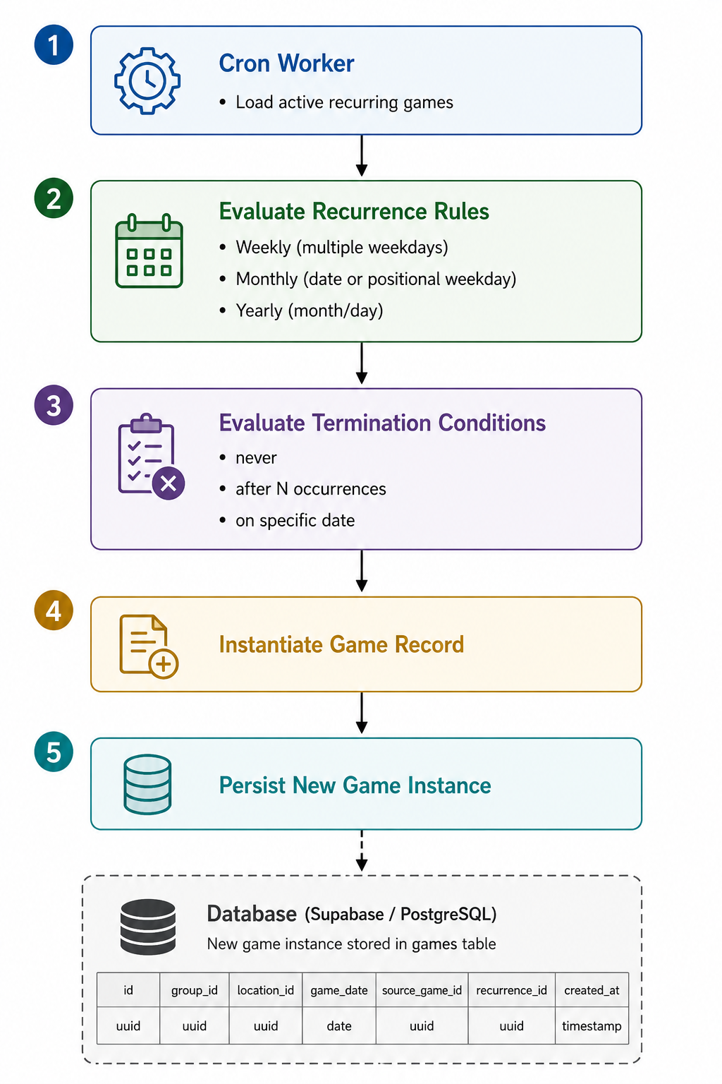
A.3 Scheduling & Recurrence Engine — Execution Flow
Description:
Shows how abstract recurrence definitions are materialized into discrete, independently managed game instances by scheduled backend workers.

A.4 Tournament Pairing Engine — Assignment Flow
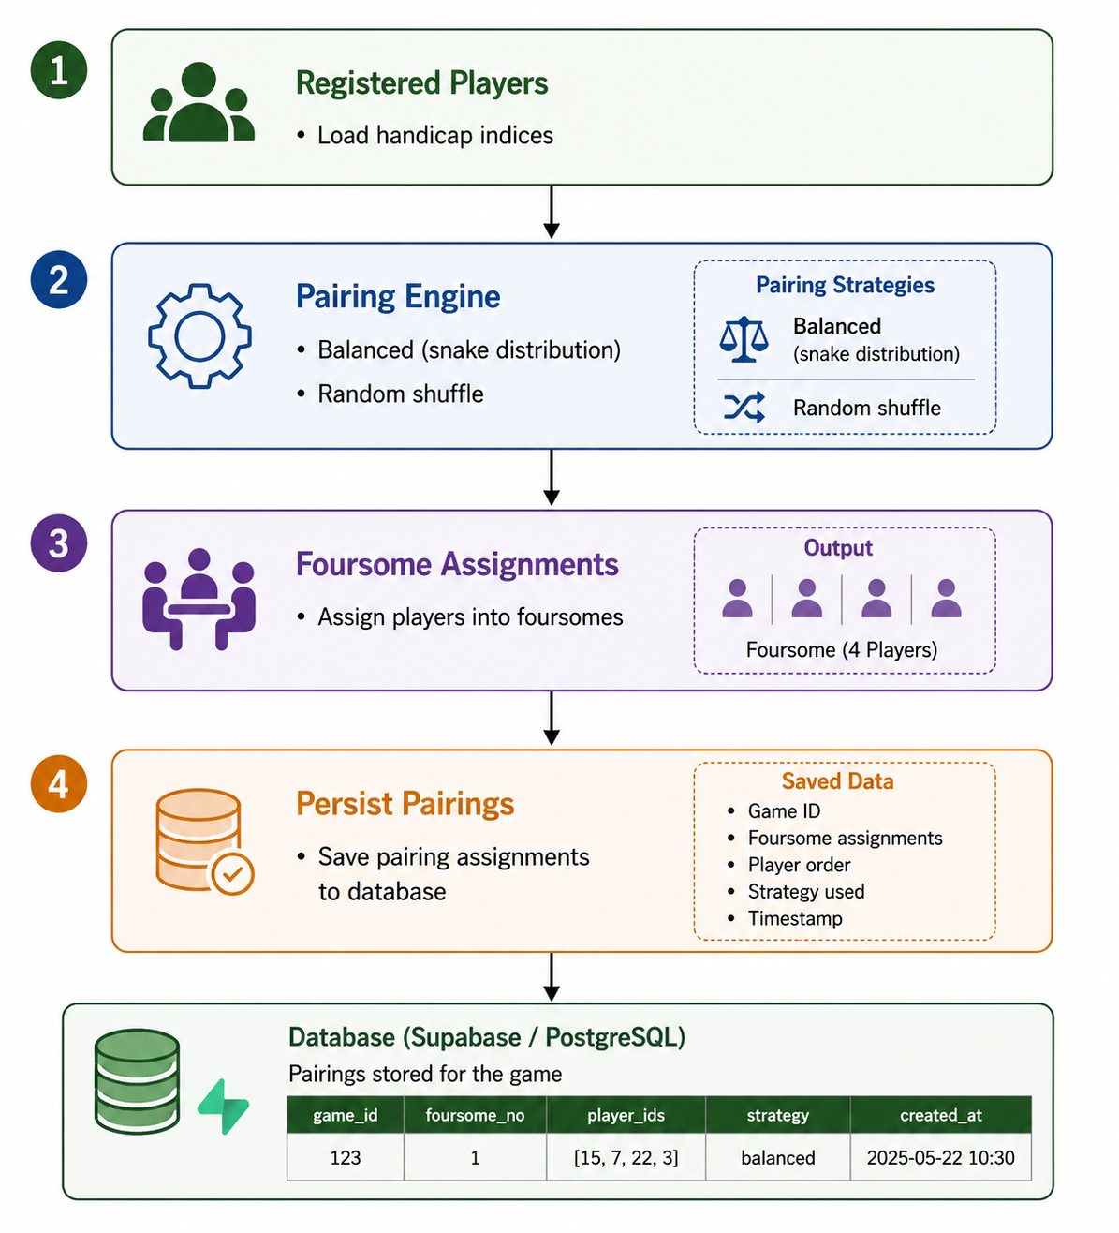Description:
Illustrates pairing logic execution, which operates independently of scheduling and registration workflows and produces deterministic groupings based on the selected algorithm.

A.5 External Data Enrichment — Integration Flow
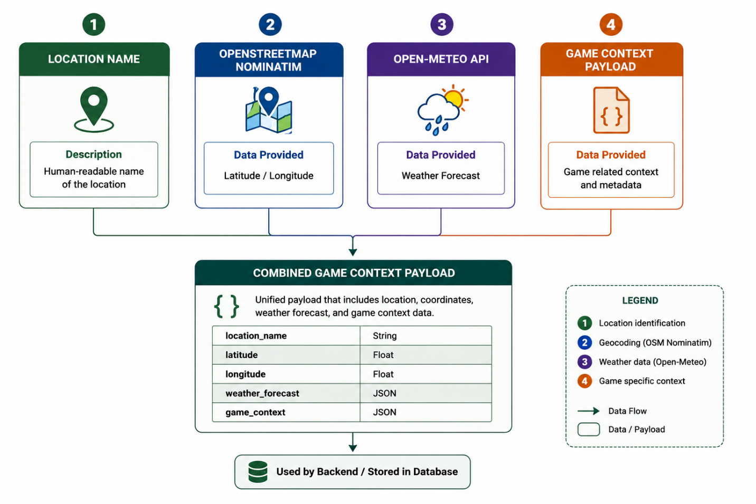
Description:
Depicts stateless enrichment of game metadata using open-source geocoding and weather services without API keys or commercial dependencies.


A.6 Overall System Diagram

A.7 Database Schema
