
Applied Science Private University
Faculty of Information Technology

Graduation Project Report

Smart monitoring using AI

Prepared by:
Hashem Mohammad 201910545
Al Motasem Abuqamar 201910625

Supervised by:
Dr. Mohammad Al-Oudat

Jun 2022

Copyright © 2021-2022 Applied Science Private University. All rights are reserved

We certify that the work and ideas presented in this project is our own unless referenced.

Name and Signature:………………………………….…………………. Date: …………………
Name and Signature:………………………………….…………………. Date: …………………
Name and Signature:………………………………….…………………. Date: …………………
Name and Signature:………………………………….…………………. Date: …………………

Contents
List of Figures
List of Tables
List of Symbols
Abstract iii
Chapter 1: Introduction 4
1.1 Description of the current situation and opportunity 4
1.2 Related work 4
1.3 Problem statement (limitation of current systems) 4
1.4 Problem solution 4
1.5 Project objectives 5
1.6 Technology and tools used 6
1.7 Project Plan (Gantt chart, PERT chart) 6
Chapter 2: Requirements and Analysis 8
2.1 Software Process Model 8
2.2 System scope with explanation 8
2.3 Functional Requirements & Non-Functional Requirements 8
2.4 Use Case Diagram with Use Cases descriptions 9
2.5 Activity Diagram 9
Chapter 3: Design 12
3.1 Sequence Diagrams 12
3.2 Class Diagram 12
3.3 Database ER Diagram 12
Chapter 4: System Implementation 13
4.1 Main System Screenshots 13
4.2 Important code fragments 18
4.3 List of Non-Implemented requirements and reasons 21
Chapter 5: System Evaluation 23
5.1 System Testing 23
5.2 System Evaluation 23
Chapter 6: Conclusion & Future Work 24
6.1 Conclusion 24
6.2 Future work 25
References 26
Appendix

Abstract
To maintain a discipline and let students grasp utmost knowledge in schools, colleges, and universities the attendance system was introduced. The usual management of the attendance can be a great burden on the teachers if it is done by hand. To resolve this problem, smart attendance management system is being utilized. Since authentication is an important issue in this system. The smart attendance system is generally executed with the help of biometrics. In the human body, the face is the most crucial factor in identifying each person as it contains many vital details Face recognition is one of the biometric methods to improve this system. Being a prime feature of biometric verification, facial recognition is being used enormously in several such applications, like video monitoring. By utilizing this framework, the problem of proxies and students being marked present even though they are not physically present can easily be solved. The main implementation steps used in this type of system are face detection and recognizing the detected face. The proposed system can be implemented in any field where attendance system is present and plays a vital role. In addition, as the project objectives and the design criteria all met, it’s greatest to say this project is an engineering solution for all university and colleges to track and manage the attendance.

Chapter 1: Introduction

Description of the current situation and opportunity

In this period, let’s say post-pandemic, even though most educational systems have switched to more advanced technologies, regarding teaching, switching to online lectures, and interactive learning, we still found a gap in one really important area, which was taking attendance, the usual approach to that is either calling each student by their name, which really is time consuming, we wondered about what can we do to solve that problem, to see how much time can we get back, to spend better, productive ways, and we saw an opportunity in developing a system, to monitor environments, like a university, or a workplace, that works real-time as well, without the need for humans to take care of such mundane details, and since it’s the age of artificial intelligence, we decided to use a really popular subfield in AI; computer vision, that wasn't really utilized in such environments, to substitute the traditional attendance system.

Related work

- AIndraLabs Smart Attendance: AIndraLabs is a company that develops Artificial Intelligence Powered Products for Businesses, such as smart attendance system, whether it’s used for a work environment, or for a school, the company also developed other projects related to computer vision, such as object detection and Optical character recognition/Natural language processing which is similar to what we decided to develop [1].

- RamcoGEEK: is a similar system that was developed, for the exact same purpose, to replace such outdated attendance systems, and it’s the same as AlndraLabs smart attendance project [2].

Problem statement (limitation of current systems)
After spending few years in our university, and almost at the time of our graduation, we started noticing the amount of work and effort taking attendance was, how much of a chore it seemed to most professors and how time consuming it was for both the students and the staff, how it also kept stealing the attention of the students and the lecturers, in fact a low percentage of the students attend lectures on time, and the rest just keep interrupting the lectures by attending late, and some of them, only caring about whether the will fail the subject if they have too many absences, only attend when the lecture is about to end, right before the professor start taking attendance, and the “calling names” attendance approach, usually wastes about 10 minutes or so from the precious lecture time, after thinking about all of this, we truly have realized how much of a burden it seemed, since it’s a mundane task, that is very prone to human error, and the whole system of traditional attendance taking isn't balanced, even with new technologies such as using a QR code, or a pass code, so each student can verify their attendance, there was still a hole in the system, an example of that was students in the class, sending the attendance information to the ones who aren't attending the class, and from our point of view, we don’t think that its fair, to treat the ones who attend and the ones who don't the same, so we thought of an idea, to utilize existing technologies to automate that mundane and time costing process, since we believe that science and technology exists to make humans lives easier.

Problem solution

After considering the problem of traditional attendance approaches, we thought about creating a system that will be able to monitor various environments, such as a university, a school, or a workplace, and since we will always believe that time is the most precious asset humans have, since you can’t get it back; we have decided to build a system that will be able to solve the problems that are time costly in that regard, which will also at the same time, be able to enhance the students and educators focus and attention level, by paying 100% of their attention at the lecture, without worrying about whether there is enough time to take attendance, and since focusing and paying attention are really important factors during the lectures, if the lectures keeps getting interrupted, we noticed that we couldn’t pay as much attention and truly focus in the lectures.
By hopefully making the lecture uninterruptable, the system we decided to develop will take care of the "heavy lifting", the manual, the most repetitive mundane tasks, that our university staff is doing, daily, and multiple times a day, which is taking attendance, that rose an opportunity, to substitute the old traditional method.
We decided to use technologies such as artificial intelligence, that isn’t really utilized, and optimized, especially in the classroom environment, by using computer-vision based technologies, such as face detection and recognition, the part of the traditional attendance would be automated, and we would have solved what we have considered a big problem, that will certainly save time for everyone, the students, and more importantly, the educators.

Project objectives
- Savings both the instructors and the student’s time
- Increasing the attention and the productivity of the students and the instructors
- Creating a smart/safe educational environment that is powered by AI technologies

Technology and tools used
- IDEs, Text editors: VS code [3]
- Programming Languages: The python ecosystem, multiple frameworks and libraries related to Ai and web development such as:
- Numpy[4]
- Pandas[5]
- Opencv [6]
- Face Recognition [7]
- streamlit.[8]

Project Plan (Gantt chart, PERT chart)

WBS | Task Name | Start date | Finish Date | Percent Complete
1 | Planning | 15 MAR 2022 | 25 MAR 2022 | 100%
2 | Requirements and analysis | 25 MAR 2022 | 30 MAR 2022 | 100%
3 | Design | 1 APR 2022 | 10 APR 2022 | 100%
4 | System implementation | 10 APR 2022 | 25 MAY 2022 | 100%
5 | System evaluation | 25 MAY 2022 | 31 MAY 2022 | 90%

Chapter 2: Requirements and Analysis

Software Process Model
We originally thought about using the waterfall model for this project, but after GP1 discussion, we decided to use Agile methodology, [9], but we noticed that it was a better fit for this kind of project.
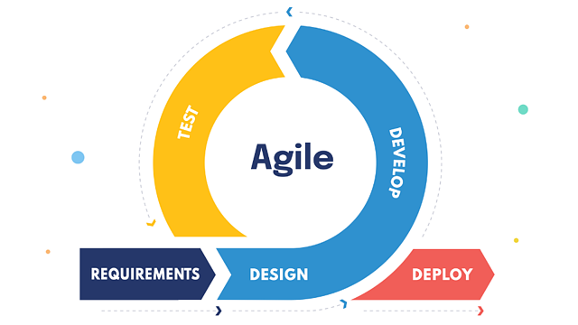

System scope with explanation
The main intention of this project is to solve the issues encountered in the old attendance system while reproducing a brand new innovative smart system that can provide convenience to the institution, an application will be developed which can recognize the identity of individuals, an excel sheet is created which shows the students attendance.
Creating an application that will help the educational staff, regarding their time and productivity, in many ways the service is designed for the educational staff only it should enable the staff to easily navigate through classes, without a need of any repetitive tasks, by taking automatic attendance the system should be able to take attendance and the exact time automatically, by using face recognition technologies, and an excel sheet is created which contains the student attendance.

Functional Requirements & Non-Functional Requirements

- Functional Requirements
- The system should capture the faces of everyone entering the lecture halls successfully, capturing the time of arrival as well
- The system must detect and recognize faces that are saved in the database
- The system shall create an excel sheet, that contains the student’s information, and the time of their arrival

- Non-Functional Requirements
- The application interface should be user friendly, and easy to navigate
- The system should identify the correct faces(security)
- Performance is important in the system, it should handle such problems, by being able to detect and recognize multiple faces at a time

Use Case Diagram with Use Cases description

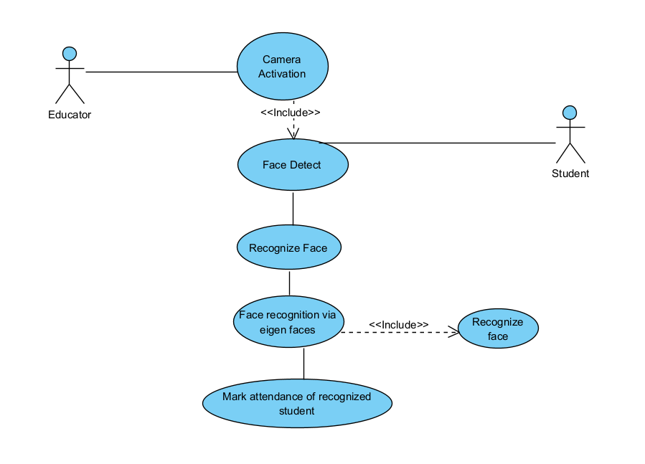

- Use case description
Use Case Name: | Camera Activation
List of Actors: | Educator and Student.
Brief Description: | From this use case the educator should start the process of taking attendance
Flow of Events: | Basic Flow:  - The Educator will activate the camera.  - The camera will start capturing faces.  - Students faces will be detected.  - The system will start recognizing the face.  - The system will create an excel file.  - The system will mark the attendance of recognized students.
Precondition: | Camera should be activated
Post Condition: | Attendance will be recorded, with students names and attendance time

Activity Diagram

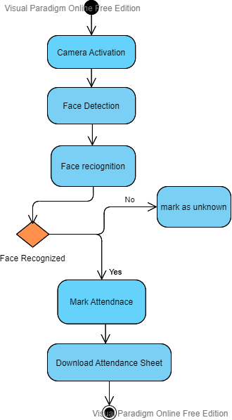

Chapter 3: Design

Sequence Diagrams

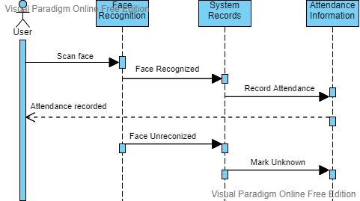

Class Diagram
Not Applicable for this Project.

Database ER Diagram
Not Applicable for this Project.

Chapter 4: System Implementation

Main System Screenshots

Important code fragments

We have tried commenting the code as much as possible, so other people who would like to continue working on the project, will be able to develop it further, since our plan is to make the code opensource.

The main UI part of the codebase, the homepage, and the navigation bar.

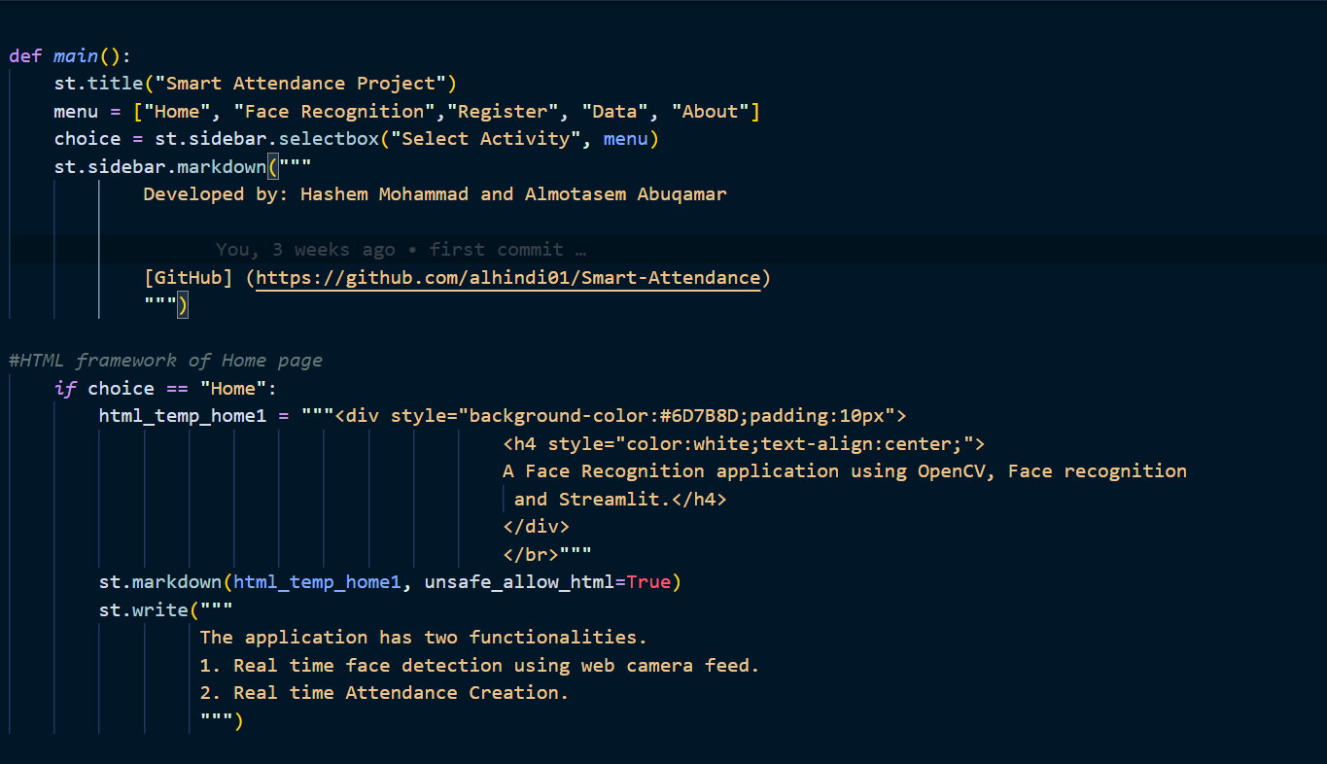

The part that handles, the image conversion, and the encoding of them.

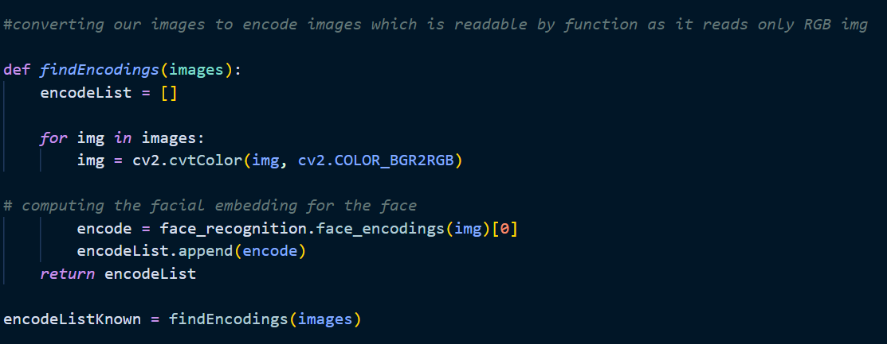

This part handles the attendance, by reading the names of the students, and tracking their attendance, writing their names and time in the attendance document, the attendance list is both viewable in the website, and downloadble as an csv file.
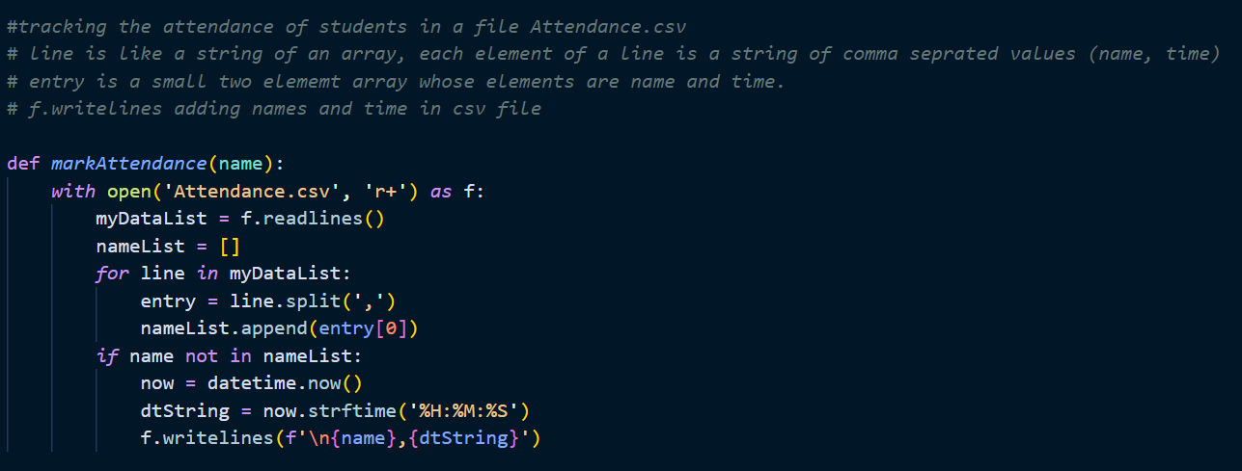

This serves as the major part of the code, which performs the face recognition, finding the encoding of the images and comparing them with the data, and after detecting the face, it either recognizes it and mark the attendance, or just show that the face is unknown, and not in the images database.
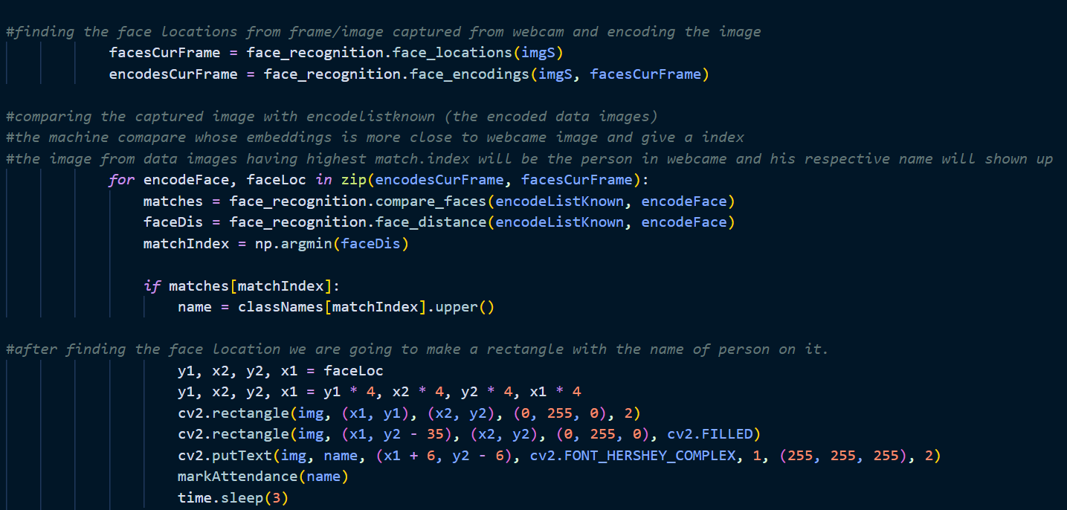

List of Non-Implemented requirements and reasons

Originally, we had a plan in mind to implement more things in this project, and to make a much more advanced system, but we weren’t able to do that, and we will state non implemented requirements and the reasons for that, the main break dealer of the project was performance, so we originally wanted to build an AI model on our own.
- Using a custom-built model
Although we had experience regarding building machine learning, and deep learning models, we underestimated the idea of the project, although we were able to collect, a decent amount of data, which took a big amount of effort and time to manually collect, clean and annotate, and to train the model, although they performed well on test images, their performance wasn’t comparable with other built in models, that would perform the same task of face detection, but which were built by tech giants, such as Facebook, and other companies that are heavily invested in artificial intelligence, we also didn’t exactly know how to use the models in a “plug and play” way, we couldn’t use them as an interface for the web app that we were building, so we ended up resorting to using pre-built models and libraries to perform the task at hand.

Chapter 5: System Evaluation

System Testing

System Evaluation

Our system was separated into two parts, the working of the recognition, and the UI part, for starters, we have used opencv, to lunch and start the camera, and to perform the video capture, and everything related to rendering the videos, and performing any edits on it, then we have used a python library called "face recognition", which is based upon a state-of-the-art face recognition system, called "dlib[10]", the model has an accuracy of 99.38% on the labeled faces in the Wild benchmark, which is much better than we could have developed using a custom built model, for a simple, not customizable task, for encoding the images and converting them to number arrays, numpy was used, and for displaying and converting the attendance information, pandas was used.

for the UI part, we have used a python library, called "streamlit", which is an open-source Python library that makes it easy to create and share custom web apps for machine learning and data science, and since its written in python, it was compatible with technologies that we have used, using streamlit enabled us to create web apps, that have a lot of functionality for data science and machine learning apps, without needing front-end web experts, since we were a team of two, we decided that it was better not to have a big gap between our tech stacks, rather than building an AI model, building a backend API for that, and building a frontend for that.

finally, the system was able to add new faces to the system immediately, using a drag and drop functionality, recognize and identify faces correctly, and mark the attendance based on that, the only limitation for us was the hardware, since the recognition part uses deep learning technologies, it wasn’t as fast as expected, but it still performed well nonetheless, with a high accuracy.
Chapter 6: Conclusion & Future Work

Conclusion

Smart attendance systems envisioned for the purpose of reducing the drawbacks in the traditional (manual) system In this project, we have implemented an attendance system, based on computer vision, we have used face recognition concepts to mark the attendance of student and make the system better, it’s designed to our saves time and effort.
This attendance system demonstrates the use of image processing techniques in the classroom, this system doesn’t only merely help in the attendance system, but also improve the goodwill of an institution, our system will be able to mark the attendance via name, it will be able detect faces via the camera and then recognize the faces, it will either recognize the student's face and mark their attendance, or it will show that they are considered unknown, we also had some processing limitation, working with a system of high processing may have resulted in even better performance of this system, using a custom built method as well may have had better results regarding performance and speed, but we thought, at our current state and knowledge, that it wouldn’t make much sense for us to reinvent the wheel, for performing simple tasks in the world of computer vision and artificial intelligence, like face detection and face recognition, and by standing on the shoulders of the giants, we eventually just decided, and were able to glue different pieces together, and create a system that will reduce time wasted, automate mundane tasks, and hopefully make the educational system more efficient.

Future work

After learning so much about the artificial intelligence field, and how fast the computer vision subfield is developing, which really caught our interest, and motivated us to pursue personal projects, and conducting original research in this area, an idea that was in our mind from the beginning, that seemed really hard, was creating a fully featured, AI based, security monitoring system, that will be able to handle everything in certain organizations, an example of that would be data related to employees/students, just by recognizing their faces, the admin would be able to get all the information saved about them immediately, including taking attendance for example, another part would be detecting different objects as well, not only face, but broadening that a bit more to include illegal things, or things not allowed in public places, examples of that are cigarettes, weapons(including different kinds), face masks, replacing fire alarms, by creating a detector for that as well, any by hopefully eventually developing such a system, it will replace and automate a lot of things, and it will make the security guards lives much easier, maybe at that stage, they will start to serve as a second measure, just in case the system didn’t catch something.

In order to develop a system of the kind, few things are needed, first we realized that we need more knowledge and practice in this area of specialty, and how to integrate it with other platforms, be it mobile, desktop, or web, not only knowing how to build the model well, it will also require us a machine with high specs, and performing capabilities, the last requirement, and maybe the most time consuming is gathering the data, which will consistent of tens of thousands of images, and annotating them based on the classes that we want to detect, we have decided that eventually we would pursue such projects in the future, whether it’s for our graduate school plans, or as an independent research, since we have realized that it's something that we were really passionate about.

References
[1] https://www.aindralabs.com/products/smart-verification

[2] https://www.ramco.com/facial-recognition

[3] https://code.visualstudio.com/

[4]https://numpy.org/

[5]https://pandas.pydata.org/

[6]https://opencv.org/

[7]https://github.com/ageitgey/face_recognition

[8]https://streamlit.io/

[9]https://www.agilealliance.org/agile101/

[10]http://dlib.net/

