Freight Rate Prediction: Validation Approach and Results
Machine Learning Engineer assessment, Spotter | Candidate: Mohamad

1. Data and goal
The task is to predict posted_rate for freight loads. train_test.csv holds 48,000 labelled loads from 1 Jan to 31 Oct 2025. validation.csv holds the 12,000 loads to predict, dated 1 Nov to 31 Dec 2025. The validation loads are therefore entirely in the future relative to the labelled data, and the validation approach is designed around that fact.

2. Train / test split and validation approach
- Time-based split. Train on Jan to Aug (38,477 loads) and test on Sep to Oct (9,523 loads). The holdout is two months long and lies after the training data, which mirrors the real situation: predicting the two months after the labelled period.
- Why not a random split. A random split lets the model see loads from every month, including days next to each test load. Market conditions drift over time, so this leaks future information and overstates the accuracy that can be expected on November and December.
- Final model. After choosing the model on the holdout, it is retrained on all labelled data (Jan to Oct) before predicting validation.csv.
- Cleaning only touches training data. Outlier rows are removed from the training set only. The test set is left as is, because the real validation data will also contain messy rows.
- Metrics. MAE (average dollar error) and MAPE (average percentage error). The scoring metric is not disclosed, so both are tracked.

3. Data-quality issues and treatment
Issue | Finding | Treatment
Negative weights | 292 rows in training with negative weight; absolute values range from 5,000 to 47,500, a normal range. | Treated as sign errors: use absolute value.
Extreme rates | Median rate is $2.15 per mile and 98% of loads fall within $1.67 to $3.18. 317 loads exceed $5 per mile and 329 are below $1. | Dropped training rows outside $0.80 to $6.00 per mile (labels judged unreliable). Test set untouched.
Missing values | weight missing in 300 training / 165 validation rows; market_index missing in 374 / 249 rows. | Left missing; the gradient boosting model handles NaN natively.
Unseen cities | 8 cities appear only in validation (Allentown, Jackson, Charlotte, Norfolk, Knoxville, Chicago, Laredo, San Diego). | City names excluded from features; latitude and longitude carry the location signal.
Duplicates, labels | No duplicate loads; equipment labels are consistent (Dry Van, Reefer, Flatbed). | None needed.

4. Model and results
The final model is scikit-learn's HistGradientBoostingRegressor. The target is log(rate per mile), and the prediction is exp(output) multiplied by distance, which removes most of the distance effect from the learning problem. Features: distance, absolute weight, market_index, quote_signal, pickup and delivery coordinates, equipment type, and day of week. Month is deliberately not used, because the model has never seen December and could not use it.
Results on the Sep to Oct time-based holdout:
Model | MAE | MAPE
Baseline 1: distance x median rate per mile | $257 | 11.6%
Baseline 2: distance x rate per mile by equipment | $229 | 10.5%
Gradient boosting, with city names | $126 | 5.4%
Gradient boosting, no city names (final model) | $131 | 5.6%

The city-name version is 0.2 points better on the holdout, but the holdout contains no unseen cities while validation contains eight. The final model therefore drops city names, trading a very small loss in holdout accuracy for safer behaviour on new cities. The holdout estimate of about 5.6% may still be somewhat optimistic for validation because of the unseen cities.

5. Fixed December prediction chart
Fixed inputs: Lexington to Fort Wayne, 360 miles, Dry Van, 32,000 lb; only the date changes. The chart file contains no market_index or quote_signal, so each day's average value from validation.csv (which covers every December day) was used, and the lane coordinates were taken from the training data. The script score.py produced the chart below.
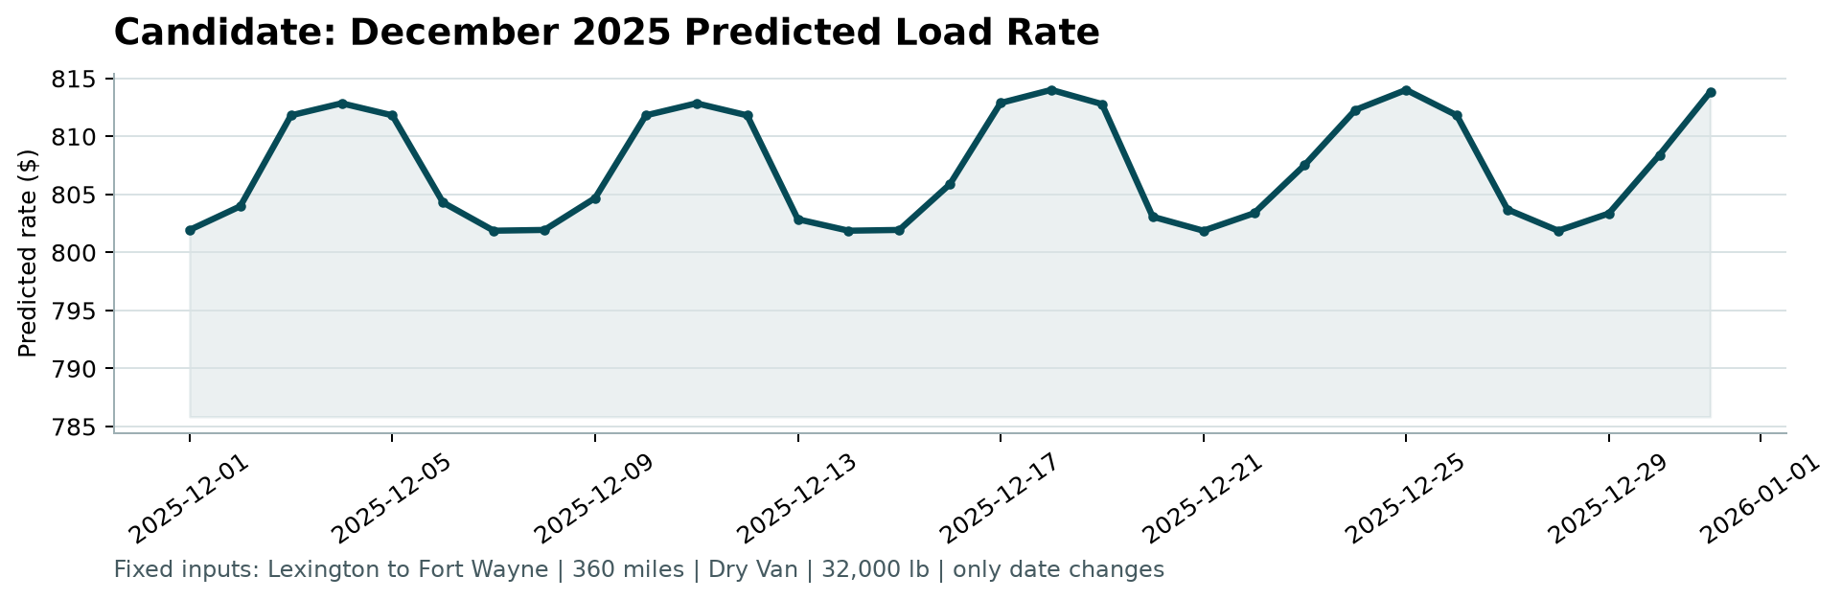
Sanity checks: predictions range from about $802 to $814 ($2.23 to $2.26 per mile). In training, Dry Van loads on this lane (32 loads) have a median rate of $808. Rates are slightly higher Wednesday to Friday, in line with training data, where average rate per mile is about 2.20 to 2.21 on those days versus 2.17 on Sunday and Monday.

6. Limitations
- Variation across December is small (about 1.5%), so the date has little influence for a single lane.
- No December or holiday data exists in training, so no holiday effect (for example around 24 to 26 December) can be learned.
- For the December chart, market signals are daily averages across all lanes, not lane-specific values.
- Validation uses a single time-based holdout; a rolling-origin comparison (for example Jan to Jun then Jul to Aug) would give a more stable estimate and is a natural next step.

