Progree Remote Internship Program

Task 2
EXPLORATORY DATA ANALYSIS
UCI Online Retail Dataset
Prepared By: Ali Ahmed
Student ID: B4/207

Executive Summary
This report documents the complete exploratory data analysis (EDA) workflow applied to the UCI Online Retail dataset. The project was intentionally structured as an end-to-end analytics exercise: understand the raw source, profile data quality, clean and transform the data, investigate distributions and outliers, engineer analytical features, analyze time, geography, products and customers, build RFM metrics and business-oriented customer segments, and finally translate the findings into recommendations.
The analysis reduced the original 541,909 source records to a final positive-sales analytical dataset of 522,725 records and 11 columns. The resulting analysis showed strong revenue concentration among loyal customers, strong relationships between revenue and transaction volume, weekday/daytime purchasing concentration, UK market dominance, high-value smaller international markets, and a distinct group of high-performing products.

1. Dataset Source, Context and Objectives
The project uses the official UCI Machine Learning Repository's Online Retail dataset. UCI describes it as transactional data from a UK-based, registered non-store online retailer covering 01/12/2010 through 09/12/2011. The company mainly sells unique all-occasion gifts, and many customers are wholesalers. The source contains 541,909 records and fields including InvoiceNo, StockCode, Description, Quantity, InvoiceDate, UnitPrice, CustomerID and Country. UCI also documents that an InvoiceNo beginning with 'C' indicates a cancellation.
A useful clarification is that this is not exclusively a 2011 dataset. It begins in December 2010 and ends on 9 December 2011. December 2010 is retained as the first baseline month in this project, while most of the analysis concerns 2011.
The business questions guiding the project were:
- Is the data reliable enough for analysis?
- What do Quantity, UnitPrice and transaction value distributions look like?
- When does purchasing activity peak?
- Which countries and products drive sales?
- Which customers are most valuable and most engaged?
- Can customers be grouped into actionable behavioral segments?
- What business actions are supported by the evidence?

2. End-to-End EDA Process
- Load the raw UCI workbook and inspect its structure.
- Profile data types, missing values, duplicates and basic statistics.
- Investigate Quantity, UnitPrice, InvoiceNo, StockCode and CustomerID for data-quality issues.
- Remove/filter invalid sales observations and duplicate records while retaining useful extreme observations as flags.
- Create TotalAmount = Quantity × UnitPrice.
- Extract Year, Month, YearMonth, DayOfWeek and Hour from InvoiceDate.
- Use descriptive statistics, percentiles, histograms and IQR rules to understand skew and outliers.
- Aggregate and visualize monthly, weekday, hourly and day × hour purchasing behavior.
- Aggregate country-level transaction count, revenue and average transaction value.
- Aggregate product-level Revenue, Orders and Quantity; add RevenuePerOrder and RevenuePerUnit.
- Create product performance quadrants using median Revenue and Quantity thresholds.
- Restrict customer-level analysis to valid CustomerID records.
- Measure customer revenue, frequency, quantity, average order value, one-time/repeat behavior and revenue concentration.
- Calculate RFM metrics and scores.
- Translate RFM behavior into business-readable customer segments.
- Compare segment size and revenue contribution and synthesize recommendations.

3. Initial Data Understanding
The first step was deliberately descriptive rather than corrective. The dataset was inspected for shape, column names, data types, missing-value counts, duplicates, numerical ranges, categorical values and suspicious identifiers. This prevented assumptions about what constituted an error before cleaning decisions were made.
Check | Why it was performed
Shape/columns | Understand scale and available information
Data types | Verify dates and numeric fields are represented correctly
Missing values | Identify fields requiring special treatment
Duplicates | Detect repeated transaction rows
Quantity/UnitPrice statistics | Detect invalid values and skew
InvoiceNo patterns | Identify cancellations/transaction anomalies
StockCode/Description | Identify non-product or accounting records
CustomerID | Assess customer-analysis coverage
Country | Understand geographical distribution

4. Data Cleaning and Quality Decisions

4.1 Duplicates
Exact duplicate rows were checked and removed where present. The original dataset contained 5268 exact duplicates. The final quality report confirmed 0 duplicate rows.

4.2 Quantity
Quantity was checked for negative and zero values because non-positive quantities can represent cancellations/returns rather than positive sales. The original dataset contained 10,624 negative values. Negative quantity records primarily correspond to cancelled transactions and therefore represent legitimate business events rather than random data-entry errors.
Most negative-quantity transactions are explicitly marked as cancellations, but not all negative quantities are represented by invoice numbers beginning with C that is why negative values belonging to transactions that were not cancelled were treated seperately. After cleaning, Quantity ranged from 1 to 4,800 and the final report showed 0 negative and 0 zero quantities. The UCI documentation also identifies cancellation invoices through the InvoiceNo convention.

4.3 UnitPrice
UnitPrice was checked for negative and zero values. These negative values were not retained in the final positive-sales analytical dataset. The final range was £0.001 to £649.50.

4.4 Missing CustomerID
CustomerID was not imputed. A fabricated customer identifier would create false customer relationships. Missing IDs were therefore retained for transaction, product, time and geography analysis but excluded from analyses requiring customer identity.
CustomerID status | Records | Share
Available | 391,296 | 74.86%
Missing | 131,429 | 25.14%

4.5 Non-standard StockCode
StockCode and Description were inspected together. Some of the StockCode values contained non-numerical values such as "POST", "DOT", "M", "AMAZONFEE." These were special cases and represented manual entries, cancellations, and fee adjustments. A notable record used StockCode 'B', Description 'Adjust bad debt', and UnitPrice £11,062.06. This was recognized as an accounting adjustment rather than a normal product sale and was treated separately from product-performance interpretation.

4.6 Outliers: investigate before removing
Outliers were investigated with the IQR method and percentile analysis. For TotalAmount, Q1 = £3.90, Q3 = £17.70, IQR = £13.80 and the upper IQR bound = £38.40. This produced 41,261 statistical outlier transaction lines. They were flagged rather than blindly deleted.
The reason was demonstrated by examples: one transaction contained 74,215 units at £1.04, while another had 60 units at £649.50. These may be genuine bulk or high value purchases. The project therefore distinguished statistical extremeness from invalidity. Quantity_Outlier and UnitPrice_Outlier were retained as analytical flags.

5. Original Dataset vs Final Analytical Dataset
Aspect | Original UCI source | Final analytical dataset
Records | 541,909 | 522,725
Source fields | 8 | 11
CustomerID | Missing values present | 131,429 missing retained
Duplicates | Inspected during cleaning | 0
Quantity | Raw, including non-positive/cancellation related observations | Positive only; 1–4,800
UnitPrice | Present, including some negative and zero values | Positive; £0.001–£649.50
TotalAmount | Not a source field | Quantity × UnitPrice
Time features | InvoiceDate | Year, Month, YearMonth, DayOfWeek, Hour added
Outlier fields | Not present | Quantity_Outlier, UnitPrice_Outlier
Customer analysis | Raw IDs | 4,334 identifiable customers analyzed
RFM/segments | Not present | Created during project

The final analytical dataset is therefore a documented transformation of the UCI source, not a replacement for it. The 19,184-row reduction resulted from the cleaning/filtering workflow. The source file should be preserved separately for reproducibility.

6. Feature Engineering
Feature | Construction | Purpose
TotalAmount | Quantity × UnitPrice | Transaction value/revenue
Year/Month/YearMonth | InvoiceDate components | Trend analysis
DayOfWeek | InvoiceDate component | Weekday behavior
Hour | InvoiceDate component | Intraday behavior
Quantity_Outlier | IQR flag | Extreme quantity awareness
UnitPrice_Outlier | IQR flag | Extreme price awareness
RecencyDays | Snapshot − latest customer purchase | Customer recency
Frequency | Unique InvoiceNo per customer | Customer engagement
Monetary | Sum TotalAmount per customer | Customer value
RFM Score | Combined R/F/M scores | Customer prioritization
CustomerSegment | Rule-based RFM interpretation | Actionable groups
RevenueGrowth | Month-over-month revenue change | Growth/decline periods
RevenuePerOrder | Product revenue / orders | Product efficiency
RevenuePerUnit | Product revenue / quantity | Unit economics proxy

7. Univariate Numerical EDA
The first histograms used the full numerical ranges. Because Quantity, UnitPrice and TotalAmount were strongly right-skewed, focused histograms were then created to make the dense majority of observations visible. Percentiles were used alongside plots to quantify the distributions.

7.1 Quantity
Mean = 10.34, median = 4, Q1 = 1, Q3 = 12. The 90th, 95th, 99th and 99.9th percentiles were 24, 30, 100 and 448.55. Most transaction lines therefore involve small quantities, with a long bulk-purchase tail.
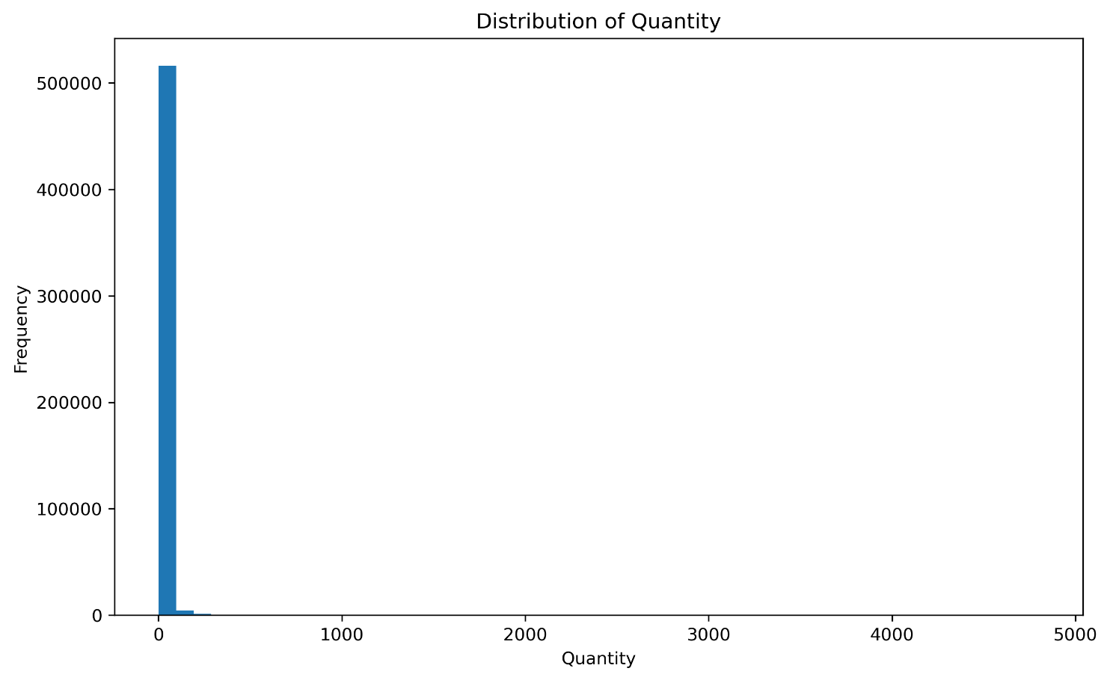
Distribution of quantity.
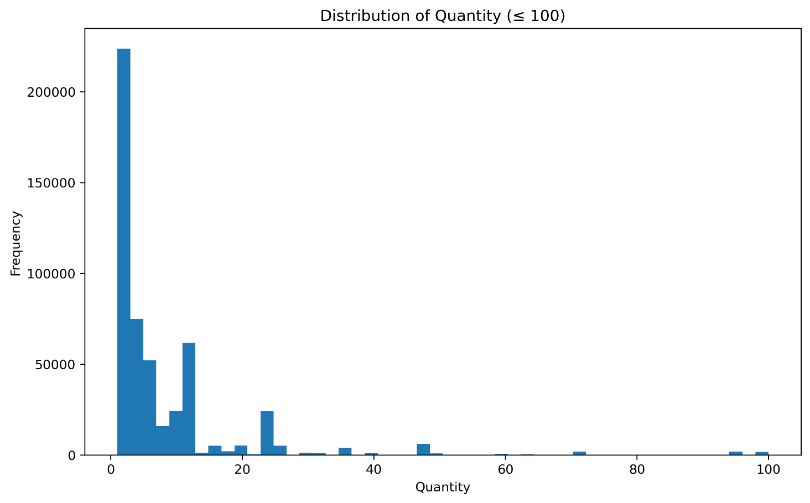
Distribution of quantity, less than 100 since the normal one was extremely skewed.

7.2 UnitPrice
Mean = £3.29, median = £2.08. The 90th, 95th, 99th and 99.9th percentiles were £7.65, £9.95, £16.63 and £39.95. Most products are low-priced, with a small high-price tail.
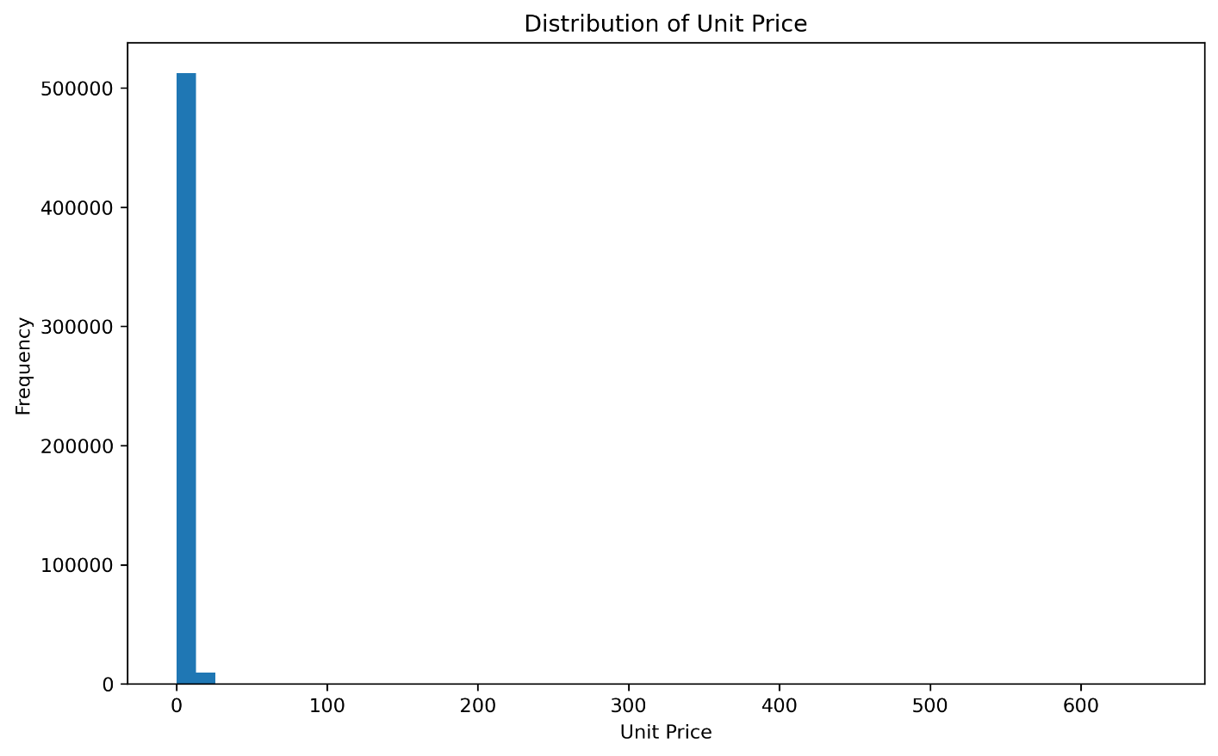Distribution of UnitPrice.
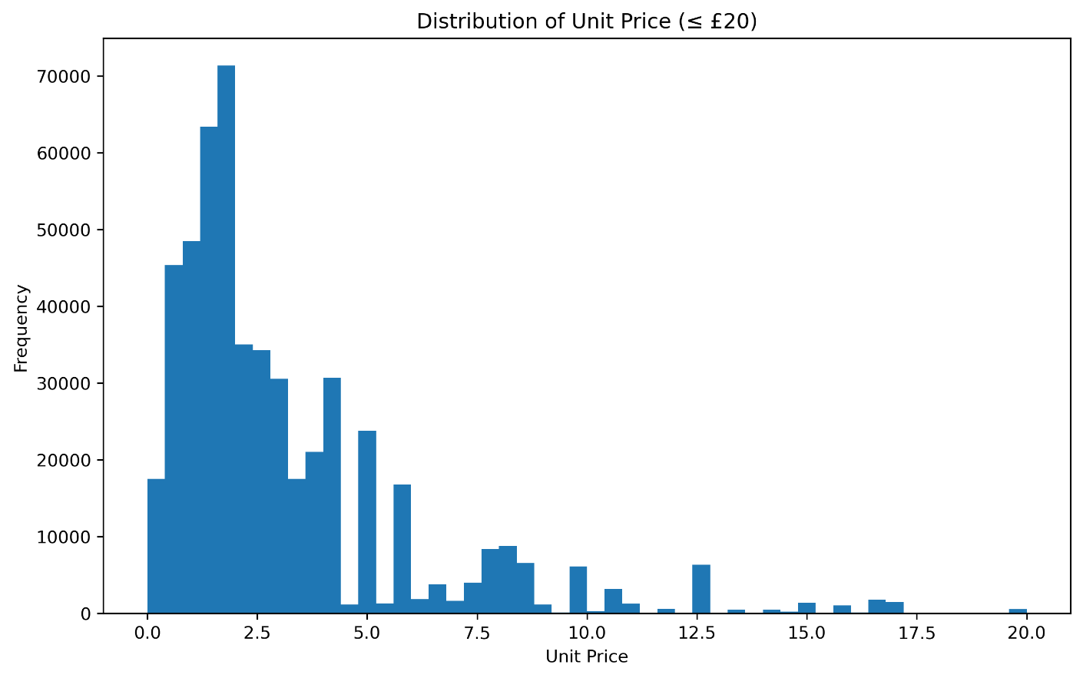Distribution of UnitPrice, less than 20 since the normal one was skewed.

7.3 TotalAmount
Mean = £19.15, median = £9.90. The 90th, 95th, 99th and 99.9th percentiles were £31.80, £59.40, £179 and £750. The mean being almost twice the median reflects the strong right skew.

8. Temporal EDA
InvoiceDate was transformed into Year, Month, YearMonth, DayOfWeek and Hour. Monthly revenue/orders/quantity/AOV tables and charts were then used to identify trends, sudden changes and operating patterns.

8.1 Monthly analysis
Revenue was irregular rather than steadily increasing. September, October and November showed a clear acceleration, with November the strongest complete month at £1,453,295.98 across 2,753 orders. December 2011 showed £446,244.65, but the dataset ends on 9 December, so it must not be interpreted as a complete-month collapse.
Revenue correlated 0.972 with Orders and 0.984 with Quantity, but only 0.404 with AverageOrderValue. This indicates that transaction volume is a much stronger observable driver of revenue than average order size.

8.2 Day-of-week
Thursday had the most transaction lines (99,807), the highest revenue (£2,133,746.60) and the highest average transaction value (£21.38). Purchasing was concentrated on weekdays; Saturday had no transactions in the cleaned data and Sunday was lower than weekdays.

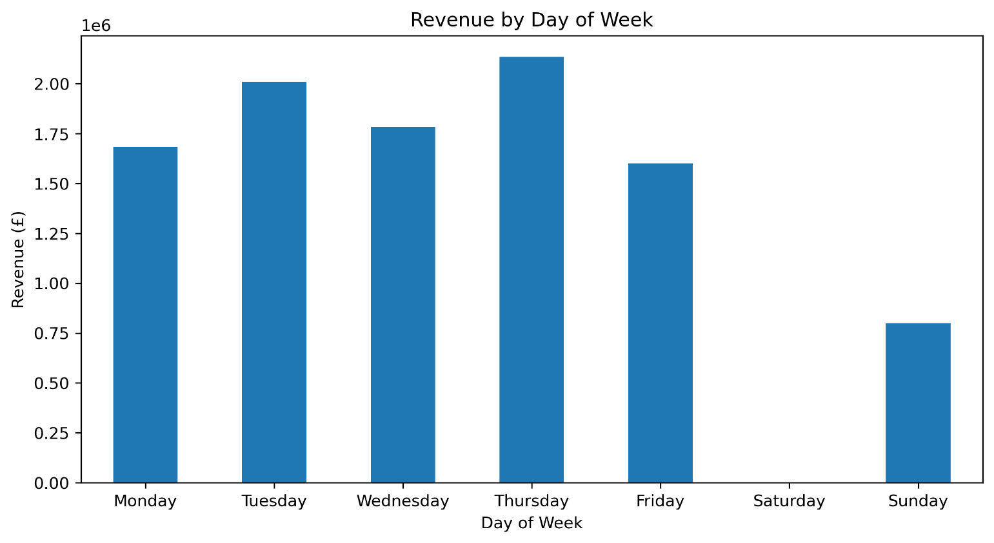Revenue generated per week.

8.3 Hourly analysis
Activity concentrated around daytime operating hours. 12 PM recorded the highest transaction activity (75,753) and revenue (£1,414,039.37). The highest average value was at 7 AM (£81.17), but this was based on only 376 observations and is therefore less robust than the high-volume noon pattern.
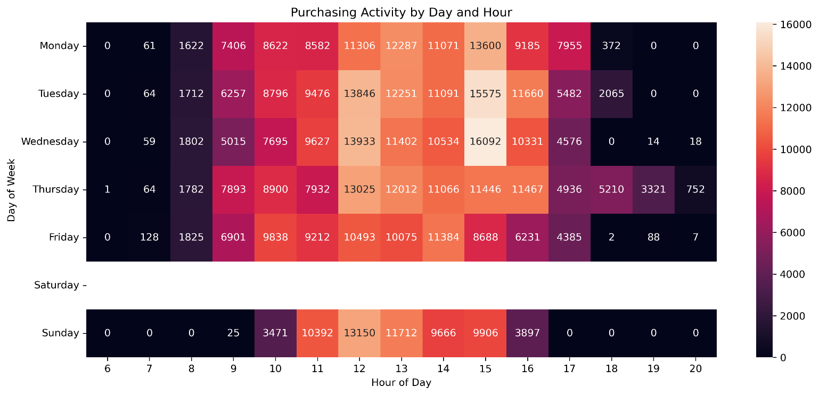Number of orders placed in a week per hour.

9. Geographical EDA
Country was analyzed using transaction count, total revenue, mean transaction value and median transaction value so that market size and spending intensity were not confused.
Country | Transactions | Revenue | Avg value
United Kingdom | 478,948 | £8,481,181.88 | £17.71
Netherlands | 2,322 | £283,889.34 | £122.26
EIRE | 7,874 | £276,090.86 | £35.06
Germany | 8,643 | £205,381.15 | £23.76
France | 8,087 | £184,679.00 | £22.84
Australia | 1,180 | £138,103.81 | £117.04
Japan | 321 | £37,416.37 | £116.56

The UK dominates scale, while smaller markets such as the Netherlands, Australia and Japan have much higher average transaction values. These markets are potential high-value opportunities, but their smaller sample sizes require caution.

10. Product EDA
Products were grouped by StockCode and analyzed using Revenue, Orders and Quantity. Additional measures RevenuePerOrder and RevenuePerUnit were created to distinguish sales volume from value generation.
Top revenue products included REGENCY CAKESTAND 3 TIER (£174,156.54), WHITE HANGING HEART T-LIGHT HOLDER (£104,284.24), PARTY BUNTING (£99,445.23), JUMBO BAG RED RETROSPOT (£94,159.81), and MEDIUM CERAMIC TOP STORAGE JAR (£81,700.92).
A performance matrix was then built using median Revenue (£2,106.84) and median Quantity (1,314) as thresholds.
Performance | Products | Revenue | Quantity | Orders
High Revenue & High Volume | 721 | £7,034,667.74 | 3,709,866 | 299,528
High Revenue & Low Volume | 318 | £1,353,748.18 | 223,379 | 52,379
Low Revenue & Low Volume | 2,797 | £1,229,752.20 | 703,918 | 114,749
Low Revenue & High Volume | 319 | £391,365.41 | 769,204 | 50,822

The matrix showed that high unit volume does not automatically mean high revenue. The Low Revenue & High Volume group is therefore a useful candidate for pricing, pack-size and margin investigation.
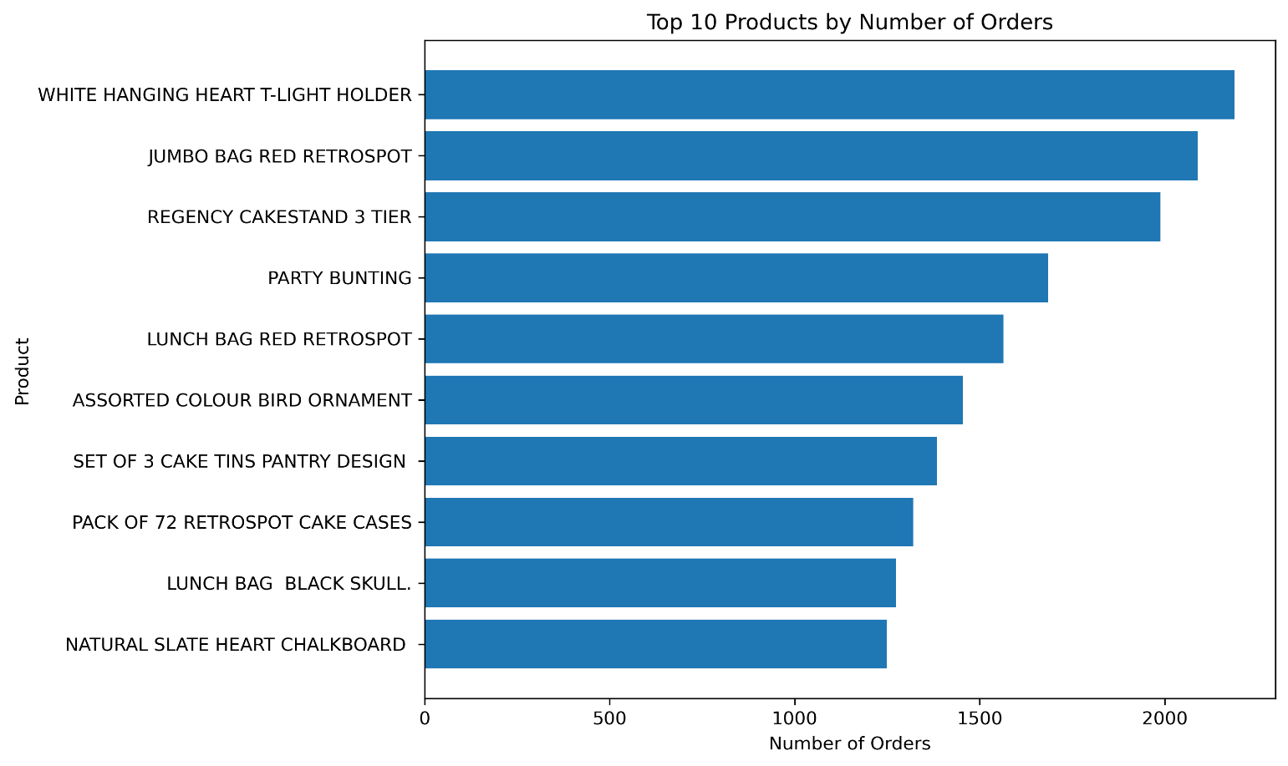Top 10 products by number of orders.
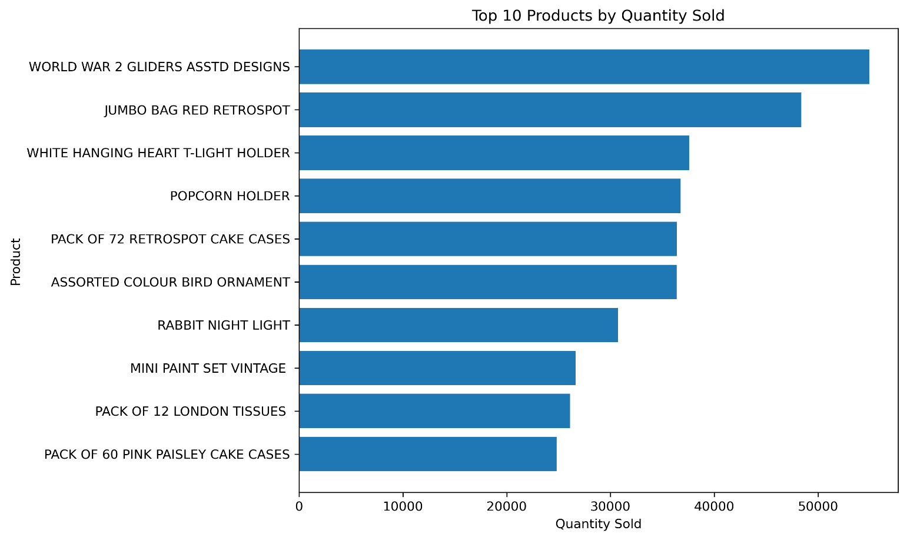Top 10 products based on quantity sold.
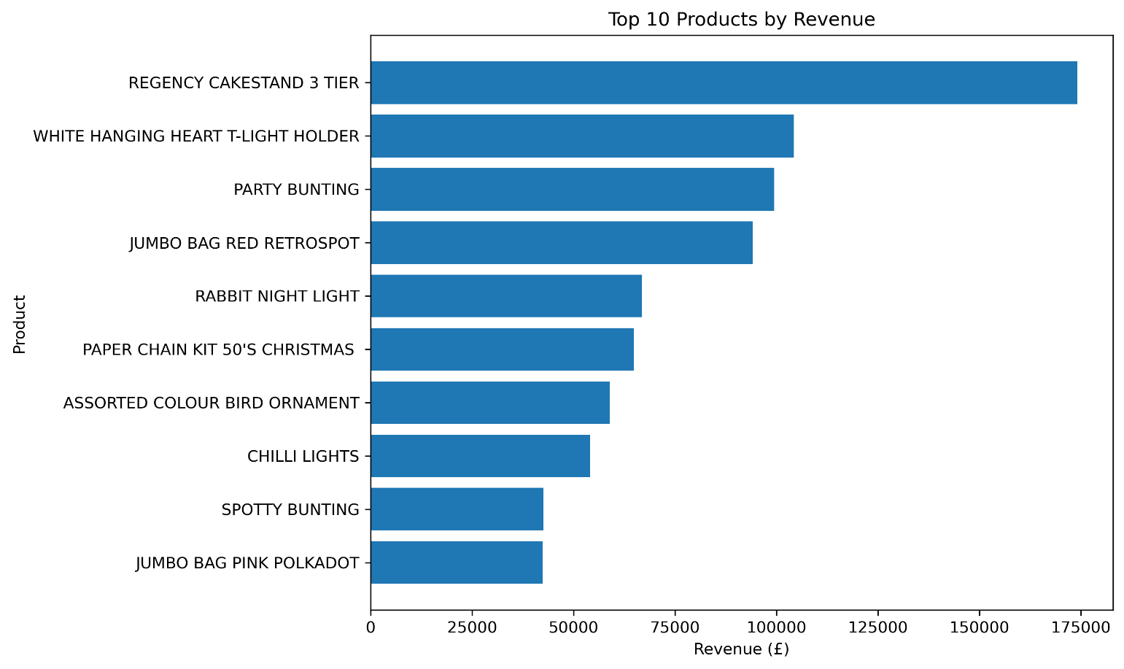Top 10 products based on revenue generated

11. Customer EDA
Customer analysis used only records with valid CustomerID. Revenue was summed from TotalAmount, orders were counted as unique InvoiceNo values, and quantity was summed. This produced 4,334 identifiable customers.
Metric | Result
Average orders/customer | 4.25
Median orders/customer | 2
Maximum orders/customer | 206
One-time customers | 1,505 (34.73%)
Repeat customers | 2,829 (65.27%)

Order-frequency bands were 1 order: 1,505. 2 orders: 829. 3–5: 1,135. 6–10: 533. 11–20: 238. 21+: 94. Revenue concentration was also measured: top 10 customers contributed 16.60%, top 20, 22.84%, and top 50, 31.91% of customer revenue.
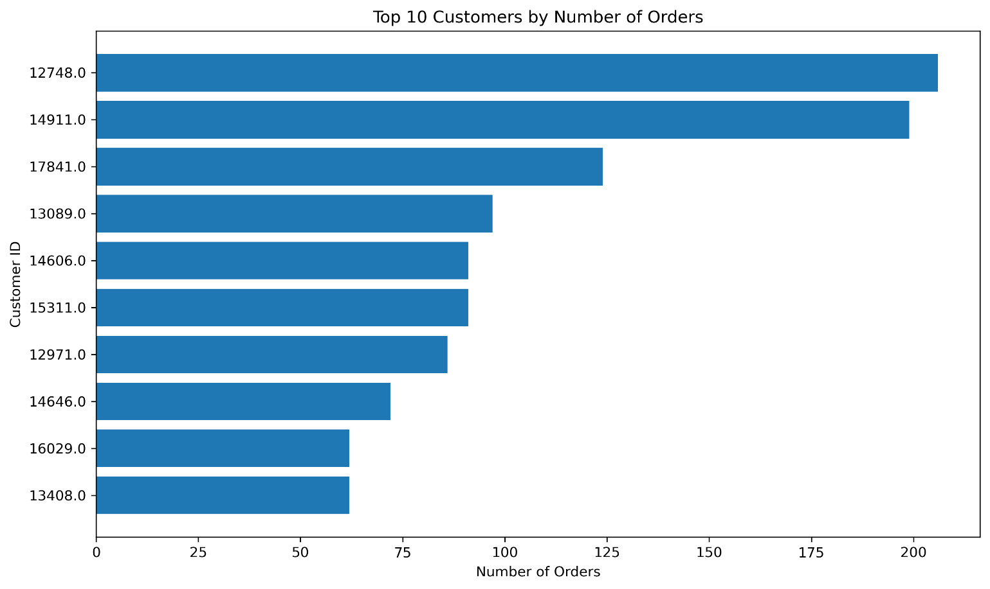Top 10 Customers by Number of Orders
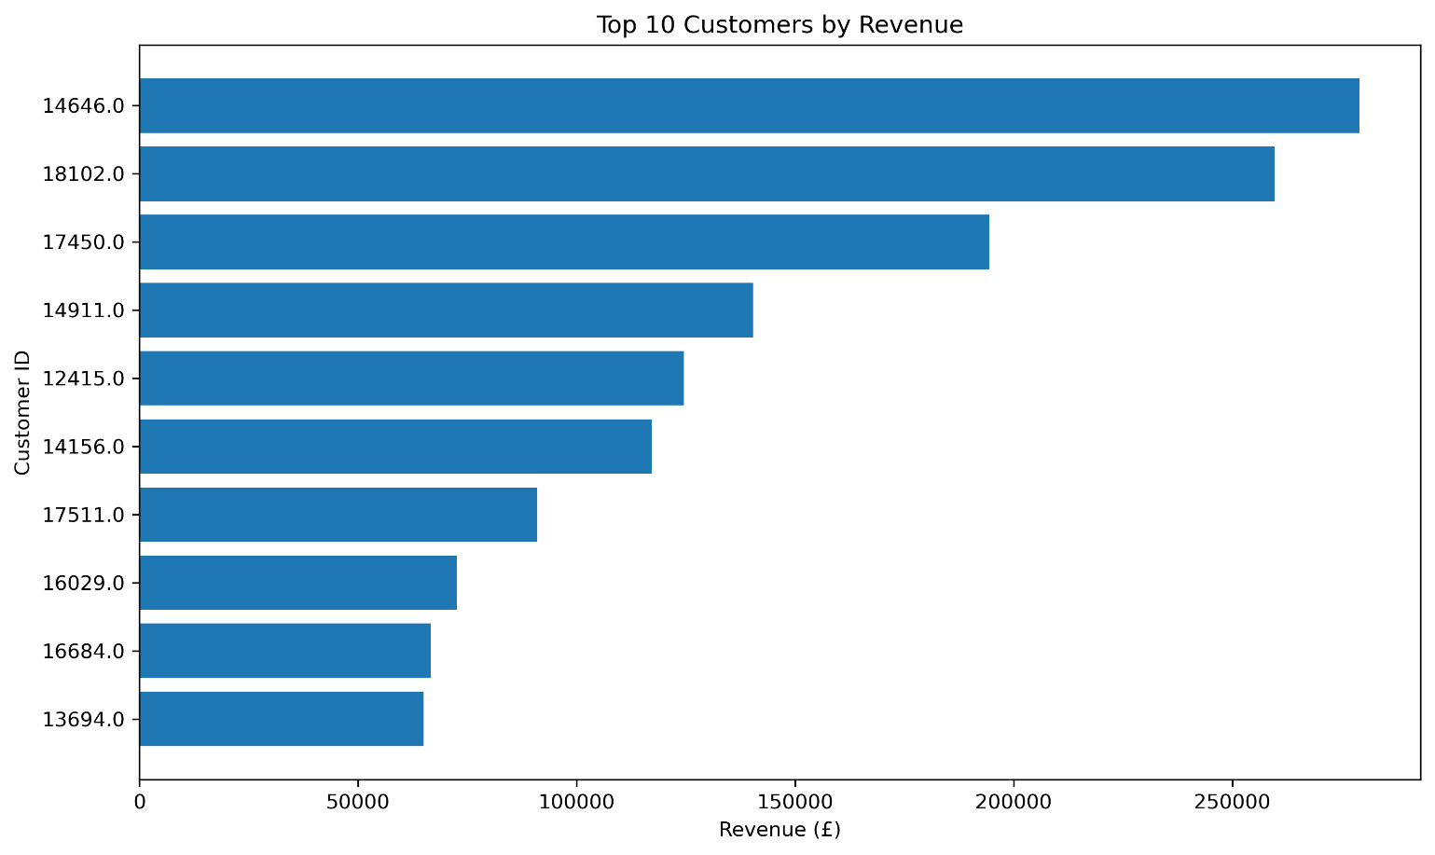Top 10 Customers by Revenue generated

12. RFM Analysis: Calculation Process
RFM was introduced after descriptive customer analysis to combine three complementary dimensions of behavior into a single customer-prioritization framework.
Metric | Calculation in this project | Meaning
Recency | 2011-12-09 12:50:00 − latest InvoiceDate | Days since most recent purchase
Frequency | Unique InvoiceNo per CustomerID | Number of purchases/orders
Monetary | Sum of TotalAmount per CustomerID | Total customer revenue

The snapshot date was the latest transaction timestamp in the analytical data: 9 December 2011 at 12:50. Recency had mean 91.70 days and median 50; Frequency mean 4.25 and median 2; Monetary mean £1,960.87 and median £661.42.
Each RFM component was converted to a 1–5 score. Recency was scored in reverse so more recent customers received better scores; Frequency and Monetary were scored positively so higher values received better scores. The three scores were summed to create an RFM Score from 3 to 15.
The score distribution was: 3=181, 4=360, 5=347, 6=425, 7=365, 8=377, 9=330, 10=352, 11=342, 12=325, 13=279, 14=300, 15=351 customers.
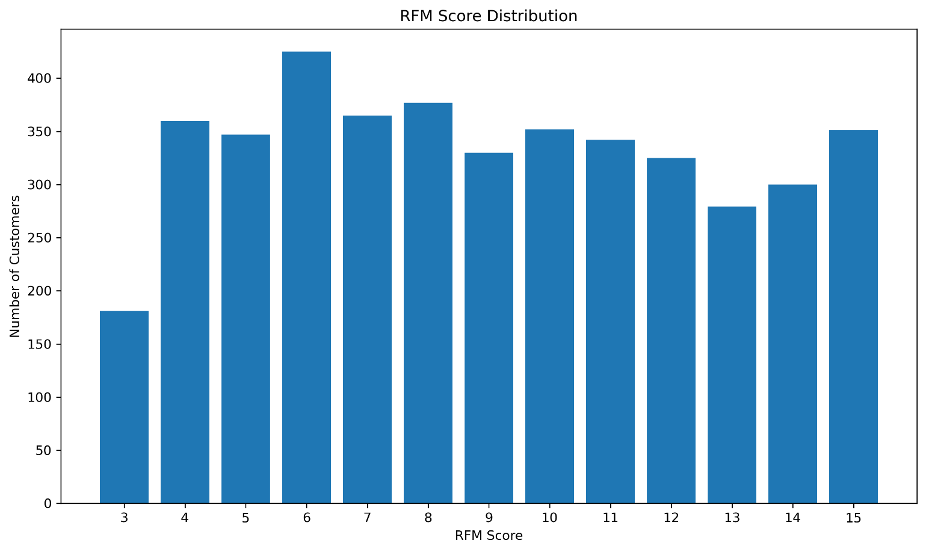RFM Score Distribution

13. Customer Segmentation: Criteria and Process
The final customer segmentation was rule-based and business-oriented, not an unsupervised machine-learning clustering model. The RFM scores and underlying R/F/M measures were interpreted together to produce labels that could directly support marketing and retention decisions.
Segment | Behavioral definition
Loyal Customers | Strong combination of recent purchases, high frequency and high monetary value; sustained engagement and value.
High-Value Customers | High monetary contribution; may have lower frequency or older recency than the Loyal group but remain financially important.
Frequent Buyers | High purchase frequency, indicating repeated engagement, without necessarily being among the highest monetary customers.
Recent / Potential Customers | Very recent purchasers with low frequency/value; candidates for conversion into repeat buyers.
Occasional Customers | Lower frequency with intermittent engagement and moderate/older recency.
Idle / Inactive Customers | Long time since purchase, generally combined with low frequency/value; reactivation risk.

The resulting population was: Occasional 1,199 (27.66%), Loyal 956 (22.06%), Idle/Inactive 848 (19.57%), High-Value 539 (12.44%), Frequent Buyers 504 (11.63%), and Recent/Potential 288 (6.65%).

14. Segment Revenue Analysis
Segment | Customers | Revenue | Share | Avg Frequency | Avg Recency
Loyal Customers | 956 | £5,711,160.77 | 67.20% | 11.06 | 11.78 days
High-Value Customers | 539 | £1,065,435.31 | 12.54% | 3.18 | 102.07 days
Frequent Buyers | 504 | £871,982.55 | 10.26% | 5.06 | 37.24 days
Occasional Customers | 1,199 | £483,747.36 | 5.69% | 1.61 | 74.14 days
Idle / Inactive Customers | 848 | £276,453.82 | 3.25% | 1.55 | 257.54 days
Recent / Potential Customers | 288 | £89,645.63 | 1.05% | 1.18 | 17.73 days

Loyal Customers represent 22.06% of identifiable customers but generate 67.20% of customer revenue. This is the clearest concentration of commercial value found in the project.
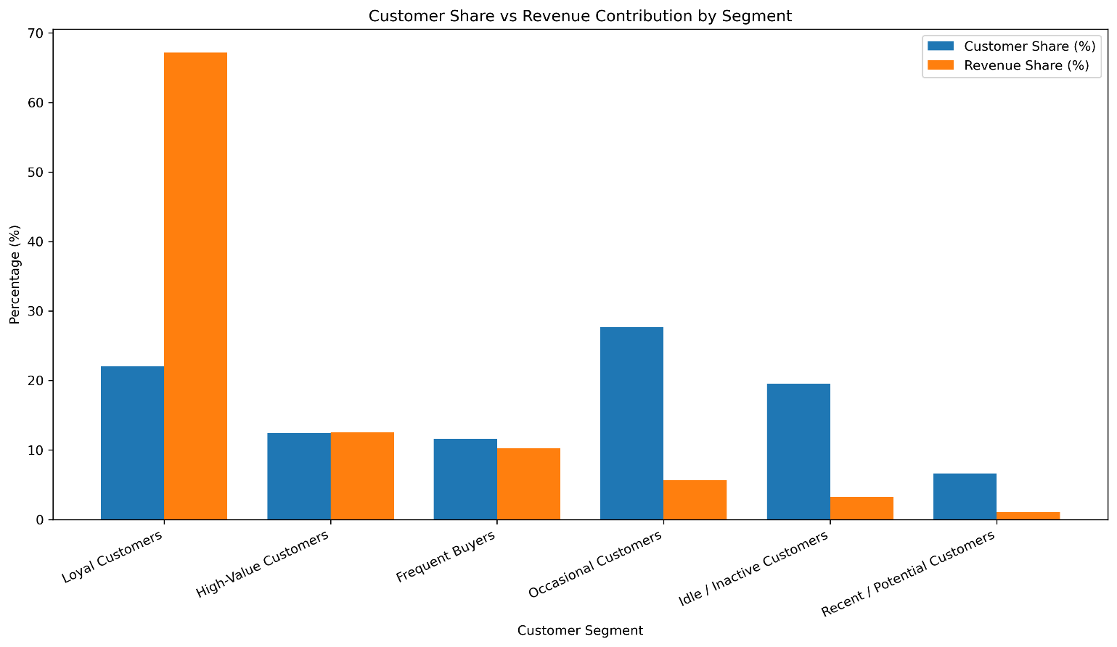Customer Segmentation & Revenue

15. Integrated Findings and Business Insights
- Revenue is strongly volume-driven: Orders and Quantity have correlations of 0.972 and 0.984 with Revenue.
- Loyal customers are the largest strategic value pool: 22.06% of customers generate 67.20% of customer revenue.
- One-time customers make up 34.73% of identifiable customers, creating a major repeat-purchase opportunity.
- The UK dominates total sales, while smaller international markets can have much higher average transaction values.
- High Revenue & High Volume products form the main product engine; High Volume & Low Revenue products warrant pricing/margin review.
- Purchasing is concentrated on weekdays and daytime hours, especially Thursday and around noon.
- September-November 2011 showed strong momentum, with November the strongest complete month.
- December 2011 cannot be used as a complete-month decline because only the first nine days are present.
- Missing CustomerIDs limit customer-level conclusions, while unusual accounting/product codes require contextual interpretation.

16. Recommendations
Retain loyal customers: Use loyalty rewards, personalized offers, recommendations and exclusive access.
Convert one-time buyers: Use post purchase follow ups and incentives designed to generate a second order.
Reactivate inactive customers: Create win back campaigns based on previous purchases and recency.
Review high-volume/low-revenue products: Investigate price, discounting, pack size and margin rather than relying on unit volume alone.
Prioritize top products: Use demand patterns to support inventory planning for High Revenue & High Volume products.
Explore high-value international markets: Evaluate logistics, acquisition cost and repeat behavior in markets with high average transaction value.
Use time-aware marketing: Align campaigns and operational resources with weekday/daytime peaks.
Improve customer data capture: Investigate the source of missing CustomerIDs to strengthen future customer analytics.

17. Limitations
- The UCI period ends on 9 December 2011, so December 2011 is incomplete.
- 25.14% of final transaction records have missing CustomerID, so customer findings apply only to identifiable customers.
- Statistical outliers are not necessarily errors; some are legitimate bulk/high-value purchases.
- Revenue is not profit because cost, shipping, tax and margin data are not available.
- Country averages can be unstable for small transaction counts.
- The segmentation is a rule-based business framework, not a predictive model or clustering algorithm.
- RFM is retrospective and descriptive; it does not by itself predict churn or lifetime value.

18. Project Workflow
- Preserve the original UCI workbook unchanged.
- Load and inspect shape, columns, types and summary statistics.
- Profile missing values and duplicate rows.
- Validate Quantity and UnitPrice; filter invalid non-positive sales observations.
- Inspect InvoiceNo and StockCode for cancellation/accounting patterns.
- Create TotalAmount and retain outlier flags.
- Extract time features.
- Perform numerical distribution and IQR/percentile analysis.
- Perform monthly, weekday, hourly and day × hour analysis.
- Perform country analysis.
- Perform product ranking and performance quadrants.
- Filter valid CustomerID for customer analysis.
- Measure one-time/repeat behavior and customer revenue concentration.
- Calculate RFM using the final transaction timestamp as the snapshot.
- Score R, F and M on 1–5 scales and sum to RFM Score.
- Assign business-readable customer segments from RFM behavior.
- Compare segment size, revenue, frequency and recency.
- Synthesize findings, limitations and recommendations.

19. Conclusion
This project demonstrates a complete practical EDA workflow rather than a collection of final charts. The analysis progressed from source understanding and quality profiling to cleaning, feature engineering, statistical exploration, temporal/geographical/product/customer analysis, RFM scoring, segmentation and business interpretation.
The central business conclusion is that commercial value is highly concentrated: loyal customers generate most identifiable-customer revenue, transaction volume is the strongest observable revenue driver, a core set of products drives sales, and purchasing activity is concentrated in specific markets, weekdays and daytime hours. The strongest next steps are therefore customer retention, conversion of one-time buyers, reactivation, product portfolio optimization and targeted international-market investigation.

