

**Team Members**

**Ali Akbar** – BSE 233016

**Laiba Zulfiqar** – BSE233022

**Zainab Fatima** – BSE233008

***Git hub URL*** = https://github.com/ali-akbar-019/db-project.git

Contents

Interface Testing Report 4

1. Products 4

Updating the product 7

Deleting 9

2. CART 10

Adding to the cart 11

Deleting from cart 13

3. Orders 14

Adding 14

4. Orders info and info graphics 17

5. Backup and Recovery 19

# Interface Testing Report

## Products

**Adding Product**

Using this **UI** to add a product

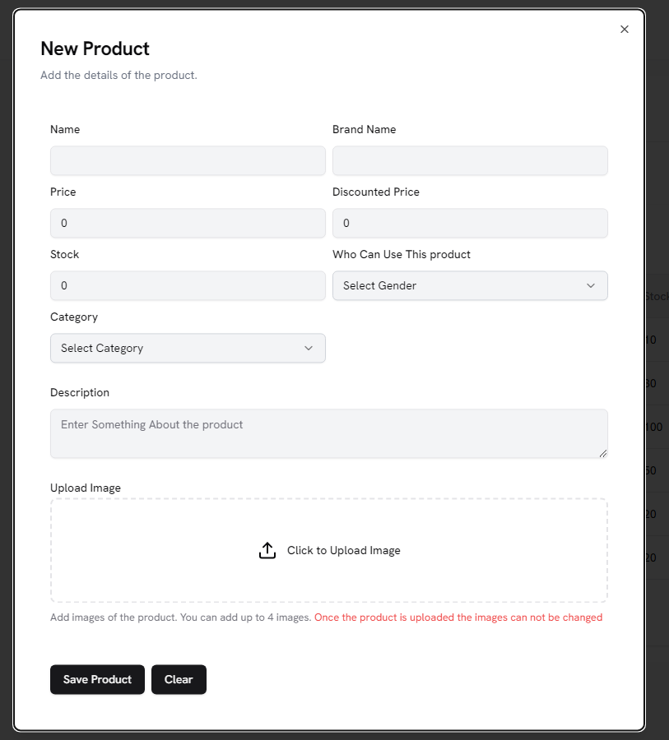

**Lets add an example product**

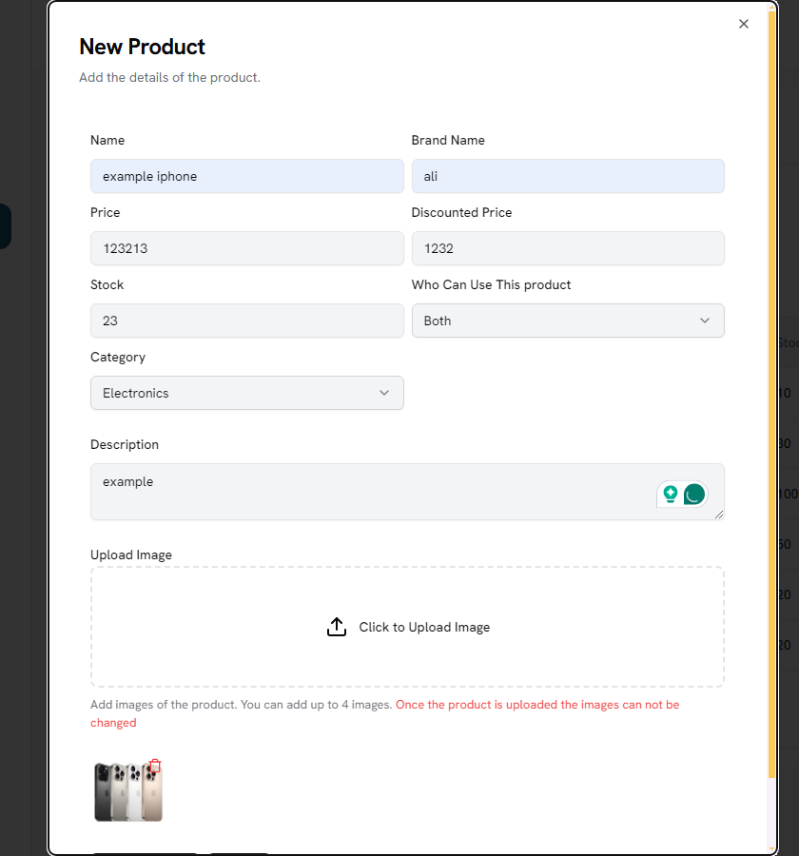

**The product is being added**



### Updating the product

**Changed the name and brand name**

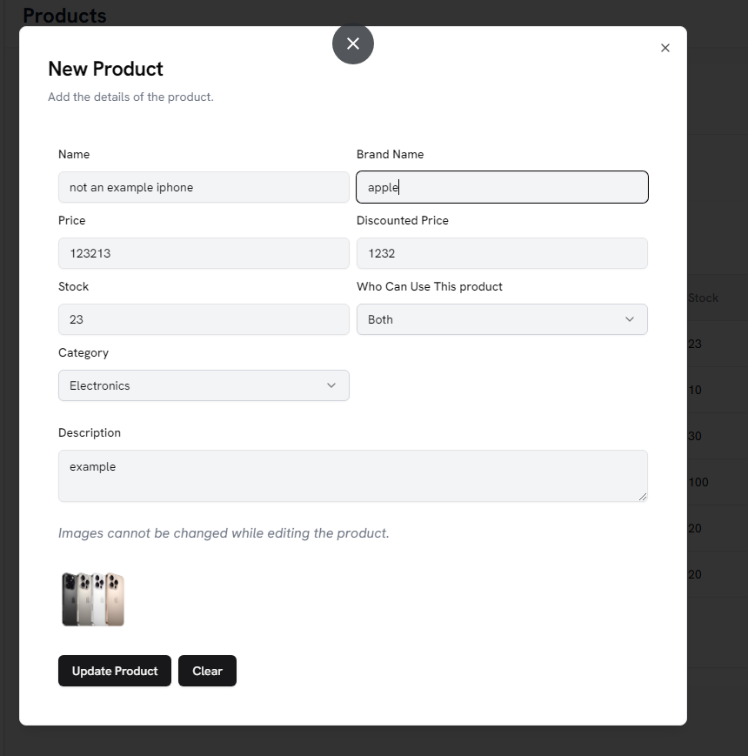

**Updated Product**



### Deleting

**Current products**

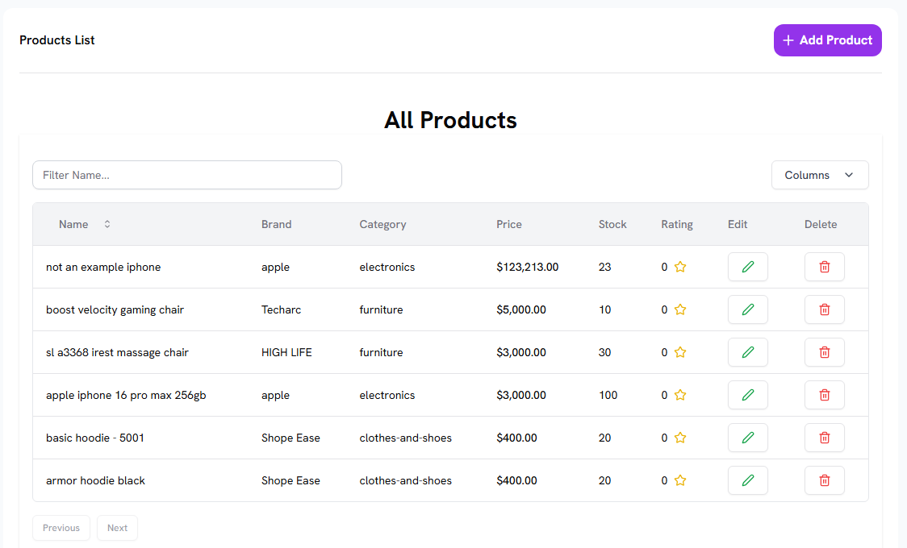

**Deleting the added product**

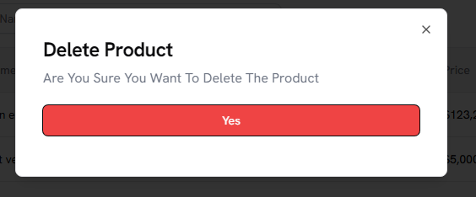

**Deleted the example product**



## CART

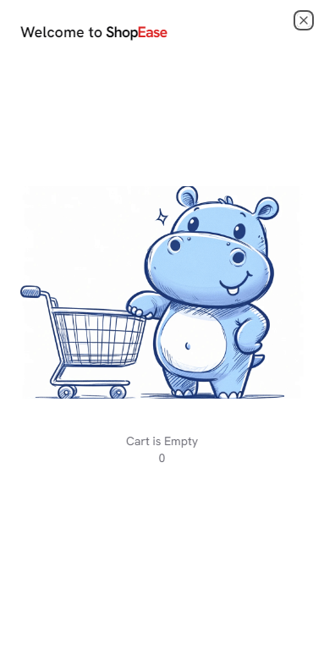

### Adding to the cart



**Added**



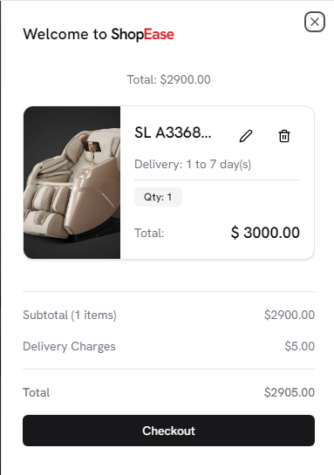

### Deleting from cart

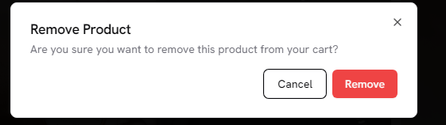

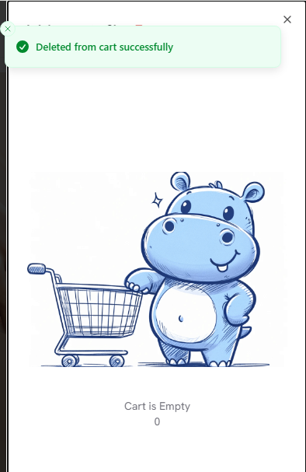

## Orders

### Adding

**This is in the cart**

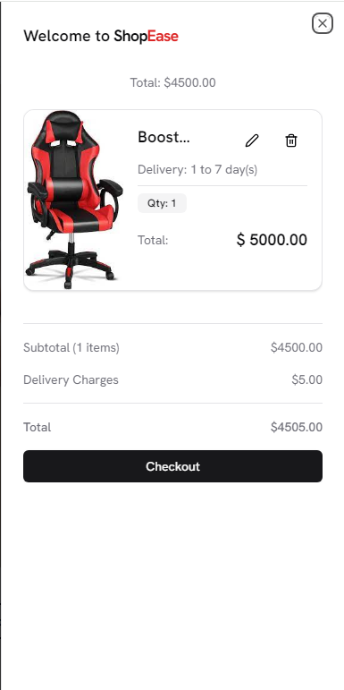

**Ordering it**

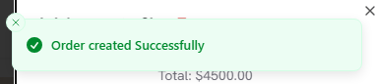

**We can check it on the users billing page and on the admin page**

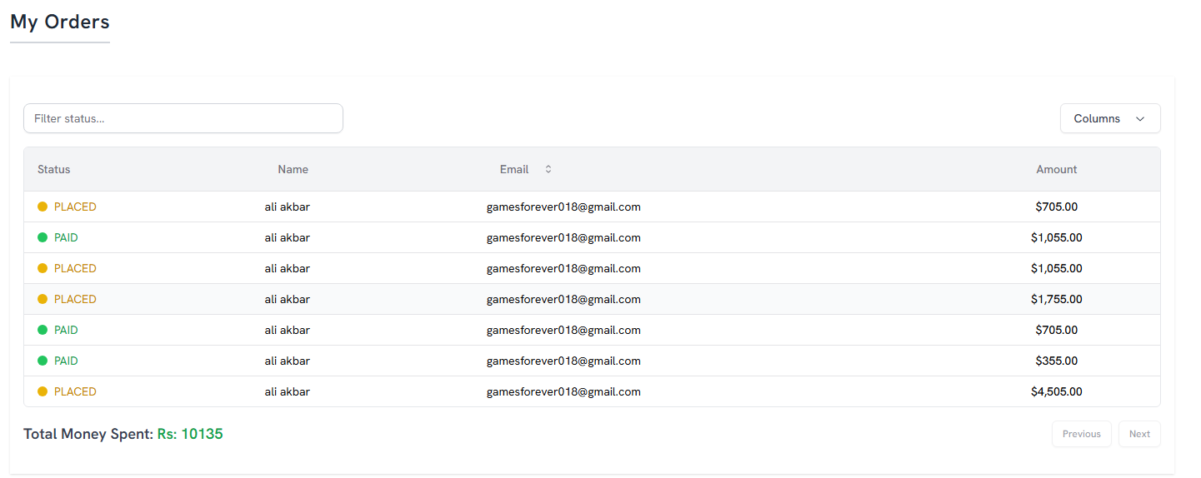

**The last order is the current one**



**Updating order status from the admin panel**

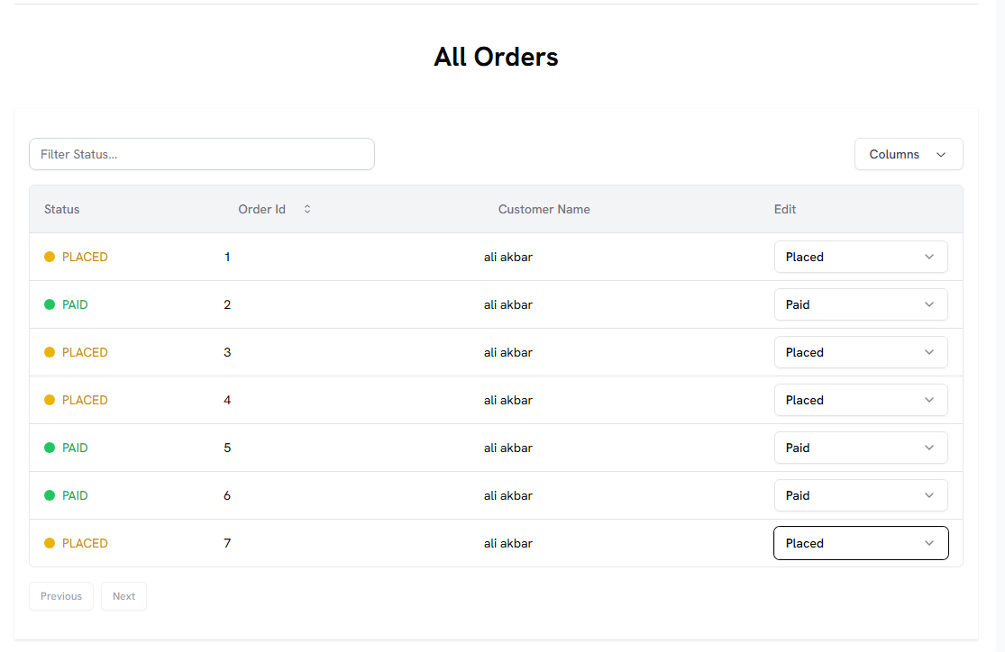

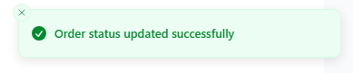



## Orders info and info graphics

**All this data is dynamic**

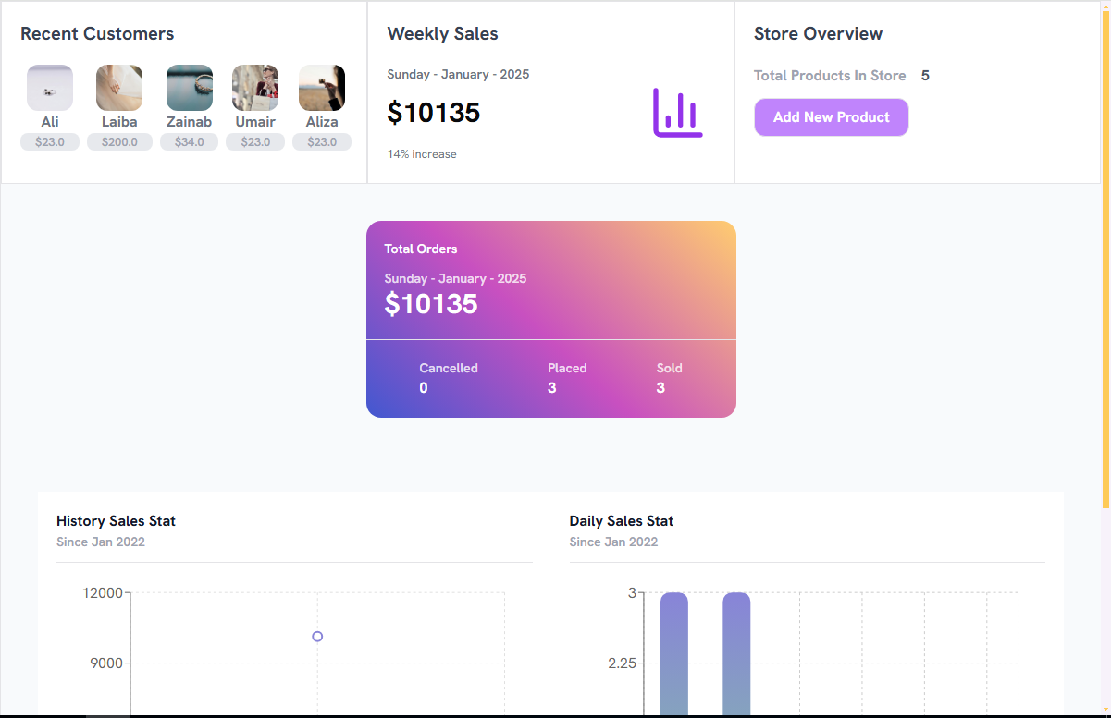

**Visuals , we have pie chart , bar chart and histogram**

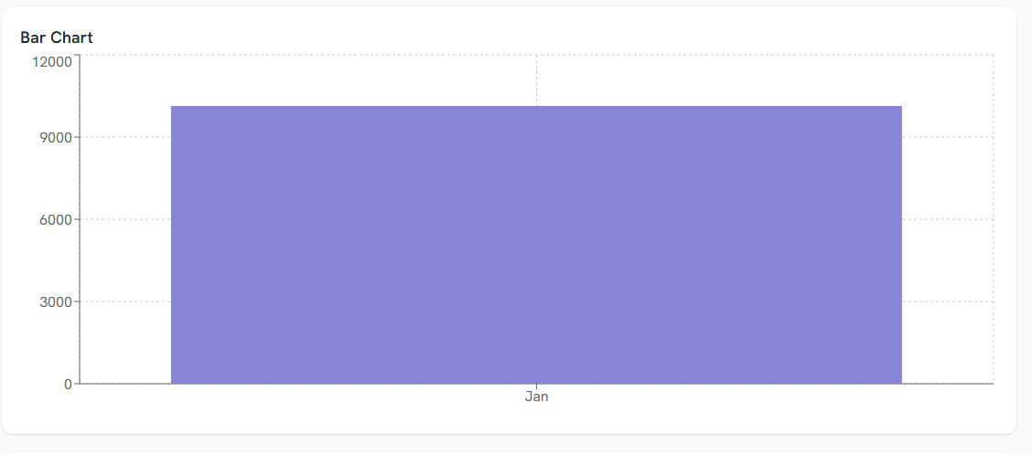



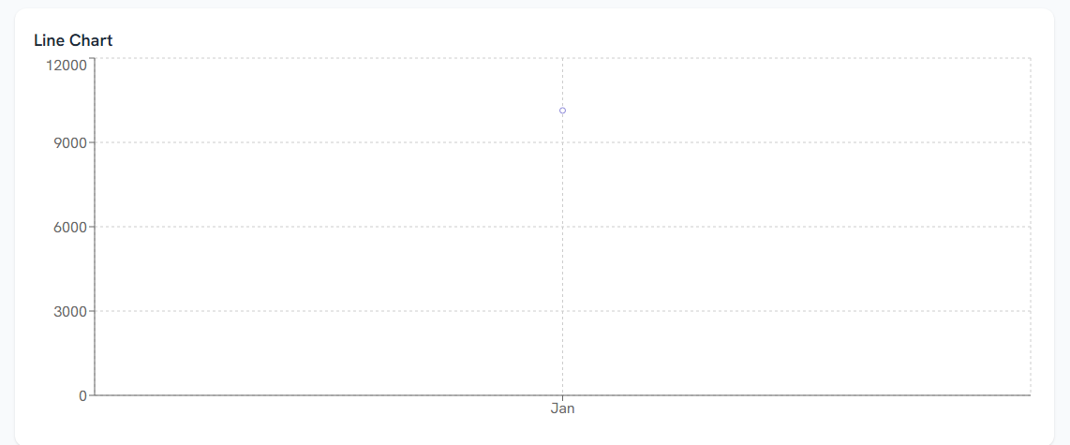

## Backup and Recovery

In Prisma when we make changed to the db and run the command **npx prisma migrate dev --name “name of the migration”**

Then it makes the **migration.sql** file, We can recover and backup from there.

**Also we have commands like**

**Mysqldump**

You can back up your MySQL database using **mysqldump**. This is a common approach for relational databases.

To create a backup, you can run the following command:

**mysqldump -u your_username -p your_database_name > backup.sql**

**Where:**

**your_username**: The username for your MySQL database.

**your_database_name**: The name of the database you want to back up.

**backup.sql**: The name of the file that will store your backup.

***The design of the website is very beautiful and attractive and everything is working fine .***

**Logging out**

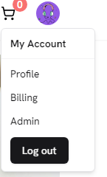

***The images of the websites are available in the websiteimages folder***