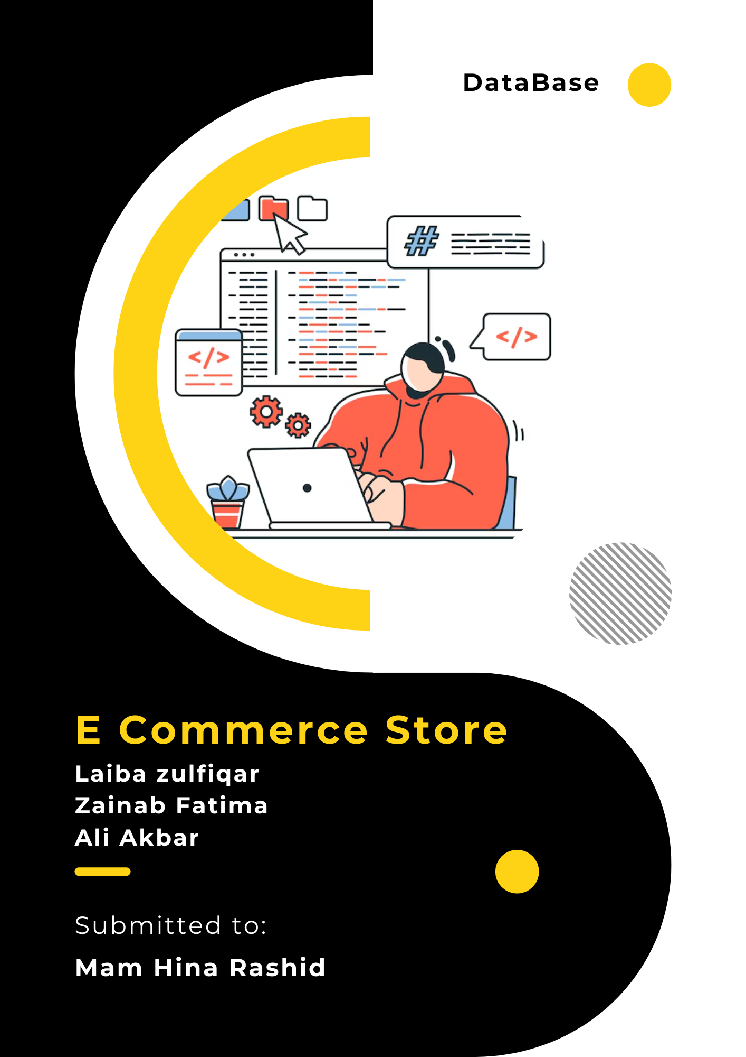

**Team Members**

**Ali Akbar** – BSE 233016

**Laiba Zulfiqar** – BSE233022

**Zainab Fatima** – BSE233008

***Git hub URL*** = https://github.com/ali-akbar-019/db-project.git

**ALL TABLES DATA (STORED)**

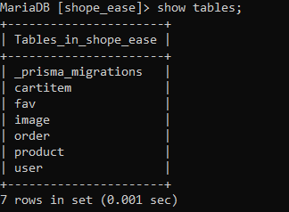

***Carttem***

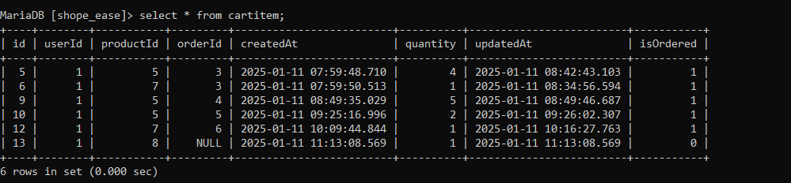

***Fav***

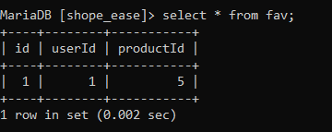

***Image***

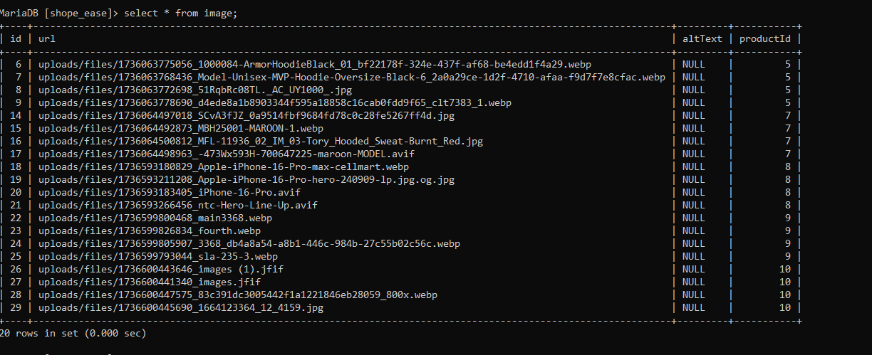

***Order***

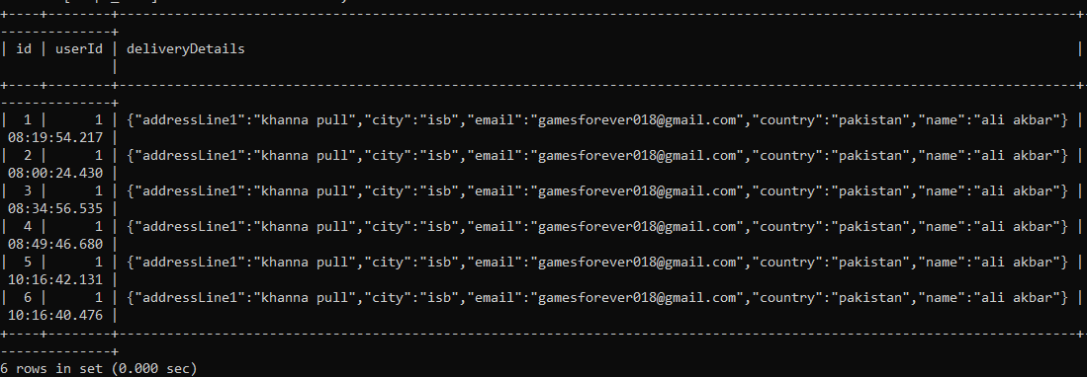

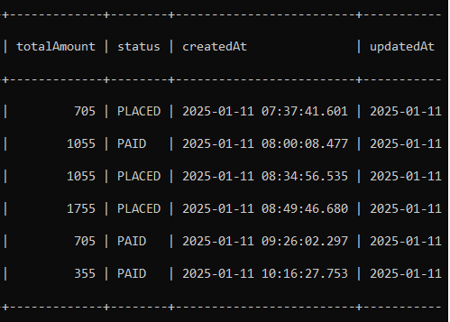

***Product***

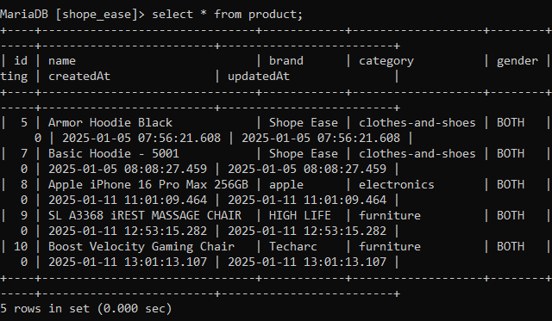

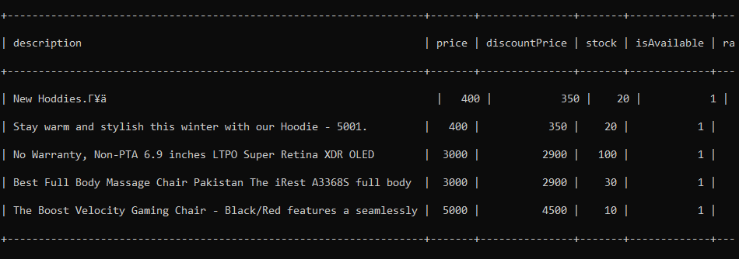

***User***

