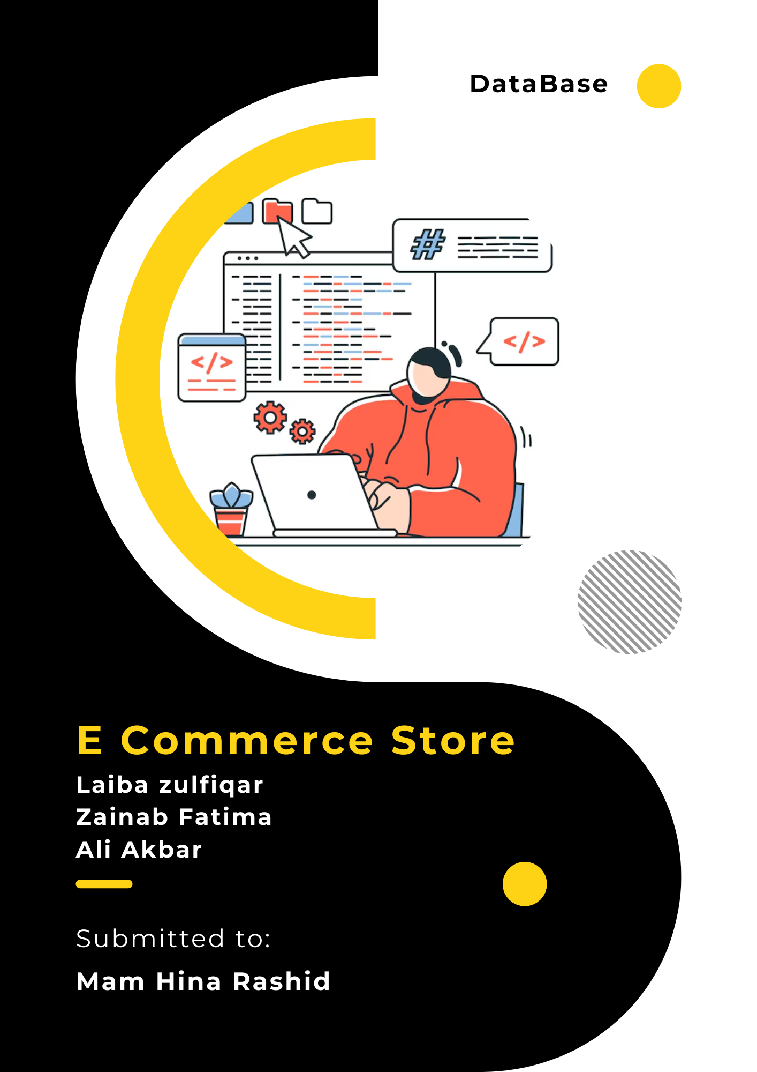

**Team Members**

Ali Akbar – BSE 233016

Laiba Zulfiqar – BSE233022

Zainab Fatima – BSE233008

***Link e din URL*** = https://www.linkedin.com/in/ali-akbar-6557a4270/

***Git hub URL*** = https://github.com/ali-akbar-019/shop-ease-frontend

**Progress**

Setted up the project folder structure and the routes

